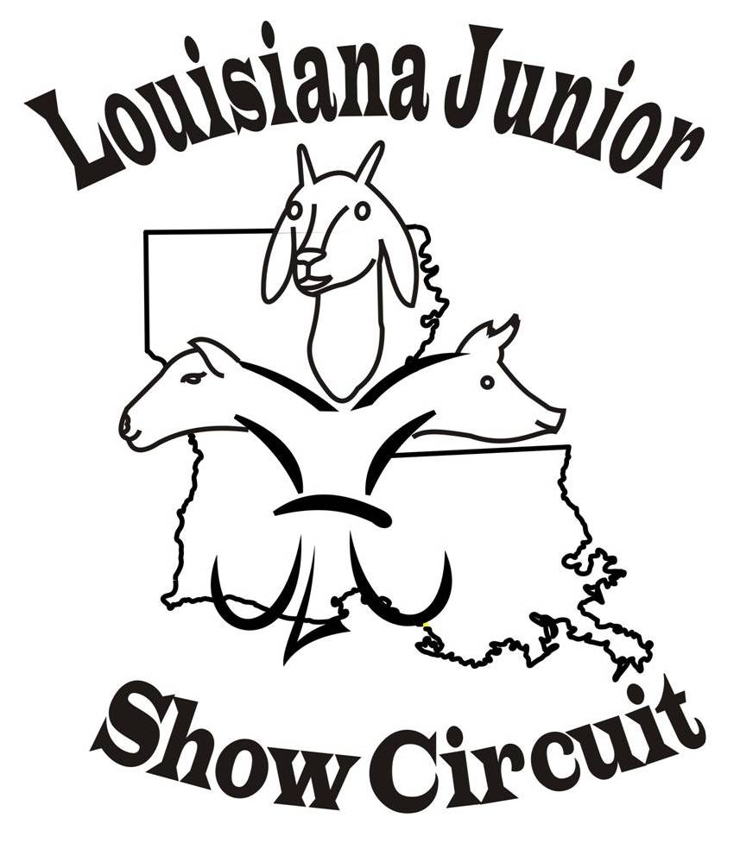

2019 LJSC SHOW Tentative Schedule

June 28th & June 29th Watermelon Festival Deridder, LA
July 5th & 6th Red River Showdown, Coushatta, LA
July 12th & July 13th Bayou Bash, Oberlin, LA
July 19th & 20st Claiborne Classic, Haynesville, LA
July 26th & 27th, Cane River Classic, Natchitoches, LA
August 2nd & 3rd Vermillon Fair & Festival, Kaplain, LA
August 9 ^{th} & 10th Black & Gold Showdown, Winnfield, LA
August Winn Sizzler, Winnfield, LA show dates pending

Website (www.louisianajuniorshowcircuit.org.) and facebook Louisiana Junior Show
Circuit (page and group) for updates. If interested in hosted a sanctioned show
please contact Nancy Nettles.

LJSC Contact Information
For Comments or questions concerning Louisiana Junior Show Circuit (LJSC) ~~~ Contacts:
Nancy Nettles-President Angie Baker - Secretary
(318) 932-5435 Home
(318) 455-2905 Cell
Membynancy1@aol.com

Vice-President- Lauribeth Padgett Judy Latiolais – Treasurer

Board Members: Dana Broussard, Stephanie Chamberlin, Josh Johnson, Allison Landry, and Guy Sanders

