Eco Orca Class DECEMBER 2025 Christmas, Community Helpers
SUNDAY |  |  | MONDAY | TUESDAY | WEDNESDAY | THURSDAY | FRIDAY | SATURDAY
 |  | 30 | 1 | 2 | 3 | 4 | 5 | 6
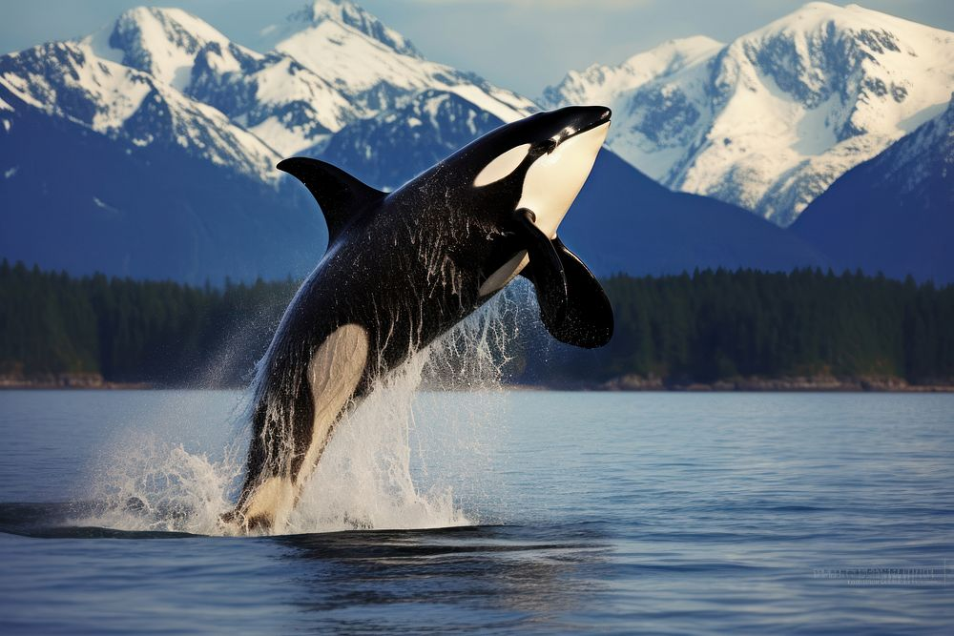 |  |  | Rainbow  Park | Willows Beach | Matheson Lake Trails | Colwood Fire Hall Visit | Honey Crisp Park
 | 7 |  | 8 | 9 | 10 | 11 | 12 | 13
 |  |  | Esquimalt Lagoon | Miniature World $5 | JDF Park | Thetis Lake Trails | Beacon Hill Feed The Ducks
 | 14 |  | 15 | 16 | 17 | 18 | 19 | 20
 |  |  | Bay Centre Christmas Trees $2 | Christmas Hill Trails | Gingerbread Houses $2 | Beckwith  Park | Christmas Party 1-2pm | 
 | 21 |  | 22 | 23 | 24 | 25 | 26 | 27
 |  |  | CLOSED | CLOSED | CLOSED | CLOSED  Christmas Day | CLOSED  Boxing Day
 | 28 |  | 29 | 30 | 31 | 1 | 2 | 3
 |  |  | CLOSED | CLOSED | CLOSED | CLOSED | CLOSED

