RSAI Legislative Update
Mar. 21, 2019
In this Mar. 21, 2019 RSAI Report of the 2019 Legislative Session, find information about:
- Next funnel deadline
- SAVE Extension assigned a Subcommittee in Senate
- Bills approved by a Chamber
- Committee work
- Advocacy Resources
- Links to members of Key Legislative Committees
Find this week’s RSAI Capitol Video Update here: https://youtu.be/v6Hf4i264Fw
Funnel Deadlines: There is no Spring Break for legislators. April 5 is the next funnel deadline by which House files must clear a Senate committee and Senate files must clear a House Committee to survive. Tax bills, appropriations bills, oversight committee bills and bills sponsored by leadership are exempt from the funnel deadlines. Any bill that died may come back as an amendment to another bill. Bills introduced this year remain in their committees for continued work in the 2020 Session. As expected, there was much time spent in caucus and on floor debate this week as each chamber is sending their ideas to the other side.
HF 546 SAVE Extension House Version Assigned a Senate Subcommittee:
See last week’s report (HERE) for details of the bill as amended. The bill was assigned to a subcommittee of the Senate Ways and Means Committee of Senators Feenstra, Dawson and Quirmbach. A new fiscal note to the House version was published this week, found HERE:
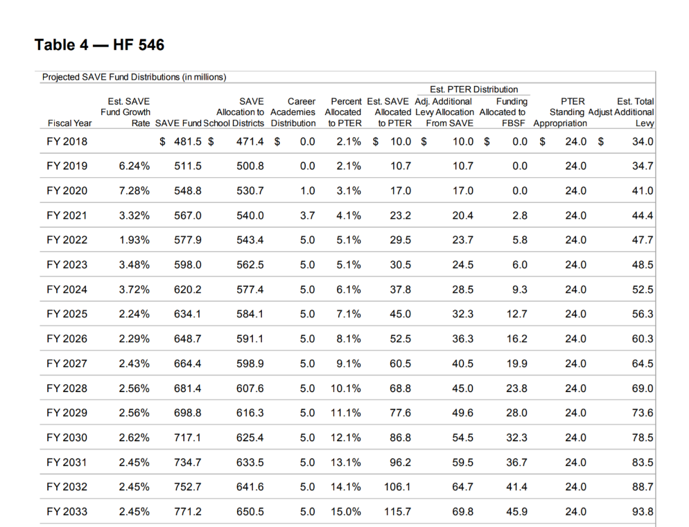
The fiscal note describes the change in property tax relief through the Property Tax Equity and Relief Fund (PTER): “The Bill extends the sunset of SAVE to January 1, 2051, and adjusts the amount of funds being directed into the PTER Fund. In FY 2020, the amount directed to PTER is 3.1% of the total funds generated by SAVE. Starting in FY 2021, for fiscal years in which the growth of SAVE is more than 2.0% over the previous fiscal year, the amount directed into the PTER Fund will increase by 1.0% until it reaches a cap of 15.0% of the funds generated by SAVE. Beginning in FY 2021, one-half (1/2) of the increase in funds each year will flow into a newly created Foundation Base Supplement Fund (FBSF) within the PTER Fund, which will function to increase the State cost per pupil foundation level. The current foundation level is set in Iowa Code section 257.1(2)(b) as 87.5% of the
State cost per pupil.” This table from the fiscal note shows the first 15 years of all estimated SAVE revenues:
Although school leaders would prefer to have more funds for other things, the provisions to reduce property taxes bring many other stakeholders (and legislators) to the table in support. The expanded sales tax base shows increased SAVE revenue in the next two years, softening concerns about the increase in property tax relief.
Next steps: if all goes well, the Subcommittee will meet and after recommending the bill move forward, the full Senate Ways and Means Committee will have a chance to support the bill. Those Committee members are listed at the end of this report.
Two Timely Advocacy Actions are still relevant:
Please send a thank you note to all representatives who voted yes for their support of the SAVE extension if you have not yet done so!!! Please also contact all of your Senators about SAVE extension and, if they are on the Senate Ways and Means Committee, recruit one other community member to also reach out to them for support. RSAI supports this bill.
Bills approved by a Chamber
HF 690 Children’s Mental Health Services: this bill by the Human Resources Committee establishes a Children’s Behavioral Health System Board and establishes requirements for core behavioral services for children. Establishes membership and duties of the board. Defines core services and sets eligibility requirements for children under the age of 18. Includes provisions on payments. Requires DHS to adopt rules on the matter. Requires the administrator of the MH/DS to assist in planning for services. Requires the MH/DS regions to submit plans to the DHS. Includes data collection and other requirements. Makes changes to the MH/DS regional boards. Makes definitions and conforming changes. Includes school success and attendance measures as outcomes for MH service provides. Does not include annual screening or any other school responsibility. The bill was amended and approved by the House 83:14. Companion SF 479 Children’s Mental Health System is on the Senate Calendar awaiting action. RSAI is registered as undecided.
SF 160 School Emergency Plans: this bill requires the Department of Public Safety to work with the DE in providing recommendations to school districts in regard to emergency operation plans. The Senate approved it 48-0, sending it to the House. RSAI supports.
SF 583 Private Generation Tariffs: this bill states the intent of the Legislature for private generators of alternative energy to pay for their share of the electric utility infrastructure. Allows a rate-regulated electric utility to file for a tariff charged to a customer using a private energy facility for the costs of providing service (solar). Requires private generation users to select a rate structure. Requires the IUB to review, and modify if needed, the tariff. Allows private generation facilities in existence at the time of enactment to continue to use the pre-existing tariff for the duration of the contract. The Senate amended and passed the bill, 28:19, sending it to the House. RSAI is opposed.
SF 438: Elimination of Mandates; this bill eliminates several mandates on schools and cleans up irrelevant or redundant Code, but does not eliminate authority for school boards and administrators, staff, parents and families, to make decisions regarding the health and welfare of students. The bill includes the following provisions:
- Eliminates schools as the middle man for dental and vision screenings, lead testing, etc., reporting. Requires parents of both public and private students to ensure their child is appropriately screened. Allows schools to provide access to screenings. Requires providers who conduct screenings to submit data to DPH. Requires schools to provide information about screenings to parents. Allows DPH to release screening data to schools with parent consent. The implementation of these screening provisions is delayed until July 1, 2020 to allow DPH to set processes in place and request the resources necessary to take on this activity through the normal budget process. The Fiscal Note estimated a cost to the DPH of $1.2 million in the first year and $850,000 in the second year. Sen. Sinclair said in her comments that schools were likely spending at least this much to gather and submit forms to DPH.
- Eliminates requirements for schools to use environmentally friendly (green) cleaning products.
- Eliminates AEA public notice of budget in the newspaper to online with the intent of more appropriately reaching their broader audience not served by one newspaper.
- Eliminates a requirement for school districts to publish a notice before entering into a loan agreement for an equipment purchase.
- Eliminates a duplicative provision for loading and unloading buses.
- Allows a school board to deposit proceeds of the sale of building or school site into any school fund other than the PPEL fund following a public hearing and board action.
- Slightly limits reporting requirements around preschool reporting, but maintains the requirement for districts to report preschool experiences of kindergarteners.
- Allows school districts to charge employees for DHS registry checks not to exceed the actual cost of the checks.
- Repeals energy audit reporting requirements
- Eliminates equipment purchase advance public notice.
The bill was passed by the Senate on a party-line vote, with Republicans in favor and Democrats opposed, 32:17. It is assigned to the House Education Committee. RSAI supports.
HF 499: 10-Passenger Vehicles: Vehicles designed to carry 10 or fewer persons when used as school buses. The bill was passed by the House, 95:0 and moves to the Senate Transportation Committee. RSAI supports.
Other Bills approved by subcommittee or committee action
SF 209 School Citizenship Tests: This bill requires accredited public and nonpublic schools to offer high school students an opportunity to take the test required by the Immigration and Naturalization Service for US citizenship. The bill requires the DE to identify an alternative for students with special education or English-language learner services. The bill was approved with amendment by the subcommittee of Reps. Hanusa, A. Meyer and Gains and is on the House Education Committee for Monday. RSAI is registered opposed.
SF 316 Special Education Interim Study: This bill requests the legislative council is establish an interim study committee to study and make recommendations relating to special education program requirements and outcomes for students with IEPs. The study committee is required to review state and federal laws relating to students with IEPs; to determine the ways in which inclusion requirements and least restrictive environment placements affect the classroom, including but not limited to the teaching staff, teacher retention, teacher professional development, and student and peer outcomes when children requiring special education are placed in a general education classroom; to review evidence-based practices and strategies by which schools and teachers can best accommodate students with IEPs who have severe emotional, social, and behavioral problems; to develop or identify strategies designed to improve outcomes for children requiring special education; and shall develop or identify a graduated process for the transfer of a child requiring special education from a self-contained classroom to a general education classroom. The bill specifies stakeholders from whom the study is required to receive input and is required to submit a report with its findings and recommendations to the legislature and each member of Iowa’s congressional delegation on or before December 18, 2020. The bill was approved by the House Education Committee. RSAI is registered in support.
SF 488 Concurrent Enrollment/On-line Learning: this bill increases weighting for liberal arts concurrent enrollment (community college) course from .045 to .05. Allows districts to meet offer and teach math and science requirements through concurrent enrollment or online courses. Allows nonpublic schools to contract for community college courses directly rather than through the public school via shared students. Replies retroactively to July 1, 2018 for entering into agreements. Clarifies that the regulations apply to courses used to meet offer and teacher requirements rather than to courses specified in the offer and teacher content areas. The bill was unanimously approved by the Senate Appropriations Committee, sending it to the Senate Calendar. As an appropriations bill, it is exempt from the funnel deadlines. RSAI supports.
SF 138 WGS an Reorg Incentives Extension: extends the incentives for 5 years, to July 1, 2024. The bill does not make any policy or process changes. The bill was unanimously approved by the Senate Appropriations Committee, sending it to the Senate Calendar. As an appropriations bill, it is exempt from the funnel deadlines. RSAI supports.
HF 633 BOEE LICENSING FEES: this bill requires the Board of Education Examiners to reduce fees by 25% and strikes requirements that 25% of such fees be deposited with the Treasurer of the State. The bill was approved unanimously by House Ways and Means committee and moves to the House Calendar, exempt from the funnel deadlines. RSAI is undecided.
HF 598 Siblings in Classes: this bill requires school administrators to defer to parent of siblings regarding class placement. The bill was amended to give the administrator more authority to appropriately place siblings under certain conditions and was approved by the House 93:5, sending it the Senate Education Committee. RSAI is opposed.
Bills Ready for Debate on the Calendar
See prior reports for descriptions of the following bills on the House or Senate Calendar.
Senate Calendar
SF 307: Repeal of state inheritance tax. RSAI opposed.
SF 159: DE sets Praxis cut score and one-year waiver. RSAI supports
SF 186: School transportation vehicles 9 and 12 passenger vans. RSAI supports.
SF 199: Voluntary diversity plans and open enrollment. RSAI opposed.
SF 283: Conflicts of interest threshold raised for school board members to $6,000. RSAI supports.
SF 376: Adds mental health, suicide prevention and awareness content to secondary curriculum. RSAI supports.
SF 394: Online Learning requirements and district authority to use ILO courses, develop individually, in partnership with other schools or through private provider approved by DE. RSAI supports.
SF 437: Academic eligibility standards for public school students participating in school-approved activities. RSAI undecided.
SF 429: Reverses burden of proof in certain judicial proceedings involving school boards and DE rules. RSAI supports.
SF 459: Right to carry, transport, or possess a firearm on real property comprising a person’s place of employment. RSAI opposed.
SF 480: Interim Committee to study virtual school days in place of snow days. RSAI supports.
SCR 8: Concurrent resolution to establish a fine arts program interim study committee. RSAI undecided.
House Calendar
SF 139: Financial Literacy implementation for class of 2022-23. Companion bill HF 420. RSAI supports.
SF 140: Increase in mileage for nonpublic school students’ minor driver’s licenses. RSAI undecided.
HF 343: Vans and pick-ups to transport students under certain condition. RSAI supports.
HF 513: DE authority to set Praxis cut score and one-year waiver. RSAI supports.
HF 517: Special minor’s drivers’ licenses for students attending nonpublic schools. RSAI undecided.
HF 596: Whole Grade Sharing and Reorganization Incentives extension for 5 years. RSAI supports.
HF 609: Legalizing act for school district that missed ISL deadline. RSAI supports.
HF 636: Carrying, possessing or transporting weapons on school grounds. RSAI opposed.
HF 637: 30-day reporting deadline to BOEE for certain employee misconduct offenses. RSAI undecided.
HF 652: City and school elections clean-up by Secretary of State. RSAI undecided.
HF 666: Periodic review of professional licenses. RSAI opposed.
HF 704: School board appoints student liaison. RSAI undecided.
HF 715: Open meetings requirements for superintendent committees. RSAI opposed.
HF 720: Weighting for students in foster care residential facility placements without special education designation. RSAI supports.
HF 730: Conflict of interest threshold for school board members raised to $6,000. RSAI supports.
Advocacy Resources
To find Advocacy Resources such as Calls to Action, Position Papers, RSAI Weekly Legislative Reports and video updates, RSAI Calls to Action when immediate advocacy action is required, testimony presented to the State Board of Education, the DE or any legislative committee or public hearing, and links to fiscal information that may inform your work, visit the RSAI legislative web page here: http://www.rsaia.org/legislative.html
Contact us with any questions, feedback or suggestions to better prepare your advocacy work:
Margaret Buckton, RSAI Professional Advocate
margaret@iowaschoolfinance.com
515.201.3755 Cell
Legislator Contact Information follows: Find out who your legislators are through the interactive map or address search posted on the Legislative Website here: https://www.legis.iowa.gov/legislators/find
You can click on any legislator to find their office phone and email address or search the Iowa Secretary of State’s general election candidate list for all House members and those Senators who were elected in November of 2018 to see their home address, local phone or cell phone number and email address.
That list is found here: https://sos.iowa.gov/elections/pdf/candidates/generalcandidatelist.pdf
To call and leave a message at the statehouse during session, the House switchboard operator number is 515.281.3221 and the Senate switchboard operator number is 515.281.3371. You can ask if they are available or leave a message for them to call you back.

Key Committee Contacts (every name is linked to their legislative email address within the table):
Senate Education Committee Members:  Amy Sinclair (R, District 14), Chair  Chris Cournoyer (R, District 49), Vice Chair  Herman C. Quirmbach (D, District 23), Ranking Member  Jerry Behn (R, District 24)  Claire Celsi (D, District 21)  Jeff Edler (R, District 36)  Craig Johnson (R, District 32)  Tim Kraayenbrink (R, District 5)  Mark S. Lofgren (R, District 46)  Amanda Ragan (D, District 27)  Ken Rozenboom (R, District 40)  Jackie Smith (D, District 7)  Annette Sweeney (R, District 25)  Zach Wahls (D, District 37)  Brad Zaun (R, District 20) | Senate Ways and Means Committee Members:  Randy Feenstra (R, District 2), Chair  Dan Dawson (R, District 8), Vice Chair  Pam Jochum (D, District 50), Ranking Member  Jerry Behn (R, District 24)  Joe Bolkcom (D, District 43)  Waylon Brown (R, District 26)  Jim Carlin (R, District 3)  Jake Chapman (R, District 10)  William A. Dotzler Jr. (D, District 31)  Jeff Edler (R, District 36)  Zach Nunn (R, District 15)  Herman C. Quirmbach (D, District 23)  Jason Schultz (R, District 9)  Jackie Smith (D, District 7)  Roby Smith (R, District 47)  Annette Sweeney (R, District 25)  Zach Wahls (D, District 37) | Senate Appropriations Committee Members:  Michael Breitbach (R, District 28), Chair  Tim Kraayenbrink (R, District 5), Vice Chair  Joe Bolkcom (D, District 43), Ranking Member  Claire Celsi (D, District 21)  Mark Costello (R, District 12)  William A. Dotzler Jr. (D, District 31)  Julian B. Garrett (R, District 13)  Thomas A. Greene (R, District 44)  Dennis Guth (R, District 4)  Craig Johnson (R, District 32)  Carrie Koelker (R, District 29)  Mark S. Lofgren (R, District 46)  Jim Lykam (D, District 45)  Liz Mathis (D, District 34)  Mariannette Miller-Meeks (R, District 41)  Amanda Ragan (D, District 27)  Ken Rozenboom (R, District 40)  Charles Schneider (R, District 22)  Tom Shipley (R, District 11)  Todd E. Taylor (D, District 35)  Zach Wahls (D, District 37)
House Education Committee Members  Cecil Dolecheck (R, District 24), Chair  Tedd Gassman (R, District 7), Vice Chair  RasTafari I. Smith (D, District 62), Ranking Member  Holly Brink (R, District 80)  Molly Erin Donahue (D, District 68)  Tracy Ehlert (D, District 70)  Joel Fry (R, District 27)  Ruth Ann Gaines (D, District 32)  Mary Ann Hanusa (R, District 16)  Lindsay James (D, District 99)  David Kerr (R, District 88)  Monica Kurth (D, District 89)  Mary Mascher (D, District 86)  Heather Matson (D, District 38)  Ann Meyer (R, District 9)  Norlin G. Mommsen (R, District 97)  Tom Moore (R, District 21)  Sandy Salmon (R, District 63)  Jeff Shipley (R, District 82)  Art Staed (D, District 66)  Sharon S. Steckman (D, District 53)  Skyler Wheeler (R, District 4)  Cindy Winckler (D, District 90) | House Ways and Means Committee Members  Lee Hein (R, District 96), Chair  Jacob Bossman (R, District 6), Vice Chair  Dave Jacoby (D, District 74), Ranking Member  Jane Bloomingdale (R, District 51)  Timi Brown-Powers (D, District 61)  Gary L. Carlson (R, District 91)  John Forbes (D, District 40)  Mary A. Gaskill (D, District 81)  Dustin D. Hite (R, District 79)  Steven Holt (R, District 18)  Charles Isenhart (D, District 100)  Lindsay James (D, District 99)  Megan Jones (R, District 2)  Bobby Kaufmann (R, District 73)  Monica Kurth (D, District 89)  Jeff Kurtz (D, District 83)  Dave E. Maxwell (R, District 76)  Charlie McConkey (D, District 15)  Amy Nielsen (D, District 77)  Anne Osmundson (R, District 56)  David Sieck (R, District 23)  Skyler Wheeler (R, District 4)  Matt W. Windschitl (R, District 17)  Mary Lynn Wolfe (D, District 98)  Louie Zumbach (R, District 95) | House Appropriations Committee Members  Pat Grassley (R, District 50), Chair  Ray Sorensen (R, District 20), Vice Chair  Chris Hall (D, District 13), Ranking Member  Bruce Bearinger (D, District 64)  Liz Bennett (D, District 65)  Brian Best (R, District 12)  Wes Breckenridge (D, District 29)  Holly Brink (R, District 80)  Dave Deyoe (R, District 49)  Joel Fry (R, District 27)  Lisa Heddens (D, District 46)  Ashley Hinson (R, District 67)  David Kerr (R, District 88)  John Landon (R, District 37)  Mary Mascher (D, District 86)  Gary M. Mohr (R, District 94)  Norlin G. Mommsen (R, District 97)  Jo Oldson (D, District 41)  Kirsten Running-Marquardt (D, District 69)  Mike Sexton (R, District 10)  Phyllis Thede (D, District 93)  Dave Williams (D, District 60)  John H. Wills (R, District 1)  Cindy Winckler (D, District 90)  Gary Worthan (R, District 11)

