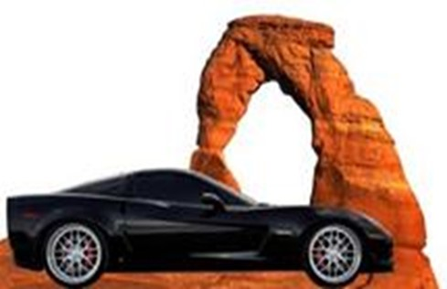
Color Country Corvette Club
Presents

A CRUISE TO LAKE HAVASU CITY, AZ
Hosted by Derek & Shelby Hall
Friday & Saturday, October 14-15, 2022

We will depart Terrible’s Gas Stop at Exit 2 at 9am on Friday, October 14

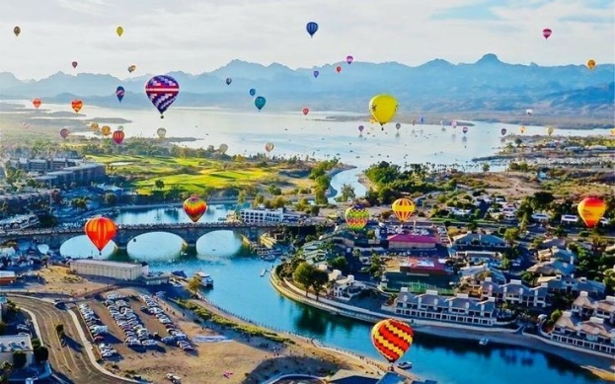
This is an overnighter you will not want to miss. The kids are back in school and so the city is much less crowded. Total miles is 279 both ways.

We’ll take a potty break in Henderson after which we will proceed to a group lunch in Havasu City at around 12:30pm AZ time at Jersey’s Bar and Grill.

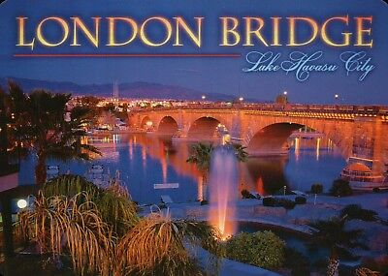
Hotel check-in time is usually 4:00pm giving us time to look around town or take in some of the outboard racing on the lake.

Group dinner is planned on a waterside patio at Martini Bay at 6:30pm.

Lake Havasu Classic Outboard Championships
9:00 AM - 06:00 PM both days

Admission: Free
Venue: The Nautical Beachfront Resort
Website: nauticalbeachfrontresort.com

Go online and find your hotel now and book it, or pay much more later

RSVP to Derek Hall – ukderekh@gmail.com

