Date patient arrived
/ /
Name
ID Number
Date of Birth
TRAUMA TEAM LEADER

Trauma Team Leader

PRESENTATION
Mechanism and brief description of events prior to arrival at UHNS
Referral from another hospital |  | Time referred | : | Time transfer agreed | :
TARN incident checklist
Vehicle incident  Fall less than 2 metres  Fall over 2 metres  Shooting  Stabbing | Blast  Burn  Skeletal/organ/vessel destruction  Blow(s)  Amputation (total / partial)  Other: |  | Non-intentional  Alleged assault  Suspected child abuse  Suspected self-harm  Sport  Suspected high risk behaviour  Alleged intent (non-assault)  Inconclusive
Weapon:
Position in vehicle (circle) | Driver, FSP, RSP, pedestrian, motorcyclist, pedal cyclist, pillion, mass transport, not known
Protection in vehicle (circle) | Seatbelt, airbag, helmet, child seat, none, not known
Additional incident information (circle) | Alcohol, drugs, pregnancy, burn, inhalation, asphyxia, toxic, explosion, radiation, drowning, psychiatric disturbance, mass incident, hypothermia, none of these.
PAST HISTORY
PERSONAL CIRCUMSTANCES

/ /

Name ID Number
Date patient arrived

TRAUMA TEAM LEADER INJURY & REFERRAL LIST
REGION | INJURIES | SPECIALTY & CONSULTANT
Head
Face & Neck
Chest
Abdomen
Spine
Limbs

Trauma Team Leader
Grade
Signature

Date & time
/ / :

Trauma Team Leader
Grade
Signature
Date patient arrived
/ /
Trauma Team Leader

Name
ID Number
Date of Birth

TRAUMA TEAM LEADER (continued)

ASSESSMENT NOTES, COMMENTS & ISSUES
Signature
Grade
Trauma Team Leader

/ / :
Date & time

Date patient arrived
Name ID Number
/ /

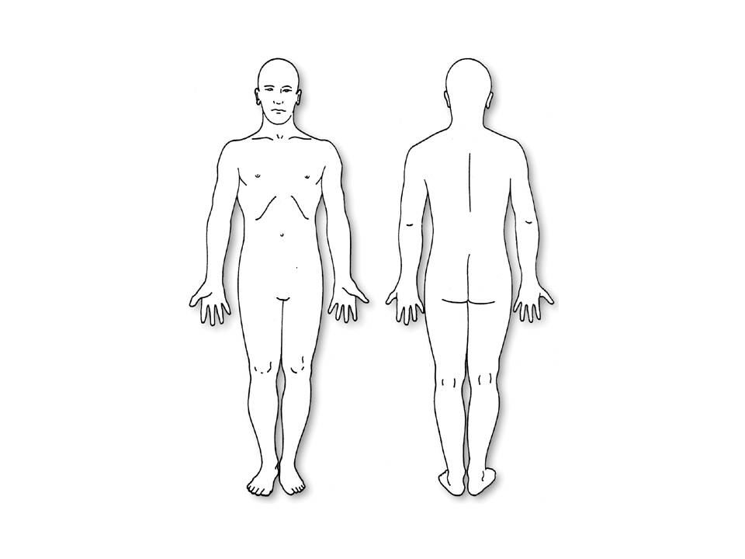
Trauma Team Leader: Body diagram

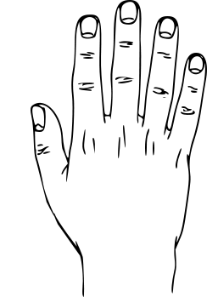
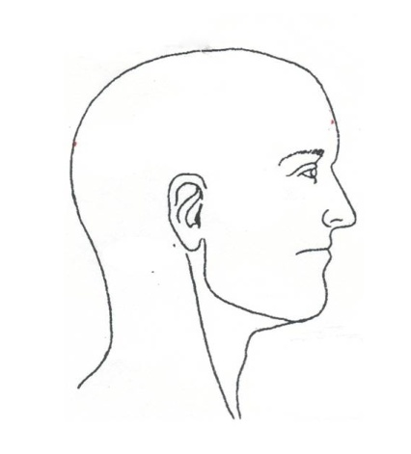
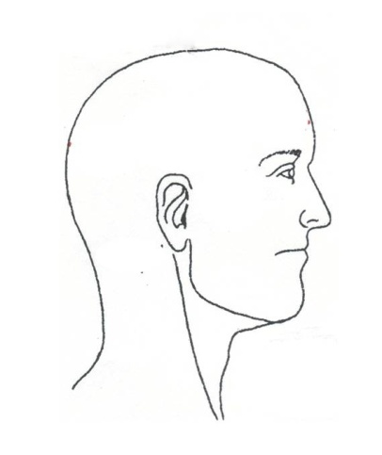

RIGHT LEFT

RIGHT: Dorsum Palm LEFT: Palm Dorsum
Date
Trauma Team Leader

/ /
/ /
Date

Trauma Team Leader

