Collegiate Way International (CWI) Conference 2026
Call for Abstracts
Dear Colleagues,
We are pleased to invite submissions of abstracts for the Collegiate Way International (CWI) Conference 2026, hosted by the University of Macau. The conference will bring together scholars, educators, and higher education professionals from around the world to share research, ideas, and practices related to collegiate education and living–learning communities. Set within the rich cultural context of Macao, CWI 2026 provides a dynamic forum for dialogue on whole-person education, community engagement, and educational innovation in a rapidly changing global landscape.
Call for Abstracts
We welcome original abstracts addressing, but not limited to, the following themes:
- Student agency and co-creation in residential environments;
- Experiential learning frameworks, theories, and methods in residential college education;
- Staff development, mentorship models, and professional practice in collegiate systems;
- Intercultural and interdisciplinary learning within residential communities;
- Ethical AI, digital literacy, AI-enabled community-based learning, and responsible use of emerging technologies in living–learning environments;
- Assessment of community-based and peer-driven educational methods and models;
- Operational models and management of collegiate systems.
All abstracts will undergo double-blind peer review by the conference committee. Outstanding accepted papers will be considered for publication in the conference proceedings by an international publisher, providing contributors with valuable international exposure. Details regarding submission guidelines, key dates, presentation formats, and conference arrangements are available on the official website: https://rc.um.edu.mo/cwi2026/
We would be grateful if you could share this call with colleagues and professional networks who may be interested. We look forward to your contributions and to welcoming you to Macao for an engaging and collegial CWI Conference 2026.
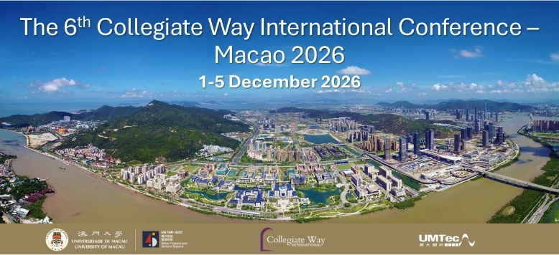
Collegiately yours,
CWI Conference 2026 Organizing Committee
University of Macau

