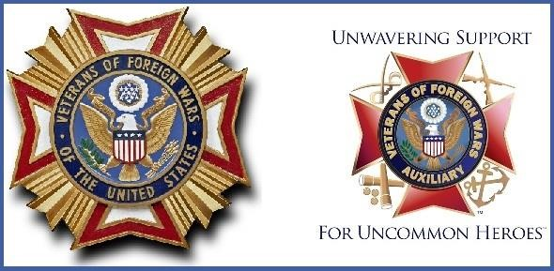
VFW POST 445 and AUXILIARY
September 2019 Newsletter
COMMANDER’S COMMENT

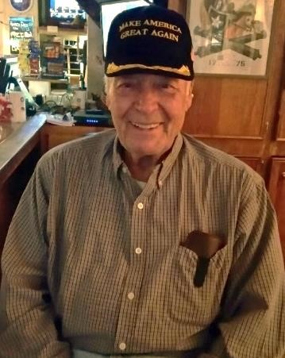
Comrades, Auxiliary and Supporters
We are entering a new fiscal year for the Veterans of Foreign Wars Programs i.e. Voice of Democracy, Patriots Pen and Teacher of the Year. We are working to secure a Candidate representing Post 445 in each of these Programs if you can help us in finding a participant it will be a great help in achieving this goal.
Comrade Joe Miller of <jim@port32marinas.com> has secured 9 homes for a program called Vacations for Veterans in Pawleys which is scheduled for 2nd week of November and as you know the weather there at that time of year is not all bad. Anyone interested I will have a list of homes at the Post. This is a great opportunity to get away for a few days free of charge.
Congratulations to the United States Coast Guard on its 229 years of service. Originally established as the Revenue Service on August 4, 1790 by Treasury Secretary Alexander Hamilton. In 1915 the modern Coast Guard was formed and has been involved in every U.S. conflict Since
The State Fair runs from October 9 thru 20, 2019 Active Duty and Retired Military together with their Family get Free Admission with proper ID
The winner our Life/ Legacy drawing at our August 13, 2019 Membership Meeting was member #234 James Wall unfortunately he was not present. You can only win if you attend the Meeting.

God Bless America and the VFW – Jim

MADAM PRESIDENT’S COMMENTS:
First, I would like to thank each and every one of you for coming out and supporting our Shish Kabob Dinner on August 16. Not enough words to express what a great meal it was and for all the Auxiliary Members and Pat Smith did for making it very successful. Thank you all! The September 20 dinner will be ham with potluck dishes, rolls and desserts. Please come out and support us.
Let's welcome our new members Carol Stramm King and Charles Miller into our Auxiliary. Please don't forget to pay your dues by September 1 to receive a $5.00 discount to help our Auxiliary once again reach 100% in membership this year.
The Auxiliary has some fundraisers coming up and we need all the help and support we can get. Please help us out so we can continue supporting our Veterans.
If any of you are signed up for the AED classes, don't forget the dates and times. The first class being held on August 22 at 1:00-3:00 will have already been completed before this newsletter will be out - but the next one will be September 12 from 1:00-3:00.
Please stop by the Post to view the calendar so you can keep up with all the fun stuff the Post and Auxiliary has coming up in September. Also, please attend our monthly meetings for a chance to win $25. Sorry Lisa Cross – your name was drawn at our August 8 meeting; however, please attend our next meeting – who knows your name could come out again. Good luck all! Our Auxiliary has been doing great, but we could use more members to attend the meetings to help us out in supporting our Veterans.
Thank you everyone for your help and support! I will close in saying God Bless our Troops past, present and future, the United States of America, the VFW and all of you!
Auxiliary President Joyce Simmons

