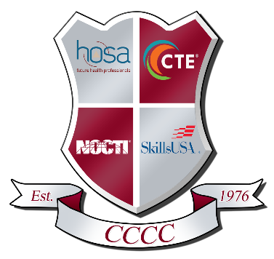

447 Career Lane Shippenville, PA 16254
814.226.4391 Fax 814.226.7350

Strategic Planning Collaboration
Agenda
August 25, 2025
Room 108

- Call Meeting to Order
- Roll Call
- Enrollment
  - 25/26
  - Non-traditional Enrollment
- Culinary Closure
- New Program
  - Education
  - Other new program options
- Next Steps
- Next Meeting
  - December 16, 2025 6pm
- Adjournment

