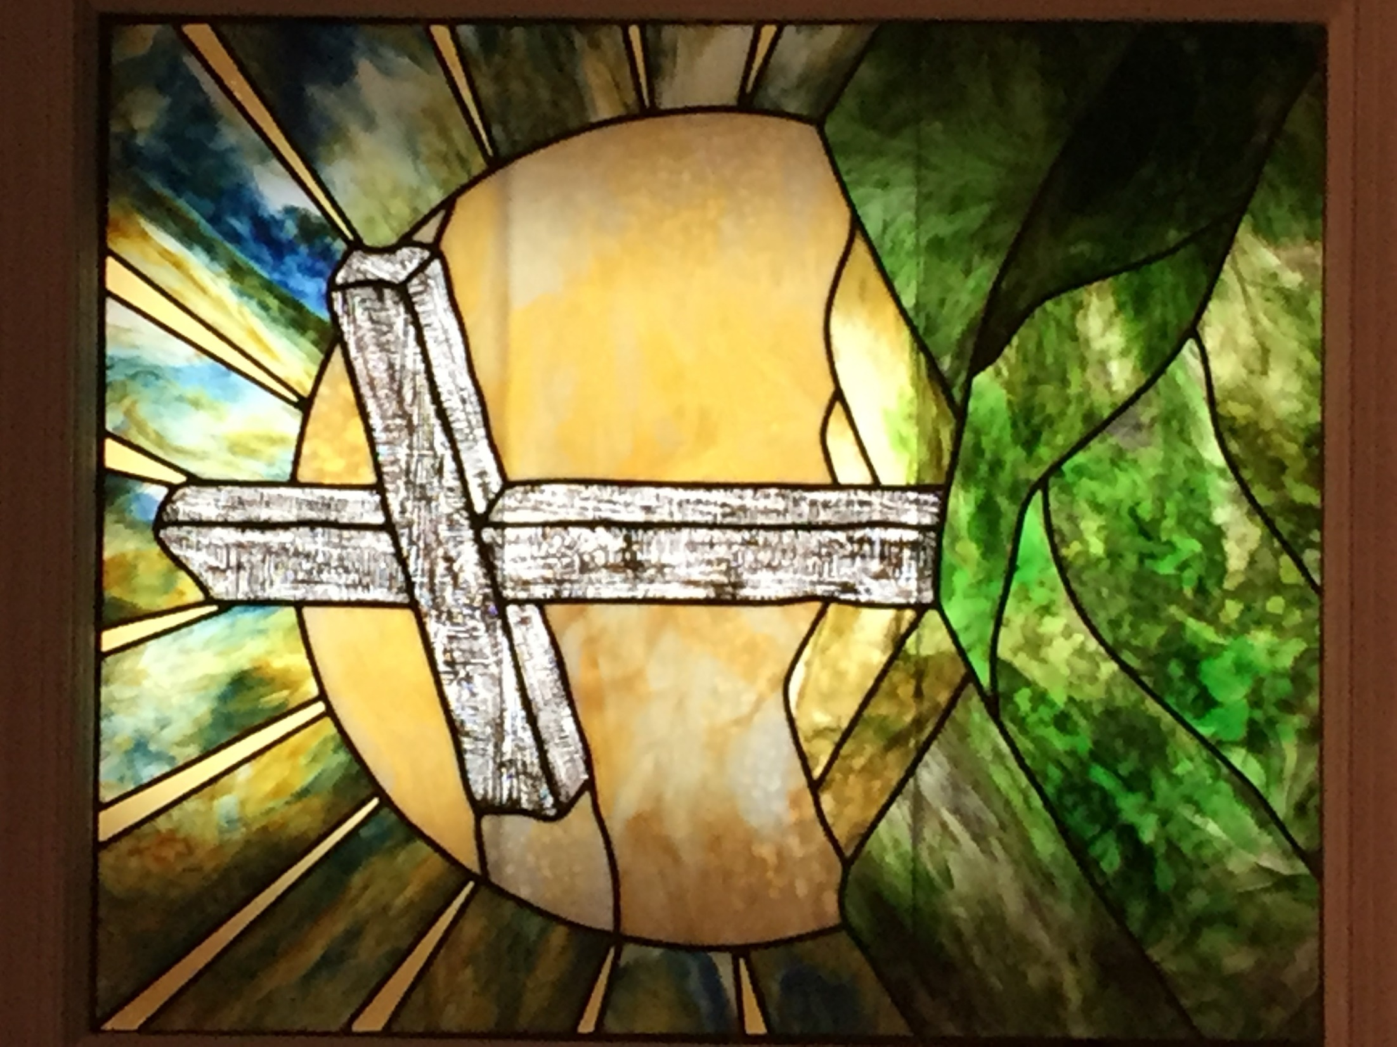
Wake Union Baptist Church Sunday School Devotion

Opening Prayer
Dear Heavenly Father,
Thank you for helping us through another week. Thank you for the privilege of prayer and for the comfort of your Holy Spirit. We pray for all that are sick and hurting. We pray for all that have lost friends and loved ones. We pray for an end to this current virus that we might soon meet together once more. Please help us to grow in Your strength and knowledge as we consider today’s scripture passages.
In Jesus’ name, Amen.

Welcome and Announcements
This is now the 12th Sunday of cancelled services. I miss seeing each of you.

Memory Verses
¹Let not your heart be troubled: ye believe in God, believe also in me. ²In my Father’s house are many mansions: if it were not so, I would have told you. I go to prepare a place for you. ³And if I go and prepare a place for you, I will come again, and receive you unto myself; that where I am, there ye may be also. John 14:1-3
We’ll continue to look at how this passage gives us hope in troubling times, focusing today on verse 2.

Strangers and Pilgrims
⁹By faith he (Abraham) sojourned (lived) in the land of promise, as in a strange country, dwelling in tabernacles (tents) with Isaac and Jacob, the heirs with him of the same promise: ¹⁰For he looked for a city which hath foundations, whose builder and maker is God. Hebrews 11:9-10
This passage, from the “Heroes of the Faith” chapter 11 in Hebrews, reminds us of the importance of faith. Abraham’s life demonstrated faith as he trusted that God would fulfill His covenant promises. We may feel discouraged and defeated because our wants and expectations are not immediately met, but we must never lose our hope in God’s promises of a better home prepared for us. “God is faithful” (1 Corinthians 1:9).

¹³These (heroes of faith, Abel to Abraham) all died in faith, not having received the promises, but having seen them afar off, and were persuaded of them, and embraced them, and confessed that they were strangers and pilgrims on the earth. ¹⁴For they that say such things declare plainly that they seek a country. ¹⁵And truly, if they had been mindful of (thinking about) that country from whence they came out, they might have had opportunity to have returned. ¹⁶But now they desire a better country, that is, an heavenly: wherefore God is not ashamed to be called their God: for he hath prepared for them a city. Hebrews 11:13-16
We are prone to forget that we are “strangers and pilgrims on the earth” our temporary home. Circumstances, such as the current virus outbreak, can remind us that this life “is even a vapour, that appeareth for a little time, and then vanisheth away” (James 4:14). While this world is not our home, as Christians we know God has prepared “a better country”, a heavenly city where we shall dwell with Him for eternity.

¹⁴For here have we no continuing (lasting) city, but we seek one to come. ¹⁵By him (Jesus) therefore let us offer the sacrifice of praise to God continually, that is, the fruit of our lips giving thanks to (confessing) his name. Hebrews 13:14-15
Since everything we have in this world is temporary, we should “lay up treasures in heaven, where neither moth nor rust doth corrupt, and where thieves do no break through nor steal” (Matthew 6:20). A “sacrifice of praise” would include thanking Jesus for his sacrifice on the cross, and telling others about it.

¹⁸For through him (Jesus) we both have access by one Spirit unto the Father. ¹⁹Now therefore ye are no more strangers and foreigners, but fellowcitizens with the saints, and of the household of God; ²⁰And are built upon the foundation of the apostles and prophets, Jesus Christ himself being the chief corner stone; ²¹In whom all the building fitly framed together groweth unto an holy temple in the Lord: ²²In whom ye also are builded together for an habitation of God through the Spirit. Ephesians 2:18-22
Currently “strangers and foreigners” just passing through this world; but through Jesus, “fellowcitizens with the saints, and of the household of God.” “Children of God by faith in Christ Jesus” (Galatians 3:26).

A Home Prepared
²⁰For our conversation (citizenship) is in heaven; from whence also we look for the Saviour, the Lord Jesus Christ: Philippians 3:20
Because we are “children of God” “our citizenship is in heaven; from whence also we look for” our Lord’s return.

⁹But as it is written (Isaiah 64:4), Eye hath not seen, nor ear heard, neither have entered into the heart of man, the things which God hath prepared for them that love him.
1 Corinthians 2:9
In our memory verse 2, Jesus said “I go to prepare a place for you.” Here in 1 Corinthians Paul quotes from Isaiah 64:4 which tells us we cannot even imagine everything that He has prepared for us. This world is not all there is. The best is yet to come.

¹For we know that if our earthly house of this tabernacle (tent, our human bodies) were dissolved (destroyed), we have a building of God, an house not made with hands, eternal in the heavens. ²For in this (house, body) we groan, earnestly desiring to be clothed upon with our house which is from heaven: 2 Corinthians 5:1-2
We will have new/better bodies, without sickness or disease, that will be perfect for eternal life.

³¹When the Son of man shall come in his glory, and all the holy angels with him, then shall he sit upon the throne of his glory: ³²And before him shall be gathered all nations: and he shall separate them one from another, as a shepherd divideth his sheep from the goats: ³³And he shall set the sheep on his right hand, but the goats on the left. ³⁴Then shall the King say unto them on his right hand, Come, ye blessed of my Father, inherit the kingdom prepared for you from the foundation (creation) of the world: Matthew 25:31-34
The sheep, the children of God or Christians, will inherit the kingdom prepared for us from creation. “That being justified by his grace, we should be made heirs according to the hope of eternal life.” (Titus 3:7).

New Jerusalem
¹²Him that overcometh will I make a pillar in the temple of my God, and he shall go no more out: and I will write upon him the name of my God, and the name of the city of my God, which is new Jerusalem, which cometh down out of heaven from my God: and I will write upon him my new name. Revelation 3:12
New Jerusalem will be our future dwelling. The home prepared within which are
“many mansions” (John 14:2).

¹⁷For, behold, I create new heavens and a new earth: and the former shall not be remembered, nor come into mind. ¹⁸But be ye glad and rejoice for ever in that which I create: for, behold, I create Jerusalem a rejoicing, and her people a joy. ¹⁹And I will rejoice in Jerusalem, and joy in my people: and the voice of weeping shall be no more heard in her, nor the voice (sound) of crying. Isaiah 65:17-19
In New Jerusalem, we will “rejoice forever” and not even think about the former earth (“not be remembered, nor come into mind”).

³⁵It was round about eighteen thousand measures: and the name of the city from that day shall be, The LORD is there. Ezekiel 48:35
The one thing that makes heaven and New Jerusalem most glorious, is the presence of the Lord.

¹And I saw a new heaven and a new earth: for the first heaven and the first earth were passed away; and there was no more sea. ²And I John saw the holy city, new Jerusalem, coming down from God out of heaven, prepared as a bride adorned for her husband. ³And I heard a great voice out of heaven saying, Behold, the tabernacle of God is with men, and he will dwell with them, and they shall be his people, and God himself shall be with them, and be their God. ⁴And God shall wipe away all tears from their eyes; and there shall be no more death, neither sorrow, nor crying, neither shall there be any more pain: for the former things are passed away. Revelation 21:1-4
“God himself shall be with” us. No more tears, no more death, no more sorrow, no more crying, no more pain. Peace, security, love, and joy in the eternal presence of our Lord. A home prepared where the saints shall abide, more wonderful than we can imagine.

Chorus Lyrics of Tribute Quartet’s “There’s A City”
There’s a city, beyond the clouds
New Jerusalem, coming down
Walls that glisten, streets that shine
Many mansions, one that’s mine
And the glory of the Lamb is the light there in that land
The saints will sing His praises all in love
What a promise given me, my home for eternity
There’s a city, beyond the clouds

Closing Prayer
Dear Heavenly Father,
Thank you for the precious gift of salvation made possible at the cross. Thank you for preparing us an eternal home, and for giving us hope through the resurrection of our Savior of a glorious future in your presence. We pray for all that do not know your love and ask for your help in reaching them. Please keep everyone safe and well until we meet again.
In Jesus’ name, Amen.

