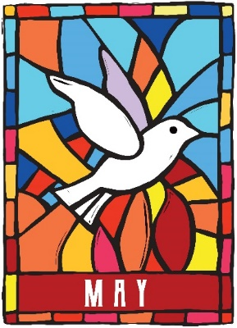
ENEZER UNITED
METHODIST CHURCH
Newsletter
144 Ebenezer Church Road … P. O. Box 70
Oldhams, Virginia 22529
Reverend Loretta Benninghove, Pastor
Office (804) 472-4642; Cell (434) 480-9992
pastorlorettaumc@gmail.com

There is life in the midst of death
There is hope, in the midst of despair
There is joy in the midst of sorrow
There is courage in the midst of fear
There is strength in the midst of weakness
There is peace in the midst of conflict
There is love in the midst of hate
There is Jesus, in the midst of all!

Greetings beloved of the Lord!
Can it really be May? Where has the time gone? Well, if you haven’t heard the news – Pastor Loretta is being re-appointed to Ebenezer. I hope that you agree with her that this is a good thing. Now that we have gotten to know each other a bit, let's see what we can dream up to challenge us to grow into the disciples God is calling us to be. We want to do more than warm the pews on Sunday. We want to do more than hear the warm and fuzzy little sermons that tell us all is good here on the Northern Neck. We have opportunities that encourage us to be the hands and feet of Christ.

Please Note:

Pastor Loretta will be in Fredericksburg on the following days April 30Th & May 2nd; 7th & 9th. I am reachable by phone or text. But it may take me a bit to respond. These dates are for “Face to Face” which is the Senior event for those who have not been to Emmaus and cannot do a 72-hour overnight event at a campground. It is being held at Fredericksburg UMC. The time frame will generally be from 8:30 to 5:30. That includes drive time. I would appreciate your prayers. Thank you. FYI our Shirley Wease will be attending!

To access the more about the General Conference there will be a panal discussion May 9, 2024 at 07:00 PM with the VA Conference. You are welcome to participate but must register.
https://zoom.us/webinar/register/WN_qKQXMFS3RLKbXxanbknBPg#/registration

Kits for conference

What kind of kits will we be collecting this year?
The best things often come in threes, and this year we will be collecting the three official United Methodist Committee on Relief (UMCOR) Kits. All of the kits collected will be ready to deploy to help communities affected by different disasters. The kits we’re supporting are hygiene kits, cleaning kits, and menstrual (period pack) kits. Below are the links with instructions on what’s inside and how to pack these kits:
- Cleaning Kits: https://umcmission.org/umcor-cleaning-kit/
- Hygiene Kits: https://umcmission.org/umcor-hygiene-kit/
- Menstrual (“Period Pack”) Kits: https://umcmission.org/umcor-menstrual-hygiene-kit/
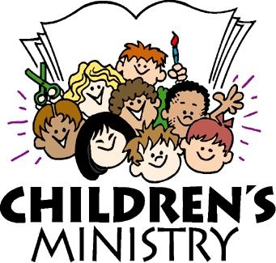




May Mission Outreach
In-Hospital Ronald McDonald House at Children’s Hospital of Richmond at VCU

The facility, run by Ronald McDonald House Charities of Richmond staff and volunteers, serves caregivers and families as their child receives medical treatment in a nearby pediatric unit. All families receiving care through acute inpatient services and the pediatric intensive care unit at Children’s Hospital of Richmond at VCU are welcome.
At 3,285 square feet, the In-Hospital Ronald McDonald House provides space for families to relax, enjoy a meal, and participate in calming activities. The family-centered facility offers dining and lounging areas, four Family Sleep Rooms, a food-service area, laundry facilities, a children’s play area, and an outdoor patio. Here compassionate RMHC Richmond staff and volunteers present regular programming including Lunches with Love and snack services, warm dinners, and interactive activities such as music, hair styling, and chair massages.

This space features non-clinical architectural design and furnishings to provide a home-away-from-home feel within hospital walls. Our In-Hospital Ronald McDonald House will be licensed according to RMHC Global best practices.


Friday 5/17th 1:30: PM volunteers are needed to help bag up the groceries for the customers who will be served on Saturday. The more helper bees the sooner we can get things done. Every month things change and Scott figures out how to pack the bags of non-perishable items and the boxes of fresh produce. Scott - has it organized – we just need to supply the willing helpers. You may come as you are able. Wear your comfortable work clothes.
Thanks to all for this important mission. 80+ families may be served. Saturday is an easier day but helper bees are needed then also.

Bible study
New and Different
So, when you get three pastors in a car traveling for an hour twice a day for four days – Ya know, something has to happen during their conversations!

Here it is! We are in the process of developing a Bible study!

What: The topic–Jesus and His Disciples as portrayed in the film series THE CHOSEN.

When: It will be twice a month on Sunday afternoons – probably about 4:00 PM
Most likely starting after Mother’s Day.

Where: Warsaw United Methodist Church

Who: All are invited, families are welcomed, and we may have something different for
the younger children to better understand. We will see how this goes.
Right now, the invitation is open and the churches leading this will be: Warsaw,
Carmel/Coles Point, and Ebenezer.

Content: Starting with Season 1, episode 1 we will watch an episode, then do a brief
study on what we have viewed. Homework will be assigned – such as reading,
in advance the scripture text, which will identify the episode we watch.

Keep in mind: The Chosen is not a documentary. There will be added characters not found in the scripture as well as ideas that are plausible but not factual. The actors are portraying real people, not ‘the saints’ with halos over their heads. This series of films and the actor’s portrayals are meant to help us relate to these men and women who turned the world upside down after being with Jesus. Our goal is that we can do the same here in our community.
The Pastor’s involved, Betty Jo Sims, Mark Lawrence, and Loretta Benninghove.

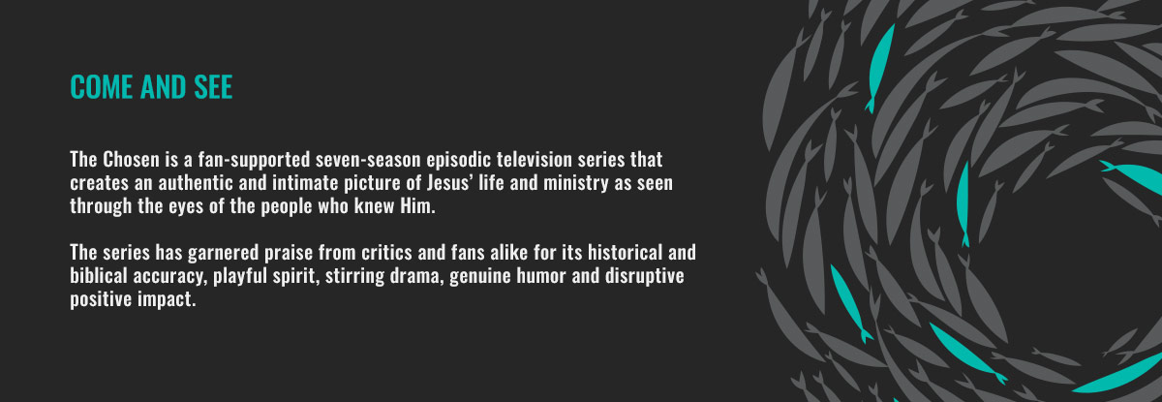
Dates to remember

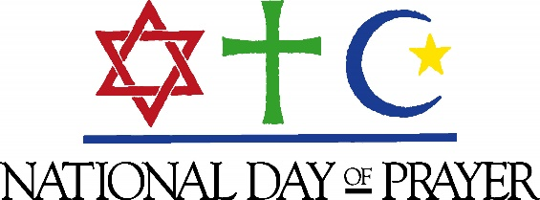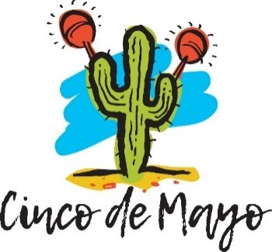
5/2 5/3 5/5

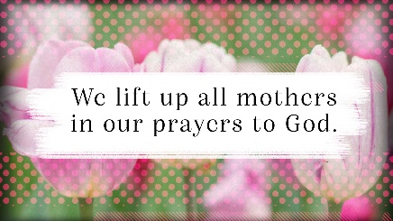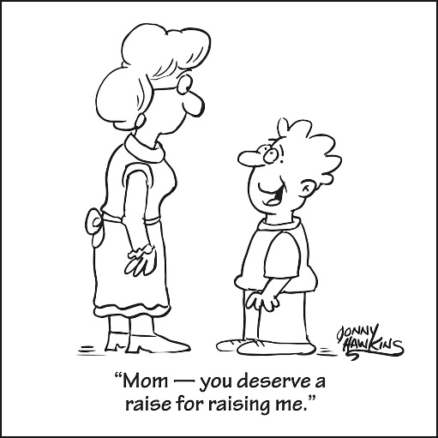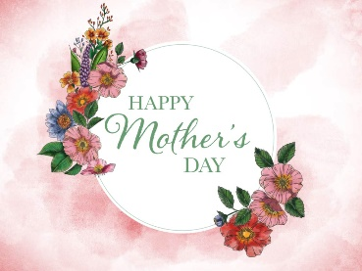

5/12

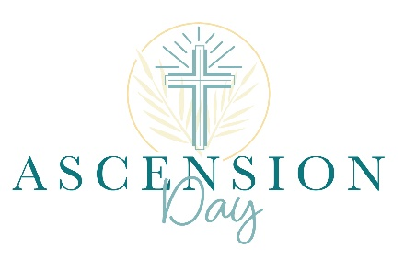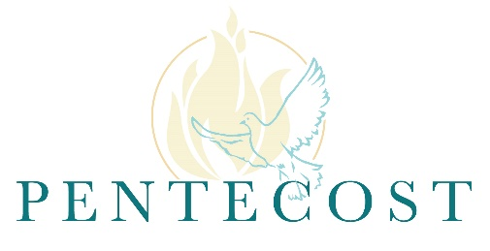
5/9 5/19

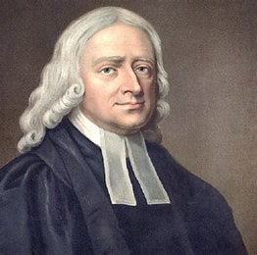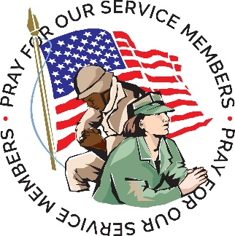

5/24 5/26 5/27

I thought you might enjoy pondering this reading entitled "YOU" from Frederic and Mary Ann Brussat's book Spiritual Literacy: Reading the Sacred in Everyday Life.

YOU
The seed of the Blessed One is planted in us, but we have trouble accepting this reality. "Our deepest fear is not that we are inadequate," writes best-selling spirituality author Marianne Williamson. "Our deepest fear is that we are powerful beyond measure. It is our light, not our darkness, that most frightens us. We ask ourselves, who am I to be brilliant, gorgeous, talented, and fabulous? Actually, who are you not to be? You are a child of God."
Nicaraguan Catholic priest Ernesto Cardenal adds: "God has been thinking of me since before I was born, for all eternity. God loves us more than we love ourselves." Why is it so hard to accept the good news? Perhaps because we are our own worst enemies? Perhaps because others make us feel like damaged goods? Perhaps because we think it's too much of a burden to bear?
“Do you know what you are?” Spanish cellist Pablo Casals asks. "You are a marvel. You are unique. In all the world, there is no other . . . exactly like you." Sing your unique song with gusto. And remember the advice of the Baal Shem Tov, a Jewish mystic, "Compare not yourself with anybody else lest you spoil God's curriculum." We are each a unique blend of good and evil. In every moment, we choose which parts of ourselves to put out into the world. Thorin, speaking to Bilbo in J.R.R. Tolkien's The Hobbit, says, "There is more in you of good than you know . . . some courage and some wisdom blended in measure.”
Tap into that courage and unspool that wisdom. “We have a thrifty God,” observes art historian Sister Wendy Beckett, “Who lets nothing good within us ever go to waste.” The German mystic Meister Eckhart repeats the point: “Become aware of what is in you. Announce it, pronounce it, produce it, and give birth to it.”
You do not need to try to become special - the God-seed inside already makes you unique. "The Greek Orthodox have a spiritual injunction that implores a person to 'become what you are,'" writer Holly Bridges Elliott explains. "This means by virtue of your creation in the image of God and by your baptism, remember your true humanity, remember that your ‘authentic self’ is inhabited by God and is a holy creation.”
You have an assignment and a purpose in life. This is your mission, should you choose to accept it. "God's dream is to be not alone but to have humanity as a partner in the drama of continuous creation," Rabbi Abraham Joshua Heschel writes. "Life is a great adventure; we are partners with the Godhead, and though our role may be small, the honor is still ours."
"The world needs all of our power, and love, and energy, and each of us has something to give," essayist Merle Shain reflects. "The trick is to find it and use it, and give it away, so there will always be more. We can be lights for each other, and through each other's illumination, we will see the way. Each of us is a seed, a silent promise, and it is always spring."

