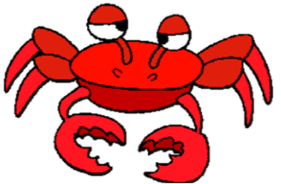
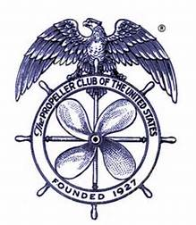
TACOMA PROPELLER CLUB
ANNUAL CRAB FEED

SATURDAY, FEBRUARY 21, 2026
HOLY CROSS PARISH HALL
5510 No. 44th St., Tacoma
6:00 - 10:00 PM

Get your tickets now . . . only 200 will be sold and there will be no tickets sold at the door!

Dungeness Crab, Clam Chowder, Salad, and Rolls

Tickets are ONLY $65.00 *** Deadline for tickets is January 31, 2026
No Host Bar *** Wine Toss *** Dessert Dash *** Awesome Raffle

SPONSORSHIP FORM
(see attached for benefits)

_____ Dungeness Crab - $800.00 Company Name:_________________________________

_____ King Crab - $500.00 Company Name:_________________________________

_____ Snow Crab - $300.00 Company Name:_________________________________

TICKET FORM
Must be received or postmarked by January 31, 2026

Number of tickets:_______ Number of drink tickets:_______
(Drinks are $5.00 each)

Name:_____________________________ Email:___________________________________________

Phone:_____________________________ Credit Card:______________________________________

Expiration Date:_____________________ Security Code:_____________________ Zip:____________

Email form to tacomapropellerclubap@gmail.com OR
Mail form and check payable to Tacoma Propeller Club to
P. O. Box 453, Tacoma, WA 98401

Must be 21 years of age or older - No minors allowed

