Eastham Conservation Foundation Guided Walk
Eastham Conservation Foundation presents
“Amphibians at Night”-Tuesday April 16, 2019, 7:15 pm at Wiley Park
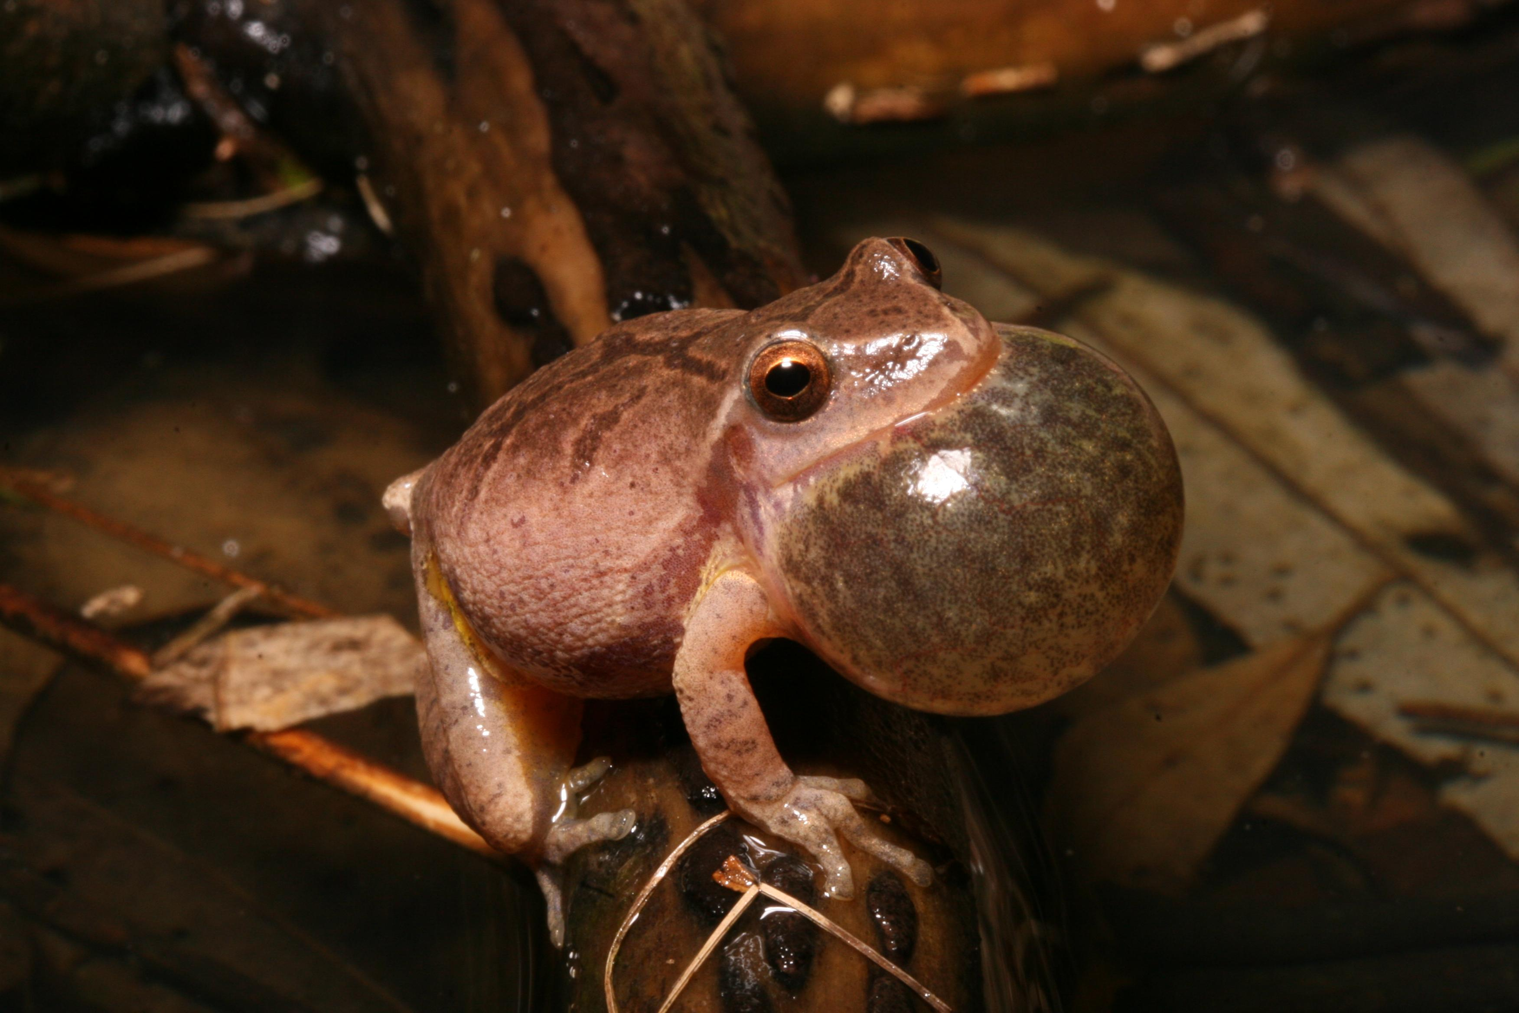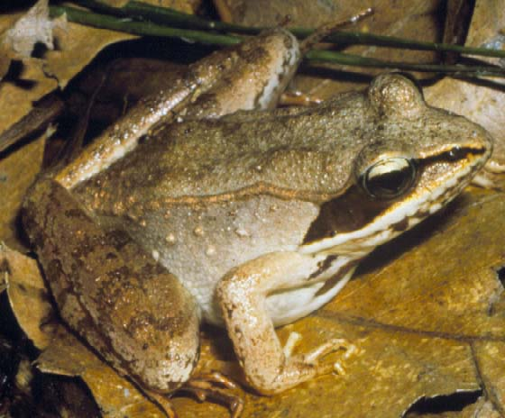
Eastham’s natural areas contain a variety of freshwater wetlands that provide important habitat for nearly all of Cape Cod’s amphibians. Many species become active in early spring and return as adults to the wetland/pond they were spawned in to begin another breeding cycle.
Eastham Conservation Foundation member and wildlife ecologist Bob Cook has spent many years studying the outer Cape’s amphibians, and will share his knowledge of their life cycles, adaptations, behavior, and ecology on this nighttime walk along Eastham’s Glacial Ponds Trail.
Walk begins in parking lot of Wiley Park, Eastham, off Herringbrook Road, 7:15 pm Tuesday April 16, 2019.
Walk will last approximately one hour. Participants should wear clothing appropriate for a nighttime hike in the outdoors. Sections of trail may be wet/soggy, so rubber boots, “duck boots”, or waterproof boots are advised. A small flashlight may be useful.
For more information contact Bob Cook at 508-617-0979

