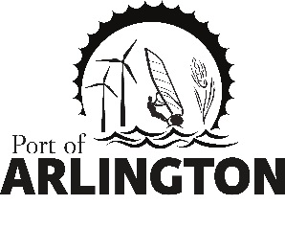

Regular Commission Meeting

THE PORT OF ARLINGTON BOARD MEETING IN ARLINGTON HAS BEEN CANCELLED FOR TUESDAY DECEMBER 8, 2020

Upcoming Meetings:

Regular Commission Meeting on Tuesday, January 11, 2020 at 5 pm – The Port will Post Location as Soon as Available

Posted: Tuesday, December 1, 2020

