7/2/2018 The Pilgrims and the End of the World

In early 1979 I was working as an engineer at a Christian TV station near Canton, Ohio. I had been born again less than a year earlier, left my job in commercial television, and had then been hired at the Christian station.

As I was waiting in the TV station lobby for my wife to arrive to pick me up after work, a boy about 12 years old came to the locked lobby door. I unlocked the door to see what he wanted. He appeared to be mentally challenged, slow, and had trouble talking, but he said to me "The coming solar eclipse is associated with one from the time of the Pilgrims". Then he turned and walked away.

I thought it odd that a young person who appeared to be mentally slow would tell me something of a technical nature and then just walk away. The young messenger apparently lived in the neighborhood.

The lesson from Moses is not to ignore or forget a strange event, like a bush that keeps on burning yet remains alive and intact.

Several days ago my wife and I were watching a TV program concerning the Pilgrims and I again remembered the above mentioned incident.

I searched the solar eclipse information for 1979 and found the solar eclipse of 2/26/1979 was in a sequence identified as Saros 120. Solar eclipses in a particular Saros sequence repeat about 300 kilometers northward on earth's surface approximately every 18.031 years.
Info link: https://eclipses.gsfc.nasa.gov/SEsaros/SEsaros.html

It happens that the solar eclipse of 7/21/1618 was a part of Saros series 120. The group that came to be known as the Pilgrims were forming in Holland and England at that time because of severe religious persecution from their governments. The Pilgrims finally sailed in the year 1620, landing near Cape Cod.
Info link: https://en.wikipedia.org/wiki/Pilgrims_(Plymouth_Colony)

Here's the path of the total solar eclipse of 7/21/1618, a member of Saros 120, the same as the eclipse of 2/26/1979:

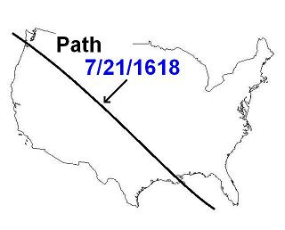

The Location of the Tav

There are 22 letters in the Hebrew Aleph Bet. The first letter is the Aleph and the last letter is the Tav.

Here's the Tav as written in ancient Paleo Hebrew from the time of King David:

The ancient tav was formed by two crossed sticks and placed at the end of a field to aid the farmer in plowing a straight furrow. Messiha YaHuShua identified Himself as the Aleph and the Tav, the beginning and the end. He was the Aleph nailed to the crossed sticks. If we keep our eyes on Him, we'll plow a straight furrow to the end.

The numbers we use today for mathematical calculations are a more recent invention. Info link: http://www.archimedes-lab.org/numeral.html

In ancient times the letters of the alpha-bet were used to represent mathematical quantities (Roman Numerals, etc.).

In the Hebrew aleph-bet, the first letter aleph is equal to 1, bet is equal to 2, etc. After reaching 10, the numerical values of each letter begin to increase. The last letter of the Hebrew aleph-bet, Tav, is equal to 400.
Info link: https://en.wikipedia.org/wiki/Hebrew_numerals

The Eclipse and the 400th Tav Year

Since the total solar eclipse of 7/21/1618 painted a stripe across the earth, the first part of a Tav, on the region that would become the United States of America, we can look 400 years down the road to see the "end mark" of the message that was begun in the time of a people desiring to escape religious persecution.

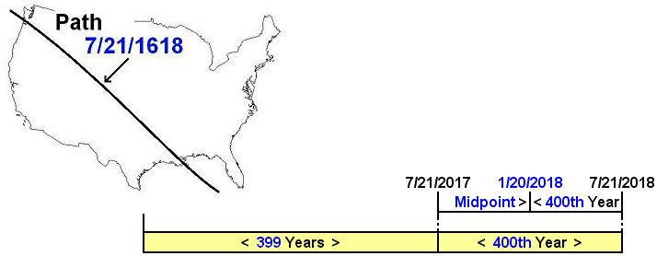

Note that the exact middle of the 400th year from 7/21/1618 is 1/20/2018, a date identified in previous articles as a special threshold date, example - Vice President Pence entered Israel on 1/21/2018.

The Tav in a Tav

Know that exactly one month after the beginning of the 400th "Tav" year on 7/21/2017 mentioned above, our Creator YaHuWaH Elohim ordained that another "Tav" be inscribed on the earth by total solar eclipses beginning on 8/21/2017. See below.

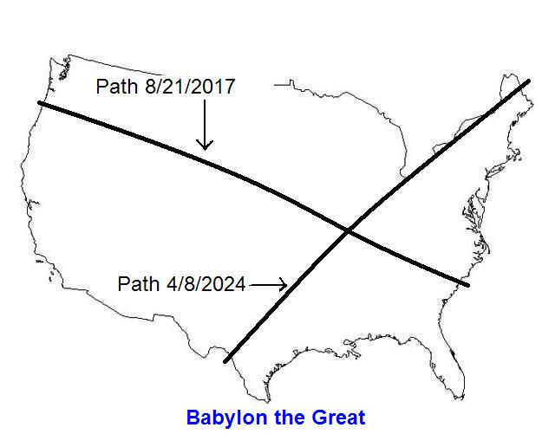

Above: The Tav that began to be inscribed on the earth by YaHuWaH Elohim exactly one month into the 400th year from the solar eclipse at the time of the Pilgrims planning to escape persecution, 7/21/1618.

Then the Hebrew Day of Trumpets on 9/21/2017 was exactly two months after the 400th anniversary of the total solar eclipse of 7/21/1618.

Then two days after the Day of Trumpets there was the sign in heaven of the Woman giving birth to the Manchild (Revelation chapter 12) on 9/23/2017. Know that signs on the earth, hurricanes Jose (Spanish for Joseph) and Maria (Spanish for Mary), also accompanied the sign of the woman giving birth in the heavens on 9/23/2017.

Below: Hurricanes Jose, near New York, and Maria near Puerto Rico, on 9/19/2017, accompany the sign of the birth of the Manchild on 9/23/2017.

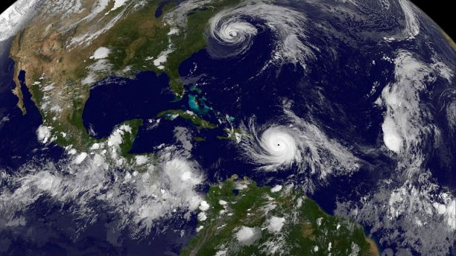
Photo courtesy NASA NOAA GOES East Satellite

Above: Jose and Maria bear witness on earth to the sign of the birth of the Manchild in heaven.

Hurricane Maria devastated Puerto Rico to such an extent that it still hasn't recovered completely 9 months later.

Also during this 400th "Tav" year from the time of the Pilgrims, USA President Donald Trump decided to recognize Jerusalem as Israel's eternal capital, making the announcement on 12/6/2017.

The United States Embassy in Tel Aviv was then moved to Jerusalem, with opening ceremonies conducted on 5/14/2018, the 70th anniversary of modern State of Israel.

These signs and portents from our Creator the great King, YaHuWaH Elohim, are given to us that we might know and believe that He exists and that He rules and reigns in the heavens and in the earth. The Tav on the USA beginning in a Tav (400th year) is not a good omen.

An Additional Note

Keep in mind that ancient Babylon was conquered by an army that walked in on a nearly dry riverbed under the city wall while the guards were partying and drunk. The event occurred the evening of 10/11/539 BC after the King of Babylon received the shock of his life as he witnessed a hand write a secret message on a wall that only Daniel could read and translate.

Walls are a major topic in the Babylons, economic powerhouses that they were, and are, like Wall Street.

Info link: http://www.livius.org/sources/content/herodotus/cyrus-takes-babylon/

A main issue right now with modern Babylon the Great is the need for a wall to stifle the influx of certain foreigners, some of whom are Persian as was king Cyrus, who could subvert the nation from within.

Ancient Babylon wasn't destroyed by the army that came in underneath its protective wall. The city and nation were given to the Medes and Persians. Ancient Babylon's governing authorities were merely changed, but Babylon continued to exist.

Modern Babylon the Great, like ancient Babylon, might also be divided and suffer a change in government. Perhaps it will be given to the Catholics in league with the Muslims, those societies who are making their ways through the vulnerable borders currently.

For some reason, the bible indicates that those of a Hebrew mindset will eventually want to leave modern Babylon in great numbers and return to the land of Israel. They just need the impetus to do so. England has gone Muslim. Who's next?

Modern Babylon will continue to exist as a global economic powerhouse until its destruction by fire in one hour as prophecied in the book of Revelation.

Revelation 18:1 And after these things I saw another angel come down from heaven, having great power; and the earth was lightened with his glory.
2 And he cried mightily with a strong voice, saying, Babylon the great is fallen, is fallen, and is become the habitation of devils, and the hold of every foul spirit, and a cage of every unclean and hateful bird.
3 For all nations have drunk of the wine of the wrath of her fornication, and the kings of the earth have committed fornication with her, and the merchants of the earth are waxed rich through the abundance of her delicacies.
4 And I heard another voice from heaven, saying, Come out of her, my people, that ye be not partakers of her sins, and that ye receive not of her plagues.
5 For her sins have reached unto heaven, and YaHuWaH hath remembered her iniquities.
6 Reward her even as she rewarded you, and double unto her double according to her works: in the cup which she hath filled fill to her double.
7 How much she hath glorified herself, and lived deliciously, so much torment and sorrow give her: for she saith in her heart, I sit a queen, and am no widow, and shall see no sorrow.
8 Therefore shall her plagues come in one day, death, and mourning, and famine; and she shall be utterly burned with fire: for strong is the Master YaHuWaH who judgeth her.

