Mars UP Church
Come Holy Spirit, Come
Before the Service – Speak to God!
During the Service – Let God speak to you!
After the Service – Speak to each other!

(*Please stand, if able)
Welcome and Mars Messages

Prelude

Apostles’ Creed
I believe in God the Father Almighty, Maker of heaven and earth; and in Jesus Christ His only Son our Lord; who was conceived by the Holy Ghost, born of the Virgin Mary, suffered under Pontius Pilate, was crucified, dead and buried; He descended into hell; the third day He rose again from the dead; He ascended into heaven, and sitteth on the right hand of God the Father Almighty; from thence He shall come to judge the quick and the dead. I believe in the Holy Ghost, the holy catholic church; the communion of saints; the forgiveness of sins; the resurrection of the body; and the life everlasting. Amen.

Gloria Patri
Glory be to the Father, and to the Son, and to the Holy Ghost. As it was in the beginning, is now and ever shall be,
world without end.
Amen. Amen.

The
Lord’s Prayer

Our Father,
who art in heaven,

hallowed be Thy
name,

Thy kingdom come,
Thy will be done,
on earth
as it is in heaven.

Give us this day
our daily bread;

and forgive us
our debts,
as we forgive
our debtors;

and lead us not
into temptation,
but deliver us
from evil.

For Thine
is the kingdom,
and the power,
and the glory,
forever. Amen.

The Doxology

Praise God
from whom
all blessings flow;
praise Him
all creatures
here below;
praise Him above,
ye heavenly host;
praise Father, Son,
and Holy Ghost.
Amen.

Introit Chancel Choir
“Turn Your Eyes Upon Jesus”

Pastoral Invocation

The Call to Worship
Leader: To the fisherman Jesus said:

People: “Follow me and I will make you fish for people.

Leader: To the tax collector Jesus said:

People: “Follow me.”

Leader: To the rich man Jesus said:

People: “Go, sell what you own, and give the money to
the poor, and you will have treasure in heaven;
then come, follow me.”

Leader: At the last supper Jesus said:

People: “Follow me.”

Leader: To you and to me and to all of us Jesus says:

People: Follow me!

*Hymn of Praise 415
“We Are Called to Be God’s People”

*Prayer of Confession
Living God, you have blessed our lives with so many gifts, so why do we find it difficult to share what we have with others? We forget about those who do not have the choices we have. Those whose economic landscape is shaped by circumstances beyond their control - no job, no skills, chronic illness, no hope...Forgive us for believing that we are the body of Christ in this place but fail to love as he loved, fail to care as he cared; fail to empty ourselves of self so that we can be filled with the desire to meet the needs of others. We want to be faithful followers of Jesus so help us to discern what hinders our commitment—whether it be our possessions, our career, our family or friends...Merciful God, our hope lies in our belief that what seems impossible for us is possible with you. In this hope we pray in Jesus’ name.

*Assurance of Pardon
*Gloria Patri

*Sharing the Peace of Christ
Leader: May the grace of our Lord Jesus Christ, the love of God, and the fellowship of the Holy Spirit be with you all!
People: And also with you.

Children’s Chat

*Doxology
*Prayer for the Offering
Offertory Response Chancel Choir
“All Things Come of Thee”

Prayer for Illumination

Scripture Mark 10:17-27

Choral Anthem Chancel Choir
“I Will Serve the Lord All My Day”

Morning Message Rev. Brian Hauser
“Psalm 100”

*Hymn of Praise 318
“I Believe in a Hill Called Mount Calvary”

Prayers of the People and Lord’s Prayer

*Hymn of Commitment 661
“Little is Much When God Is in It”

*Benediction

*Congregational Response (Everyone sings)
The time has come, O Lord, for us to leave this place;
Guide us and protect us and lead us in Thy grace;
Wherever life may take us as we go our separate ways;
Help us share with others the things we’ve shared today;
May the peace of God the Father
And the love of Christ His Son
Guide us in the days ahead and strengthen us each one;
May the blessings of the Spirit fill us from within;
God bless us and return us to this fellowship once again. Amen.

Church Staff
Rev. Brian Hauser
Pastor
pastor@mars-up.org
724-689-3412

Ms. Jamie Daugherty
Choir Director & Organist
JamieD0714@gmail.com

Mrs. Shelly Bocheff
Administrative Assistant
marsup@mars-up.org

AV TEAM
Alma Staskiewicz, Lisa Barbour, Marie Matthews, Bill Guesman, John Ivory, Keith Nichols, Mike Bocheff, Herb Wellman

Mars United Presbyterian Church

232 Crowe Ave
PO Box 805
Mars, Pennsylvania 16046
724-625-1365
www.mars-up.org
marsup@mars-up.org

Church Office Hours:
Mon -Thurs from 9 a.m. -2:30 p.m.
Morning Worship:
10:00 am

20th Sunday after Pentecost

Prayer of Preparation
Lord, we come to you today with so many things on our hearts.

You call us to be in relationship of trust and love with you and you offer healing to us for those portions of our lives that are broken and injured.

Help us to be open to your mercy and healing love. For we ask this in Jesus’ Name.
AMEN.

*Postlude
- Today is Pastor Appreciation Sunday, we are blessed to have Rev. Brian Hauser as our new pastor. In such a short time he has already made a difference in our church and community.

Mars United Presbyterian Church
Welcome!

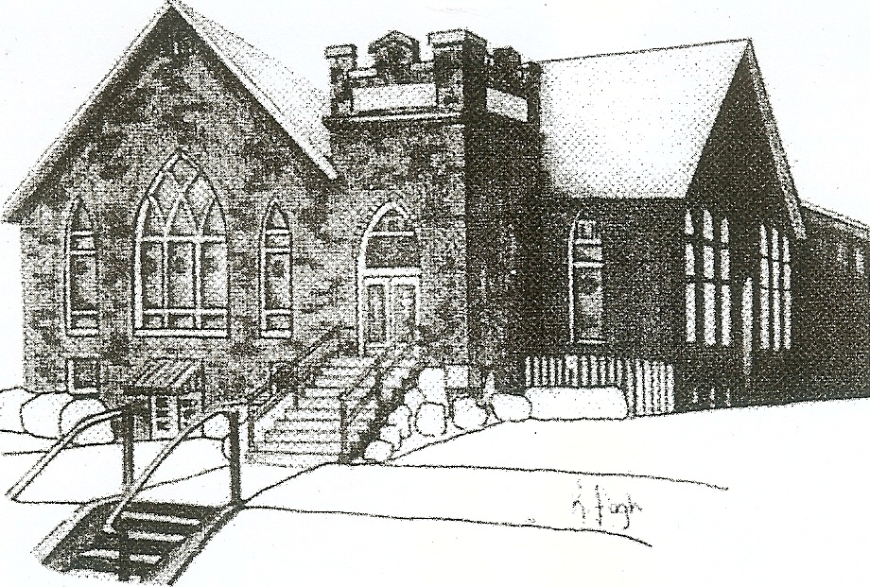
We are your hometown church: Faithful to Tradition, Loving in Fellowship, & Reaching for Tomorrow!

October 10, 2021

We welcome you and we are glad you’ve chosen to Worship with us today!

CALENDAR: October 10th – October 17th

Church Office Hours: Monday -Thursday from 9 a.m. – 2:30 p.m.

Today, October 10, 2021
VOLUNTEERS☺

LAST SUNDAY’S In-House ATTENDANCE: 59

LAST SUNDAY’S OFFERING:
Operating Funds: $3285.00
Kindness: $70.00
Mission: $60.00
Building Improv. $10.00
Total: $3425.00

9:00 am Sunday School Hour
10:00 a.m. THE MORNING WORSHIP SERVICE
11:15 am. 80+ Luncheon
1:00 pm Youth Group
Monday, October 11, 2021
6:30 p.m. Griefshare
Tuesday, October 12, 2021
9:00 am A team
7:00 pm AA
Wednesday, October 13, 2021
9:00 am Material Girls
7:00 pm Chancel Choir Rehearsal
Thursday, October 14, 2021
Friday, October 15, 2021
Private Wedding Rehearsal
Saturday, October 16, 2021
Private Wedding
Sunday, October 17, 2021
9:00 a.m. Sunday School
10:00 am THE MORNING WORSHIP SERVICE
4:00 pm Lifting Up Body, Mind, & Soul—Old Union Church
Welcome to all who are Worshiping with us today!

Guests
We sincerely hope our service is a blessing to you. We ask that our guests please take a few minutes to complete one of the Connect Cards found in the pew holder.

Should you have questions regarding any aspect of our church, including membership, please contact Pastor Brian or the church office during the week at 724-625-1365. Thank you for being with us today.

PRAYER – JOYS & CONCERNS
Lou Beckwith Kennedy (Great Granddaughter of Marlene Edwards
Jan Balentine (sister of Karen Purvis) Paige Barbour (daughter of Andrew and Steph Barbour)
Reid Christopher Hall (June Stirling’s nephew) Maria Elizabeth McKaveney (June Stirling’s niece)
Lindy McCartney (Lisa Barbour’s Sister)

ANNOUNCEMENTS
Bulletins are printed Thursday mornings; let us know if you have an announcement…

KITCHEN HELP INTEREST DEACON EMAIL The deacons would love to welcome anyone who would like to help with the kitchen for events, (ex: funeral lunches, Turkey bash, etc.) The deacons and other “Honorary Deacons” have a lot of fellowship in the kitchen while working the events. If you have any interest, please contact the office or Carol Kopar to be added to the Deacon email.

LIFTING UP BODY, MIND, & SOUL Old Union Presbyterian Church
A Time to Seek God’s Wholeness and Healing Sunday, October 17, 2021 @ 4:00 pm
Light meal to follow.
God desires a life of joy and peace for us all. Join us for a time to seek his mercy and grace for the troubled parts of our lives.
Physical Emotional Mental
Spiritual Relationships Economic

SAVE THE DATE/ MARK YOUR CALENDARS!! MUP ANNUAL BONFIRE @ Quality Gardens on Route 228 October 24th! At 5:00 pm. The church will provide the chili, hot dogs, and refreshments. Be sure to bring a chair to sit in, flashlight and a roasting stick. Looking forward to some great campfire fun!

IT’S BACK !!!! ROTARY PANCAKE BREAKFAST Come Support the Pancake Breakfast on November 13, 2021 7am until 11am All you can Eat Pancakes and Sausage. Event held at MUP Fellowship Hall. Tickets available at the door. Watch for more details!

MUP OCTOBER NEWSLETTER Hard copies of the October Newsletter are available in Tarry N Talk. If you would like added to the mailing or emailing list, please contact the office.

PASTOR APPRECIATION MONTH The month of October is Pastor Appreciation Month. Take time to think of ways to show Brian that you appreciate him.

