
Christ Lutheran Church
“A Place Where You are Always Welcome”
Services: Saturday 5:30 pm and Sunday 10:00 am
Sunday School: 9:00 am (September- May)
600 North Main Street, Stockton, IL 61085 Office: 815-947-2033
Email: christlutheranchurch70@gmail.com http://www.christlutheranstockton.com

Fourth Week of Lent

A Conversation in Community
This week, we see Jesus and his disciples encounter a man born blind. The disciples want to understand suffering by explaining it by assigning blame. Jesus redirects the conversation from why the man is blind to focusing on what God is doing. The healing that follows disrupts the man’s life and unsettles the community around him. Those who thought they understood the world are forced to confront their assumptions, while the unnoticed one becomes a living sign of God’s work. As we continue in our Lenten journey, you are invited to examine how we talk about brokenness, how we respond to change, and how we react when God’s work challenges what we know.

About the Northern Illinois Synod
This resource is provided for your use by the Northern Illinois Synod.
The Northern Illinois Synod is one of 65 synods in the Evangelical Lutheran Church in America (ELCA). We connect and support 136 congregations and their leaders to share in God’s mission across Northern Illinois. Through leadership development, congregational support, shared ministry, outreach, and innovation, we walk together to proclaim the Gospel and serve our neighbors for the sake of the world.

Over the next three years, we will be centered on the theme of Going Deeper – Naming, Claiming, Proclaiming. Inviting congregations and individuals to explore the why behind what they do in response to God’s call in an ever-changing world.

To learn more, visit us at www.nisynod.org and find us on Facebook and Instagram@nisynod.

Prelude

Gathering
The love of God poured into our hearts, the saving grace of Jesus Christ, and the abundant life of the Holy Spirit be with you all.
And also with you.

Opening Prayer
God of love and mercy, open our hearts to find your work where we least expect it. Change how we see ourselves and others, that we may walk in your truth and live as children designed to be in community. Amen.

Song | Take, Oh, Take Me As I Am | ELW #814
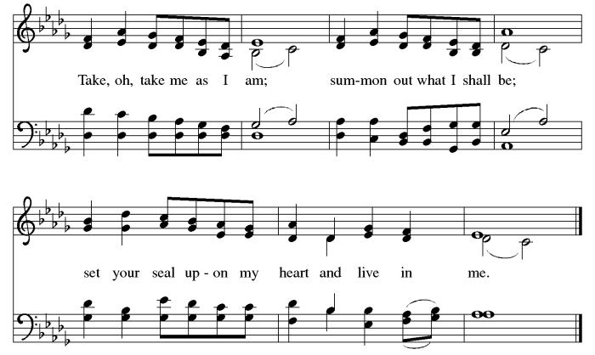

Word |  | John 9:1-11
The Gospel according to St. John, the ninth chapter.

¹ As Jesus walked along, he saw a man blind from birth. ² His disciples asked him, “Rabbi, who sinned, this man or his parents, that he was born blind?” ³ Jesus answered, “Neither this man nor his parents sinned; he was born blind so that God’s works might be revealed in him. ⁴ We must work the works of the one who sent me while it is day; night is coming when no one can work. ⁵ As long as I am in the world, I am the light of the world.” ⁶ When Jesus had said this, he spat on the ground and made mud with the saliva and spread the mud on the man’s eyes, ⁷ saying to him, “Go, wash in the pool of Siloam” (which means Sent). Then he went and washed and came back able to see. ⁸ The neighbors and those who had seen him before as a beggar began to ask, “Is this not the man who used to sit and beg?” ⁹ Some were saying, “It is he.” Others were saying, “No, but it is someone like him.” He kept saying, “I am the man.” ¹⁰ But they kept asking him, “Then how were your eyes opened?” ¹¹ He answered, “The man called Jesus made mud, spread it on my eyes, and said to me, ‘Go to Siloam and wash.’ Then I went and washed and received my sight.”

The Gospel of our Lord.
Thanks be to God.

Holy Conversation
- Naming
  - What hard questions do you want to ask Jesus about suffering, injustice, or brokenness in the world?
  - What assumptions does your congregation make when faced with pain or unmet needs?
- Claiming
  - Imagine yourself as the man from the Gospel, approached by a stranger offering the possibility of healing. What emotions arise – hope, fear, skepticism, gratitude, or something else?
  - How does your congregation typically respond to change? What helps you trust God in moments of transformation?
- Proclaiming
  - How do you respond when your assumptions or prejudices are exposed?
  - How might your congregation proclaim God’s work by choosing curiosity, humility, and openness when confronted with change?

Prayers of Intercession
Seeing in Christ life and salvation, let us pray for the church and the world, responding, “Be with us, and have mercy.”

A brief silence.
That the baptized may share their faith in Christ, and so praise God who sent him, we pray: Be with us, and have mercy.

That the faith of those preparing for baptism and confirmation may be strengthened by Christ’s transforming power, we pray: Be with us, and have mercy.

That all people may turn away from sin and embrace instead the vision of the world to come, we pray: Be with us, and have mercy.

That justice for persons with impairments may overcome neglect, pity, and prejudice, we pray: Be with us, and have mercy.

That Christ the healer may strengthen those burdened by illness and fear, including those we now name (pause), we pray: Be with us, and have mercy.

That this assembly may make visible in word and action the righteousness, truth, and mercy of the Savior, we pray: Be with us, and have mercy.

For what else do we pray? (pause)
For these and all the prayers of our hearts, we pray . . .

Saving God, open our hearts to the Savior you sent so that we may praise you through Christ, who lights our way as we go deeper in trusting your call in our lives. Amen.

Lord’s Prayer
Gathered into on by the Holy Spirit, let us pray as Jesus taught us.
Our Father in heaven, hallowed be your name, your kingdom come, your will be done, on earth as in heaven. Give us today our daily bread. Forgive us our sins as we forgive those who sin against us. Save us from the time of trial and deliver us from evil. For the kingdom, the power, and the glory are yours, now and forever. Amen.

Song | Christ, Be Our Light | ELW 715
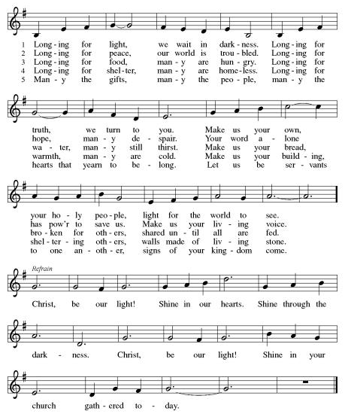
Sending
May you have courage to name the questions you carry,
the doubts, the longings, and the truths you have not yet spoken.
May you have faith to claim the love God offers you—
a love that meets you in wilderness and night,
at wells and in grief,
in brokenness and in new birth.
And may you be sent to proclaim that love
through your words and your actions,
through justice and mercy,
through hope lived out in the world.
Go deeper in faith,
go deeper in love,
and go deeper in following Jesus.
Amen.
A greeting of peace may be shared by all as you depart this place.

Copyright
Liturgical texts adapted from sundaysandseasons.com Conversations with Jesus: Services of Word and Healing for Lent © 2026 Augsburg Fortress. All rights reserved.

