**Transient Food Establishment Application 2025-2026**

This form must be received 14 days prior to your first event. If there is less than 5 days before an event, contact the Health Department for approval before submitting this application. Incomplete applications will not be approved.

I have read and understood the Temporary Food Stand Requirements by REHA. Yes No

|  |  |  |  |
| --- | --- | --- | --- |
| APPLICANT/ORGANIZATION INFORMATION: | | | |
| Name of Business/Organization: | | | |
| Contact Person: | Contact Person Email: | Contact Person Phone  ( ) | |
| Business/Organization Address: | | State | Zip |
| Billing Adress *(if different)* | | State | Zip |

|  |  |  |
| --- | --- | --- |
| **Date(s)** | **Location of Food Service Event** | **Time** |
|  |  |  |
|  |  |  |
|  |  |  |
|  |  |  |

**If you have more events please indicate on a separate piece of paper.

|  |
| --- |
| MENU INFORMATION |
| List the food items you will be providing: |

|  |
| --- |
| FOOD PREPARATION |
| **Where is your food source coming from** (*home prepared foods are not allowed*):  Restaurant Retail Grocery Wholesaler Other: ___________________________________  **Food preparation site** (*all food must be prepared in a commercial kitchen or on-site at the event*):  Commercial Kitchen: ________________________________________ On-site Both  Attach a copy of the agreement for use of the commercial kitchen with dates and times when food will be prepared  **Food Transport Method:**  Cooler/Container Refrigerated Truck Other: _________________________________________  Cooking Equipment: _______________________________________________________________________  *Grill, deep fryer, smoker  Hot Food Holding Equipment: _______________________________________________________________  *Nesco, crockpot, sternos  Cold Food Holding Equipment: ______________________________________________________________  *Cooler, Ice chest, Refrigerator  **Handwashing Set Up**: Plumbed Sink Temporary Station |
| FOOD STAND REQUIREMENTS |
| **Please ensure you have the following items when you operate your food stand:**  • Disposable gloves, deli tissue, tongs, etc. (bare hands are not allowed to touch ready to eat food).  • Metal-stem food thermometer (required for foods needing temperature control).  • Sanitizer solution (bleach water or quaternary ammonia).  • Overhead protection (tent or canopy if outdoors) and floors must be maintained in sanitary condition.  • Screening at food prep areas, if applicable.  • All food must be protected from consumer contamination using packaging, food shields, display cases or other effective means.  • Utensil washing facilities (required for on-site food prep and for events more than one day).  • Access to restroom facilities. Set up must not be within 100feet of |

This transient license allows you to serve meals or sell food **ONLY** at community events (e.g. Fairs, Festivals, Farmer Markets) or for occasional sales promotions. Under a transient license, you may serve food an unlimited number of days during the licensing year with the following exceptions

* You may not serve meals or sell food for more than 14 consecutive days at a single location.
* An occasional sales promotion (e.g. car dealership having brat fry), only limited 3 days per year.
* Non-Profit Organizations: serve meals for 3 or fewer days a year or sell non-meals (e.g. ice cream, desserts) for 12 or fewer days a year

**Non-Profit Organization:** If your organization has more days of food service/sales than indicated above, then you are required to complete this form to apply and pay for a transient license. A permit will be issued at that time for the licensing year. Otherwise permits will not be issued as they are not needed for exempt organizations. We do appreciate your organization’s cooperation in notifying us about events by completing this form.

**Food Safety Training**: When serving food under a transient license a Certified Food Manager is not required. However, we encourage everyone working in a food stand to be knowledgeable about food safety. Visit our website for a free food safety class and short test. For non-profit organization applying for a transient license, having at least one member trained entitles the organization to a reduce fee license.

Trained Individual(s): _________________________________________________

|  |  |  |  |  |
| --- | --- | --- | --- | --- |
| ANNUAL LICENSE FEE | | | | |
| **For-Profit** | | **Non-Profit Organizations** | | |
| Annual License | $130/yr | Annual License (with training) | | $100/yr |
| Licensed REHA Food Establishment for 1-3 days | $40 | Annual License (without training) | | $130/yr |
| Licenses are not transferable. All licenses expire on June 30th annually. Licenses issued between April 1st – June 30th will expire on June 30th of the following year. The license fee is not prorated for a partial license year.  • Wis. Stat. § § 97.67 (5) and 97.605 (1)(c) “No license may be issued until all applicable fees have been paid.”  • Wis. Stat. § 97.605 (1)(a) “No person may conduct, maintain, manage or operate a hotel, restaurant, temporary restaurant, tourist rooming house, vending machine commissary or vending machine if the person has not been issued an annual license by the department or by a local health department that is granted agent status under s. 97.615 (2).” | | | | |
| **I certify that I am familiar with the Temporary Food Service Requirements – as required in the Wisconsin Food Code. The described establishment will be operated and maintained in accordance with applicable regulations.** | | | | |
| **Signature:** | | | **Date:** | |

**Electronic Payment Options:**

[**https://client.pointandpay.net/web/marquettecountyhealthdept**](https://client.pointandpay.net/web/marquettecountyhealthdept) **Or** Use this QR Code

**Other Payment Option:**

**Make Checks Payable to:** Marquette County-REHA

**Mail Completed Application and Payment to**:

Marquette County Health Department

Attention: REHA

428 Underwood Ave

Montello, WI 53949

**MINIMUM SETUP AT TEMPORARY FOOD EVENTS**

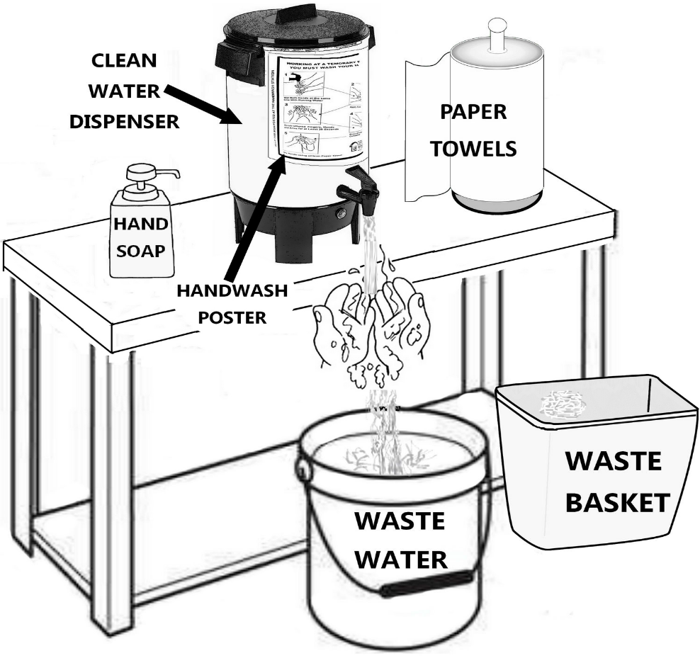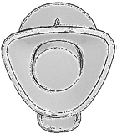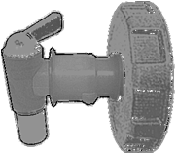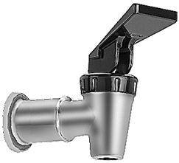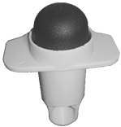

YES

Water dispenser used must have a spigot that stays open without holding or pressing it.

NO

**Provide plenty of clean water at your event:**

* + So, workers must wash their hands as needed.
  + To clean and sanitize utensils

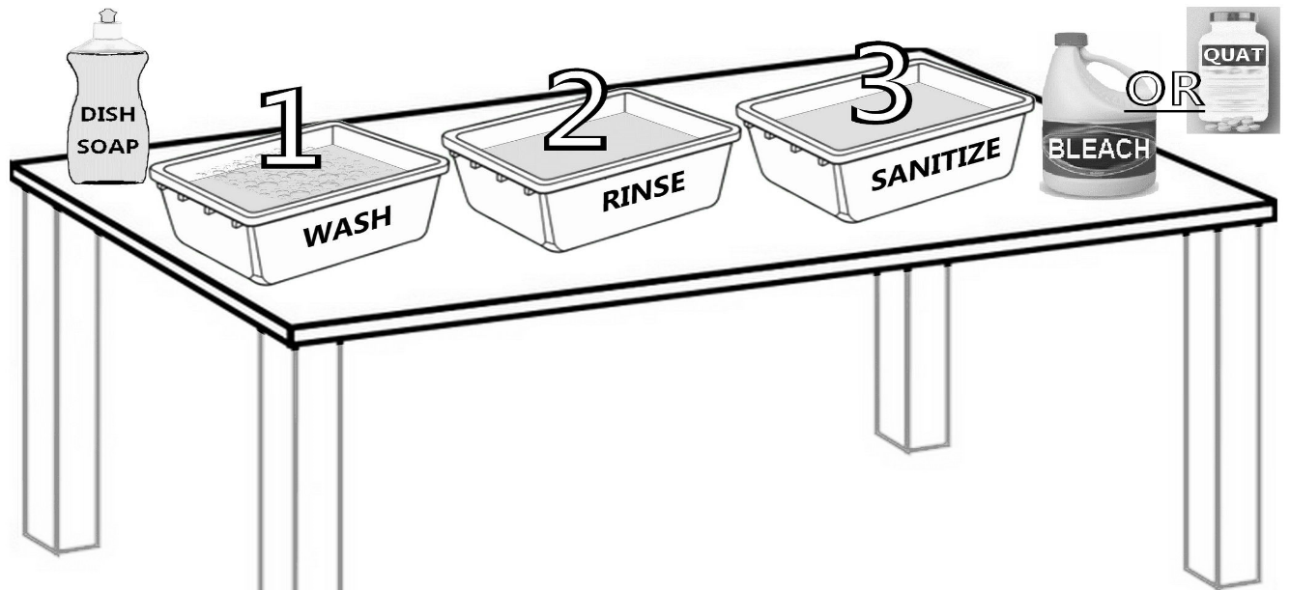

**Step 1: (wash basin)-** soap and warm water

**Step 2: (rinse basin)-** clean warm water

**Step 3: (sanitize basin)-**mix one tablespoon of bleach **OR** one quat tablet in one gallon of water **(DONT MIX CHEMICALS TOGETHER)** and be sure to allow utensils to submerge in sanitizer for at least one minute.

**\*Any wiping cloths used must be stored in the sanitizer solution while not in use.**

**\*All wastewaters must be disposed of in a sanitary sewer drain or functioning septic system.**