Hawthorne’s Annual Spring Raffle

February 16th, 2018 - March 9th, 2018 9am

Ready. Set. Raffle.
It’s that time of year! Enclosed are the packets for the raffle so start cheering on your students to sell! The online option is available again this year, so save time and sell online!! Post and share with family and friends! Supporting their favorite HSA student is just a click away!

There are only 3 – we said three weeks of ticket sales before the March 9th announcement of the big winners. And we mean BIG!
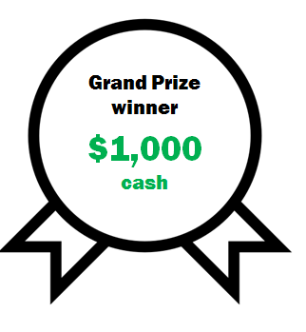
2 Grand prize winners:
$1,000 cash each
1st place: $500
2nd place: $350
3rd place: $250

We have great prizes for top student sellers too!

Primary grades (K-3rd): Upper grades (4th-8th):

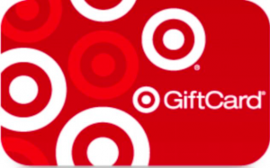
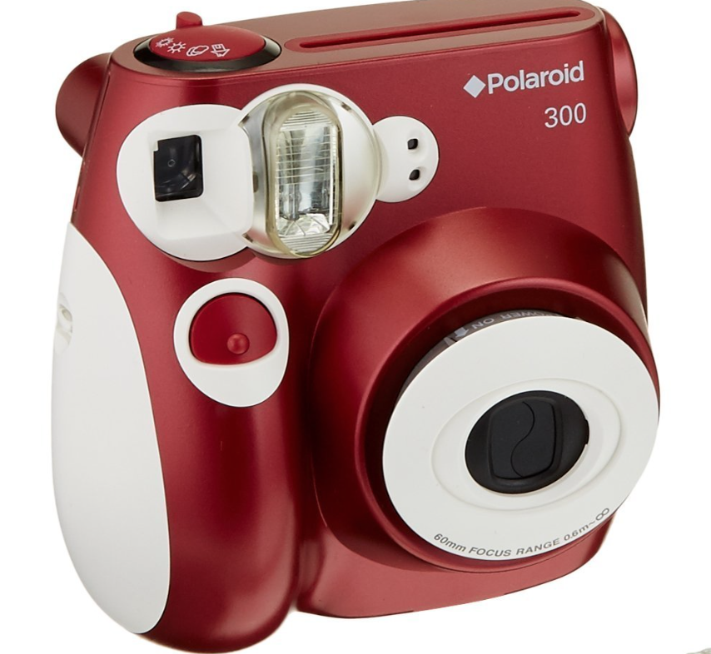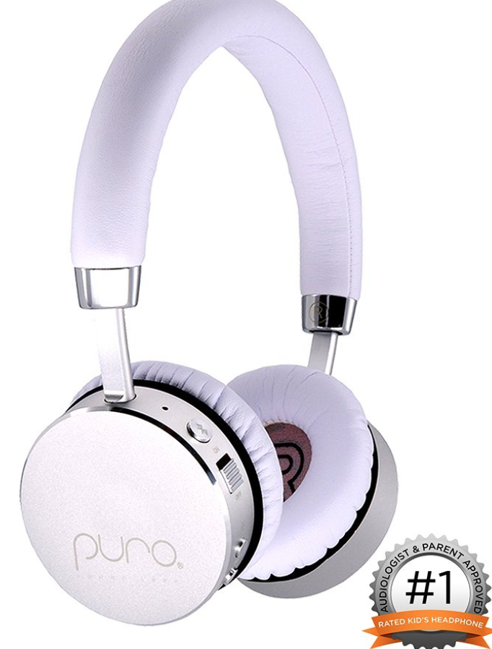
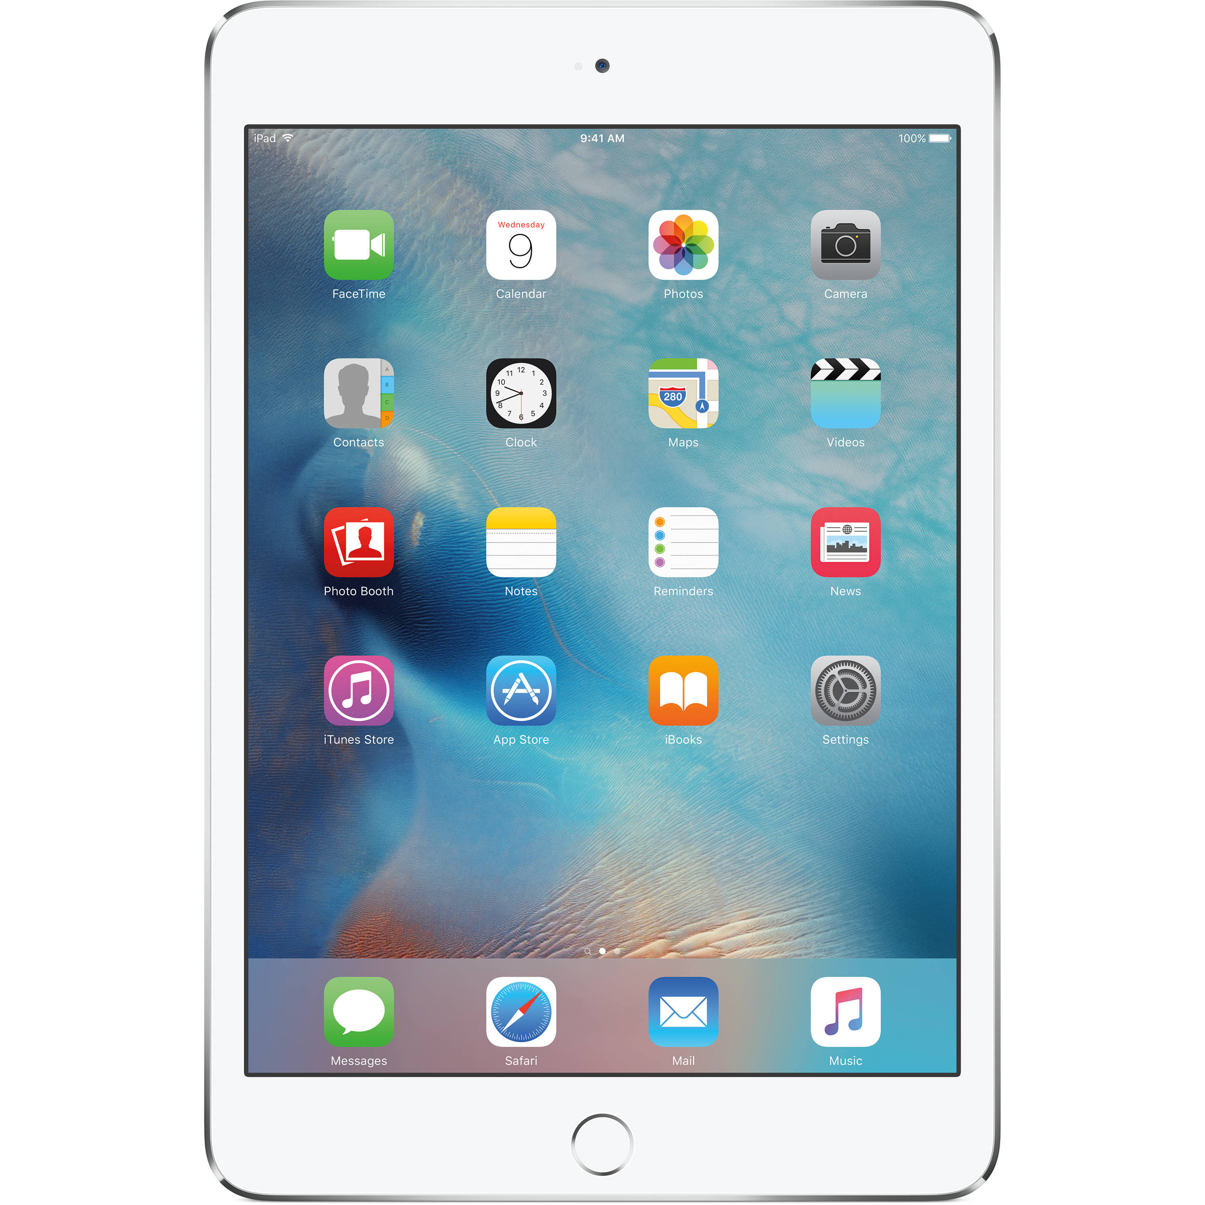

iPad Mini, Polaroid Bundle, Pura Wireless Headphones Gift cards ($225, $200 and $175)

Prizes don’t stop there! Check out these other great ways to win.

- Daily prizes for students that sell a complete book include gift cards for DQ, Starbucks, iTunes and much more!
- Top selling grade (after final week) will have a pizza party!
- Any class with 100% participation will receive a class “sweet” party!
- The student who sells the most books between 7th and 8th grade wins a $50 Starbucks gift card!

Ticket Costs
Save $5
1 book = 35 tickets for $1 per ticket. Save $5 when you purchase an entire book for $30!
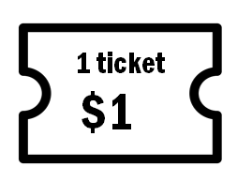
35 tickets = 1 booklet

$30 per booklet

Save time and buy online!

Online ticket sales were a big hit last year, so let’s continue the trend! Takes less time, is easy to share with friends and family! Post the link to your social media accounts! Spread the word and support HSA! It’s just a click away!

Go to: https://rafflecreator.com/pages/19504/hawthorne-scholastic-academy-raffle

Or go to our PTA website and just click on the link! https://www.hawthorneacadpta.org
*There is a small convenience fee to purchase the tickets online that does not go towards the auction.

Paper Ticket Booklets
Paper booklets will be provided and more are available in the office. You only need to fill out your name and number as well as your student’s name and classroom number on the booklet cover if you purchase an entire book. You will need to put all applicable information on each individual ticket if you purchase less than a full book. Make any checks payable to Hawthorne Scholastic Academy PTA.

Make sure we get it!
Include the collected money, raffle booklet cover with student’s name and classroom number and ticket stubs, in an envelope if possible and send them to the office each day!

Don’t forget - 7th and 8th graders must sell at least one book of tickets to attend the Annual Afternoon Pizza bash.

If you have any questions, email beccawalls@yahoo.com or amyomullins@gmail.com

