Mars UP Church
Come Holy Spirit, Come
Before the Service – Speak to God!
During the Service – Let God speak to you!
After the Service – Speak to each other!

(*Please stand, if able)
Welcome and Mars Messages

Prelude

Apostles’ Creed
I believe in God the Father Almighty, Maker of heaven and earth; and in Jesus Christ His only Son our Lord; who was conceived by the Holy Ghost, born of the Virgin Mary, suffered under Pontius Pilate, was crucified, dead and buried; He descended into hell; the third day He rose again from the dead; He ascended into heaven, and sitteth on the right hand of God the Father Almighty; from thence He shall come to judge the quick and the dead. I believe in the Holy Ghost, the holy catholic church; the communion of saints; the forgiveness of sins; the resurrection of the body; and the life everlasting. Amen.

Gloria Patri
Glory be to the Father, and to the Son, and to the Holy Ghost. As it was in the beginning, is now and ever shall be,
world without end.
Amen. Amen.

The
Lord’s Prayer

Our Father,
who art in heaven,

hallowed be Thy
name,

Thy kingdom come,
Thy will be done,
on earth
as it is in heaven.

Give us this day
our daily bread;

and forgive us
our debts,
as we forgive
our debtors;

and lead us not
into temptation,
but deliver us
from evil.

For Thine
is the kingdom,
and the power,
and the glory,
forever. Amen.

The Doxology

Praise God
from whom
all blessings flow;
praise Him
all creatures
here below;
praise Him above,
ye heavenly host;
praise Father, Son,
and Holy Ghost.
Amen.

The Call to Worship adapted from Psalm 85

Leader: Restore us again, O God of our salvation,

People: Put away your indignation toward us.

Leader: Revive us again,

People: So that your people may rejoice in you.

Leader: Show us your steadfast love, O LORD, and
grant us your salvation.

People: We hear what God the LORD will speak, for
he will speak peace to his people,

Leader: Surely his salvation is at hand for those who fear
him, that his glory may dwell in our land.

People: Steadfast love and faithfulness will meet;
righteousness and peace will kiss each other.

Leader: Let us worship our God.

Mission Partner Greg Nichols from Greater Europe Mission

Offering
*Doxology
*Offering Prayer

*Hymn 107
“Lord, I Lift Your Name on High”

Scripture Luke 11:1-13

Children’s Chat

Morning Message Rev. Brian Hauser
“The Secret of My Success”

Prayers of the People and Lord’s Prayer

*Hymn
Congregational Choice

*Benediction

*Congregational Response (Everyone sings)
May the Peace of the Lord Christ
go with you, whenever He may send you.

May He guide you through the wilderness,
protect you through the storm.

May he bring you home rejoicing
at the wonders He has shown you.

May he bring you home rejoicing
once again into our doors.

Church Staff
Rev. Brian Hauser
Pastor
pastor@mars-up.org
724-689-3412

Ms. Jamie Daugherty
Choir Director & Organist
JamieD0714@gmail.com

Mrs. Shelly Bocheff
Administrative Assistant
marsup@mars-up.org

AV TEAM
Alma Staskiewicz, Lisa Barbour, Marie Matthews, Bill Guesman, John Ivory, Keith Nichols, Mike Bocheff, Herb Wellman

Mars United Presbyterian Church

232 Crowe Ave
PO Box 805
Mars, Pennsylvania 16046
724-625-1365
www.mars-up.org
marsup@mars-up.org

Church Office Hours:
Mon -Thurs from 9 a.m. -2:30 p.m.
Morning Worship:
10:00 am

7th Sunday after Pentecost

Prayer of Preparation
Lord, we come to you today with so many things on our hearts.

You call us to be in relationship of trust and love with you and you offer healing to us for those portions of our lives that are broken and injured.

Help us to be open to your mercy and healing love. For we ask this in Jesus’ Name.
AMEN.

*Postlude

Flowers are presented to the Glory of God and in celebration to our MUP Family by the Staskiewicz Family. Happy Summer!!

Rosebud on the altar is in celebration of the birth of Holland Jean Medsger born July 10, 2022 to Hannah and Brad Medsger. Proud Grandparents are Jim and Shirley Govan and Great-Grandmother is Nancy Govan.

GUEST SPEAKER TODAY – GREG NICHOLS
This morning (via zoom) we are pleased to welcome Greg and Debby Nichols to worship. Greg is Keith’s brother. Mars United Presbyterian Church has supported and been involved in the Nichols’ ministry for nearly 30 years. Greg and Debby were married in 1990 and soon moved to Ukraine to work in one of the newly opened seminaries in the former Soviet Union. He completed his PhD in Russian history and they moved to Prague, Czech Republic where he continued to teach Church History and Theology. After 8 years in leadership, their ministry is transitioning to leader development and refugee assistance in Prague. Debby has been actively working with refugees since 2015. They have two adult children; Nicolas and Selina.

If you would like to contribute to “The Greater Europe Mission” please mark your check or envelope with GEM and place in the offering plate. We will be collecting for this mission until Sunday, August 14th.

Mars United Presbyterian Church
Welcome!

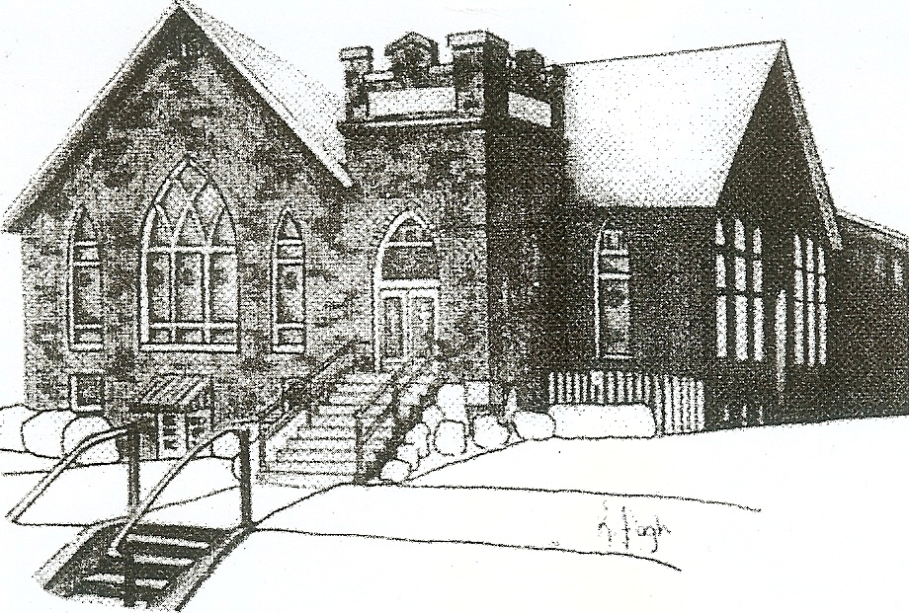
We are your hometown church: Faithful to Tradition, Loving in Fellowship, & Reaching for Tomorrow!

July 24, 2022

We welcome you and we are glad you’ve chosen to Worship with us today!

CALENDAR: July 24, 2022 – July 31, 2022

Church Office Hours: Monday -Thursday from 9 a.m. – 2:30 p.m.

Today, July 24, 2022
VOLUNTEERS☺

LAST SUNDAY’S In-House ATTENDANCE: 53

LAST SUNDAY’S OFFERING:
Operating Funds: $5592.00
Kindness Offering $80.00
Mission: $10.00
Total: $5682.00

Tarry N Talk Hosts
Deacons Committee
10:00 a.m. THE MORNING WORSHIP SERVICE
Monday, July 25, 2022
Tuesday, July 26, 2022
9:00 am A team
7:00 pm AA Meeting
Wednesday, July 27, 2022
9:00 am Material Girls
Thursday, July 28, 2022
Friday, July 29, 2022
Saturday, July 30, 2022
Sunday, July 31, 2022
10:00 am THE MORNING WORSHIP SERVICE

Welcome to all who are Worshiping with us today!
Guests
We sincerely hope our service is a blessing to you. We ask that our guests please take a few minutes to complete one of the Connect Cards found in the pew holder.

Should you have questions regarding any aspect of our church, including membership, please contact Pastor Brian or the church office during the week at 724-625-1365. Thank you for being with us today.

PRAYER – JOYS & CONCERNS
Lou Beckwith Kennedy (Great Granddaughter of Marlene Edwards
Patty Jackson Paige Barbour (daughter of Andrew and Steph Barbour
Reid Christopher Hall (June Stirling’s nephew) Maria Elizabeth McKaveney (June Stirling’s niece)
Lindy McCartney (Lisa Barbour’s Sister) Isabel Boynton

ANNOUNCEMENTS
Bulletins are printed Thursday mornings; let us know if you have an announcement…

VBS REUNION We had so much fun at VBS that we can’t wait until next year. Join us on Sunday, August 7th from 1pm to 3pm to have an extra day of VBS. Just like VBS, there will be Bible Adventure, crafts, songs, games, science and snacks. Of course, lots of fun too! Bring your friends and come have a great time and see your Crew leaders again. If you have any questions, please contact Pastor Brian at 724-625-1365
GRIEFSHARE SUMMER MEETINGS Griefshare will continue to hold one monthly meeting during the summer. Next Meeting will be held on August 8th. The fall session will resume on September 12th at 6:30 For more information, please contact Denise @ ddemarco5@yahoo.com
COMING THIS FALL Mothers of Preschoolers (MOP) group starting at Mars UP Church. To register or questions contact church office or Ashley Hauser at 814-270-9101. More details to follow!!
SAVE THE DATE Mars UP church annual picnic will be held Sunday, September 11th at Adams Township Park. We will also be celebrating Rally Day this Sunday. More Details to Follow!!

SAVE THE DATE Sunday, September 18th we welcome Michael Kelly Blanchard, storyteller and musician. Michael will be joining us for worship at 10 a.m. and will also be back at 6:30 for an evening of music and drama. For more information on Michael, please visit his website, michaelkellyblanchard.com.
NEW KIDS CLUB Calling all 2nd – 5th graders!! Mars UP Church and St. John Lutheran Church are hosting a New Kids Club. Kids of the Mars area will have time with old and new friends as they play, learn, and grow in their faith. Kid’s club will meet twice per month. For more info, please see Pastor Brian or contact the office at 734-625-1365

