Color country Corvette Club of So. Ut
A VETTS & CAFFININE EVENT
Hosted by Morey & Mary Sanford
February 16, 2023
WE WILL MEET & LEAVE FROM TERIBILS CHEVRON AT EXIT 2 ON I 15

We will leave at 8:30 head down I 15 to Mesquite and exit #122 (first exit to Mesquite). Turn right at light and go down one block turn left at next light. You have arrived at the Virgin River Casino. We will all meet at the Buffet.

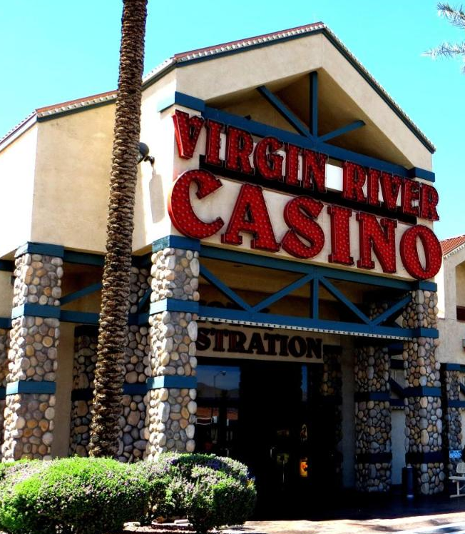 RSVP Requested

Breakfast will be served at the Virgin River Sierra’s Buffet. Cost $8.99

After Breakfast, for a little friendly competition and fun, join us for bowling a few games at the Virgin River Bowling Center. Two handed bowing is allowed.
BOWLING RATES Per Game $4.00 Shoe Rental $4.50

