**May 2025**

***GUIDE LINE***

**VOL 33, No 5**

**President’s Message**

Submitted by Mike Pearl, President

**TABLE OF CONTENTS**

President’s Message 1,2

From the Editor 2

Committee Updates … . .…3-10

Quiz 11,12

May Member Meeting Info 13

Garden of the Gods Update 14

Organization Activities 16-18

NFTGA Activities 18-19

Members Meetings 19

Purpose of RMGA 22

Officers and Chairpersons 22

The April Annual Meeting showed the vibrancy and relevance of our Association. Jim Carr, President of the National Federation of Tourist Guides, was in attendance. He scheduled a personal trip to Colorado to coincide with our meeting so that he could attend. In his remarks, Jim commended members for their dedication to professionalism in tour guiding and tour directing.

RMGA thanks the presenters at the April program: Jamie Richards, Rocky Mountain National Park; Courtney Law, Denver International Airport; Emily Bates, VISIT Aurora; Kaiti Jacobson, Colorado Tourism Office; and Juliet Jacoby of VISIT Colorado Springs.

RMGA thanks VISIT Aurora for the use of their meeting room at the Stanley Marketplace, their technology for the ZOOM component, beverages from their refrigerator, “schwag” from their cupboards, and snacks from *Miette et Chocolat* in the Stanley Marketplace. Thanks, also, to Heather Savoca and Emily Bates of VISIT Aurora, who set up the space for our meeting. Bruce Dalton is President and CEO of VISIT Aurora.

Check out the Members Only page of the RMGA website to access a video recording of the meeting and program.

There is a generous offer from the History Colorado Center detailed on the Members Only page of the RMGA website. Have you taken advantage of it? Send your reactions to the exhibits to [rmgaeditor@rockymountaintourguides.com](mailto:rmgaeditor@rockymountaintourguides.com).

Of the eight monthly meetings scheduled for 2025, two have no program yet: October and November. What can you do to put together one of these programs? Because of our ZOOM account, programs can originate from any of our members’ locations in Colorado and New Mexico.

Are you craving a Familiarization Trip? All you have to do is start setting one up. Find some guidance elsewhere in this issue of the *Guide Line*.

As a civic organization, RMGA is owned and operated by its members. It is truly a democratic organization and relies on its members to give it relevance and life. RMGA will continue to serve tour guide professionals only if current members engage in organizational activities. Check out the **Leadership and Volunteer Opportunities** available in the Association listed elsewhere in this issue. I am tremendously grateful for the members who volunteer to take on Board positions and or Committee Chair positions.

RMGA members continue to determine in what ways the organization is beneficial to them, then join to actualize that vision. Please email your ideas and thoughts about the future direction of the organization to rmgapresident@rockymountaintourguides.com.

.

Mike Pearl, President RMGA

**FROM THE EDITOR**

Deadline for submissions for the September *Guide Line* is Tuesday, August 26, 2025.

Future contributions should be emailed to *Guide Line* editor Eileen Pearl at [rmgaeditor@rockymountaintourguides.com](mailto:rmgaeditor@rockymountaintourguides.com). If anyone has photos to share, please send them along with either a short description and/or names.

I am delighted that we have submissions of articles from more members this month, including

Richard Farley and Charles Foster. Thank you!

**COMMITTEE UPDATES**

**Communications Committee**

Submitted by Tom Jensen

**What’s New on the Website?**

These updates have been made to the website since the last report:

Modified and created member’s profile as requested

Added 1 year experience to member’s profiles

**Monthly Visitors to the RMGA Website**

Below is a year-to-date comparison of the number of visitors that viewed the RMGA Website.

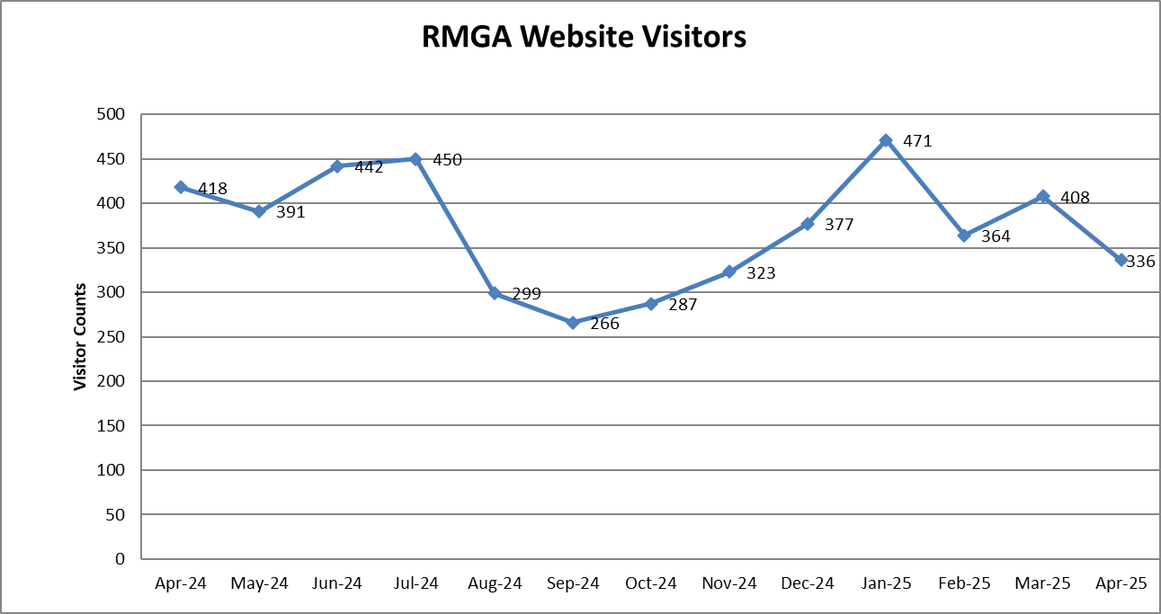

Access to Members Only Page – On April 4th an e-mail was sent to current members with the new access code and instructions for the Members Only page. On this page you will discover archived copies of the Guide Line, Program and FAM triip reviews, and governing documents. If you are having difficulties accessing the page contact Tom Jensen at [tom.jensen72@yahoo.com](mailto:tom.jensen72@yahoo.com).

Profile Update – For instructions on creating or changing your Profile see the “Creating & Changing Your Profile” button on the Members Only page.

**E-Mail Distribution:**

The distribution of e-mails continues to be done on a temporary basis. If you are interested in sending out the e-mail blasts, contact Mike Pearl at [rmgapresident@rockymountaintourguides.com](mailto:rmgapresident@rockymountaintourguides.com).

If you are not receiving e-mails please contact Tom Jensen at [rmgacommunicaations@rockymountaintourguides.com](mailto:rmgacommunicaations@rockymountaintourguides.com).

**Education Committee**

Submitted by Mike Pearl

**Call for Familiarization (FAM) Tours.** Did you come across an experience that all members should know about? Is there a venue, attraction, or place that you’d like to learn about? That’s a great excuse for a FAM trip. We haven’t had many since COVID that we’ve forgotten why and how to conduct them.

FAM trips usually occur over a 6-hour time (ideally, 9:00 am-3:00 pm) on a weekday. Members get an inside look at a venue or attraction (or two) during a morning session and an afternoon session and have lunch together in the middle. The event provides a great opportunity for members to sharpen their knowledge about places and to network with venue and attraction operators. (As well as each other.)

Organize a FAM Trip. Contact President [Mike Pearl](mailto:rmgapresident@rockymountaintourguides.com) to get the ball rolling.

**Membership Committee**

Submitted by Mike Pearl, Membership Committee Chair

The RMGA Board of Directors thanks you for your membership. The latest membership directory is posted on the Members Only page of the RMGA Website. Is your information correct?

RMGA welcomes new members! Do your part to improve and expand RMGA’s knowledge base by increasing the number and diversity of our members. The best means is for each of us to make a personal connection with non-member tour guides.

Invite tour guides to RMGA’s next meeting in-person or on Zoom. Send their contact information to Membership Committee Chair [Mike Pearl](mailto:rmgamembership@rockymountaintourguides.com) so they can be included on the Zoom Meeting Invitation.

**Nominations Committee**

Submitted by Mike Pearl, Nominating Committee Chair

Nominees for the Board of Directors for the 2025-26 term were affirmed by a quorum of members present at the April Annual Meeting:

President – Mike Pearl

Vice President – Hans Kleinschmidt

Secretary – Dawn Nelsen

Treasurer – Brad Hatfield

Director at Large – Tom Jensen

**Program Committee**

May Members Meeting & Program

WHEN: Monday, May 12, 2025

6:00 pm Networking

6:30 pm Business Meeting –

6:45 pm Program “World Trade Center Denver Meets RMGA”

WHERE: Inside the GeoTech Building: 2650 E 40th Av, Denver, CO 80205

WHAT: Find out about the World Trade Center Denver Campus being built to anchor the Fox Park Development in Globeville. Charles Foster has organized this program; contact him for details. [adventurecharlie03@gmail.com](mailto:adventurecharlie03@gmail.com)

ONLINE: The meeting will also be available via ZOOM. Watch for an invitation.

Read more information on Page 13.

**Public Relations Committee**

Submitted by Tom Jensen, Public Relations Committee Chair



|  |
| --- |
| **Gov Con Save the Date** |

|  |  |
| --- | --- |
| |  | | --- | | Save the date for the 2025 Colorado Governor's Tourism Conference (Gov Con), taking place Oct. 22-24, 2025 at newly opened Hotel Polaris in Colorado Springs.  Gov Con brings together tourism leaders for the state’s premier travel industry event and provides opportunities to gain expert insights on the latest trends and issues. The annual three-day event consists of educational sessions, insightful programming, networking and opportunities to learn from industry peers. For more information please click[here](https://click.oeditmc.state.co.us/?qs=38fddd74933a896abd450c6c4266f6dc753eeacd764eb4d2dfc2c8468a35e380fa4fa5b0d6ed30493e06fdc155b95cc9e1a7955289f5e348). | |
|   **Reminder**  Emily Turner of the History Colorado Center in Denver invites RMGA members to visit the History Colorado Center to see **Where is Denver’s Chinatown? Stories Remembered, Reclaimed, Reimagined.** “We’d like to offer a complimentary general admission ticket for all your members to visit the History Colorado Center museum during our normal operating hours of 10:00 AM to 5:00 PM daily. To redeem the comp tickets, members must reserve their ticket online and enter the code RMGA25 at checkout. The code is valid only once per person, and the comp ticket must be reserved online. (It is not available at our front desk.)” Please do not share this code with anyone else. It’s only for RMGA members. Closes August 9, 2025.  **To thank the History Colorado Center for the ticket, email Emily:** [**emily.r.turner@state.co.us**](mailto:emily.r.turner@state.co.us)**.**  **A group of people walking in a street  AI-generated content may be incorrect.** | |



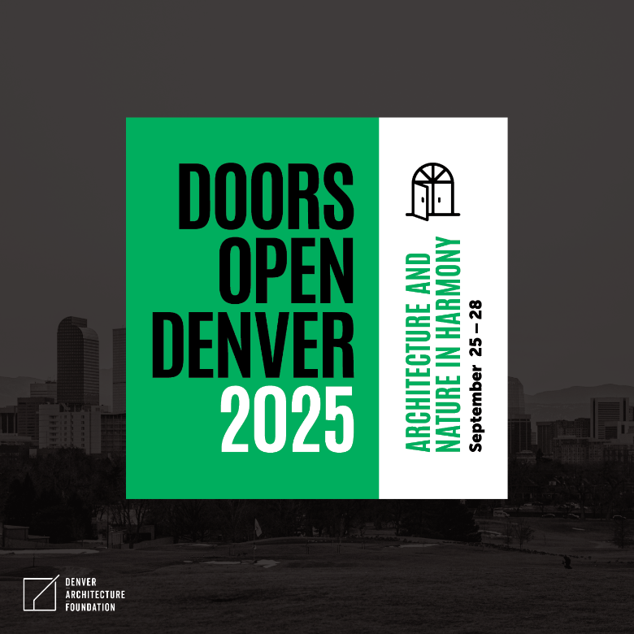

**Save the Date:** September 25-28 for Doors Open Denver 2025

Doors Open Denver 2025 will celebrate the places and the people of our city that best represent this year’s theme “Architecture and Nature in Harmony.” With this concept in mind, our programming will encourage exploration of the vital relationship between the built environment and the natural world in Denver’s unique setting



|  |  |
| --- | --- |
| |  | | --- | | From the Colorado 2025 Group Tour Planner | |



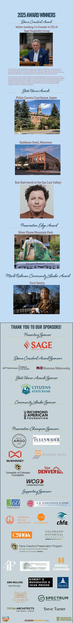

**From the April 24, 2025 edition of the Denver Post in the YourHub section:**

Terri Gentry is a staff member at History Colorado, as an engagement manager for Black communities. In her role, she conducts Museum of Memory Projects, to engage Colorado community members and gather oral histories, photos and memorabilia, to bring into the History Colorado collection. She is currently working to gather the stories from the Lincoln Hills resort and the Whittier Neighborhood in Denver. She collaborates with other departments and with community agencies and organizations to collect, share and teach Black History in Colorado. She is on the board of directors and a volunteer docent at the Black American West Museum, and conducts Five Points Walking Tours, Museum Tours and history presentations to schools, community groups and organizations.

**Congratulations Terri**

**QUIZ**



**How Well Do You Know Colorado?**

1. What is the original name of Glenwood Springs?
   1. Indian Hot Springs
   2. Defiance
   3. Grand River Hot Springs
2. True or False: Colorado is a perfect rectangle!
3. What is the Gang of 19?
   1. An outlaw gang who hid out at Brown's Park (aka Brown's Hole), an isolated mountain valley along the Green River, straddling Colorado and Utah
   2. A group of individuals from the Atlantis/ADAPT who protested against RTD for the lack of wheelchair accessibility for RTD buses
   3. A movie filmed in Buckskin Joe, Colorado in 1938
4. Which is Denver’s first National Historic Landmark?
   1. Civic Center Park
   2. Union Station
   3. Cheeseman Park
5. Where is this mural located?

1. RiNo
2. Colorado Convention Center
3. Denver, Iowa
4. True or False: American socialite and philanthropist Margaret Brown was married to hotel developer Henry C Brown.

See pages 19-21 for answers to the questions.

**May Member Meeting**

**World Trade Center Denver**

May 12, 2025

Submitted by RMGA Host Charles Foster

The upcoming May meeting will take place at the World Trade Center Denver.

This program will outline for the first time the World Trade Center Denver which is affiliated with the WTC New York City. Come, enjoy, and learn. The experience will be beneficial for RMGA as we learn about this exciting new project that is now underway at Interstate 25 & Interstate 70.

We will also explore the growing role the mile high city plays in the world trade sector and view the variety of complex architecture gems. Our program will be very complementary and a first of its kind.

A building with a large building and a large building with a large building and a large building with a large building and a large building with a large building with a large building and a large building with

**Don't miss World Trade Center Denver meets RMGA May 12th, 2025 6pm.**

**More details will be sent. Please look out and plan to attend this event!!!**

**What’s Happening at the Garden of the Gods**

Submitted by Colorado Springs Member Richard Farley

*Hopefully you'll be able to glean some useful information regarding the construction in the Garden of the Gods. I stopped by their Visitor Center last week & spoke with some of the folks & today a useful article & interactive map came out to illustrate the situation. This is probably the most helpful link;* [*https://parks.coloradosprings.gov/GOGWaterlineProject*](https://parks.coloradosprings.gov/GOGWaterlineProject)*. The link provides various updated maps of construction. GoG will be hard pressed for parking so I suggest if any of our Guides wish to take a Group into the Park early morning - circa 7:30am - or after 6pm would be your most opportune times.*

*Also this article -*[*https://gazette.com/garden-of-the-gods/limited-access-to-garden-of-the-gods-scheduled/article_64e3666a-0334-44ae-8489-11d475670458.html*](https://gazette.com/garden-of-the-gods/limited-access-to-garden-of-the-gods-scheduled/article_64e3666a-0334-44ae-8489-11d475670458.html)*outlines some of the restrictions.*

*It was a pleasure to visit with everyone last week [at the April Member Meeting] & I hope to see more folks next time.*

*Kindest regards,*

*Richard Farley*

*719-493-3729*

**Editor’s Notes**: Here are some key notes from the articles Richard provided:

* Construction has been ongoing in the Garden of the Gods which may impact tours of the park or parking.
* This project will upgrade and enhance the park’s water supply infrastructure, increasing water pressure to ensure a sustainable and reliable source for fire hydrants and restroom facilities within the park. The objectives are:
* **Enhance fire and park safety:** The installation of 8,000 linear feet of waterline and 9 fire hydrants will ensure a readily available water source for firefighters, improving emergency response capabilities and park safety. This waterline will increase the water supply capacity ensuring a sufficient and reliable water source for firefighting purposes.
* **Improve accessible parking:** approximately 3,200 square feet of asphalt will be replaced to provide parking nearer to the Central Garden for persons with disabilities.
* **Create more accessible routes:**the project will replace a significant amount of the concrete path from Parking Lot #4 to the Central Garden and correct excessive slopes to provide a more easily navigable route between the two locations.
* **Improve restroom facilities:**The project aims to ensure a reliable water supply for park restrooms which will enhance the visitor experience.
* Improvements will also be made to increase accessibility into the Central Garden with more ADA compliant hard surface trails .
* The project broke ground in September and crews expect it to be finished by Memorial Day. The project is 97% completed, with work continuing on the trail connecting Parking Lot 4 to Central Garden.
* Parking Lot 4 [northern end of Garden] remains closed and is expected to reopen in May. It is being reconstructed to a fully accessible parking lot with 8 stalls and an accessible trail into Central Garden.
* Parking Lot 1 [near Visitor Center] is available for visitors throughout the duration of the construction project with access into Garden of the Gods Park via the Gateway Trail.

|  |
| --- |
|  |

**ORGANIZATION ACTIVITIES**

Submitted by Mike Pearl, President

**Organization Activities**

Submitted by Mike Pearl, President

Rocky Mountain Guides Association represents professional tour guides in Colorado and the Rocky Mountain Region to tourism-related organizations. As vice president and president, Hans Kleinschmidt and I meet with other leaders of US tour guide associations and guilds through monthly Zoom meetings. We report to RMGA members the information from those meetings.

President Mike Pearl and Vice President Hans Kleinschmidt represent RMGA to

* National Federation of Tourist Guides Associations monthly leadership meetings, and
* Care for Colorado Partners quarterly meetings

Tom Jensen and the Public Relations Committee lead in keeping RMGA and us professional tour guides in the forefront of the minds of local tourism industry leaders. He is our liaison to VISIT Denver, the Colorado Tourism Organization, VISIT Colorado Springs, and Tour Colorado, among other such organizations. Do you know of a tourism organization with which RMGA should be affiliated? Contact Tom with information.

The RMGA Website and the RMGA Facebook Page are the digital faces of the organization. They are resources available for members to use to promote their own activities and develop business leads.

The *Guide Line* newsletter disseminates relevant information to members in nine monthly installments.

RMGA Email Blasts inform members of available job opportunities as well as time-sensitive information.

**VISIT Denver “Go the EXTRA Mile” Training**

Submitted by Mike Pearl, President

VISIT Denver’s Front Line Staff Training Program **“Go the EXTRA Mile”** has returned. Many members of RMGA have taken the training and have found it very valuable. The training program is free to RMGA members because of RMGA’s partnership with VISIT Denver.

The training program is completely online. Once you have completed the course, you will receive a certificate and access to the Go the Extra Mile Savings Pass. Go to <https://qrs.ly/uufb2z5>. There you will set up an account, then proceed through the course information and learning modules.

After you receive your certificate, add that information to your biography on the RMGA website.

**NOTE** I followed the directions in the article above and completed the course. Upon successful completion, I received the app: *VISIT Denver Experiences* where I located the “Go the Extra Mile Savings Pass.” Inside I found discounts on tickets for 7 experiences, including one from RMGA member Discover Denver Tours. The online course took me about 30 minutes to complete. – Mike Pearl

**What’s in Your Library?**

Submitted by Mike Pearl, President

RMGA members wanting to form a book club, contact President Mike Pearl.

**RMGA Facebook Page**

Another way for members to communicate with each other is the RMGA Facebook page. Find it at <https://www.facebook.com/groups/RMGAssoc>. It’s a great place for members to post pictures and tidbits of information that we all can use.

**RMGA *Guide Line***

The official way that RMGA as an organization communicates with members is by means of the newsletter, *Guide Line*, published September through May. Editor Eileen Pearl collects articles submitted by members for the benefit of professional tour guiding. In addition to RMGA members, the *Guide Line* is sent to the Colorado Tourism Organization (CTO), the National Federation of Tourist Guide Associations (NFTGA), and other tourism-promoting organizations. The newsletter is distributed by Tom Jensen, in his temporary role as transmitter of the RMGA email Blasts. Send your articles to [Eileen Pearl](mailto:rmgaeditor@rockymountaintourguides.com.).

**RMGA Leadership and Volunteer Opportunities**

Members are encouraged to volunteer to lead these committees:

* Certification Committee Chair (Must have the RMGA Colorado Certification)
* Education Committee Chair
* Email Distribution Committee Chair
* Program Committee Chair

Contact any Board member with your interest.

**Memorable Experiences on Tour**

Please use the *Guide Line* to share some of your memorable experiences so that we can all learn. Email your submissions to the [Editor](mailto:rmgaeditor@rockymountaintourguides.com). You may also post to the RMGA Facebook [page](https://www.facebook.com/groups/RMGAssoc).

**Future Conferences & Meetings**

Are you going? Send stories of your experiences to the [Editor](mailto:rmgaeditor@rockymountaintourguides.com). Post comments to the RMGA Facebook [page](https://www.facebook.com/groups/RMGAssoc). This way, we can all learn.

**Care for Colorado Coalition Quarterly Meeting** June 2025. Online. All RMGA members are welcome to sit in on the meeting. Contact President [Mike Pearl](mailto:rmgapresident@rockymountaintourguides.com) for a link.

**GOVCON-Colorado Governor’s Tourism Conference** October 22-24, 2025; Hotel Polaris, Colorado Springs, CO.

**World Federation of Tourist Guide Associations (WFTGA)** Fukuoka, Japan, February 5-17, 2026. Registration opens in the spring. <https://wftga.org/activities/convention/2026-fukuoka-japan/>

**National Federation of Tourist Guide Associations-USA (NFTGA-USA)** Salt Lake City, Utah, January 2027. Registration opens in 2026.

**Colorado Destination Stewardship Strategic Plan**

Preserving Colorado’s Legacy: Protecting our natural wonders, communities, and cultural heritage for generations to come.

<https://www.ctostewardship.com/>

**Are You Colo-Ready?**

RMGA is a Stewardship Partner with the Care for Colorado Coalition. Check out the RMGA logo alongside other Stewardship Partners at <https://www.colorado.com/care-colorado-coalition>. Watch for this logo on the RMGA website and the *Guide Line*:

The Care for Colorado Coalition has joined with Do Colorado Right to amplify the message. RMGA has access to Care for Colorado assets such as stickers and flyers. Contact President [Mike Pearl](mailto:rmgapresident@rockymountaintourguides.com) with your request for materials.

***Be Careful with Fire***

Time spent around the campfire can be a memorable part of our summer adventures, but when not managed responsibly, even the smallest flame can have damaging impacts on public lands. To prevent igniting wildfires, please join us in reminding residents and visitors to Do Colorado Right and Be Careful with Fire using the Care for Colorado messaging and assets, as well as the resources below. Also, help us encourage everyone to sign up and use the free COTREX app, which provides real-time fire advisories, regulations and bans to keep everyone safe and our lands protected this wildfire season. (from *Monthly Messaging* newsletter, May 2025)

View the May *Monthly Messaging* newsletter [here](https://view.oeditmc.state.co.us/?qs=e74b4680589d7ac0d9d1623804edc71baa6891926acd22e5d16b9a3325450af5195fdf4b41122cb695051e6dbb006ecdb6e7ff83692455591a4a79c50f6bbfc4a11f444502838efd362c3cefebc4f0f8).

**NFTGA Leadership Meetings**

Submitted by Mike Pearl, President

RMGA is a member of the National Federation of Tourist Guides ([NFTGA-USA](https://www.nftga.com/)), a collective of local tourist guides associations and guilds across the US. From time to time, RMGA Members receive notices from NFTGA via our email Blast system.

Under the leadership of newly elected president Jim Carr, NFTGA is taking on two initiatives for the next two years. The first initiative is to provide educational programming from a national perspective to all local association members via monthly webinars. The next webinar is set for May 14, 2025. It will feature Fred Ferguson, President and CEO of the American Bus Association (ABA), who will discuss trends in the world of motor coaches. Go [here](https://tourguidesofchicago.com/event-6162299) for more details and register for this virtual event. If you are unable to attend the live-stream, the recording will be available to watch for the following 30 days.

**April 21 program on cemeteries and gravestones**: You can watch the recorded presentation from Dr. Joy M. Giguere and Dr. Perky Beisel [here](https://zoom.us/rec/share/UPuDrgftHWypRCsxyRGcvYx36KdbPdNRuH0hPHnaGenalpkBEgiaqv2LKP6ACo5G.6Kzamr93-_e0TLeS) any time before May 23.

The second initiative is to provide a library of resources to member associations. These resources include “Best Practices” documents for local associations. The initiative aligns with NFTGA’s mission to support local associations in their endeavors to serve their members. The group is developing a resource library based on the best practices of the local associations. The next NFTGA Leadership Meeting will be held Thursday, May 8, 2025 via ZOOM 6:30-8:00 pm. The topic will be on organizing programs and FAMs. All RMGA members are welcome to sit in on the meeting. Contact President [Mike Pearl](mailto:rmgapresident@rockymountaintourguides.com) for a link.

2026 also marks Colorado’s Sesquicentennial (150th) Anniversary. Check out <https://www.historycolorado.org/colorado-150> for more information. Are you a member of any group organizing for Sesquicentennial? Contact President [Mike Pearl](mailto:rmgapresident@rockymountaintourguides.com).

The associations “next door” to us are the Utah Tour Guide Association ([UTGA](https://utahtourguide.org/)) and the Santa Fe Tour Guides ([SFTG](http://santafetourguides.org/)). Check out their websites. When you’re traveling, check the NFTGA membership [page](https://www.nftga.com/members.html) to locate the web address for the organization serving your destination. Then, reach out to the organization and make a connection.

To see resources for tour guides, go to NFTGA’s [Guide Resources](https://www.nftga.com/resources.html).

**Board of Directors Meetings**

The first Monday of January, February, March, April, May, June, September, October, November, December

Monday, May 5, 2025 (7:00 pm)

Monday, September 8, 2025 (7:00 pm)

Monday, October 6, 2025 (7:00 pm)

Monday, November 3, 2025 (7:00 pm)

(Meetings via ZOOM; email Communications Committee Chair [Tom Jensen](mailto:rmgawebsite@rockymountaintourguides.com) for an invitation)

All Members are welcome and invited to attend.

**Member Meetings**

The second Monday of January, February, March, April, May, October, November, December

Monday, May 12, 2025 (6:00 pm)

Monday, October 13, 2025 (6:00 pm)

Monday, November 10, 2025 (6:00 pm)

**Answers to How Well Do You Know Colorado?**

1. What is the original name of Glenwood Springs?

Glenwood Springs was originally known as "Defiance" because its original white settlers squatted on the Ute Indian Reservation. Defiance was a camp of tents, saloons, and brothels.

1. False. Colorado is not a perfect rectangle!

As posted by member Steve Kaverman on the Rocky Mountain Guides Association Facebook page: <https://www.facebook.com/groups/RMGAssoc>

“*Let's get something straight about Colorado...*

*Just a reminder that Colorado isn’t an actual square (nor rectangle), it’s a really a hexahectaenneacontakaiheptagon, which means Colorado has 697 sides, and I love ❤️ every one of them. Colorado’s state lines have a number of angles and bends, and our southern border with New Mexico and Oklahoma is actually 22 miles longer than the northern border with Wyoming and Nebraska!*

**Are you following RMGA on Facebook?**

1. What is the Gang of 19?

On July 5 and 6 in 1978, a group of 19 individuals from the Atlantis/ADAPT Community blocked the busy intersection of Broadway and Colfax in downtown Denver in a protest against the lack of wheelchair accessibility for RTD buses. The group of disability activists, who became known as the “Gang of 19,” blocked traffic and chanted “We will ride!” until the city and RTD agreed to make the buses accessible to people who use wheelchairs.

These disability activists ditched their wheelchairs and crawled onto the inaccessible RTD buses at Colfax and Broadway.

Their activism contributed to the passage of the Americans with Disabilities Act in 1990. As part of the changes to the southern portion of Civic Center Park (Greek Theatre), a memorial will be created bearing the words “we will ride.”

1. Which is Denver’s first National Historic Landmark?

From the the Denver Post, “Denver’s Civic Center has been designated a [National Historic Landmark](http://www.nps.gov/nhl) by the U.S. Department of Interior, the first such designee in Denver…

National Historic Landmarks are buildings, sites, districts, structures, and objects that have been determined by the Secretary of the Interior to be nationally significant in American history and culture. (<https://www.nps.gov/subjects/nationalhistoriclandmarks/faqs.htm>

1. Where is this mural located?

This is one of four murals from the Visit Denver ‘Love This City’ Mural Campaign. It is located at 2314 Broadway, just at the edge of RiNo. It's easy to spot! It is located parallel to Park Ave. W. However, there are three streets that kind of border the triangular(ish) lot in front of the mural. They are Broadway, Arapahoe St., and Park Ave. West.

The SO GNAR Creative Division created the series. The artists involved were Pat Milbery, Jason Graves, Pat McKinney & Remington Robinson. It was written up on 9News to be the most “Instagram-able” places in Denver and the wall has gained traction on social media along with being the backdrop for various marketing campaigns.

1. False. Margaret “Molly” Brown was married to J.J. Brown

Margaret met and married James Joseph Brown (1854–1922), nicknamed "J.J.", an imaginative, self-educated man, at the Leadville Annunciation Church on September 1, 1886

On January 14, 1841, Henry C. Brown married his first wife, Anna Louise Inskeep, at St. Clairsville in Belmont County, Ohio. After Anna’s death, Brown married a Quaker schoolteacher, Jane Cary Thompson, on August 3, 1858, in Decatur, Nebraska.

**PURPOSE of the ROCKY MOUNTAIN GUIDES ASSOCIATION**

The nature of the business and activities of this Corporation is educational and the objects and purposes thereof to be transacted, promoted, or carried on are TO PROMOTE THE HIGHEST DEGREE OF COMPETENCE AND PROFESSIONALISM AMONG PERSONS WHO ACT AS TOUR GUIDES AND TOUR MANAGERS/ DIRECTORS, TO PROVIDE ETHICAL AND PROFESSIONAL STANDARDS AGAINST WHICH ALL TOUR GUIDES AND TOUR MANAGERS/DIRECTORS ARE MEASURED, and, in pursuing said basic purposes,

1. To hold meetings and familiarization (“FAM”) trips for the improvement and continuing education of its members;
2. To provide opportunities for the exchange of experiences and opinions regarding tour guides and tour managers/directors and their profession;
3. To provide a forum for development and promotion of common professional interests and concerns of tour guides and tour managers/directors;
4. To cooperate with other related and non-related organizations in a common endeavor to promote the profession of tour guiding, tour management and tour directing and to promote the public awareness of said profession. – *Articles of Incorporation,* Rocky Mountain Guides Association

**Committee Chairpersons**

Certification *Vacant*

Communications [Tom Jensen](mailto:rmgawebsite@rockymountaintourguides.com) 303-968-0515

Education *Vacant*

Hospitality [Lily Ewing](mailto:lwhichcraft@aol.com) 303-250-9679

Membership [Mike Pearl](mailto:rmgamembership@rockymountaintourguides.com) 303-868-0023

Newsletter Editor [Eileen Pearl](mailto:rmgaeditor@rockymountaintourguides.com) 303-868-0021

Program *Vacant*

Public Relations [Tom Jensen](mailto:rmgawebsite@rockymountaintourguides.com) 303-968-0515

Nominations [Mike Pearl](mailto:mike.pearl.rmga@gmail.com) 303-868-0023

**Officers**

President [Mike Pearl](mailto:rmgapresident@rockymountaintourguides.com) 303-868-0023

Vice President [Hans Kleinschmidt](mailto:hans1986@hotmail.com) 303-990-2505

Secretary [Dawn Nelsen](mailto:dawnnelsen@gmail.com) 303-898-6853

Treasurer [Brad Hatfield](mailto:bradstoursofcolorado@gmail.com) 303-522-3944

Director-at-Large [Tom Jensen](mailto:rmgawebsite@rockymountaintourguides.com) 303-968-0515