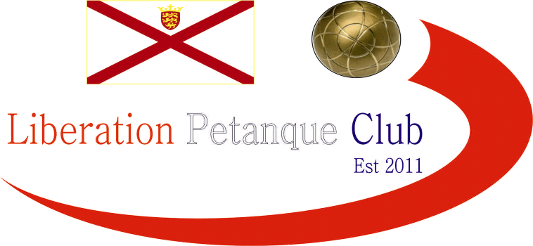

**SUMMER 2025 SEASON**

**WEEK 18 – 30th July 2025**

**DOUBLES LEAGUE**

# Wow, huge wins for James & Geoffroy over Alan & Joey also handing out a 13 – 0 certificate, but they were not the only ones as Jean & Laurent hand out one to Graeme & Keith with their second win in a row.

# League leaders Andrew & Callum dropped points against Gary & Wendy.

# Two draws in Division 1 as Garry & Sue took points off Keith & Mo whilst a 13 – 12 defeat in game one meant Colin & Jim could only get a draw against Alex & Dawn.

# NEXT WEEK - SINGLES LEAGUE

# Club email address - [liberationpc@gmail.com](mailto:liberationpc@gmail.com)

# Club Website - [www.liberationpetanque.co.uk](http://www.liberationpetanque.co.uk)

# Kind Regards

# Toby Northern

# Chairman - Liberation Petanque Club