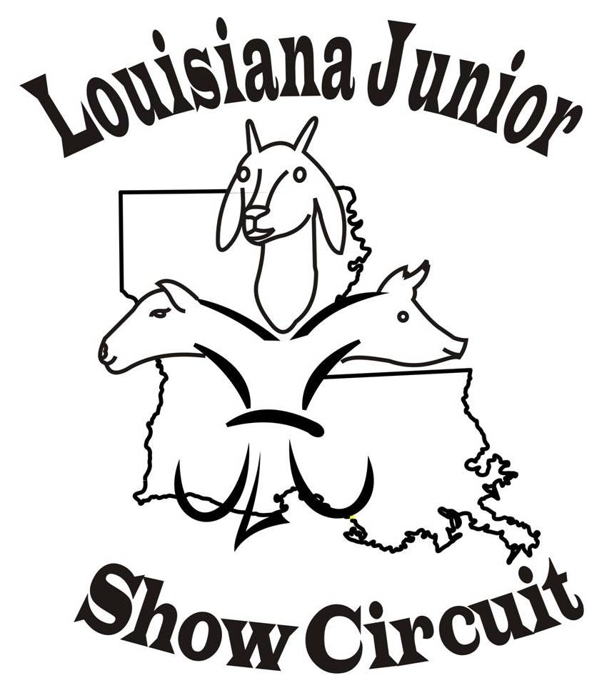
2021 LJSC SHOW Schedule
June 25th & 26th Watermelon Festival, DeRidder, LA
Beauregard Fairgrounds 506 West Drive
July 2nd & 3rd Holiday NO SHOW
July 9th & 10th Red River Showdown, Coushatta, LA
Red River Fairgrounds 718 Fairgrounds Rd.
July 16th & 17th Claiborne Classic, Haynesville, LA

July 23rd & 24th Bayou Blitz. Grand Cane, LA
David B Means Memorial 4-H Center, 10117 US-171
July 30th & 31st Black & Gold Showdown, Winnfield, LA
Winn Fairgrounds, Fairgrounds Rd
August 6th & 7th Cane River Classic, Coushatta, LA
Red River Fairgrounds, 718 Fairgrounds Rd
August 13th & 14th Last Chance Show Off, Winnfield, LA
Winn Fairgrounds, Fairgrounds Rd
August 20th & 21st Gulf Coast Classic, Jennings, LA

Website (www.louisianajuniorshowcircuit.org.) and Facebook Louisiana Junior Show
Circuit (page and group) for updates. If interested in hosted a sanctioned show
please contact Nancy Nettles.
LJSC Contact Information
For Comments or questions concerning Louisiana Junior Show Circuit (LJSC) ~~~ Contacts:
Nancy Nettles - President Stephanie Chamberlin Secretary
(318) 455-2905
Email Membynancy1@aol.com
Lauribeth Padgett - Vice-President Judy Latiolais – Treasurer
Board Members: Dana Broussard, Guy Sanders, Josh Johnson,
Jennifer Winslett, and Melinda Miles

