SPRING CREEK INDEPENDENCE DAY PARADE JULY 4, 2019
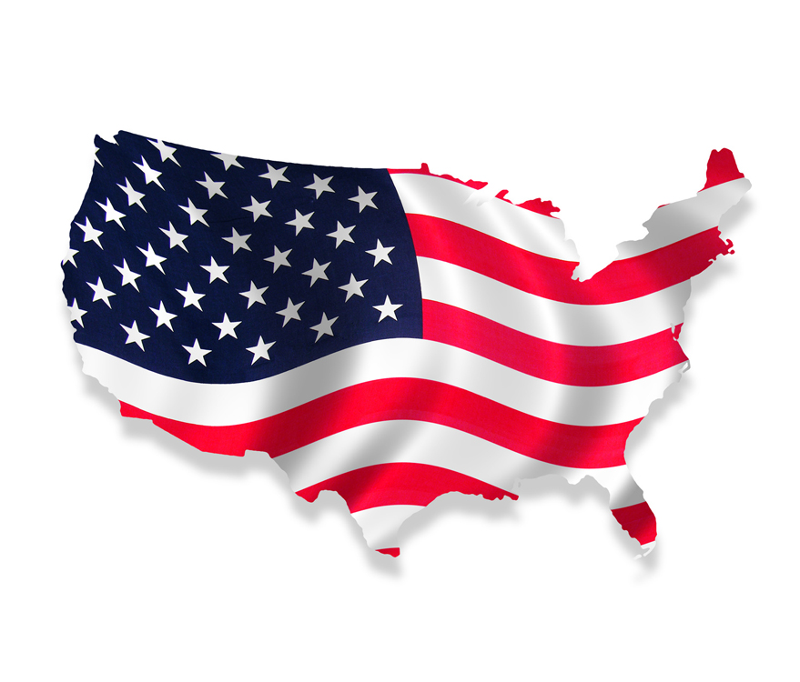

The Spring Creek Independence Day Parade Committee would like to invite you to participate in this year’s Spring Creek Independence Day Parade, and help us celebrate our nation's Independence Day, inspire patriotism, and unite our community by producing a truly patriotic and entertaining parade.

This year’s theme is “Let Freedom Ring.” The parade will be on Thursday, July 4th at 10:00 a.m. on the Spring Creek Parkway between Glenvista and Country Club Drive (due to construction on Parkchester Dr.).

If you are interested in participating, please read the following, and send in an entry form. Entries will be judged and cash awards will be given in each category for 1st, 2nd and 3rd places. Entries should meet the following criteria:

Rules and Guidelines

- Floats must be decorated with parade theme in mind.
- No negative advertisements or negative political campaigning.
- Continual forward motion at about 2 miles per hour must be kept unless otherwise directed by the parade officials. Keep a reasonable distance between you and the participants in front of you.
- All vehicles must be operated in a safe manner.
- Participants may not exit their float or vehicle while the parade is in motion, in addition, no one is allowed to ride or stand on running boards or ride on fenders or hoods of cars or trucks.
- Any participants ages 12 and younger must be accompanied by an adult.
- All entries should be family appropriate.
- Candy or treats are encouraged.

All parade entries are subject to approval by the Parade Committee. The types of entries that will be considered for the parade are:

- Marching Bands
- Floats
- Drill and Dance Teams
- Clowns
- Antique and Specialty Cars
- Equestrian Teams and Horse Drawn Carriages
- Other teams or groups

Equestrian Teams or Carriages must have control of their animals at all times. Equestrian riders must be at least 10 years old, and if under 14, be accompanied by an experienced adult. Children 5 and older may ride if led by a walking adult. Any animal deemed unsafe in the parade will be removed.

Please have entries turned into the Association by June 28, 2019. The entry application form must be completed and signed with the understanding of the general rules and guidelines. Due to space limitations and guidelines, all entries submitted may not be accepted. All applicants will receive a letter of acceptance or decline. The general rules and guidelines listed are for the safety and quality of the parade. Failure to abide by these rules and guidelines may result in the unit’s removal from the parade and jeopardize future invitations. The Spring Creek Parade Committee and Association will not be responsible for any injuries incurred due to negligence or poor judgments.

We are excited to celebrate Independence Day with you and our community. We are hopeful of many participants and the annual success of the Spring Creek Independence Day Parade. If you have any questions you can e-mail them to Jackie Allred frontdesk@springcreeknv.org or call 775-753-6295.

Mail or e-mail the completed entry form to:

Jackie Allred
Spring Creek Independence Day Parade
401 Fairway Blvd
Spring Creek, NV 89815
frontdesk@springcreeknv.org
“Let Freedom Ring”
2019 Spring Creek Independence Day Parade
Entry Application Form

Organization | Name: ______________________________________________________
Contact Information | Person:______________________________________________________  Address:_____________________________________________________  _____________________________________________________________  Phone #: __________________________________________  E-mail address: _______________________________________________
Entry Type  Please circle one. | *Marching Musical Unit  *Floats  *Equestrian Group  *Antique/Specialty Vehicles  *Drill and Dance Teams  *Clowns  *Other Groups
Number of Entry Participants | Total Number of Members: ________________
Antique/Specialty Vehicles | Make and model of car: _______________________________________
Floats | Float length including tow vehicle: _____________________________
Please write a little bit about your group that you would like to have announced during the Parade.

I understand and will comply with the parade rules and guidelines. I agree that the Spring Creek Parade Committee and Association are released from any and all responsibility for loss, damage, or injury to any person or property in any way relating to participation in the parade.

Signature: ______________________________________________________ Date:_____________________

Mail or e-mail a copy to: Jackie Allred
Spring Creek Independence Day Parade
401 Fairway Blvd, Spring Creek, NV 89815
frontdesk@springcreeknv.org

