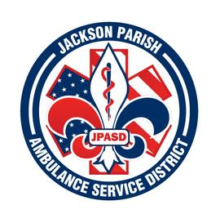

**Jackson Parish Ambulance Service District**

**115 Watts Street**

**Jonesboro, LA 71251**

**Office: (318)-259-2877 Fax: (318)-259-2099**

**jacksonparishambulance@jpasd.com**

**Aaron K. Johnson, Jr. Paula Parkerson,MD**

**EMS Director Medical Director**

**Governing Board: Joe Vail, Allen Lindsay, Alma Williams, Conchita Doyle, Deidre Hollis**

Meeting Minutes for Regular Scheduled Board Meeting: Thursday, September 14, 2023 @ 12:00 noon

Present: Allen Lindsay, Joe Vail, Deidre Hollis, Conchita Doyle, Amber Swanner, Michelle Bartlett, Aaron Johnson, and Jeff Carpenter

Absent: Alma Williams

Guests:None

Meeting was called to order by Allen Lindsay. Roll call by Aaron Johnson: Present: Allen Lindsay, Deidre Hollis, Conchita Doyle, and Joe Vail. Absent Alma Williams. Guest present: None. No comments. Invocation led by Conchita Doyle. Pledge of Allegiance led by Joe Vail. Motion made by Conchita Doyle and seconded by Deidre Hollis to accept Meeting Minutes for August 2023. All in favor motion carried. Motion made by Joe Vail and seconded by Conchita Doyle to approve and accept the financials and pay bills for August 2023. All in favor motion carried. Director’s report given by Aaron Johnson. Director’s report includes maintenance report, September schedule, Safety training, Grant awarded, EMT class, CPR class, Fire surge response, Hurricane Idalia Response, State Inspection, Opioid training. Motion made by Deidre Hollis and seconded by Joe Vail to accept the Director’s report. All in favor motion carried. No Old Business. New Business. A. Request to bid for new ambulance. Motion made by Joe Vail and seconded by Conchita Doyle. All in favor motion carried. Motion made by Joe Vail and seconded by Deidre Hollis to adjourn meeting. All in favor motion carried.

Next Regular Board Meeting will be held:

Thursday, October 12, 2023 @ 12:00 noon

Thursday, November 9, 2023 @ 12:00 noon Aaron Johnson /Secretary-Treasurer

@ JPASD – 115 Watts Street – Jonesboro, LA Unofficial Minutes