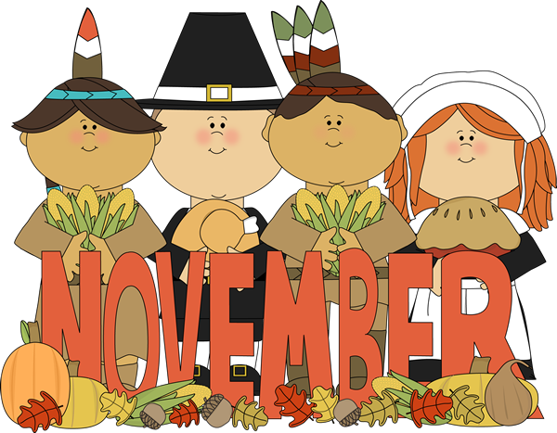
The Smile

Happy Face Nursery School • (908) 832-7510
smile@happyfacenurseryschool.org

November 2024

Volume 21, Issue 3

Letter from the Director
Elizabeth Denis

Dear Parents,

We had so much fun at Happy Face during the month of October! We had a visit from the Califon Volunteer Fire Dept. during Fire Prevention month. We also had a visit from Emmie’s dad who is a nurse at Morristown Memorial Hospital. The children learned how people from our community help us every day!

During the month of November much of our curriculum is centered on Thanksgiving and the things we are thankful for in our lives.

Along with the "thankful" theme, the 4's will concentrate on the Five Senses and Nutrition.

The 4’s will have their own Thanksgiving Feast at school on Monday, November 25th. The children will help plan the menu and prepare food.
The shape for the 3's in November is the SQUARE and the color is GRAY. In order to enhance what your child learns in school, please take the time to point out objects at home shaped like squares and colored gray.
The 2.5’s will learn the nursery rhymes Peas Porridge Hot, Here We Go Round the Mulberry Bush and Do You Know the Muffin Man.

School will be closed Thursday and Friday, 11/7 and 11/8 for Teachers Convention and Wednesday, Thursday and Friday, 11/27, 11/28 and 11/29 for our Thanksgiving break.

This is a busy time of year for all of us. Be sure to appreciate the time you have at home with your little ones. They grow up so quickly!

The Happy Face staff wishes you and your families a very healthy and happy Thanksgiving.

Keep Smiling,
Elizabeth

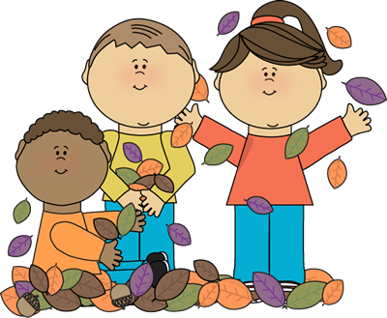
Teaching Staff
Director
Elizabeth Denis
Teachers
E. Denis
D. Mayberry
D. McDede
M. Schafer
Teaching Assistants
D. Mayberry
J. McCloskey
Administrative Assistant
J. McCloskey

Board of Trustees
President
Brynna McGinnis
Director
Elizabeth Denis
Vice President
Nicole Lang
Secretary
Public Relations
Jessica Keyes
Room Mom Coordinator
Whitney Wilding
Members At Large
Scholastic Book Club
J. McCloskey

Board Notes

Updates from the Board of Trustees
Meeting was held on October 10, 2024

Board meetings are typically held the 1st Thursday of the month in the Happy Face Nursery School Conference Room @ 7pm

All are Welcome!

Meeting Notes:
- Budget
- 50th Anniversary fun run
- Discussed Halloween party – set up Sign-Up Genius
- Fundraising:
  - Craft Kits
  - Shoprite Gift Cards
  - Dessert Club
  - Clothing Drive

- A very special thank you to the parents that made the Halloween party and parade so festive and special for our little ones!

Elizabeth Denis
908-399-5310
ehsica@yahoo.com
Brynna McGinnis
908-310-3911
brynna.cunningham@gmail.com
Nicole Lang
973-307-4337
nicolegentilelang@gmail.com
Jessica Keyes
732-703-0342
jessicamkeyes1@gmail.com
Whitney Wilding
435-962-0484
whitneywilding3@gmail.com

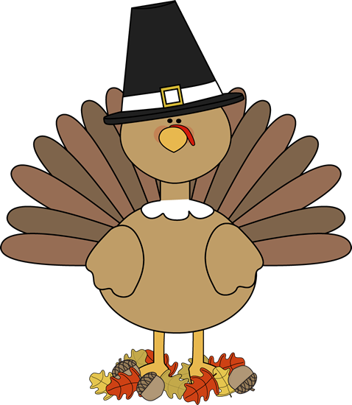
Page 2 of 6

The next meeting will be held on Thursday, November 21st in the Happy Face Conference Room at 7pm.

News

Thanksgiving Feast

On Monday, November 25th, the 4s will enhance their ongoing discussions of Thanksgiving with an in-school Thanksgiving Day feast.
During the celebration, students will enjoy turkey (a.k.a. chicken), potatoes, vegetables, cranberry sauce (a.k.a. jello), and ice cream. Please encourage children to try new foods at the school feast and at home. Thanksgiving is a harvest festival and traditionally a time to give thanks and express gratitude for the harvest and our many gifts. The first Thanksgiving dates back to 1621 at the English Colonial settlement of Plymouth Plantation in Massachusetts.

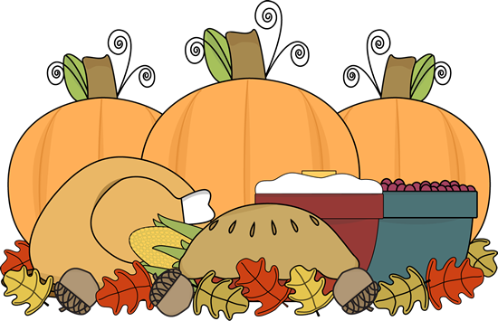

* Inclement Weather *

In case of inclement weather, we base our school delays and closings on the Lebanon Twp. School System. In the event of a delayed opening, Happy Face will open from 10:45 AM – 12:30 PM with lunch bunch pick up at 1 PM, enrichment programs will continue as scheduled. If there is an early dismissal all afternoon programs including lunch bunch will be cancelled. Don’t worry if you’re not connected with the LT School system yet. The Room Parents phone/text chain will contact you any time there is a schedule change. Information will also be eBlasted out and posted on our FaceBook page.



Page 3 of 6

Fundraising &
Community
Page 4 of 6

SHOPRITE GIFTCARDS

Do you shop at Shoprite?
Why not purchase giftcards to shop with from Happy Face?

November orders due by Friday, November 15th




Each month you can log onto Scholastics.com and place an order. The first time you will have to follow the steps to create an account. Our Class Code is HLWJV. With each book order, Happy Face receives free books and learning materials. The more book orders, the more free stuff for our school! For every $1 in orders Happy Face receives 1 point to redeem towards merchandise. For more information or help, please contact Mrs. M.
.

Scholastic Book Club
Dessert of the Month

Holiday pie orders will be distributed on Monday, November 25th and Tuesday, November 26th. Thank you to all who placed an order!

Notices

November Events & School Closing

Thursday & Friday, November 7th & 8th – School Closed, NJEA Conference
Monday, November 25th – Thanksgiving Feast (4s)
Wed. - Fri., November 27th - 29th – School Closed for Thanksgiving

Show & Tell

Show & Tell is a fun and very important activity that promotes language development, self-esteem and creativity. Each student presents their item to the class and provides a brief description or story about the item. The date and theme of each show & tell appear on the monthly calendar in the handbook.

3s (bring in object) 4s (bring in picture of something that starts with letter)
Tues., 11/5: Something Smelly Mon. 11/4: Letter I
Tues., 11/12: Something Square Mon., 11/11: Letter J
Tues., 11/19: Something Thankful for Mon., 11/18: Letter K
Tues., 11/26: Something Holiday Mon., 11/25 No Show & Tell

November’s Show & Tell Schedule:

Page 5 of 6

***ALL STUDENTS WILL NEED A FLU VACCINE BY DECEMBER 31ST OR WILL NOT BE PERMITTED TO RETURN TO SCHOOL IN JANUARY!!! ***

Review & Events

November in Review

Children will spend this month reading literature and investigating several themes and topics including:

The 2.5s will be studying:
- Nursery Rhymes
  - Muffin Man
  - Peas Porridge Hot
  - Mulberry Bush

The 3s will be studying:
- Color-GRAY
- Shape-SQUARE
- Thanksgiving

The 4s will be studying:
- Thanksgiving
- Being “Thankful”
- The Five Senses
- Nutrition

The author of the month for the 4s is:
- Eric Carle, author of The Very Hungry Caterpillar and The Grouchy Ladybug.

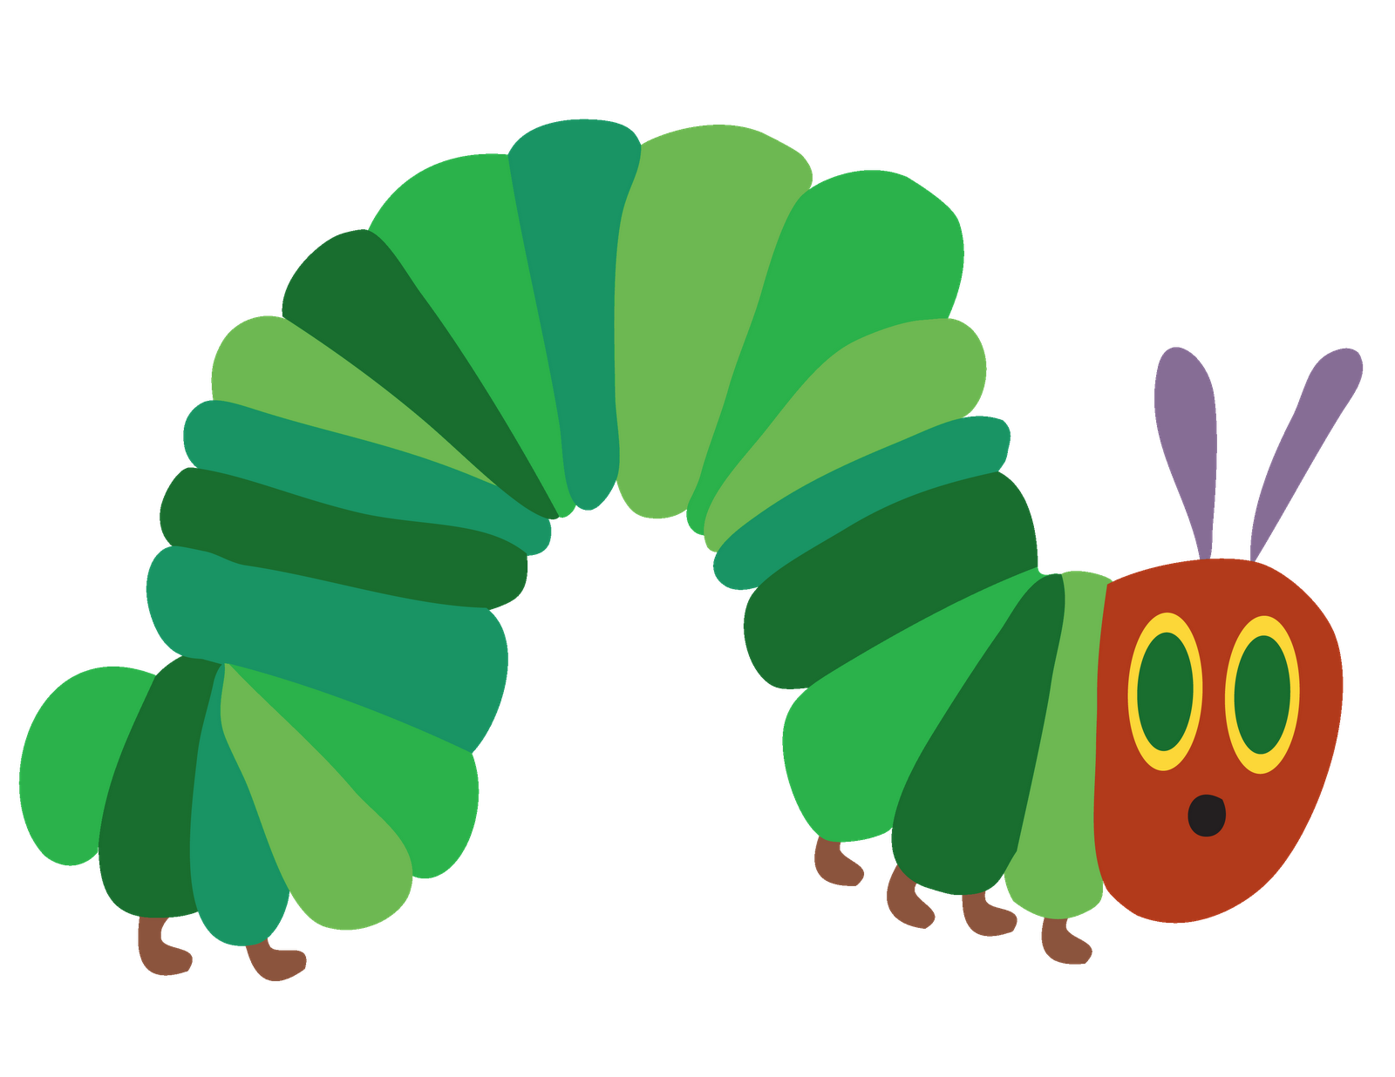

Page 6 of 6

Happy Face Nursery School does not expressly or implicitly warrant or endorse the goods or services provided by the advertisers appearing in the newsletter. Use at your own discretion.

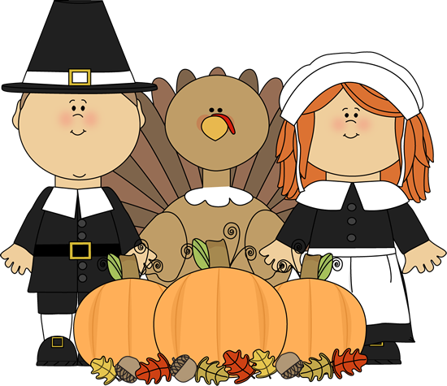
Happy Face Nursery School
would like to wish
you and your family a
Happy Thanksgiving!

