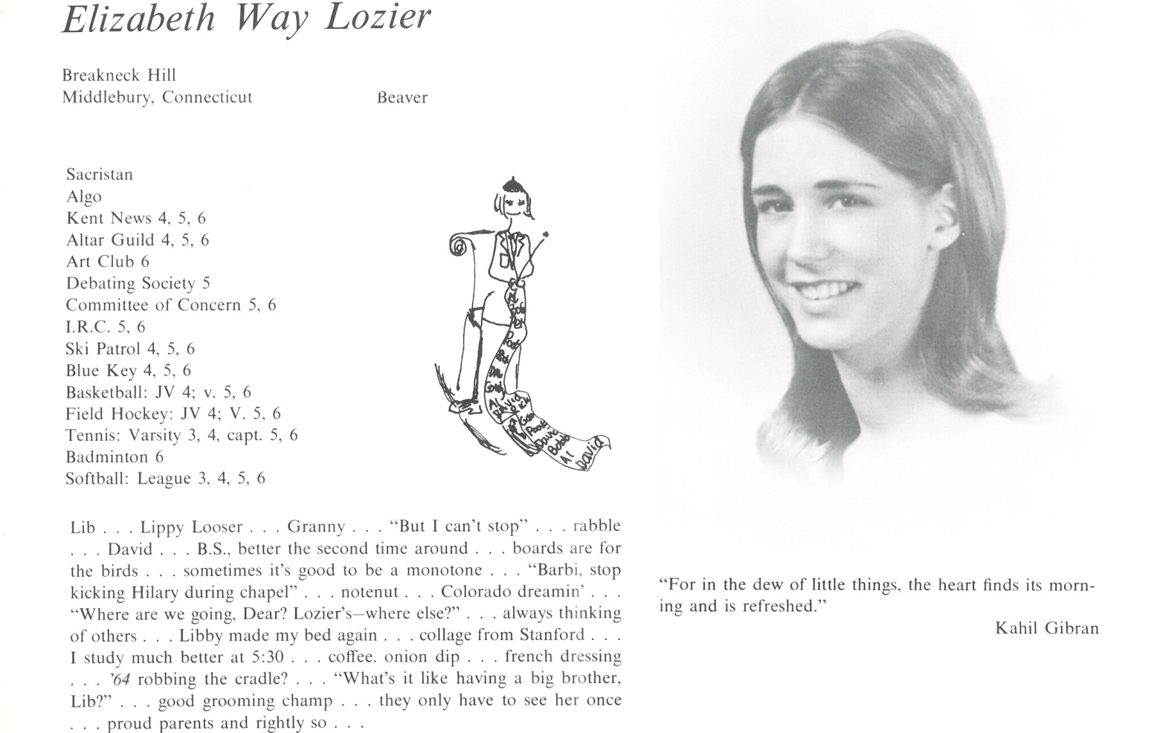

Elizabeth W. Lozier Chapin

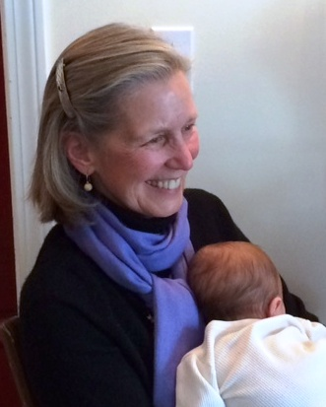After 29 years living in Connecticut, where we raised our three children, my husband and I moved to Vermont. In 2003, John opened the Canoe Club restaurant in Hanover, NH, just over the VT border. We have happily settled into the Upper Valley of the CT River, living on a beautiful lake in part of an old boys' summer camp. I have retired from teaching the hearing impaired, which I did for 25 years. For the past decade, I have continued my educational focus, mostly environmental outreach, at the local and occasionally state level.

Life is full and rich up here, and I smile at the many ways I seem to keep growing -- especially the opportunities I have to expand my knowledge and involvement in the natural world. So many of my friends up here have some expertise to share on our year-round outdoor adventures, and I get to be the eager student! That's been very gratifying, as has the chance to be within striking distance of at least two of our three children.

Our daughters Dana (36) and Lucy (34) both have their own wonderful families (3 grandchildren for us!) and live close enough for regular visits. Dana works in Admissions and as Head Lacrosse coach at Berkshire School (quite an amazing place these days!) and Lucy is a nurse-midwife and singer-songwriter who lives in the Mad River Valley of Vermont. Lucy's twin brother, Seth, is passionate about his own organic, field-grown flower business in Napa, CA (evermoreflowers.com) which he launched about 2 years ago. It's a lift to see them living lives that are such good fits.

John and I are hoping to find a path to a comfortable end game, but that appears to be quite elusive at the moment. We're confident we'll get there, just not as soon as so many of our friends.

I am very much looking forward to catching up with old classmates and revisiting some of the places and memories from a half-century ago - whoa! How did that happen?



______________________________________________________________

______________________________________________________________ ______________________________________________________________ ______________________________________________________________ ______________________________________________________________ ______________________________________________________________ ______________________________________________________________ ______________________________________________________________ ______________________________________________________________

Attach Picture in .jpg Format

______________________________________________________________

______________________________________________________________

___________________________________________________________________________________ _________________________________________________________________________________________________________________________________________________________________________________________________________________________________________________________________________________________________________________________________________________________________________________________________________________________________________________________________________________________________________________________________________________________________________________________________________________________________________________________________________________________________________________________________________________________________________________________________________________________________________________________________________________________________________________________________________________________________________________________________________________________________________________________________________________________________________________________________________________________________________________________________________________________________________________________________________________________________________________________________________________________________________________________________________________________________________________________________________________________________________________________________________________________________________________________________________________________________________