Jasper Economic Development INC.
618.783.3409
Box 165, Newton, IL. 62448
jaspercountyjedi@gmail.com www.jaspercountyillinois.org
“A community that strives together, thrives together.”

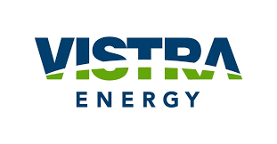
VISTRA ENERGY: NEWTON POWER PLANT
PANDEMIC RELIEF GRANT APPLICATION

INFORMATION: Vistra Energy: Newton Power Plant is providing pandemic relief grants to Jasper County, Illinois businesses. Limited $1,500 grants will be available. Must be a business located in Jasper County, Illinois. Must currently be in business. Only one entry per business. Any grant awarded must be used towards the business. Deadline for application entries is August 31st, 2020 by 5pm. Completed applications can be mailed to: Box 165, Newton, IL. 62448, emailed to: jaspercountyjedi@gmail.com, dropped off at the City Hall’s drop box located at 108 N. Van Buren St. #A, Newton, IL. 62448, or to the County Clerk at the Jasper County Government building located 204 W. Washington St. Newton, IL. 62448
- NAME OF BUSINESS:

- ADDRESS OF BUSINESS:
STREET CITY ZIP STATE

- EMPLOYER IDENTIFICATION NUMBER (EIN):

- CONTACT PERSON:

- TELEPHONE #:

- EMAIL:

- USE THE SPACE BELOW AND FOLLOWING PAGE OR ATTACH DOCUMENT TO APPLICATION DESCRIBING YOUR BUSINSESS AND EXPLAINING HOW THE COVID-19 PANDEMIC HAS/IS AFFECTING YOUR BUSINESS.

