ARLINGTON MILL SENIOR CENTER
Presents
THE EATON WOMAN
By ANTHONY ERNEST GALLO
Wednesday, February 13, 2019, 8:00 PM
909 S Dinwiddie St Arlington, VA 22204

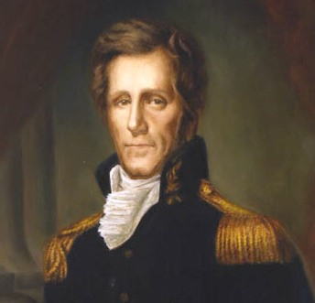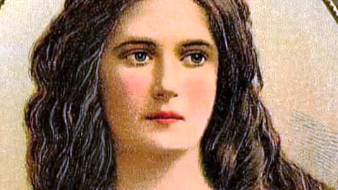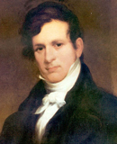

The Eaton Woman is not well suited for people who hate gossip. But the play dispels any notion that Washington was once a kinder, gentler city.

This historically based two act dramedy by Anthony E. Gallo(’93) is all about morals, adultery, lies, deception, women’s roles in Washington Society, the quasi downfall of the Jackson Administration, and the most beautiful woman in Washington history. Others say the most immoral and abrasive. All agree on one thing. She and her husband, the US Secretary of the Army, Jackson biographer, and Tennessee Senator (elected at age 28) created more controversy than any other power couple in Power Washington’s political history.

Andrew Jackson defeated the British in New Orleans and the Adams family of Massachusetts, vanquished Native American Indians, was involved in at least twelve duels, and was a loved and respected hero of the American people. But how was he to handle the Petticoat Rebellion brought on by the Cabinet wives who objected to the de facto first lady and boycotted the White House? But it was a matter of honor. Beloved Rachel Jackson died shortly following her husband’s election to the presidency of the United, killed by hurtful attacks on her morality. The seventh President therefore would defend his Margaret O’ Neal Timberlake Eaton.

Through 79 years she goes through three husbands raises more eyebrows when she marries in her late fifties, and spends her last days reminiscing and defending her morality. Was she responsible for Marin van Buren’s ascendancy to the presidency? And how about John Calhoun?

CAST
Margaret Eaton Kacie Greenwood
Andrew Jackson Samuel A. Simon
John Eaton James McDaniel
Rachel Jackson, Deborah Ingham Kathleen Reilly
John Campbell, John Berrien Steve Rosenthal
Ezra Ely George Spencer
Floride Calhoun Margaret Bagley
John Calhoun Bob Cohen
Emily Donelson. Kathleen Reilly
Mabel Jones Beatrix Whitehall
Martin Van Buren Grant Bagley
Antonio, Jones, Willie, John Branch Miles Benson
Elizabeth Branch Kathleen Reilly
Eliza Berrien Beatrix Whitehall
Narrator Reilly, Rosenthal, Whitehall
Sound Designer Beatrix Whitehall
Ensemble Entire Cast

Questions and Reservations : Nicholas Englund nenglund@arlingtonva.us 703-228 7320 Anthony Gallo agallo2368@verizon.net 202-54 6973 No charge or donation /Free indoor Parking

