3/25/2016 The Warning

On 3/21 and 3/22/2016 there were two comets that flew unusually close to earth. One of the comets, P/2016 BA14 (Pan STARRS), was the closest comet to approach the earth since the year 1770.

Those comets were associated with President Obama's trip to Israel exactly 3 years earlier, and helped to complete the following graphic:
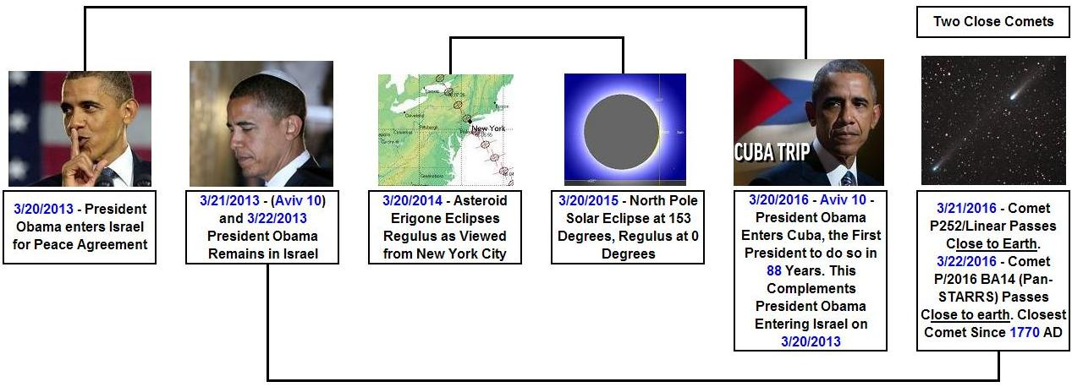

The current scientific reasoning as to why these two comets would both arrive very near the earth within a day of each other is that they may have originally been a single comet that split into two pieces. Out in frictionless space, when one object separates from another, each one is deflected away from the other. Neither object would follow the same exact path as the original single object.

Here's a graphic that illustrates the paths of the two comets that came close to earth on 3/21 and 3/22/2016.

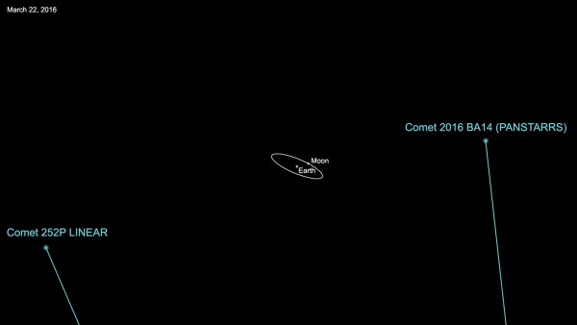
Image Courtesy NASA JPL - CalTech

The two comets and the earth-moon system are displayed in the image above. The current theory is that two comets may have split from a single larger comet, pushing against each other as they split.

If the original comet had not split at some time in the past, its trajectory may have originally had the earth-moon system more closely in its boresight.

The Warning

These two comets arriving at the time they did may have been a "shot across the bow", a warning, from our Creator, YaHuWaH Elohim.

The reason for the warning is supplied in the original timeline graphic far above, and also in the graphic below.

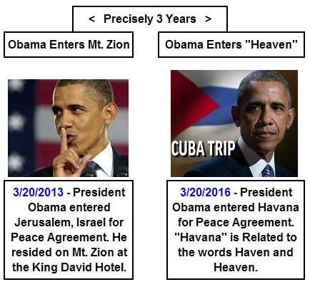

On 3/20/2013 President Obama entered Jerusalem, staying at the King David Hotel on Mt. Zion.

Mt Zion is the mount of the "congregation" mentioned in Isaiah 14. The phrase "mount of the congregation" in Hebrew actually means the "mount of appointment" or "appointed mountain". It is YaHuWaH Elohim's special appointed place where He will sit on His throne to judge the nations.

Isaiah 14 also tells us that Lucifer wants to sit on that particular appointed mountain that is special to YaHuWaH Elohim.

Isaiah 14:12 How art thou fallen from heaven, O Lucifer, son of the morning! how art thou cut down to the ground, which didst weaken the nations!
13 For thou hast said in thine heart, I will ascend into heaven, I will exalt my throne above the stars of Elohim: I will sit also upon the mount of the congregation, in the sides of the north:
14 I will ascend above the heights of the clouds; I will be like the most High.
15 Yet thou shalt be brought down to hell, to the sides of the pit.

On 3/20/2016 President Obama entered Havana, Cuba, on a mission of peace and reconciliation. The name "Havana" is closely related to the English names Haven and Heaven. President Obama entering Havana may be spiritually symbolic of Lucifer himself entering heaven.

The events of 3/20/2013 and 3/20/2016 may be symbolic of Lucifer entering Mt. Zion in 2013 and also Heaven in 2016.

YaHuWaH Elohim was attacked by a close angelic being at some point in eternity. Mt. Zion on earth is symbolic of the throne of YaHuWaH Elohim in heaven. The cherub that attacked YaHuWaH was thrown to the earth like a bolt of lightning.

Events happening on the earth and surrounding universe may be material representations of an invisible greater reality around us that we call "heaven".

Luke 10:17 And the seventy returned again with joy, saying, Lord, even the devils are subject unto us through thy name.
18 And He said unto them, I beheld Satan as lightning fall from heaven.
19 Behold, I give unto you power to tread on serpents and scorpions, and over all the power of the enemy: and nothing shall by any means hurt you.
20 Notwithstanding in this rejoice not, that the spirits are subject unto you; but rather rejoice, because your names are written in heaven.

Remember that Pope Benedict announced his resignation on 2/11/2013. That very evening a bolt of lightning struck the Vatican.

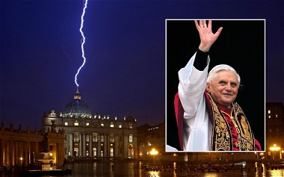
Pope Benedict resigns and lightning strikes the Vatican.

On 3/13/2013 Pope Francis became the first Jesuit Communist in history to become Pope.

The Jesuits are a secretive military order of Roman Catholicism involved in assassinations and covert political plots in order to eventually rule the earth in the place of YAHUSHUA Messiah.
Exactly 7 days after Pope Francis took office, President Obama entered Mt.Zion on 3/20/2013 to secretly secure a peace agreement.

