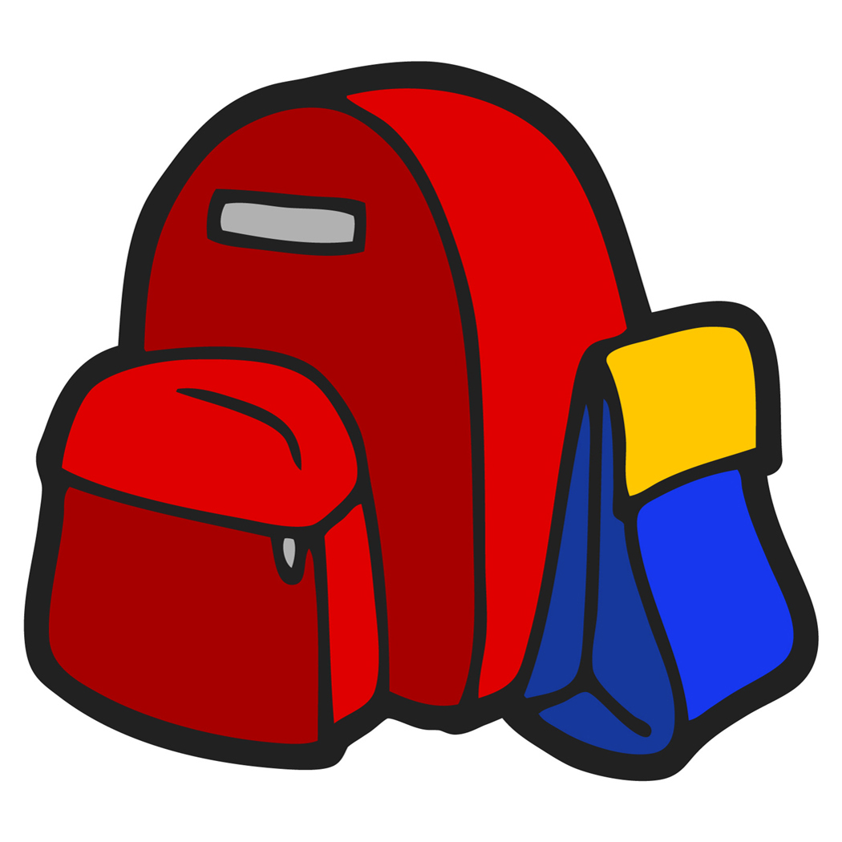
Pre-K Supply List
Please bring these items to school daily:
- A backpack (large enough for child to fit a folder and lunchbox independently.)
- A lunchbox, labeled
- One folder, labeled
- 2 masks
- 1 water bottle, filled and labeled
We would ask that the following items be brought in on the Pre-K meet and greet day in a shopping bag:
- One folder to keep in school, labeled
- Rest/Nap Mat (samples shown, not a sleeping bag, all items attached)
- 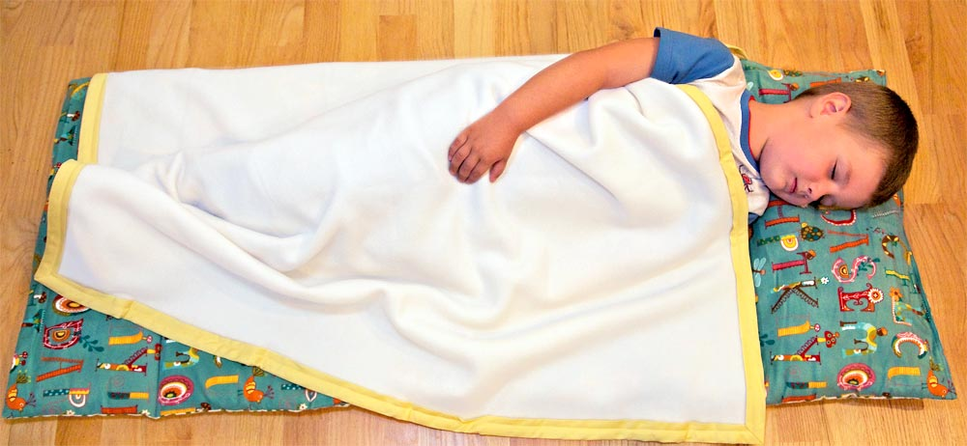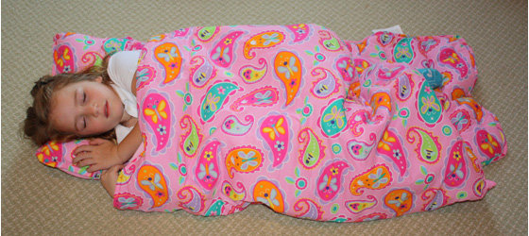
- A change of clothes-underwear, socks, pants and shirt in a labeled Ziploc bag (to be kept in the classroom)
- 1 container of sanitizing wipes (if you can find them)
- 4 large glue sticks
- 1 box of regular crayons, not “chubby”
- 1 box of Ziploc storage bags (any size)
- 2 boxes of tissues


