Medical Reserve Corps
Well Check Program

A FREE service to
Improve Your Health
Reduce Hospital Visits
Improve Quality of Life
MRC Well Check Teams consist of medical professionals and compassionate volunteers whose experience in coordinating support and resources can improve your health and well being. By signing up for our Well Check Program we can work together to reduce hospital visits, medical costs, and assist you in improving your life.
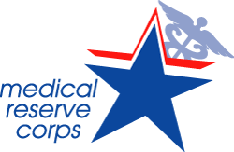
All MRC volunteers are HIPPA compliant,
Passed a CORI and SORI background check,
and ensure that all personal info is safe and secure.

Sign Up Here: http://www.mrcvolunteer.org/well-check-program.html
Liisa Jackson Medical Reserve Corps Coordinator
LiisaJackson@mrcvolunteer.org

