WAG A TAIL PAWSITTING
DOG WALKING PROFILE
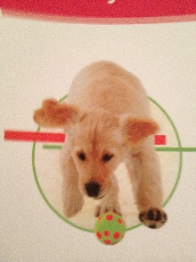

Dog’s Name:________________ Age: ________ Male/Female
Spayed/Neutered Breed: _________________ Markings:__________________
Is your dog micro-chipped? Yes No Chip #:_________________________
Is your dog licensed with the town? Yes No License number:___________________

When you walk your dog, if he sees another dog does he:
___ Ignore the other dog ___ Show some interest but keeps walking
___ Wag his tail in a playful manner and wants to play ___ Growl/Sneer
___ Pull hard on the leash in an attempt to get to the other dog

When you walk your dog, if he sees a cat or other small animal, does he:
___ Ignore the animal ___ Show some interest but keeps walking
___ Wag his tail in a playful manner and wants to play ___ Growl/Sneer
___ Pull hard on the leash in an attempt to get to the other animal

Commands your dog knows: (Please circle)
Sit Eyes Down Stay Come Heel Let’s Go Off Paw
Speak Quiet Lay Down Roll Over Fetch Leave it
Other:_____________________________________________________________

Do you wish for us to walk your dog off-leash? Yes No
If yes, under what circumstances:___________________________________________
__________________________________________________________________
Is there anything in particular we should be aware of when walking your dog (i.e., behavioral or health issues)? _______________________________________________________
__________________________________________________________________
__________________________________________________________________
Where do you keep your dog walking items (leash, waste bags, etc.)? ___________________
__________________________________________________________________

_________________________________________________________________
Client Signature Date

