Vision By Neil Hull NSCAA National Staff

After recently presenting 1v1-3v3 Transitions Games for the NSCAA on their new E learning platform, I received a call from an old adversary, who listened to it online. Jim Bruno (of Maryland fame!), whom now has been a good friend for many years, quizzed me on some thoughts about player’s vision, and how we could facilitate or improve its implementation in the youth game. Here, the end result being a joint article to share and/or stimulate other coaches thoughts on the same topic.

If vision with out action is hallucination, what is action without vision? How many times do we see our players’ just kick the ball, instead of passing it? A blind kick creates little, or no intended end product. Where as, a visualized pass surly denotes an opportunity of success. Either through a goal, a positive attempt to maintain possession, penetration or using the ball to draw play through onside and offside space. Maybe that’s why it’s called a ‘Goal Kick’; the keeper has little, or no control over its end product. But when a team, or player, passes it out the back, the ability to see the conceptual connection between ball and player offers a product the team can develop from.
Continually watching players and coaching teams, often, I become a witness to a perceived lack of vision. In particular on the field where, when applied, a player’s technical eyesight can lead to a team’s tactical foresight.
How can we lift our heads from the grass roots and improve our use of vision on the field? Firstly, where does vision stand when we look through the four, or so, pillars of play? Is it technical, tactical, physical or psychological? I believe, yes! It can be the adhesive in them all.
A limited example:
- Technically we have to be able to see, or know where the ball is throughout the whole game, in advance read our touch, personal space, angles and pressure.
- Tactically understanding the vision offered by shapes, support and movement on and off the ball, interpret actions and visual clues, to make correct decisions.
- Physically, being able to read, anticipate and understand the timing of 1st 2nd and 3rd man runs in the attack and for the defense.
- Psychologically, being able to play purposefully in a ‘heads up’ environment. Reading body language of both players and officials. Knowing where to pass or place the ball, before even receiving it!

Where does this all start? Well the beginning is a good place!
When planning the simplest or more advanced games challenge your self, with the incorporation of vision. How do we plan with vision? Using colors, targets and facilitating their use exactly in a ‘heads up’ environment.
Why just play with two teams, this only offers one successful visual passing color option, why not attempt three teams in possession or four colors in a game. Color pattern passing activities at younger ages like ‘Fly the Flag’: Red passes to white, who passes to blue and then back to red (below).

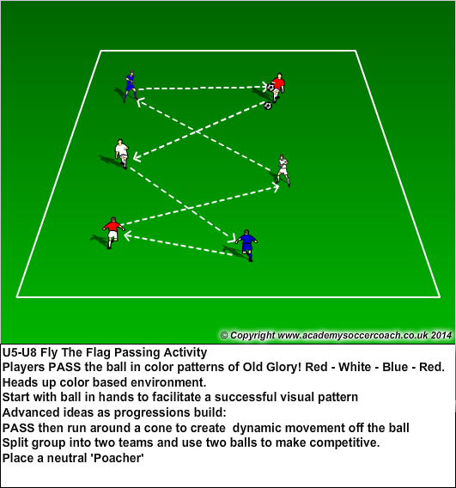

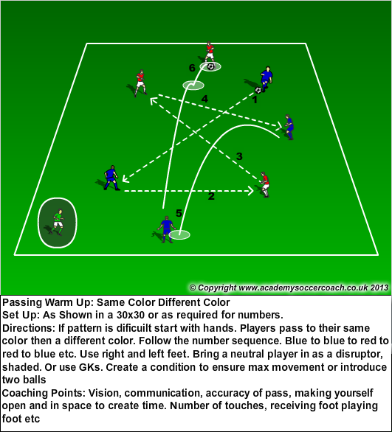

‘Same Color Different Color’ can be a fine example of creating a ‘heads up environment’ at younger ages. Here players have to cognitively look for a color to pass to. The dynamic continually changes through movement and challenges. Why not add a second ball to support speed of play and speed of vision / decision. To support more dynamic movement of colors add a ‘joker’. Rather than have them try to ‘steal’ the ball and have the session technically break down, have them just touch the player in possession to transfer the joker role / responsibility.

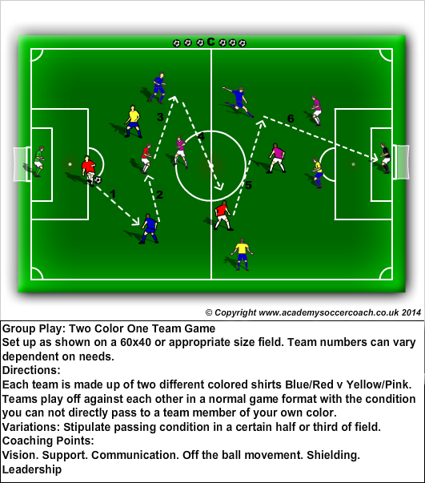

As with all games, through facilitation, they can be expanded to a very technical level, as cognitive maturity and understanding develops. In the ‘Two Color One Team’ game, it offers the same basic thoughts as previously mentioned, but incorporates more players. Now, vision does not only enforce possession, but creates visual games with in the game. Attacking solutions, derived from defensive containment, are created through high performance vision and team mobility off the ball.

Lionel Messi explains: He does not see more than other players; he just has more solutions to what he sees. (paraphrased).
Watch Frank Lampard, when he does not have the ball, continually processing visual information, right side and left. Then when he receives playing both feet, right and then left. (https://www.youtube.com/watch?v=F51WNjZuWzU )

Creating clarity through the use of visual targets, the ultimate one being the back of the net, but we can use many others to support a ‘heads up’ environment: Gates, goals, balls, hurdles, bibs, certain players etc. Almost an endless option if correctly planned and facilitated to support a hyper visual environment.

The commonality in successfully developing all these vision-building exercises is creating a ‘heads up environment’. Possibly, we are not looking for a ‘drill’ to teach vision, more of a supplemental training methodology, progressively implemented to stimulate the environment. Think on it? What can a coach offer to cognitively demonstrate the activity and enforce a concept? A clue, we functionally train one player from the team, using this style of methodology, the Goalkeeper!
My thoughts to create such an environment: Why not start activities with a version of handball? It supports eye contact, successful movement, less technical breakdowns, thus, creating positive player confidence. Try listening: The communication level also rises, as players start to look left and right, communicating while the ball’s in flight! Through the law of unintended circumstances players start to see with their ears and hear with their eyes.
In todays’ modern game, we use technology to monitor heart rates, distance covered etc, amongst a myriad of other factors. How can we use technology to advance a player’s factual, not perceived, visual options pre and post touch? How about a Gopro? Taking the role of an individual player, and placing a Gopro on their head you can see what they see, but more important they can see what they saw. Lets take a HM (6) and some of his/her roles:
- Are they looking for distribution/space/options prior to first touch?
- Can they see oncoming pinching pressure?
- Are visual thoughts and directions consistent to position or distracted and random?
- Once received, do their eyes remain in their feet, or are they playing out in a heads up fashion?
- Do they track the flight of the ball to intercept the touch?
- If they are right footed, is their % view to the right side option?
An unintended consequence, it records sound too! So we can ‘see’ direction and leadership. Player and coach are now in a connected first person environment. Malcolm Alison said ‘…if you only play with one foot, you will only see the field with one eye.’ Thus offering visually a lesser performance level, than a two-footed player.

When coaching coaches on how to transfer visual ideas to young players, whom are very concrete in their interpretation (Puget). I offer the metaphor of ‘crossing the road’. If, as a coach, we do not communicate thoroughly, the player will possibly not be able to solve completely. Often, it is not how a question is posed, but how it is received.
This might sound a little obvious, but bear with me. If a parent is teaching their child to cross the road, she asks the child to look right, left and right again, they cross the road. BOOM!! A possible accident happens. Why? Because the parent did not explain to the child exactly what to look for: On coming traffic cars, trucks, bikes, etc. Far-reaching, I see you thinking.
Back to coaching, think about coaching 10 year olds when to dribble and when to pass. Too many times our players dribble with their head down straight into pressure. The coach shouts ‘get you head up, look! Look!!’ two minutes later the player does exactly the same thing again!! Why? Because the coach did not offer possible visual solutions:
- Look left and right for open unmarked support and team mobility
- Look forward for the opportunity to play a ‘split’ pass.
- Look to play the team mobility onside by passing the ball into space behind the defenders.
- If you cannot see options, or nothing appears check, shield and play backwards to teammates to maintain possession.

‘Players with good soccer vision also increase the team’s tactical flexibility, allowing their coach to make adjustments and know the players will see match-ups or areas of the field to attack.’ Stuart Flaharty livestrong.com
As Xavi, Barcelona’s midfield maestro, explains, “Think quickly, look for spaces. That’s what I do: look for spaces. All day. I’m always looking. All day, all day. Here? No. There? No. People who haven’t played don’t always realize how hard that is. Space, space, space. I see, the defender’s here, I play it there. I see the space and pass. That’s what I do.”

Neil Hull. NSCAA National Staff. Director Players Academy Soccer Skills – PASS www.Pass1on1.com

