RSAI Legislative Update
March 2, 2018
These updates are posted on the RSAI legislative web page, along with the weekly Capitol Recap Video, at http://www.rsaia.org/legislative.html.

This update includes news about RSAI priority issues SSA, Transportation and Formula Equity on their way to the Governor. Bills on assessment and civics test mandate progress. SF 2383, Senate tax overhaul bill is approved in the Senate. Other priorities, SAVE extension, district flexibility, and operational sharing are awaiting expected action. This weekend, thank your legislators for forward progress on many of these priorities and share your concerns about others. Let us know if you need assistance with any of your advocacy work. Thanks for all you do to advocate for Iowa’s children. margaret@iowaschoolfinance.com
SSA to the Governor: The Senate rescinded their amendment to the House State Supplemental Assistance bill, sending HF 2230 to the Governor. The bill sets the FY 2019 state cost per pupil increase at 1%, including an increase of 1% for categorical funds and continuing the practice of the state assuming what would otherwise be the property tax contribution to the growth. The 1% is estimated to provide $32 million in state funds, assuming continuation of the $15 million cut to AEAs. This is lower than the Governor’s budget recommendation, which was 1.5% or $54 million. Find the impact of 1% on your district with the ISFIS FY2018 New Authority Report. Statewide impact on schools:
- Sets a state cost per pupil of $6,731, which is an increase of $67 per student. This amount subjects 180 school districts to the 101% budget guarantee. 103 districts will experience a net reduction in funds available compared to FY 2018. (Note: with the $5 per pupil formula equality from SF 455, there will be 178 districts on budget guarantee.)
- The property tax relief payment (the amount that would be paid by property taxes if the normal working of the formula was not interrupted) costs the state $91 per student for a total of $52 million.
RSAI is registered as undecided on this level of funding, with school leaders grateful to have been spared in the deappropriations process so far, but still keenly aware that continued consecutive years of low funding increases are disappointing and more difficult to implement every year.
SF 455 Formula and Transportation Equity as amended by the House was agree to in the Senate, sending it to the Governor. The bill provides $11.3 million in grants (miscellaneous income) to school districts with the highest transportation costs per pupil enrolled and embeds $5 per pupil in the formula to increase the base of the state cost per pupil. This action closes the formula equality gap to $170. The bill does not set up a process or phase in period for closing the remaining $170 equity gap. RSAI was registered as undecided on the amended version, as this amendment did not significantly resolve formula equality and this transportation solution, although it helps many school districts including RSAI members, would not provide certainty for long-term transportation assistance. The current inequity disadvantages rural schools’ ability to provide staff and programs. However, the $5 per pupil is a necessary first step and $11.2 million is a significant state investment for transportation assistance. We are encouraged that legislative leaders have stated that they will continue to look at this issue and although they may refine their approach, this is not intended to be a one-time solution. RSAI is now registered in support of SF 455.

HF2438 SAVE Extension: this bill is still in the House Ways and Means Committee. See last week’s report for policy details in the bill. RSAI supports the extension of the state penny for another 20 years and appreciates that the process has started. Continue to contact your legislators, both House and Senate, encouraging their support of the extension. RSAI is registered in favor.

SF 2382 “Iowa Working Families Tax Relief Act”, which is the Senate Republican tax relief bill, moved forward Wednesday with a party-line vote in the Senate. It goes over to the House where it will be assigned to the Ways and Means Committee. See last week’s RSAI weekly report for many of the details of the bill.
According to the nonpartisan LSA staff analysis, published in the Fiscal Note, https://www.legis.iowa.gov/docs/publications/FN/925227.pdf:
- Income tax cuts alone are estimated to lower tax year 2019 Iowa personal income taxes by $696.5 million. That number grows to a reduction of $1,031.5 million by 2023.
- Changes to the sales tax base are estimated to increase revenue to the State General Fund by $22.4 million in FY 2019. These changes also impact the SAVE fund, by an estimated 3.6% increase, growing to $14.3 million more SAVE revenue by FY 2023.

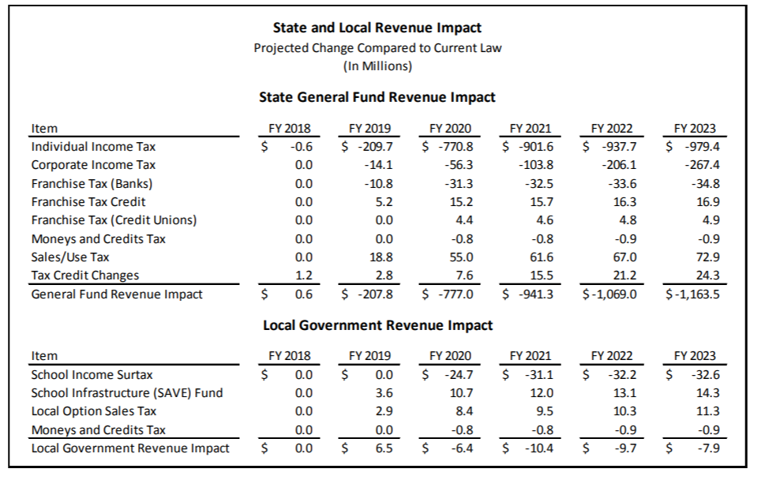
Although the FY 2019 impact is frightening enough, showing a reduction of $207.8 million, that number balloons to $777 million in FY 2020. RSAI is registered opposed to the bill, concerned about the ability of the state to adequately fund public education in the future. The details of each section of the bill are included, with the net impact of the changes shown in this table from the Fiscal Note, page 8:

Meanwhile, the House began deliberations on HSB 671, the Governor’s tax package. This bill does not have the LSA fiscal note, so we will keep you posted when we see that. A subcommittee was held on Thursday and the members recommended passage of the bill in the Ways and Means Committee. RSAI registration on this bill is pending an analysis of the Fiscal Note once completed.

HF 633, Operational Sharing Incentives, a priority for RSAI, is sitting in the Senate Appropriations Committee, likely not moving until deappropriations differences between the House and Senate for 2018 are resolved. RSAI supports this bill.
HF 2441 District Flexibility: this bill removes the DE from the process of approving district dropout prevention plans, sets up a process for the SBRC to approve modified supplemental amount for districts to fund their plans, and includes other flexibility provisions. RSAI is registered in support. This bill is on the House Calendar.
HF 2235 State Assessment: this bill mandates use of Iowa Tests (next iteration, so Next Gen) for state compliance with ESSA. RFP process selecting AIR3 was appealed. The Administrative Law Judge’s ruling released Feb. 14 affirmed that the DE and DAS followed the process. This bill was approved by the House 95:3 last week and is now over to the Senate Education Committee, where a subcommittee has recommended it move forward. RSAI is opposed, concerned that the Next Generation Iowa Tests have not yet been confirmed to align to Iowa Core standards. Without such alignment, Iowa’s state ESSA plan is at risk of failing peer review, placing $96 million in Title I funds on the line. See the RSAI legislative page for a position paper explaining the assessment issue and providing talking points and next advocacy steps. Find the Call to Action on our website here.
SF 2341 Civics Test: this bill requires that Iowa students pass the civics test used for citizenship for graduation from an Iowa High School. The bill mandates that a student score at least 60% of the 100 questions required. The mandate applies to both public and private schools. Students may start taking the test annually in 7th grade. The bill further requires that the test taking be proctored, but there is no source of revenue to pay for the additional staff time to proctor the test. The bill was approved in the Senate 38:12, and now will be assigned to the House Education Committee.
Other Bills Moving this week:
SF 2131 Online Instruction: this bill allows home school and private school students to access Iowa Learning Online courses for a fee. Passed the Senate, 48:0. Amended in the House to include a study by the AEAs to determine effective means of delivering content over the internet and range of partnerships currently in place. The House approved the bill as amended 60:39, so back to the Senate. RSAI is monitoring this bill.
SF 2155 Local operating Funds: this bill allows local government fund balances in excess of 33% of operating funds to be invested in CDs. Approved in the Senate 48:0. This bill is assigned to the State Government Committee in the House where a subcommittee has recommended amendment and consideration by the full committee. RSAI is monitoring this bill.
SF 2171 Praxis Waiver: this bill allows a teacher with an offer to teach in Iowa who has not achieved a Praxis score above the 25th percentile and who has completed all course requirements in their preparation program or is licensed in another state with a lower threshold on the Praxis for licensure, to apply for a one-year license from BOEE that would allow employment to begin. The district must provide an affidavit for the teacher to submit to the BOEE with the waiver request, that the teacher has received the offer of employment and the district made every effort to find an Iowa licensed teacher. Upon receiving the one-year license, the teacher would then have the year to complete the Praxis requirement at the 25th percentile. RSAI is registered in favor of the bill. Is was approved by the Senate, 46:3, and goes over to the House.

SF 2274 Education Reports: this bill requires DE to include state or federal citations authorizing them to collect data from school districts. Passed the Senate 37:11 and was approved in the House Education Committee this week with a bipartisan but not unanimous vote. RSAI is registered in favor.
SF 2315 Open Enrollment: this bill specifies which funds would follow the student, including categorical funds, but maintains local property taxes in the district of residence. The bill is in the Senate Appropriations Committee and was assigned a subcommittee of Senators Schneider, Danielson, and Greene. The subcommittee met this week, learned more about the complicated nature of school finance, and determined that the bill should move through the Education Committee. That process will probably not happen until the 2019 session due to funnel deadlines. RSAI is registered as undecided on this bill.
HF 2354 Student Information Protections: this bill restricts third parties/vendors which receive K-12 student data from using that data to target marketing. The bill allows some limited uses, including improving educational opportunities and includes restrictions on selling or disclosing the information. The House approved the bill 95-0, sending it to the Senate. RSAI is monitoring this bill.
HF 2406 Social Workers Shared Weighting: this bill allows school districts to share a licensed social worker and generate the equivalent of 3 students in operational shared weighting. The bill was amended and approved by the House 98:0 and is now over to the Senate. RSAI is in favor.
Advocacy Actions this week:
Senate Switchboard # 515.281.3371
House Switchboard # 515.281.3221

From links above or the legislative page https://www.legis.iowa.gov/legislators , find email addresses, home mailing address and home/work phone numbers for you legislators.
- Thank all 50 senators for continuing their push for solving the transportation and formula inequalities for school districts over the long haul.
- Contact senators, especially on the Senate Education Committee, asking for a no vote on the Assessment bill, HF 2235. See the March 1 call to action of talking points and contact information.
- State penny extension. Remind all legislators that extending the penny is critical to solve your infrastructure, equipment and technology needs without raising property taxes. Shore up members of the House Ways and Means Committee to support the bill and move it out of committee. See if your representatives are on this committee. House Ways and Means Committee Membership
- Ask all House Education Committee members to oppose HF 2341, mandates that students pass a civics test in order to graduate from high school. See talking points above.
- Connect one parent in your district to Parents for Great Iowa Schools. https://p4gis.org/ They are helping parents find their advocacy strength in prioritizing public schools, both in terms of funding and state policy.

RSAI Contacts
RSAI Professional Advocate, margaret@iowaschoolfinance.com 515.201.3755
Robert Olson, Chair, Clarion-Goldfield/Dows, Superintendent, robert.olson@rsaia.org ,
Paul Croghan, East Mills and Essex Superintendent, pcroghan@emschools.org ,
Lee Ann Grimley, Springville, Board President, leeann.grimley@rsaia.org ,
Dennis McClain, Clay Central Everly, Superintendent, dmcclain@claycentraleverly.org
Laurie Noll, Fairfield, Superintendent, laurie.noll@fairfieldsfuture.org
Dan Smith, Harmony, Board President, dan.smith@rsaia.org
Duane Willhite, Superintendent, North Fayette Valley, dwillhite@nfv.k12.ia.us

