6/7/2017 Wonder Woman

In 1896-97 there were four events that would have future global and biblical significance.

1. The Olympic Games were restarted in Athens, Greece on 4/5/1896.

2. Henry Ford took his new invention, the Quadricycle, out for its first test drive on 6/4/1896.

3. The Nashville Parthenon was constructed and the Tennessee Centennial and International Exposition was held 5/1 to 10/31/1897.

4. The First Zionist Conference was held in Basel, Switzerland, 8/29 to 8/31/1897.

Note that we are now, in 2016 and 2017, at the 120th anniversary of the above mentioned events. The numeric value of 120 years is mentioned in Genesis 6:3 in relation with fallen angelic beings whose progeny, Nephilim, were destroyed in Noah's flood.

The Original Quadricycle

The four events mentioned above are relevant to YaHuWaH Elohim and His adversaries. Henry Ford's invention might not seem to be biblically relevant, but it is symbolic of the mobile throne that YaHuWaH Elohim sits on when traveling. Link: http://www.history.com/this-day-in-history/henry-ford-test-drives-his-quadricycle

The prophet Ezekiel describes a vision of YaHuWaH 's four wheel traveling throne in chapter 10.

Ezekiel 10:1 Then I looked, and, behold, in the firmament that was above the head of the cherubims there appeared over them as it were a sapphire stone, as the appearance of the likeness of a throne.

Ezekiel 10:8 And there appeared in the cherubims the form of a man’s hand under their wings.
9 And when I looked, behold the four wheels by the cherubims, one wheel by one cherub, and another wheel by another cherub:...

Return of the Ancient Gods

The revival of the ancient Olympic Games in 1896 signaled a summoning of the ancient gods who had descended on Mount Olympus in Greece. In Greek mythology, twelve Olympians resided on Mount Olympus.

The book of Enoch tells us that rogue angelic beings gave mankind forbidden knowledge that concerned waging war. It was just a few years after 1896 that man would "invent" the powered airplane and be given the secret knowledge (of atomic structure, artificial intelligence, etc.) that would enable man to annihilate himself, eradicating the image of YaHuWaH Elohim from the earth.

Genesis 2:16 And YaHuWaH Elohim commanded the man, saying, Of every tree of the garden thou mayest freely eat:
17 But of the tree of the knowledge of good and evil, thou shalt not eat of it: for in the day that thou eatest thereof thou shalt surely die.

The Nashville Parthenon

A full scale replica of the Parthenon Temple that sits on a mountain in Athens, Greece, was constructed in Nashville, Tennessee, for the Tennessee Centennial and International Exposition in 1897. The pagan Temple was contemporary with the revival of the ancient Olympic games in 1896.

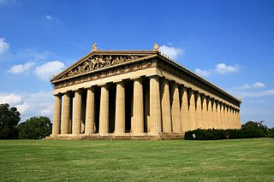
Above: The Nashville Parthenon

Note that Nashville, Tennessee, home of the Parthenon Temple, became the music capitol of modern Babylon the great.

The Parthenon is Inhabited

In 1982 the city of Nashville commissioned a sculptor to recreate the full size statue of the goddess Athena.

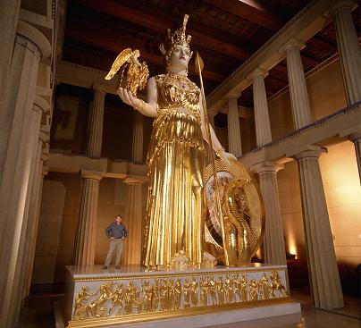
Above: The 42' high golden gilded image of the ancient Greek goddess Athena located in the full sized Parthenon in Nashville, Tennessee, music capitol of the world.

This is relevant because the king of ancient Babylon constructed a golden image and ordered everyone to bow to it at the sound of music. Daniel chapter 3 tells of the event.

Daniel 3:4 Then an herald cried aloud, To you it is commanded, O people, nations, and languages,
5 That at what time ye hear the sound of the cornet, flute, harp, sackbut, psaltery, dulcimer, and all kinds of musick, ye fall down and worship the golden image that Nebuchadnezzar the king hath set up:
6 And whoso falleth not down and worshippeth shall the same hour be cast into the midst of a burning fiery furnace.

Concerning the king of Babylon, identified as Lucifer the musical angelic being who would weaken the nations:

Isaiah 14:4 That thou shalt take up this proverb against the king of Babylon, and say, How hath the oppressor ceased! the golden city ceased!

Isaiah 14:10 All they shall speak and say unto thee, Art thou also become weak as we? art thou become like unto us?
11 Thy pomp is brought down to the grave, and the noise of thy viols: the worm is spread under thee, and the worms cover thee.
12 How art thou fallen from heaven, O Lucifer, son of the morning! how art thou cut down to the ground, which didst weaken the nations!

A 6' tall image of the Greek god Nike stands in Athena's right hand. Eight pounds of gold leaf were used to embellish the image. The construction of the statue was completed in 1990, and the golden embellishments and decorations were completed in 2002. People with musical talent will often head to Nashville to seek their fortunes.

Note that the year 1982 was the 2520th year from the Handwriting on the Wall incident on 10/11/539 BC that prophesied the fall of ancient Babylon. Remember that the number 2520 was encoded into the Handwriting on the Wall. The year 1982 has also been identified as 36 years from 1945 and the use of the atomic weapon that propelled the United States to world's superpower status. The number 36 is related to the ancient Babylonian Magic Square amulet with its 36 numbered gods which add up to 666.

The Timeliness of the Wonder Woman Movie

Be aware that the movie Wonder Woman had its Hollywood premiere showing on 5/25/2017, the very first day after the 50th Hebrew calendar anniversary, 18 Iyyar, 5/24/2017, of the taking of Jerusalem by Israel in the 1967 Six Days War. Prophecy buffs should note that President Donald Trump was in Brussels, Belgium, on 5/25/2017, the day that Wonder Woman premiered.

The movie Wonder Woman is set in 1918, making its 100th anniversary year 2018.

The main actress in the movie is an Israeli, Gal Gadot. The Hebrew name Gal means "wave" or "billow". The Hebrew name Gadot means "riverbank". The name Gal Gadot may be associated with a wave rolling to the shore, as Gal is associated with the word galgal which means wheel, or rolling wheel.

The name Gal Gadot, meaning “wave riverbank”, brings to mind Moses who was placed in an ark, and the ark placed in the reeds near the shore of the Nile River. The river bank is the threshold, the doorway, to the river. This is prophetically relevant because the 100th anniversary of the setting of the movie will be 2018, the movie concerns a supernatural savior, and the sign of a Woman Clothed with the Sun, a "Wonder Woman", will appear in the sky later this year. The Wonder Woman in the sky on 9/23/2017 will symbolically give birth to a male child like unto Moses who will rule the world.

Wonder Woman is a goddess, a supernatural savior, and she will be adored by millions of people in the theater "temples" around the world.

The Symbolic "Wonder Woman" in the Sky

On 9/23/2017 there will appear in the sky a sign that many people believe relates to Revelation chapter 12. Below is a graphic that depicts the events in the sky on 9/23/1846 when the planet Neptune was discovered as related with events at the 100th year anniversary in 1946 and the sign of the Woman Clothed with the Sun on 9/23/2017.

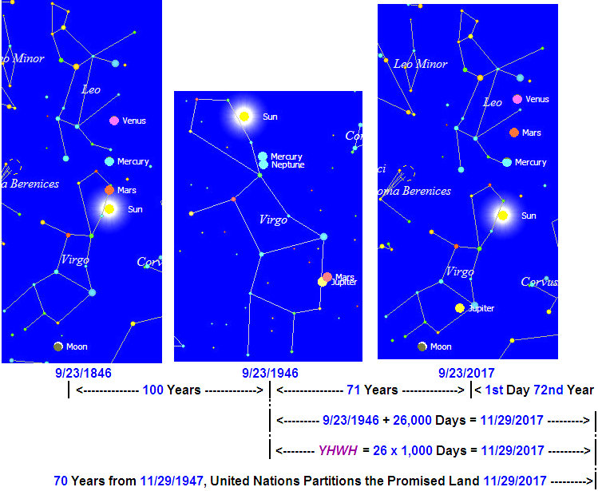

The 26,000 Days from 9/23/1946 to 11/29/2017

In the graphic above there are exactly 26,000 days from the 100th anniversary of the discovery of the planet Neptune to the 70th anniversary of the dividing of the land promised by YaHuWaH Elohim entirely to Jacob's descendants. The letters of the ancient Hebrew alphabet were used as numbers, just like Roman numerals are letters from the Latin alphabet.

Below is YaHuWaH Elohim's Name in Modern Hebrew font. Note that the numeric value of His Name is 26.

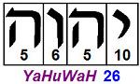

Below is the Name YaHuWaH in ancient pictorial Hebrew. The ancient pictorial Hebrew of 3,300 years ago reveals who He is.

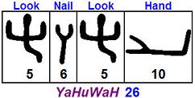

Hebrew is read from right to left. YaHuWaH 's Name means "Hand, Look, Nail, Look".

Zechariah 12:8 In that day shall YaHuWaH defend the inhabitants of Jerusalem; and he that is feeble among them at that day shall be as David; and the house of David shall be as Elohim, as the angel of YaHuWaH before them.
9 And it shall come to pass in that day, that I will seek to destroy all the nations that come against Jerusalem.
10 And I will pour upon the house of David, and upon the inhabitants of Jerusalem, the spirit of grace and of supplications: and they shall look upon Me whom they have pierced, and they shall mourn for Him, as one mourneth for his only son, and shall be in bitterness for Him, as one that is in bitterness for his firstborn.

Summary

Revelation 17:1 And there came one of the seven angels which had the seven vials, and talked with me, saying unto me, Come hither; I will shew unto thee the judgment of the great whore that sitteth upon many waters:
2 With whom the kings of the earth have committed fornication, and the inhabitants of the earth have been made drunk with the wine of her fornication.
3 So he carried me away in the spirit into the wilderness: and I saw a woman sit upon a scarlet coloured beast, full of names of blasphemy, having seven heads and ten horns.
4 And the woman was arrayed in purple and scarlet colour, and decked with gold and precious stones and pearls, having a golden cup in her hand full of abominations and filthiness of her fornication:
5 And upon her forehead was a name written, MYSTERY, BABYLON THE GREAT, THE MOTHER OF HARLOTS AND ABOMINATIONS OF THE EARTH.
6 And I saw the woman drunken with the blood of the saints, and with the blood of the martyrs of YaHuShua: and when I saw her, I wondered with great admiration.

