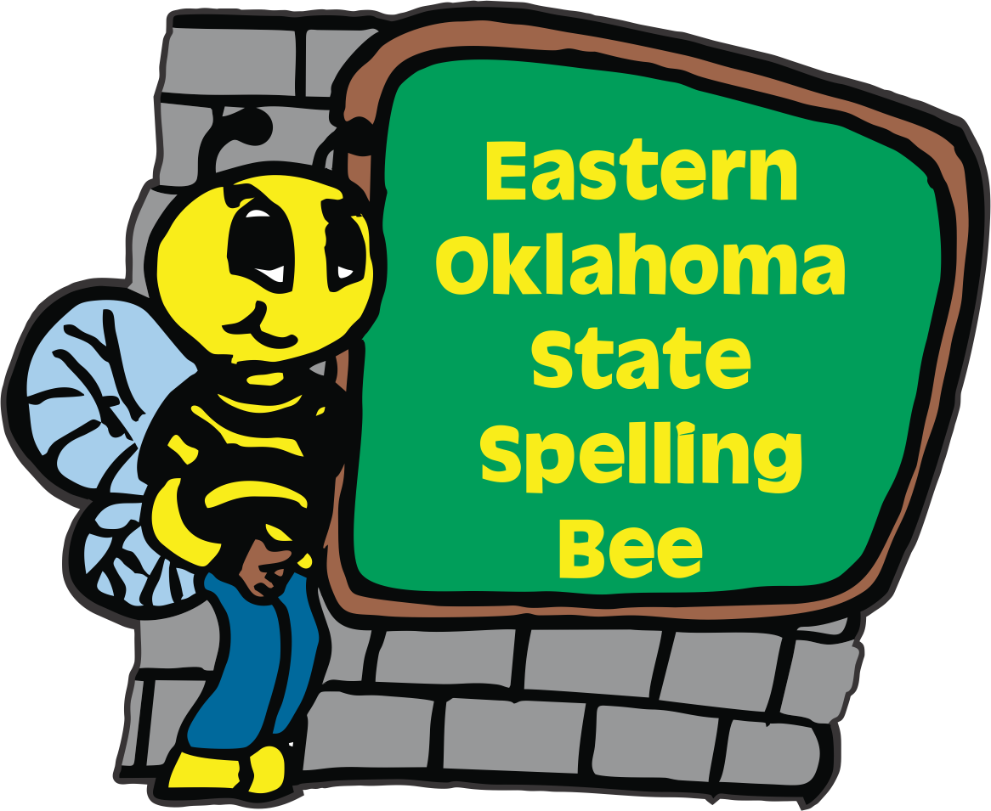
2024
Eastern Oklahoma State Spelling Bee Event
Registration Form

Welcome to the 14th Annual Eastern Oklahoma State Spelling Bee Event. The Bee will be held on a Friday April 26th 2024 at the Muskogee Civic Center. To participate in the EOSSB competition, please e-mail or send this form in the U.S. mail with your PO# or entry fee payable to the Eastern Oklahoma State Spelling Bee. We are excited to announce that our registration fee has remained at $50.00 per school site. Registration Deadline is Friday, Dec. 15th.
We are not able to take credit cards.
_____ Please register our school. Check is included.
_____ Our school is using a PO number. #_____________________________

Name of School __________________________________________________
School Phone ____________________________________________________
School Address __________________________________________________
City ___________________________________ Zip Code _______________
County ________________________________
Spelling Bee Coordinator__________________________________________
Spelling Bee Coordinator Cell Phone Number ______________________________________
Spelling Bee Coordinator’s Email Address_________________________________________
Contact Person for Purchase Order_______________________________________________
Purchase Order Person’s Email Address___________________________________________
You may e-mail this entry form to sehoog@gmail.com or send us in the US mail to:

Eastern Oklahoma State Spelling Bee
Attn: Registration Form
1404 East Broadway
Muskogee, OK 74403

