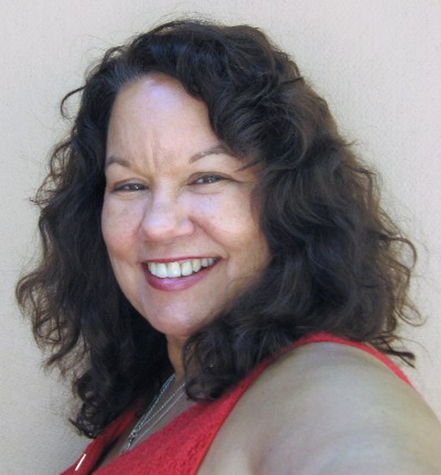
Mari Joiner’s Resume

EXPERIENCE:
Florida Keys Resident since 1981
Florida Realtor since 2000
Property Manager 1996 to 2014
EDUCATION AND DESIGNATIONS:
Bachelor of Science in Community Development
SFR-Short Sale and Foreclosure Certification, NAR Designation
Licensed Community Association Manager (C.A.M.)
AHWD-At Home With Diversity, FAR Designation
CGREP-GREEN, NAR Sustainable Property Designation
AFFILIATIONS & LEADERSHIP POSITIONS:
Member, Florida Realtors since 2000
Board of Directors, Florida Realtors 2009 & 2010
Member, National Association of Realtors since 2000
Voting Delegate 2009 & 2010 & 2011
Florida Realtors Honor Society recipient, 2 years
Multiple Listing Service (MLS) President 2002, Pres. Elect 2001, Treasurer 2000, Past Pres. 2003
Florida Keys Board of Realtors, President 2010
Immediate Past President 2011
Treasurer 2008, President Elect 2009
Chairperson Professional Standards Committee 2012-13. Committee member 2014
COMMUNITY:
Founding Member of Florida Keys Orchid, Fern & Bromeliad Society
Member of BPOE 1872, Tavernier, Florida
PERSONAL:
Daughter Bridget and Grandson Devin Crossen, Granddaughter Lilly Ann Oberman
Hobbies Landscape Painting, Sailing and an Award winning Bonefishing!
Each RE/MAX® Office Independently Owned and Operated

