

REUSEABLE SHOPPING BAGS FOR SALE
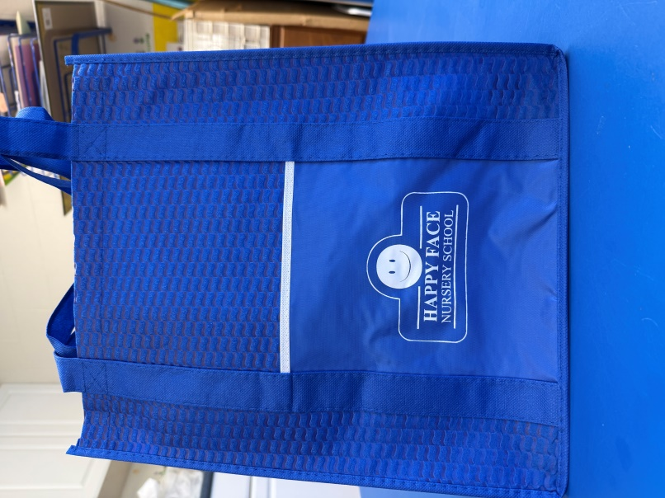
$3 each or two for $5

Name: ____________________________________
# of Bags: __________________________________
Cash or Check (made out to Happy Face Nursery School)

