

Birmingham Wheelchair Service Referral Form
* COVID Status
COVID Positive: Yes☐ No☐ Unknown ☐  Date of result: | Symptoms:  Date of onset:

- Please complete all sections of this form clearly by hand or in Microsoft Word.
All Questions marked with an * must be completed if they are not then the referral will be rejected.
- Referral forms will be screened by the Wheelchair Service with relation to our service specification and criteria. Please note that information may be shared with other professionals such as your GP.
- This form can be e-mailed, hand-written, posted or faxed. Details on back page.
* Patient’s First name: Date referral received:
* Patient’s Surname:
* Patient’s NHS Number:
* Please tick all boxes which apply:
Wheelchair is required for more than 6 months
Wheelchair is required for hospital discharge
Patient is receiving palliative care
Patient is on the Gold Standard Framework
Patient has a rapidly deteriorating condition
Patient has consented to this referral

1. Referrer’s Details *:

* Referrer: * Profession:
* Self referral Healthcare professional / GP
Student (must be counter-signed)
* Address:
* Postcode: * Telephone Nº:
* Referrers email address:

* Signed: * Date:
 Signature required for referrals sent by post or fax, not required for electronic referrals.

2. GP Details *:
* Name:
* Address:
* Postcode: * Telephone Nº:

3. Patient Details *:
* Date of Birth: ..............................................
* Home address:
* Postcode:
* Contact telephone number(s):
* Contact email address:
* If appropriate would you be able to engage in a virtual assessment (video call) using your own smartphone or lap top?” Yes No

* Alternative/delivery address:
* Postcode:
* Statements: Patient is a war pensioner?
Patient lives alone?
Patient attends school? * School Name:…………………
Patient has a regular carer? Carer Name:……………………
* Contact number:
* Any Identified risks or access issues: …………………………………..………
………………………………………………………………………………………………….
Will an interpreter be required? Yes No – if yes please state language:
………………………………………………………………………………………………….
Ethnic origin: (Please tick one)
White  British  Irish  Other white background | Mixed  White and Black Caribbean  White and Black African  White and Asian  Other mixed background | Asian or Asian British  Indian  Pakistani  Bangladeshi  Other Asian background
 | Other Ethnic Categories  Chinese  Any other ethnic category | Not stated  Not stated

4. Clinical information *:
* Primary diagnosis (If patient has Cerebral Palsy please give GMFCS level:

* Past medical history: (relevant history such as surgery, illnesses, development delay,
seizures falls)

* Allergies:
* Height: ………………………. * Weight:……………………….
(If this cannot be obtained easily please comment why and provide an estimate).

* Other medical factors that may need to be considered, please name relevant Health Professional’s involved: (planned surgery, spinal bracing, spine curvature, hip stability,
vision, cognition, pressure sores).

*….Suctioning: Do you use cough assist or suctioning equipment to assist with your breathing? No Yes, if yes, please provide comments:

5. Functional abilities *:
Please indicate functional abilities of the patient:
* What activities does the patient need to do in the wheelchair? (Tick all that apply)
Mobility within the home, Work,
Personal care, Education,
Attending Rehabilitation, Outdoor leisure,
GP / Hospital appointments, Access to day centre,
* Transfer method: How does the patient transfer in and out of the wheelchair?
Independent (standing or sliding transfers)
With assistance of carer(s)
Standing hoist
Sitting hoist with sling
* Walking ability:-
Independent (walking without assistance)
With equipment (walking using sticks or furniture to help)
Unable (cannot walk, may be able to stand, risk of falling)
* Balance when in a seat position:-
Good balance (can sit up without support and reach for objects)
Variable balance (sometimes needs some kind of support)
Poor balance (Cannot sit unaided, may slide or lean)

* How often would the wheelchair be used (approximately, on average)?
Infrequent (1 or 2 days per week)
Occasional (3 or 4 days per week)
Regular (5 to 7 days per week)

* How long will the patient be seated in the wheelchair at any one time?
Less than 2 hrs, 2-4 hrs, 4-8 hrs, All day
* Will the patient need to be transported in the wheelchair? Yes, No
If yes, please give vehicles used:

* Any Home Environment restrictions for wheelchair access (tight turns, small
doorways,ramps):………………………………………………………………………………………
……………………………………………………………………………………………………………
* If there are any specific features about the home environment that need to be
considered: (e.g. wheelchair access ramps, narrow doors, steep ramps, internal steps, etc.), Please refer to the home adaptations service, part of the Adults and Communities Access Point – see back page for details.

6. Equipment *

* Already has a wheelchair? Yes (private), Yes (NHS), No
If yes, please give details/concerns:
 Please note: If repairs needed for existing equipment, see back page for repairs information.
* What is needed from this referral? (tick all that apply)
Manual wheelchair (pushed by an attendant)
Manual wheelchair (self propelled with large wheels)
Electrically powered wheelchair (to enable access indoors)
Seat cushion / Pressure cushion
Bespoke / custom made seating (If patient cannot sit in a standard seat),
Wheelchair accessories (e.g. amputee leg rests, elevating leg-rests etc.)
Other:
Wheelchair seat measurements (exception Specialist Seating):  Seat Width:   Seat width: (Please see diagram).  Seat Depth:   Seat depth: (Please see diagram).   Please state units of measurement (ins/cms) and do with a metal tape measure to gain a straight measurement. | 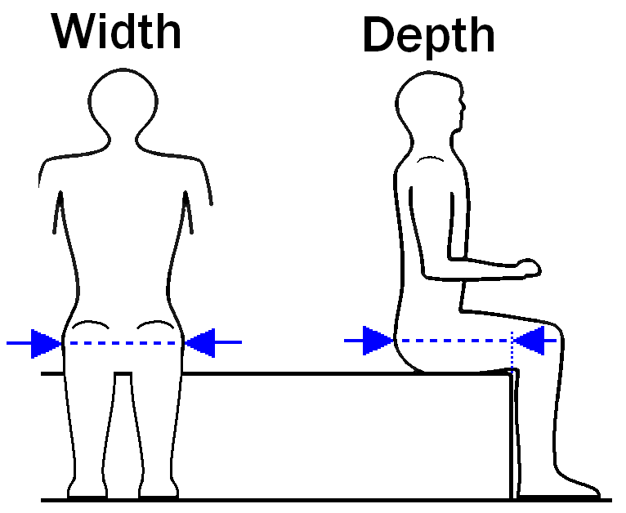
* If a pressure cushion assessment has been carried out, please state the
recommended cushion:

* Pressure Areas: Does the patient have a history of pressure areas, or have
any high risk factors.

* Is there a Tissue Viability Nurse or District Nursing Team involved?
Yes, No
If yes, please give details about their involvement:
and contact name and telephone number:
…………………………………………………………………………………………….

7. Additional information e.g. Posture in Seating/Health & Safety/General
Information *:
* If you have any further information to add please use the space below (If patient
has falls please give details of frequency and contributing factors) :

8. Please make your recommendations here *:
Wheelchair Service to choose appropriate equipment and arrange delivery.
I (referrer) think the following equipment is appropriate:
I feel the patient requires a clinical assessment by the Wheelchair
Service.

9. Please send to Birmingham Wheelchair Service by email, fax, or post:
E-mail: Birmingham.Wheelchairs@NHS.net
Fax: 0121 471 3690 (This is our safe-haven fax number suitable for referrals.)
Post: Birmingham Wheelchair Service
West Midlands Rehabilitation Centre
91 Oak Tree Lane
Selly Oak
Birmingham
B29 6JA Tel: 0121 466 3220
Website: www.bhamcommunity.nhs.uk/wheelchair (inc. referral forms)
Repairs: Rosscare: 0121 328 0227.
- Home Adaptations: Please contact Birmingham City Council, Adults and Communities Access Point:
Tel: 0121 303 1234, or email: ACAP@birmingham.gov.uk
- Criteria: Please note that if the patient does not meet our criteria for provision of equipment, a letter will be sent to the patient to inform them and sign-post them to other possibilities such as charities, wheelchair hire, private purchase, carers grants etc.

The Data Protection Act 1998 - Personal data supplied on this form may be held on and/or verified by reference to information already held on the computer.
The principles of the Data Protection Act 2018 and the Caldicott guidelines should be adhered to at all times. Incoming and outgoing email messages may be monitored in accordance with relevant legislation, including Regulation of Investigatory Powers Act 2000, the Telecommunications Regulations 2000 and Human Rights Act 1998.

Thank you for completing this referral.

