l

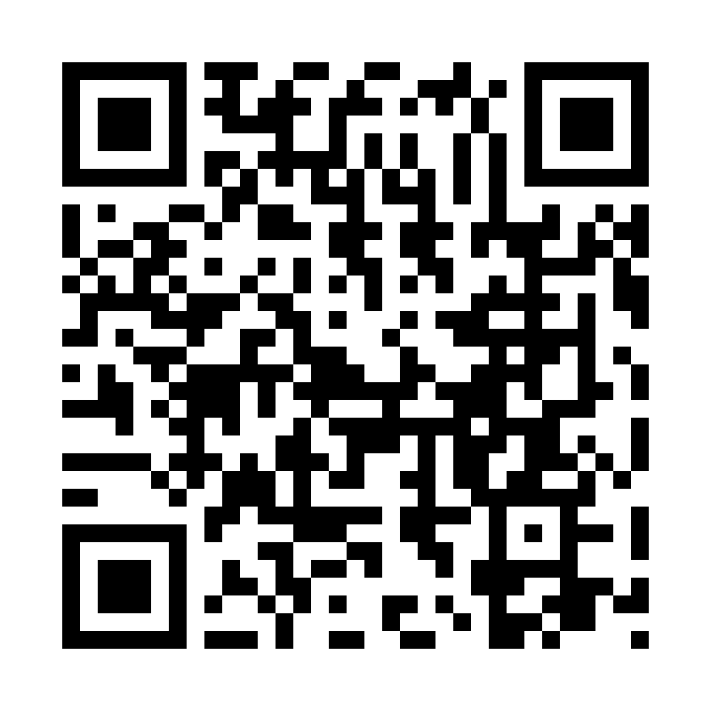

Catholic Church *cluster* of Davenport

St. Francis of Assisi – Harrington

Immaculate Conception Catholic Church – Davenport

St. Michael Catholic Church – Reardan

St. Kateri Tekawitha Catholic Church – Ford

Sacred Heart Catholic Church – Wellpinit

***Mailing Address***: Immaculate Conception Catholic Church - Davenport

1310 Adams St., Davenport, WA 99122-9454

(509)725-1761

***Office manager***: Jackie – [icdavenport@dioceseofspokane.org](mailto:icdavenport@dioceseofspokane.org)

Immaculateconceptiondavenport.org

Any information for the bulletin needs to be to Jackie

***Pastor*** – Fr. Maria - [mlmariadoss@dioceseofspokane.org](mailto:mlmariadoss@dioceseofspokane.org)

Sacramental requests:Call Fr. Maria 802-289-3703

**The Holy Sacrifice of the Mass**

**Daily** Tues. Davenport at 5:30pm, Wed. & Fri. Davenport 9am, Reardan Thurs. 9am.

**Saturday**  Harrington mass at 5:30pm **Sunday** Rosary at 8am in Davenport

Davenport at 8:30am**,** Reardan at 10:30am, Ford 12:30pm (1st-2nd-3rd Sunday in Ford) (4th Sunday in Wellpinit)

**Confessions** – half hour before Sunday mass.

**Tuesday** 5:30 pm mass, adoration to follow.

**14th Sunday in Ordinary Time**

From Fr. Maria,

Thank you to all the generous volunteers who brought food last Sunday and appreciation for the farewell and anniversary cards that were signed!

Thank you so much for your help!

Fr. Maria

*BIG welcome to Fr Brian Sadler on his new assignment to our cluster of parishes!

We will have coffee and goodies after mass July 13 to welcome him. Please bring what you can and say Hi to Fr Brian Sadler!

Kathy Woods made a signature quilt for Fr Sean. Called “Thank you for being a friend” from Davenport cluster. We want **all** to sign it, so it will be making rounds.  **Davenport June 22 & 29** and Ford July 6. We would like to present it to him at a mass as some point, looking like late August.

**Mass Intentions:** July 6 Sun. (8:30am) Pro Populo (10:30am) For vocations to the priesthood (12:30pm) private intention July 8 Tues. 5:30pm July 9 Wed. 9am July 10 Thurs. 9am July 11 Fri. 9am