Business Case Worksheet
Comprehensive Version
Multiple Alternatives Version

Business Case Name: ______________________________

READ THIS IMPORTANT APPLICATION NOTE TO MAKE SURE YOU ARE USING THE RIGHT WORKSHEET - This worksheet is for a business case that involves solving a problem or making an improvement where multiple alternative solutions exist. This worksheet also covers business cases for major decisions where multiple alternatives exist. Several examples of many major decisions having multiple alternatives would include selecting one of multiple new systems to be acquired, forming a partnership with one of several potential partners, building one of multiple possible new facilities or determining which of a number of potential new products or services would be developed. If your business case involves a single alternative decision such as a decision to acquire a specific new system or not, form a partnership with another specific organization or not, build a specific new facility or not or a decision to develop a specific new product or service or not, then this is NOT the right worksheet and you should use one of the “Single Alternatives” worksheet versions available at www.ManageProjectsBetter.com. See the “Site Map” at this site for other business case worksheets. Note also that multiple worksheets of varying complexities are available.

CONTENTS

Introduction
- What is a Business Case and Why is it Important?
- What is This Worksheet and Why Use It?

Instructions

The Worksheet

- State the Need, the Problem or the Needed Improvement
- Define the Environment - Background, Strategic Interests, Urgency, Impacts of No Action
- Define “Needed Outcomes”
- Identify Root Causes of the Problem or the Root Drivers of the Needed Improvement
- Select Root Causes You Can Affect and Select the Most Important Root Causes
- Identify Alternative Solutions that Address the Root Causes and Attain the Needed Outcomes
- Reduce the Set of Alternatives - Optional
- Define Alternative Comparison Criteria and Collect Alternative Comparison Information
  - Investment, Resources and Negative Impacts
    - Financial Analysis - Investment and Resource Needs
    - State the Risks or Concerns
    - State the “Most Likely” Negative Impacts on Customers
    - State the “Most Likely” Negative Impacts on the Organization
    - State the “Most Likely” Negative Impacts on Employees
    - State the “Most Likely” Negative Impacts on Other Stakeholders
  - Payback and Positive Impacts
    - Financial Analysis - Payback
    - State Potential Opportunities
    - State the “Most Likely” Positive Impacts on Customers
    - State the “Most Likely” Positive Impacts on the Organization
    - State the “Most Likely” Positive Impacts on Employees
    - State the “Most Likely” Positive Impacts on Other Stakeholders
  - Additional Alternative Comparison Criteria
    - State the Alignment with the Organization’s Strategic Information
    - State Alignment with the Needed Outcomes
    - State the Estimated Probability of Success and Key Assumptions
    - State the Feasibility in terms of Technology, Resources, Politics, etc.
    - State Significant External Environment Factors
    - State Significant Internal Environment Factors
    - State Significant Legal or Regulatory Aspects
    - State Significant External Political or Cultural Aspects
    - State “Internal Interdependencies”
    - State “External Interdependencies”
- Build Alternatives Comparison Table, Enter and Validate Comparison Information
- Business Case Analysis, Alternative Selection, Plans Forward and Report
  - Analyze the Contents of the Alternatives Comparison Table
  - Form a Bottom Line Draft Recommendation and Generate Rationale
  - Identify a Backup Plan
  - Define Needed Management and Customer Involvement
  - Define any Needed Third Party Relationships
  - Define Needed Resources for Selected Alternative and Assumptions
  - Develop the “Plan to Proceed”
  - Prepare the Draft Business Case Report and Distribute to Selected Stakeholders for Comment
  - Identify and Complete Needed Final Tasks
  - Prepare and Distribute the Final Business Case Report

Introduction

What is a Business Case and Why is it Important?

What - A business case is an analysis to determine if it is in the best interests of an organization to make a decision for some type of important change. The business case analysis looks at the advantages and disadvantages of a given decision and all factors and impacts related to that decision to ensure the right decision for customers, the organization and employees is made. Business cases are performed for many different decisions. A few examples include a decision to invest in a new system, build a new facility, develop a new product or service, develop and implement new organization processes, enter into a new or modified business partnership or making significant organization structural changes.

Why - Sound business decisions are needed for any organization to be successful. Organizations often make critical decisions that require significant time and resources to implement and these decisions can have substantial positive and negative impacts on the organization, the organization’s customers and employees. As such, these decisions must be carefully considered. To make sound business decisions for important topics, a decision making structure is needed to support both the collection and the review of all relevant information. A business case process and template, such as this worksheet, provides this necessary structure.

What is This Worksheet and Why Use It?

This worksheet is a generic business case information collection structure and process. This worksheet includes common components of a business case and is organized in a sequence consistent with developing and communicating the key information needed for a considered decision. An organization might use this worksheet “as is” or modify it for specific situations.

Worksheet Functions - This worksheet provides:
- A means to identify needed information to complete the business case
- A process to support an effective business case analysis
- A working document to both collect and disseminate information
- A format for the final business case report
- A means to set stakeholder expectations on what a business case involves
- Material to support for training on business case analysis content and methods

Available Worksheet Variations - Since many different situations exist, no single worksheet or template will meet all needs. Different levels of detail are provided along with worksheet variations for multiple decision alternatives and singular decisions situations. See “Instructions” in the next section for information about these different worksheet versions. See www.ManageProjectsBetter.com for all worksheet versions.

Multiple Alternative Worksheets
- Comprehensive Detail Version, Multiple Alternatives This Worksheet Is This Version
- Intermediate Detail Version, Multiple Alternatives
- Basic Detail Version, Multiple Alternatives
- “Just the Fundamentals”, Multiple Alternatives
Single Alternative Worksheets
- Comprehensive Detail Version, Single Alternative
- Intermediate Detail Version, Single Alternative
- Basic Detail Version, Single Alternative
- “Just the Fundamentals”, Single Alternative

<< Back to Contents >>

Instructions

A – Match a Worksheet Version to Your Business Case Analysis Needs
Review the different worksheet versions that are available and choose the version best aligned with your business case needs. All versions available at www.manageprojectsbetter.com.
- Multiple Alternative Versions – Use these worksheet versions for situations where multiple alternatives are being considered. An example is the resolution problem where a system is not meeting current needs with alternative solutions being considered might include a new system, a system modification or changing business processes to alter how the system is employed. Out-sourcing the work associated with this system might even be considered. Here multiple alternatives exist.
- Singular Alternative Versions – Use these worksheet versions for situations where only a “yes or no” decision exists. An example would be to team with a business partner or not. Here, there is only one option, not multiple alternatives, and a “yes or no” answer is the intended result.
- Level of Detail Versions – Different levels of detail are provided to best meet the needs of a given business case. General selection guidance follows.
  - Comprehensive Detail Version – Use this version for the most important decisions, where careful consideration of many factors is needed and/or if your team has significant experience in performing complex business cases.
  - Intermediate Detail Version – Use this version for more complex decisions where the level of detail in criteria in the comprehensive version is not needed and if your team has experience in completing business cases. Review the criteria content of the comprehensive version to support any needed content being added to this version.
  - Basic Detail Version - Use this version if the magnitude and complexity of the decision is not complex in nature and if you or your team has limited business case analysis experience. Review the content of the other versions to support adding important content to this version.

B – Decide If the Worksheet Will Be Modified, Your Options Include:
- Use the worksheet “as is,” or
- Modify the worksheet …
  - To remove unneeded sections and/or
  - To add new needed sections, and/or
  - To change section content

C – Perform the Business Case
- Review the business case steps in this worksheet (See “Contents” on the first page)
- Define the timeframe for business case completion, interim milestones are recommended
- Define the team that will work on the business case
- Go through the steps in the worksheet in the order listed
- Expect that step iteration and overlap will happen as your work progresses
- Expect that you might adjust the set of individuals working on the business case as you learn more of what analysis work and what information is needed
- At appropriate places in the process, review the current information with appropriate stakeholders for purposes of awareness, comment, guidance and ownership
- At appropriate places in the process, ask the business case team if the analysis is heading in the right direction to support an eventual solid decision, make analysis course corrections as needed to support a sound decision

<< Back to Contents >>
Business Case
WORKSHEET
Multiple Alternatives Version
Comprehensive Detail Version

Note: There are a number of different business case worksheet versions available. This worksheet is for situations where multiple options or alternatives exist for a given decision. This is the most detailed worksheet version and is suitable for large, risky and complex analyses. If your effort is limited in scope, or does not have multiple alternatives, visit www.ManageProjectsBetter.com for other business case worksheet versions that might better suit your situation.

STEP 1

State the Need, the Problem or the Needed Improvement
The Current State, the “As Is”, the Problem or a Needed Improvement

This step states the current situation for which the business case is being performed.

Background - Business cases determine if a change to something will be made. To make an effective change, the current situation or the current state must be well known. This step identifies the current situation for which change is being considered. See examples below.

Current State Examples
- Problem Example – Let’s say that a problem exists and it is random system failures for a system your organization and customers use on a daily basis. The effects are that you are losing business to competitors. The current state is a failing system that needs resolution for known performance issues. Other problem examples may be related to organization processes, employee skills, supplier issues and technologies.
- Improvement Example – Let’s say that a needed improvement is related to the same system above, your system is running acceptably but you want to improve the system operation to enhance your customer’s experience. The current state is a given level of system performance that you want to increase.
- New Idea Example – Let’s say that an idea has surfaced for consideration. Examples might be to out-source certain work or to form a strategic alliance with a new potential business partner or to expand your business into a new market area. These are not problems and may not necessarily be improvements but do constitute a significant change for which a business case is typically needed. The current state could be the current business model and current business performance.

Instructions - Complete One of the Following Statements:

- The Problem Needing a Solution is ………………………………., or

- The Situation Needing Improvement is ……………………………, or

- The New Idea to Be Evaluated is ……………………………

STEP 2

Define the Environment
State the Background, Strategic Interests, the Urgency, the Impacts of No Action and any Current Work Status

This step identifies background, context and other environment information related to this decision.

Instructions – Complete the following topics in a manner that would provide an individual unfamiliar with the respective situation a sound understanding of the environment surrounding this business case decision. Add any other information categories needed.

Background - The background of this situation is ….xxx….
Context – This situation is a part of a larger situation and that is ….xxx….

Related Organization Strategic Interests – State how this issue or improvement or new idea is aligned with the strategic interests of the organization.
- Mission Alignment – xx
- Vision Alignment – xx
- Strategic Plan Alignment – xx
- Current Priorities Alignment - xx

Urgency
Two urgency factors are important.
- If completion of this business case is delayed beyond ….(date)….the following impacts might result:
  - xx
  - xx
- If the change, project or effort for which this business case is being prepared is delayed beyond …..(date)…… the following impacts mightl result
  - xx
  - xx

Impacts of No Action – If no action is taken on this topic, the most likely outcomes are:
- Customers - Impacts of No Action to Customers are …
- Employees - Impacts of No Action to Employees are …
- Organization - Impacts of No Action to the Organization are …
- Other Impacts of No Action are …

Current Work Status – State status of any work related to this effort:

☐ No Work Started or Completed Related to this Decision
☐ Some Work In-Process
- State Work In-Process ………………
☐ Some Work Completed
- State Work Completed ………………

STEP 3

Define “Needed Outcomes”
State what results or outcomes or end conditions are needed

This step identifies what is needed as a result of the change being considered.

Notes: As you complete this step, be aware of the following:
- To make an effective change, you must know the “Destination,” i.e. “knowing where you want to be when you are done!” Effort outcomes or results are the “destination.”
- You can’t “Boil the Ocean” – You cannot solve all of your organization’s issues or needs in one effort. Pick the specific outcomes in the list below, (“3A”) that are at the heart of what changes are needed per the statement included in Step 1. Less is often best.
- Beware that many of the items listed below are related and can be causes of each other, but check all of the most relevant important items that clearly and directly apply to the needed change to ensure a complete “end state or outcome” picture is captured.
- Add any factors not listed in “3A)” that further define needed outcomes for the change being considered.

Instructions
- Under “3A)” check those topics that are at the heart of the changes that are needed. For each item “checked” add a descriptive statement to further define the needed change.
- Under “3B)” enter the items “checked” in “3A)” into Table 1 that will be used in subsequent steps.

3A) Needed Outcomes WORKING LIST
i.e. “What Things Need to Change?”

Select a limited number of the MOST IMPORTANT “Needed Outcomes” below. All items listed are typically important, but a focus on only the most important outcomes is necessary to define a work scope that is feasible to complete. Add a descriptive statement of what specific outcome is needed.

☐ Outcomes Related to Products Provided to Customers, Select High Focus Items Related to Products Below
☐ Quality of Product - State what specific outcomes are needed: ………………
☐ Product Functions - State what specific outcomes are needed: ………………
☐ Product Performance - State what specific outcomes are needed: …………
☐ Product Technologies - State what specific outcomes are needed: …………
☐ Product Line Changes - State what specific outcomes are needed: …………
☐ Costs to Customer - State what specific outcomes are needed: …………
☐ Product Life Cycle Costs - State what specific outcomes are needed: ……
☐ Product Production - State what specific outcomes are needed: …………
☐ Product Maintainability - State what specific outcomes are needed: ………
☐ Product Upgradeability - State what specific outcomes are needed: ………
☐ Product Disposal - State what specific outcomes are needed: …………
☐ Other ……… - State what specific outcomes are needed: …………

☐ Outcomes Related to Services Provided to Customers, Select High Focus Items Related to Services
☐ Quality of Service - State what specific outcomes are needed: ………………
☐ Types of Services - State what specific outcomes are needed: ………………
☐ Service Features - State what specific outcomes are needed: ………………
☐ Schedule of Services - State what specific outcomes are needed: ………
☐ Service Availability - State what specific outcomes are needed: ……
☐ Costs to Customers - State what specific outcomes are needed: ……
☐ Other Service Outcome…… - State what specific outcomes are needed: …
☐ Other Service Outcome…… - State what specific outcomes are needed: …

☐ Outcomes Related to Customer Relationships
State what specific outcomes are needed: ………………

☐ Financial Outcomes for the Organization
State what specific outcomes are needed: ………………

☐ Outcomes Related to Market Share / Competitors / Marketplace
State what specific outcomes are needed: ………………

☐ Outcomes Related to Employee Skills and Growth
State what specific outcomes are needed: ………………

☐ Outcomes Related to Employee Acquisition and Retention
State what specific outcomes are needed: ………………

☐ Outcomes Related to Employee Welfare
State what specific outcomes are needed: ………………

☐ Outcomes Related to Organization Structure or Roles
State what specific outcomes are needed: ………………

☐ Outcomes Related to Organization Processes and Improvements
State what specific outcomes are needed: ………………

☐ Outcomes Related to Organization Systems
State what specific outcomes are needed: ………………

☐ Outcomes Related to Facilities
State what specific outcomes are needed: ………………

☐ Outcomes Related to Other Organization Infrastructure
State what specific outcomes are needed: ………………

☐ Outcomes Related to Improvements in Organization Stability / Volatility of Operations, Down Time, Disruption of Operations
State what specific outcomes are needed: ………………

☐ Outcomes Related to Management
State what specific outcomes are needed: ………………

☐ Outcomes Related to Business Partners
State what specific outcomes are needed: ………………

☐ Outcomes Related to Suppliers or Subcontractors
State what specific outcomes are needed: ………………

☐ Outcomes Related to International Governments or Agencies or Regulations
State what specific outcomes are needed: ………………

☐ Outcomes Related to Federal Government Agencies (such as regulatory)
State what specific outcomes are needed: ………………

☐ Outcomes Related to State or Local Governments
State what specific outcomes are needed: ………………

☐ Other Outcomes ________________________
State what specific outcomes are needed: ………………

☐ Other Outcomes ________________________
State what specific outcomes are needed: ………………

☐ Other Outcomes ________________________
State what specific outcomes are needed: ………………

Notes:
- If you have selected more than 5 items above, consider reducing that number to only those that are at the heart of what change is needed.
- If too many items are “checked,” you may be defining a work scope too large to handle successfully or you maybe obscuring more important outcomes with less important ones.
- If more than 5 or so items are checked and all are at the core of your needs, be aware that a significant effort may be required to complete the business case.

3B) Needed Outcomes SUMMARY

Instructions:
- For the items selected in “3A)” above, copy those topics into the summary table below in the “Needed Outcomes” column.
- Note: Parts of this table will be used in subsequent steps.

TABLE 1

Top Needed Outcomes and Root Causes

 | Needed Outcomes | Root Causes or  Root Drivers  From Step 4 | Importance Relative to Other Outcomes | You Can Affect These Root Causes | Root Causes Selected for Action
1 | TITLE: …….  Description: …….. | - xx  - xx  - xx | H / M / L  H / M / L  H / M / L | ☐  ☐  ☐ | ☐  ☐  ☐
2 | TITLE: …….  Description: …….. | - xx  - xx  - xx | H / M / L  H / M / L  H / M / L | ☐  ☐  ☐ | ☐  ☐  ☐
3 | TITLE: …….  Description: …….. | - xx  - xx  - xx | H / M / L  H / M / L  H / M / L | ☐  ☐  ☐ | ☐  ☐  ☐
4 | TITLE: …….  Description: …….. | - xx  - xx  - xx | H / M / L  H / M / L  H / M / L | ☐  ☐  ☐ | ☐  ☐  ☐
5 | TITLE: …….  Description: …….. | - xx  - xx  - xx | H / M / L  H / M / L  H / M / L | ☐  ☐  ☐ | ☐  ☐  ☐

STEP 4

Identify Root Causes of the Problem or the Root Drivers of the Needed Improvement or New Idea

This step identifies the root things that must be addressed to cause the desired outcomes to result.

Background - To make effective changes, the root causes of a problem or the root drivers of a needed improvement must be known. This is important so that subsequent actions address the core causes of a topic and not the symptoms. See the following examples.

Root Cause Examples

- Problem Example – Let’s say that the problem is a slow system response time for a system your organization uses and maintains. The Root Causes of this problem might be inadequate server capacities, inadequate communication line rates, inefficient software or a poor user interface design, or combinations of these, or all of these would be root causes of a problem. The root causes of errors in the performance of organization processes might be lack of training, lack of role definitions, poorly written processes or poor process communication.
- Improvement Example – Let’s say that the needed improvement is related to services your organization provides to your customers and you want to increase the quality of those services. The Root Drivers of service quality could be employee technical work skills, employee abilities to work with customers, employee roles (employees specialize in certain services vs. all employees providing all services), the organization’s ability to properly set customer expectations during engagement, or combinations of these or all of these could be root drivers of a needed improvement. Let’s say you want to improve organization schedule performance for a given process. The root drivers of schedule performance might be lack of process training, lack of role definitions, poorly written processes or poor process communication. (Note that these “schedule issue” root causes happen to be the same potential root causes for the “error” example above.)
- New Idea Example – Let’s say that an idea has surfaced to out-source certain work or to initiate a strategic alliance with a potential new business partner or to expand into a new market area. These are not problems and are not necessarily improvements, but do constitute an important decision that warrants a business case evaluation. Root Drivers for these types of situations will be a function of the respective decision. Often such drivers will include quality, cost, schedule, market-share, financial factor and the strategic interests of the given organization.

Root Cause Determination Techniques

- Multiple “Why” Questions – One root cause determination technique is the multiple “why” questions. An example for the problem noted above would be the following. “Our system is not performing adequately, why is that?” One answer would be that response times are too slow and one would ask “why is that?” One answer could be that server capacities are too low to support the current communication loads. This situation with the servers could be a root cause. Sometimes 3 or 4 “why” questions need to be asked to eventually get to the root cause, in some cases more than 4 questions may be needed.

- Fishbone Diagrams – A related root cause surfacing technique is using a “Fish Bone” diagraming method where the root causes or the root drivers of a given situation are diagramed. In this example, a problem where projects are late on schedules is being analyzed. The question is asked “why are we late on completing projects?” The answers come back that projects are late because of low productivity and poor schedule management and lacking resources. Let’s say that “poor schedule management” cause is further analyzed and the question would be “why do we manage schedules in an inadequate manner?” The answers might be that our project teams lack the skills and that we have no process to guide schedule management. These two situations can be the root causes of “poor schedule management” which is a root cause of “late schedules.” The fish bone diagraming approach is really the same as the “multiple why question” approach where the fish bone captures the resulting information in a graphic.

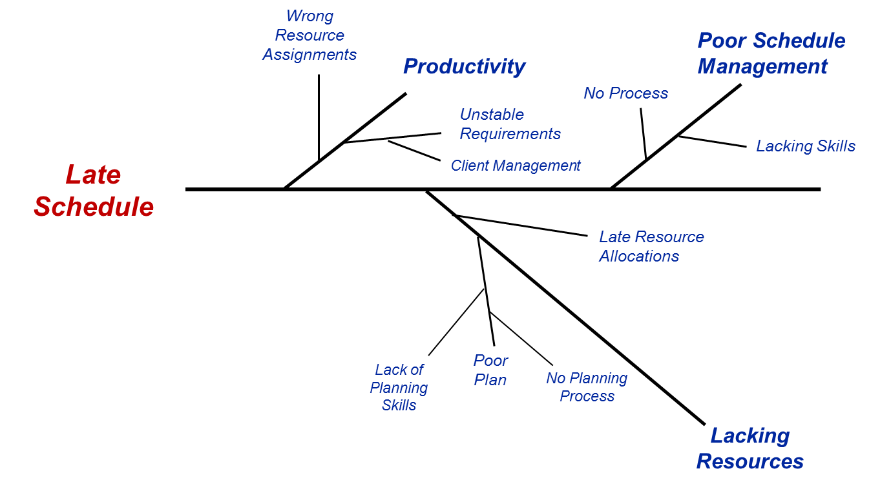

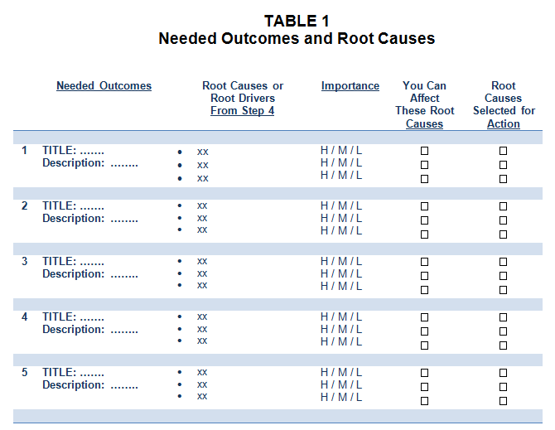
INSTRUCTIONS

In your team, select an approach for determining root causes of the problem or the situation to be improved.

Discuss what root causes exist and enter that information into Table 1 started in Step 3.

Add an overall relative importance rating for each root cause or root driver relative to the other root causes in the table.

<< Back to Contents >>

STEP 5

Select the Root Causes You Can Affect and
Select the Most Important Root Causes

You typically do not have control over all root causes and you can’t boil the ocean, so select the most important things that you can change

This step selects the root causes or root drivers that can be addressed and makes a determination as to the importance of each root topic.

INSTRUCTIONS

Table 1 in Step 3 should now contain needed outcomes, root causes and an importance rating.

Now, select the root causes over which you have some control or can affect.

Then, select the root causes for which you have identified as being important and ones over which you have some level of control.

<< Back to Contents >>

STEP 6

Identify Alternative Solutions that Address the Root Causes and Attain the Needed Outcomes

What are the Different Paths or Ways to get to “The Destination,” i.e. the Desired Outcomes?

This step identifies the optional ways to attain the desired results or outcome.

Background – There are typically multiple ways a given problem can be solved or a given improvement can be accomplished. To employ the best approach, alternative approaches need to be identified and evaluated. This step identifies alternative or optional ways of addressing the “root causes” or “root drivers” to attain the “needed outcomes” now defined in Table 1. Comparisons of alternatives and a selection of the best alternative (or combinations of alternatives) will be accomplished in subsequent steps. See examples below.

Example Alternatives for Problem Resolution
Let’s say that the problem is slow system response times for a system your organization needs and that the root cause has been determined to be both inadequate server capacity and inefficient user interface software. Your alternative solutions might be:
  - Increase server capacity to the point that the inefficient software is much less of an issue, or
  - Modify the software, or
  - Do both of the above, or
  - Outsource the work associated with this system, or
  - Do nothing at this time because the costs and negative impacts of the above alternatives outweigh the benefits (Note that we have yet to determine the costs and impacts of all alternatives, but we are reserving an alternative for doing nothing in case the costs and impacts do not support a change action)

Example Alternatives for Improvement Attainment
Let’s say that the needed improvement relates to increasing the quality of services provided to customers. Your analysis has determined that the root driver of this needed improvement is lacking employee skills. Your alternatives might be:
  - Change hiring practices
  - Provide more employee training
  - Implement a “coaching” approach where senior employees support new employees
  - Provide checklists and templates for employee customer interactions to support consistent quality of delivered services
  - Do a combination of the above
  - Do all of the above
  - Do nothing at this time because the costs or negative impacts of all alternatives outweigh the benefits

INSTRUCTIONS - Review the “Root Causes or Root Drivers” and the “Needed Outcomes” you previously identified in Table 1. Work to identify alternative ways to address these root causes or root drivers and to cause the needed outcomes to exist. Team brainstorming is often a good approach to accomplish this. Do not eliminate any options or alternatives at this time unless they are clearly unfeasible. Less desirable alternatives will be eliminated in subsequent steps.

Capture your alternatives in Table 2 below. Most decisions should have 2 or 3 alternatives at a minimum. Capture as many feasible alternatives as the team identifies.

TABLE 2

Alternative Solutions

 | Alternative | A Few Notes Describing Each Alternative
1 | (Insert statement describing alternative #1) | - xx  - xx  - xx
2 | (Insert statement describing alternative #2) | - xx  - xx  - xx
3 | (Insert statement describing alternative #3) | - xx  - xx  - xx
4 | (Insert statement describing alternative #4) | - xx  - xx  - xx
n | DO NOTHING | State Impacts of NO ACTION  - xx  - xx

<< Back to Contents >>

STEP 7

Optional - Reduce the Set of Alternatives

Reducing the Set of Alternatives if Too Many Exist

If you have only several alternatives, skip this step and proceed to the next step.

If you have many alternatives and want to perform an in-depth comparison on all, skip this step and proceed to the next step.
If you have identified more than 4 or 5 alternatives and want to perform a detailed evaluation for a lesser number of alternatives, filter the current set of alternatives to identify the best candidates for more in-depth comparison. One method to accomplish this is to use one or more simple quad filtering tables.

One common type of quad table is a “Difficulty and Payback” table. This approach compares an estimate of the difficulty in implementing each alternative vs. the associated payback of that alternative. See example.

Another quad filtering table variation is an “Impacts on Stakeholders” table. This approach can be a table that compares the impacts to customers, the organization and employees. See example.

Other table variations can be used.

Instructions
- Select a table type, or select multiple table types, to filter your alternatives.
- Assign your alternative solutions from Table 2 to one of the categories in a selected quad table. This is most commonly done in a team meeting environment.
- As an example using the “Difficulty and Payback” table
  - Select those alternatives that are “EASY to Do and HIGH Payback” for further consideration. If 3 to 5 alternatives are in this category, proceed to the next step. Retain other alternatives for potential future actions.
  - If only 1 or 2 alternatives exist in the “EASY to Do and HIGH Payback” category, consider which alternatives in the “Hard to Do and HIGH Payback” or the “Easy to Do and LOW Payback” categories are the best additional alternatives to be included in your pending alternatives comparison. Those alternatives that are “HARD to Do and LOW Payback” probably offer little value to your efforts and should be discarded unless the team feels their allocation to this category was accomplished in error or if some other value exists to retain these alternatives for now.
  - Review your results from this step with appropriate stakeholders to support good agreement on table contents.
- If you are using multiple quad tables, complete each table separately and then view tables collectively and select the alternatives that the team believes to be the best choices for further detailed evaluation.
- Note that if more than 5 or so alternatives exist, this will make the subsequent detailed evaluations much more time consuming, increasing the risk that the business case team may become overwhelmed with the amount of work required.

Use one or both of the following tables to complete this step.

Table 3A - Alternatives Filtering Table
Difficulty and Payback

Use the following table (3A) to reduce the number of alternatives that will be compared in detail in subsequent steps. Also use table 3B if that helps reduce the set of alternatives.

EASY To Do and HIGH Payback  - Alternative xx  - Alternative xx  - Alternative xx | HARD to Do and HIGH Payback  - Alternative xx  - Alternative xx  - Alternative xx
EASY to Do and LOW Payback  - Alternative xx  - Alternative xx  - Alternative xx | HARD to Do and LOW Payback  - Alternative xx  - Alternative xx  - Alternative xx

Table 3B - Alternatives Filtering Table
Impacts on Stakeholders

All or Mostly Positive Impacts on Customers and Positive Impacts on the Organization and Employees  - Alternative xx  - Alternative xx  - Alternative xx | All or Mostly Positive Impacts on Customers and Some Negative Impacts on the Organization  - Alternative xx  - Alternative xx  - Alternative xx
All or Mostly Positive Impacts on Customers and Some Negative Impacts on Employees  - Alternative xx  - Alternative xx  - Alternative xx | Mostly Negative Impacts on Customers  - Alternative xx  - Alternative xx  - Alternative xx

<< Back to Contents >>

STEP 8

Define Alternative Comparison Criteria and
Collect Comparison Information

Define how the alternatives will be compared

This step is a set of worksheets to collect information for each alternative for a wide variety of comparison criteria. A summary of the information inserted into these worksheets will be inserted into a comparison table in a subsequent step. At this point, it is best to have 3 to 5 alternatives. More can be compared, but comparing more alternatives can be quite difficult and the team may get “lost in the details.”

There Are Multiple Criteria Worksheets Included in This Step

Instructions – Complete the following worksheets, one at a time. If some worksheets clearly do not apply, skip those worksheets. Follow the instructions included in each worksheet. Later you will transfer a summary of the information in these worksheets to a comparison table to compare all alternatives.

8.1. Investment, Resources and Negative Impacts
8.1.1. Financial Analysis - Investment and Resource Needs
8.1.2. State the Risks or Concerns
8.1.3. State the “Most Likely” Negative Impacts on Customers
8.1.4. State the “Most Likely” Negative Impacts on the Organization
8.1.5. State the “Most Likely” Negative Impacts on Employees
8.1.6. State the “Most Likely” Negative Impacts on Other Stakeholders

8.2. Payback and Positive Impacts
8.2.1. Financial Analysis - Payback
8.2.2. State Potential Opportunities
8.2.3. State the “Most Likely” Positive Impacts on Customers
8.2.4. State the “Most Likely” Positive Impacts on the Organization
8.2.5. State the “Most Likely” Positive Impacts on Employees
8.2.6. State the “Most Likely” Positive Impacts on Other Stakeholders

8.3. Additional Alternative Comparison Criteria
8.3.1. State the Alignment with the Organization’s Strategic Information
8.3.2. State Alignment with the Needed Outcomes
8.3.3. State the Estimated Probability of Success and Key Assumptions
8.3.4. State the Feasibility in terms of Technology, Resources, Politics, etc.
8.3.5. State Significant External Environment Factors
8.3.6. State Significant Internal Environment Factors
8.3.7. State Significant Legal or Regulatory Aspects
8.3.8. State Significant External Political or Cultural Aspects
8.3.9. State “Internal Interdependencies”
8.3.10. State “External Interdependencies”

8.1) Investment, Resources and Negative Impacts

8.1.1) Financial Analysis - Investment and Resource Needs

This section is a financial analysis for each alternative to identify short term and long term costs and resource needs. Financial payback is addressed in a subsequent section.

Instructions
- Determine the type of investment information that will be compiled for each alternative.
- Collect and calculate selected investment information for each alternative and enter in the worksheet sections that follow.

ALTERNATIVE 1

(Example Only – Use Your Financial Analysis Information Categories)

New Costs, Investment (example categories only)
- Non-Recurring or Development Costs, Short Term
- Non-Recurring or Development Costs, Long Term
- Recurring or Operational Costs, Short Term
- Recurring or Operational Costs, Long Term
- Tax Implications, Short and Long Term
- (other financial factors such as cost of money, exchange rates, incentives, etc.)
- Year 1 Costs
- Year 2 Costs
- …..
- Year n Costs

Resources Needed for this Alternative
- Personnel - xx
- Facilities - xx
- Special Support - xx
- Other - xx
- Other - xx

ALTERNATIVE 2

(Enter cost information and resource needs for this alternative)

------------

ALTERNATIVE “n”

(Enter cost information and resource needs for this alternative)

“Take No Action” ALTERNATIVE

(Enter cost information and resources that will be expended if no action is taken and costs happen and resources are expended.)

8.1.2) State Risks or Concerns for Alternatives

What concerns or risks exist for each alternative?

Instructions
- Identify the top risks for each alternative in the tables below. Include estimated possible impacts and an estimated probability of occurrence for each risk as that is possible.
- Consider having stakeholders external to the business case team provide input to this risk identification step.

Alternative #1 Risks

 | Risk | Possible Impacts | Estimated Probability | Notes
1 | xx | xx | H / M / L | xx
2 | xx | xx | H / M / L | xx
3 | xx | xx | H / M / L | xx
4 | xx | xx | H / M / L | xx

Alternative #2 Risks

 | Risk | Possible Impacts | Estimated Probability | Notes
1 | xx | xx | H / M / L | xx
2 | xx | xx | H / M / L | xx
3 | xx | xx | H / M / L | xx
4 | xx | xx | H / M / L | xx

Alternative #n Top Risks

 | Risk | Possible Impacts | Estimated Probability | Notes
1 | xx | xx | H / M / L | xx
2 | xx | xx | H / M / L | xx
3 | xx | xx | H / M / L | xx
4 | xx | xx | H / M / L | xx

Take No Action Top Risks

 | Risk | Possible Impacts | Estimated Probability | Notes
1 | xx | xx | H / M / L | xx
2 | xx | xx | H / M / L | xx
3 | xx | xx | H / M / L | xx
4 | xx | xx | H / M / L | xx

8.1.3) State the “Most Likely” Negative Impacts on Customers

How will the customers be negatively impacted for each alternative?
(Note that positive impacts are included in a different section.)

Instructions
- Identify all negative impacts to customers for each alternative.

Alternative #1
- Negative Impacts on Customers – Short Term
  - …yyy….
  - …yyy….
- Negative Impacts on Customers – Long Term
  - …yyy….
  - …yyy….

Alternative #2
- Negative Impacts on Customers – Short Term
  - …yyy….
  - …yyy….
- Negative Impacts on Customers – Long Term
  - …yyy….
  - …yyy….

------------------

Alternative #n
- Negative Impacts on Customers – Short Term
  - …yyy….
  - …yyy….
- Negative Impacts on Customers – Long Term
  - …yyy….
  - …yyy….

“Take No Action” Alternative
- Negative Impacts on Customers – Short Term
  - …yyy….
  - …yyy….
- Negative Impacts on Customers – Long Term
  - …yyy….
  - …yyy….

8.1.4) State the “Most Likely” Negative Impacts on the Organization

How will the organization be negatively impacted by each alternative?
(Note that positive impacts are included in a different section.)

Instructions
- Identify all negative impacts to the organization for each alternative.

Alternative #1
- Anticipated Negative Impacts on the Organization’s Productivity
  - Short Term Impacts are …..yyyy…..
  - Long Term Impacts are …..yyyy…..
- Anticipated Negative Impacts on the Organization’s Teamwork, Communication and Cohesiveness
  - Short Term Impacts are …..yyyy…..
  - Long Term Impacts are …..yyyy…..
- Anticipated Negative Impacts on Organization Processes
- Anticipated Negative Impacts on Organization Systems
- Anticipated Negative Impacts on Organization Structure and Roles
- Other Negative Impacts on the Organization ……

Will this alternative inject a level of volatility into organization operations?

☐ No Short Term Volatility Impacts
☐ Minor Short Term Volatility Impacts
☐ Significant Short Term Volatility Impacts and these would be ………..

☐ No Long Term Volatility Impacts
☐ Minor Long Term Volatility Impacts
☐ Significant Long Term Volatility Impacts and these would be ………..

Alternative #2
- Anticipated Negative Impacts on the Organization’s Productivity
  - Short Term Impacts are …..yyyy…..
  - Long Term Impacts are …..yyyy…..
- Anticipated Negative Impacts on the Organization’s Teamwork, Communication and Cohesiveness
  - Short Term Impacts are …..yyyy…..
  - Long Term Impacts are …..yyyy…..
- Anticipated Negative Impacts on Organization Processes
- Anticipated Negative Impacts on Organization Systems
- Anticipated Negative Impacts on Organization Structure and Roles
- Other Negative Impacts on the Organization ……

Will this alternative inject a level of volatility into organization operations?

☐ No Short Term Volatility Impacts
☐ Minor Short Term Volatility Impacts
☐ Significant Short Term Volatility Impacts and these would be ………..

☐ No Long Term Volatility Impacts
☐ Minor Long Term Volatility Impacts
☐ Significant Long Term Volatility Impacts and these would be ………..

Alternative #n
- Anticipated Negative Impacts on the Organization’s Productivity
  - Short Term Impacts are …..yyyy…..
  - Long Term Impacts are …..yyyy…..
- Anticipated Negative Impacts on the Organization’s Teamwork, Communication and Cohesiveness
  - Short Term Impacts are …..yyyy…..
  - Long Term Impacts are …..yyyy…..
- Anticipated Negative Impacts on Organization Processes
- Anticipated Negative Impacts on Organization Systems
- Anticipated Negative Impacts on Organization Structure and Roles
- Other Negative Impacts on the Organization ……

Will this alternative inject a level of volatility into organization operations?

☐ No Short Term Volatility Impacts
☐ Minor Short Term Volatility Impacts
☐ Significant Short Term Volatility Impacts and these would be ………..

☐ No Long Term Volatility Impacts
☐ Minor Long Term Volatility Impacts
☐ Significant Long Term Volatility Impacts and these would be ………..

“Take No Action” Alternative
- Anticipated Negative Impacts on the Organization’s Productivity
  - Short Term Impacts are …..yyyy…..
  - Long Term Impacts are …..yyyy…..
- Anticipated Negative Impacts on the Organization’s Teamwork, Communication and Cohesiveness
  - Short Term Impacts are …..yyyy…..
  - Long Term Impacts are …..yyyy…..
- Anticipated Negative Impacts on Organization Processes
- Anticipated Negative Impacts on Organization Systems
- Anticipated Negative Impacts on Organization Structure and Roles
- Other Negative Impacts on the Organization ……

Will this alternative inject a level of volatility into organization operations?

☐ No Short Term Volatility Impacts
☐ Minor Short Term Volatility Impacts
☐ Significant Short Term Volatility Impacts and these would be ………..

☐ No Long Term Volatility Impacts
☐ Minor Long Term Volatility Impacts
☐ Significant Long Term Volatility Impacts and these would be ………..

8.1.5) State the “Most Likely” Negative Impacts on Employees

How will employees be negatively impacted by each alternative?
(Note that positive impacts are included in a different section.)

Instructions
- Identify all negative impacts to employees here for each alternative.

Alternative #1
- Negative Impacts on Employees – Short Term
  - …yyy….
  - …yyy….
- Negative Impacts on Employees – Long Term
  - …yyy….
  - …yyy….

Alternative #2
- Negative Impacts on Employees – Short Term
  - …yyy….
  - …yyy….
- Negative Impacts on Employees – Long Term
  - …yyy….
  - …yyy….

Alternative #n
- Negative Impacts on Employees – Short Term
  - …yyy….
  - …yyy….
- Negative Impacts on Employees – Long Term
  - …yyy….
  - …yyy….

“Take No Action” Alternative
- Negative Impacts on Employees – Short Term
  - …yyy….
  - …yyy….
- Negative Impacts on Employees – Long Term
  - …yyy….
  - …yyy….

8.1.6) State the “Most Likely” Negative Impacts on Other Stakeholders

How will stakeholders beyond the organization, customers and employees be negatively impacted by each alternative?
(Note that positive impacts are included in a different section.)

Instructions
- Identify “Other Stakeholders” directly involved in addition to the organization, customers and employees
- Identify negative impacts to these other stakeholders.
- Consider short team and long term potential impacts

Alternative #1
- Anticipated Negative Impacts on Society as a Whole
- Anticipated Negative Impacts on Stakeholder A
- Anticipated Negative Impacts on Stakeholder B
- Anticipated Negative Impacts on Stakeholder C

Alternative #2
- Anticipated Negative Impacts on Society as a Whole
- Anticipated Negative Impacts on Stakeholder A
- Anticipated Negative Impacts on Stakeholder B
- Anticipated Negative Impacts on Stakeholder C

Alternative #n
- Anticipated Negative Impacts on Society as a Whole
- Anticipated Negative Impacts on Stakeholder A
- Anticipated Negative Impacts on Stakeholder B
- Anticipated Negative Impacts on Stakeholder C

“Take No Action” Alternative
- Anticipated Negative Impacts on Society as a Whole
- Anticipated Negative Impacts on Stakeholder A
- Anticipated Negative Impacts on Stakeholder B
- Anticipated Negative Impacts on Stakeholder C

8.2) Payback and Positive Impacts

8.2.1) Financial Analysis - Payback

This section is a financial analysis for each alternative to identify short term and long term payback.

Instructions
- Determine the type of investment information that will be compiled for each alternative.
- Collect or calculate selected payback information for each alternative and enter in the worksheet sections that follow.

ALTERNATIVE 1

(Example Only – Use Your Financial Analysis Format and Information Categories)

- Increased Revenue / Cost Savings / Other Financial Advantages
- Year 1 Financial Increase
- Year 2 Financial Increase
- …..
- Year n Financial Increase

Net Financial Outcome, Payback
- Year 1 Net
- Year 2 Net
- …..
- Year n Net

ALTERNATIVE 2

(Enter payback information for this alternative)

------------

ALTERNATIVE “n”

(Enter payback information for this alternative)

“Take No Action” ALTERNATIVE

(Enter positive financial information for taking no action)

8.2.2) State Potential Opportunities

What opportunities might exist for each alternative beyond the “Needed Outcomes” defined earlier?

Examples might be future business opportunities, setting the foundation for entry into new market areas, setting the foundation for future improvements or supporting or fulfilling adjacent strategic interests.

Instructions
- Identify potential opportunities for each alternative below.
- Consider having stakeholders external to the business case team provide input.
- Move the most important opportunities into the “ALTERNATIVES COMPARISON TABLE.”

The following opportunities may exist:

- Opportunities for Alternative #1
  - xx
  - xx

- Opportunities for Alternative #2
  - xx
  - xx

---------

- Opportunities for Alternative #n
  - xx
  - xx

- Opportunities for “Take No Action” Alternative, If Any Exist
  - xx
  - xx

8.2.3) State the “Most Likely” Positive Impacts on Customers

How will the customers be positively impacted for each alternative?

Instructions
- Identify positive impacts to customers in the worksheet sections below.

Alternative #1
- Positive Impacts on Customers – Short Term
  - …yyy….
  - …yyy….
- Positive Impacts on Customers – Long Term
  - …yyy….
  - …yyy….

Alternative #2
- Positive Impacts on Customers – Short Term
  - …yyy….
  - …yyy….
- Positive Impacts on Customers – Long Term
  - …yyy….
  - …yyy….

------------------

Alternative #n
- Positive Impacts on Customers – Short Term
  - …yyy….
  - …yyy….
- Positive Impacts on Customers – Long Term
  - …yyy….
  - …yyy….

“Take No Action” Alternative
- Positive Impacts on Customers – Short Term
  - …yyy….
  - …yyy….
- Positive Impacts on Customers – Long Term
  - …yyy….
  - …yyy….

8.2.4) State the “Most Likely” Positive Impacts on the Organization

How will the organization be positively impacted by each alternative?

Instructions
- Identify positive impacts to the organization in the worksheet sections below that are in addition to the financial payback information noted earlier.

Alternative #1
- Anticipated Positive Impacts on the Organization’s Productivity
  - Short Term Impacts are …..yyyy…..
  - Long Term Impacts are …..yyyy…..
- Anticipated Positive Impacts on the Organization’s Teamwork, Communication and Cohesiveness
  - Short Term Impacts are …..yyyy…..
  - Long Term Impacts are …..yyyy…..
- Anticipated Positive Impacts on Organization Processes
- Anticipated Positive Impacts on Organization Systems
- Anticipated Positive Impacts on Organization Structure and Roles
- Other Anticipated Positive Impacts on the Organization ….

Will this alternative reduce the level of volatility in organization operations?

☐ No Short Term Volatility Reductions
☐ Minor Short Term Volatility Reductions
☐ Significant Short Term Volatility Reductions Impacts and these would be ……

☐ No Long Term Volatility Reductions
☐ Minor Long Term Volatility Reductions
☐ Significant Long Term Volatility Reductions and these would be ………..

Alternative #2
- Anticipated Positive Impacts on the Organization’s Productivity
  - Short Term Impacts are …..yyyy…..
  - Long Term Impacts are …..yyyy…..
- Anticipated Positive Impacts on the Organization’s Teamwork, Communication and Cohesiveness
  - Short Term Impacts are …..yyyy…..
  - Long Term Impacts are …..yyyy…..
- Anticipated Positive Impacts on Organization Processes
- Anticipated Positive Impacts on Organization Systems
- Anticipated Positive Impacts on Organization Structure and Roles
- Other Anticipated Positive Impacts on the Organization ….

Will this alternative reduce the level of volatility in organization operations?

☐ No Short Term Volatility Reductions
☐ Minor Short Term Volatility Reductions
☐ Significant Short Term Volatility Reductions Impacts and these would be ……

☐ No Long Term Volatility Reductions
☐ Minor Long Term Volatility Reductions
☐ Significant Long Term Volatility Reductions and these would be ………..

Alternative #n
- Anticipated Positive Impacts on the Organization’s Productivity
  - Short Term Impacts are …..yyyy…..
  - Long Term Impacts are …..yyyy…..
- Anticipated Positive Impacts on the Organization’s Teamwork, Communication and Cohesiveness
  - Short Term Impacts are …..yyyy…..
  - Long Term Impacts are …..yyyy…..
- Anticipated Positive Impacts on Organization Processes
- Anticipated Positive Impacts on Organization Systems
- Anticipated Positive Impacts on Organization Structure and Roles
- Other Anticipated Positive Impacts on the Organization ….

Will this alternative reduce the level of volatility in organization operations?

☐ No Short Term Volatility Reductions
☐ Minor Short Term Volatility Reductions
☐ Significant Short Term Volatility Reductions Impacts and these would be ……

☐ No Long Term Volatility Reductions
☐ Minor Long Term Volatility Reductions
☐ Significant Long Term Volatility Reductions and these would be ………..

“Take No Action” Alternative
- Anticipated Positive Impacts on the Organization’s Productivity
  - Short Term Impacts are …..yyyy…..
  - Long Term Impacts are …..yyyy…..
- Anticipated Positive Impacts on the Organization’s Teamwork, Communication and Cohesiveness
  - Short Term Impacts are …..yyyy…..
  - Long Term Impacts are …..yyyy…..
- Anticipated Positive Impacts on Organization Processes
- Anticipated Positive Impacts on Organization Systems
- Anticipated Positive Impacts on Organization Structure and Roles
- Other Anticipated Positive Impacts on the Organization ….

Will this alternative reduce the level of volatility in organization operations?

☐ No Short Term Volatility Reductions
☐ Minor Short Term Volatility Reductions
☐ Significant Short Term Volatility Reductions Impacts and these would be ……

☐ No Long Term Volatility Reductions
☐ Minor Long Term Volatility Reductions
☐ Significant Long Term Volatility Reductions and these would be ………..

8.2.5) State the “Most Likely” Positive Impacts on Employees

How will employees be positively impacted by each alternative?

Instructions
- Identify positive impacts to employees in the worksheet sections below.

Alternative #1
- Positive Impacts on Employees – Short Term
  - …yyy….
  - …yyy….
- Positive Impacts on Employees – Long Term
  - …yyy….
  - …yyy….

Alternative #2
- Positive Impacts on Employees – Short Term
  - …yyy….
  - …yyy….
- Positive Impacts on Employees – Long Term
  - …yyy….
  - …yyy….

Alternative #n
- Positive Impacts on Employees – Short Term
  - …yyy….
  - …yyy….
- Positive Impacts on Employees – Long Term
  - …yyy….
  - …yyy….

“Take No Action” Alternative
- Positive Impacts on Employees – Short Term
  - …yyy….
  - …yyy….
- Positive Impacts on Employees – Long Term
  - …yyy….
  - …yyy….

8.2.6) State the “Most Likely” Positive Impacts on Other Stakeholders

How will stakeholders beyond the organization, customers and employees be positively impacted by each alternative?

Instructions
- Identify “Other Stakeholders” directly involved aside from customers, the organization and employees
- Identify positive impacts to these other stakeholders in the worksheet sections below.

Alternative #1
- Anticipated Positive Impacts on Stakeholder A
- Anticipated Positive Impacts on Stakeholder B
- Anticipated Positive Impacts on Stakeholder C

Alternative #2
- Anticipated Positive Impacts on Stakeholder A
- Anticipated Positive Impacts on Stakeholder B
- Anticipated Positive Impacts on Stakeholder C

Alternative #n
- Anticipated Positive Impacts on Stakeholder A
- Anticipated Positive Impacts on Stakeholder B
- Anticipated Positive Impacts on Stakeholder C

“Take No Action” Alternative
- Anticipated Positive Impacts on Stakeholder A
- Anticipated Positive Impacts on Stakeholder B
- Anticipated Positive Impacts on Stakeholder C

8.3) Additional Comparison Criteria

Many factors may exist that will affect the business case analysis and decision in addition to the investment, payback and stakeholder impacts stated above. The following sections represent common additional criteria that the business case may need to consider.

Instructions
- Read the following criteria topics and their descriptions and make notes in each section about how that topic relates to this business case.
- Where differences exist for the different alternatives being considered, note those differences. “Highlight” any significant differences that exist for different alternatives that will be important for your subsequent alternative selection.

8.3.1) The Alignment of the Organization’s Strategic Information to Each Alternative

Answer the following question: “How do the organization’s mission, vision, strategic plan and priorities align with each proposed alternative?”

Alternative #1
- ☐ This alternative aligns well with strategic needs including
  - xx
  - xx
- ☐ This alternative aligns somewhat with strategic needs including
  - xx
  - xx
- ☐ This alternative does NOT align well with strategic needs but is important because
  - xx
  - xx

Alternative #2
- ☐ This alternative aligns well with strategic needs including
  - xx
  - xx
- ☐ This alternative aligns somewhat with strategic needs including
  - xx
  - xx
- ☐ This alternative does NOT align well with strategic needs but is important because
  - xx
  - xx

-----------------

Alternative #n
- ☐ This alternative aligns well with strategic needs including
  - xx
  - xx
- ☐ This alternative aligns somewhat with strategic needs including
  - xx
  - xx
- ☐ This alternative does NOT align well with strategic needs but is important because
  - xx
  - xx

“Take No Action” Alternative
- ☐ This alternative aligns well with strategic needs including
  - xx
  - xx
- ☐ This alternative aligns somewhat with strategic needs including
  - xx
  - xx
- ☐ This alternative does NOT align well with strategic needs but is important because
  - xx
  - xx

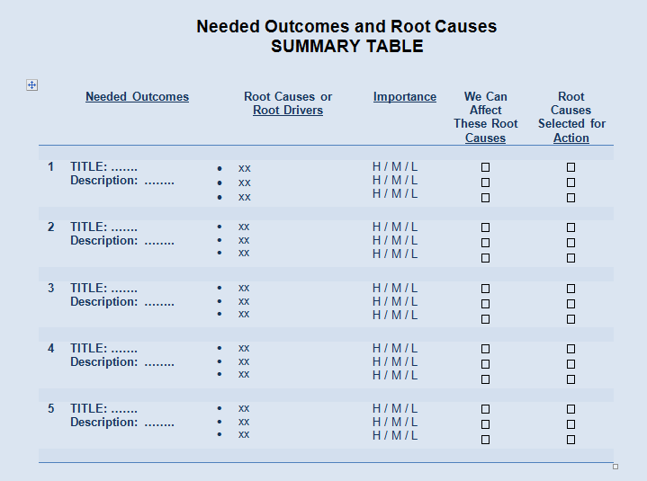
8.3.2) Alignment with Needed Outcomes

This section compares how each alternative matches or does not match the needed outcomes defined earlier.

Instructions – Review the previously defined “Needed Outcomes” in Table 1, and copy the top “Needed Outcomes” into Table 4 below. Then enter how each alternative meets or does not meet these needed outcomes.

Table 4

Alternative #1 and Needed Outcomes

 | Needed Outcome | How This Alternative Meets this Outcome | Notes or Clarifications
1 | (Needed Outcome #1) | ☐ Meets Outcome  ☐ Partially Meets Outcome  ☐ Does Not Meet Outcome | - xx  - xx
2 | (Needed Outcome #2) | ☐ Meets Outcome  ☐ Partially Meets Outcome  ☐ Does Not Meet Outcome | - xx  - xx
3 | (Needed Outcome #3) | ☐ Meets Outcome  ☐ Partially Meets Outcome  ☐ Does Not Meet Outcome | - xx  - xx
4 | (Needed Outcome #4) | ☐ Meets Outcome  ☐ Partially Meets Outcome  ☐ Does Not Meet Outcome | - xx  - xx

Alternative #2 and Needed Outcomes

 | Needed Outcome | How This Alternative Meets this Outcome | Notes or Clarifications
1 | (Needed Outcome #1) | ☐ Meets Outcome  ☐ Partially Meets Outcome  ☐ Does Not Meet Outcome | - xx  - xx
2 | (Needed Outcome #2) | ☐ Meets Outcome  ☐ Partially Meets Outcome  ☐ Does Not Meet Outcome | - xx  - xx
3 | (Needed Outcome #3) | ☐ Meets Outcome  ☐ Partially Meets Outcome  ☐ Does Not Meet Outcome | - xx  - xx
4 | (Needed Outcome #4) | ☐ Meets Outcome  ☐ Partially Meets Outcome  ☐ Does Not Meet Outcome | - xx  - xx

Alternative #n and Needed Outcomes

 | Needed Outcome | How This Alternative Meets this Outcome | Notes or Clarifications
1 | (Needed Outcome #1) | ☐ Meets Outcome  ☐ Partially Meets Outcome  ☐ Does Not Meet Outcome | - xx  - xx
2 | (Needed Outcome #2) | ☐ Meets Outcome  ☐ Partially Meets Outcome  ☐ Does Not Meet Outcome | - xx  - xx
3 | (Needed Outcome #3) | ☐ Meets Outcome  ☐ Partially Meets Outcome  ☐ Does Not Meet Outcome | - xx  - xx
4 | (Needed Outcome #4) | ☐ Meets Outcome  ☐ Partially Meets Outcome  ☐ Does Not Meet Outcome | - xx  - xx

“Take No Action” Alternative and Needed Outcomes - OPTIONAL
(Complete this table only if comments in table make sense and provide value for the decision process as it is presumed that taking no action will not attain any needed outcomes)

 | Needed Outcome | How This Alternative Meets this Outcome | Notes or Clarifications
1 | (Needed Outcome #1) | ☐ Meets Outcome  ☐ Partially Meets Outcome  ☐ Does Not Meet Outcome | - xx  - xx
2 | (Needed Outcome #2) | ☐ Meets Outcome  ☐ Partially Meets Outcome  ☐ Does Not Meet Outcome | - xx  - xx
3 | (Needed Outcome #3) | ☐ Meets Outcome  ☐ Partially Meets Outcome  ☐ Does Not Meet Outcome | - xx  - xx
4 | (Needed Outcome #4) | ☐ Meets Outcome  ☐ Partially Meets Outcome  ☐ Does Not Meet Outcome | - xx  - xx

8.3.3) State the Estimated Probability of Success and Key Assumptions

This step is an estimate the probability of success of each alternative and includes what conditions are related to that success probability estimate. Your estimate is most often a guess formed by discussion with your team.

Instructions
- Make an estimate of the probability of success for each alternative in qualitative or quantitative terms.
- Identify any conditions or assumptions associated with this estimate.

Alternative #1
- Probability of Success Estimate is ………….. xx% or aa% to bb% or H / M / L
- The above success probability estimate is based on the following assumptions or conditions being true:
  - Condition 1 ……………………
  - Condition 2 ……………………
  - Condition 3 ……………………

Alternative #2
- Probability of Success Estimate is ………….. xx% or aa% to bb% or H / M / L
- The above success probability estimate is based on the following assumptions or conditions being true:
  - Condition 1 ……………………
  - Condition 2 ……………………
  - Condition 3 ……………………

………………………..

Alternative #n
- Probability of Success Estimate is ………….. xx% or aa% to bb% or H / M / L
- The above success probability estimate is based on the following assumptions or conditions being true:
  - Condition 1 ……………………
  - Condition 2 ……………………
  - Condition 3 ……………………

“Take No Action” Alternative - (Does Not Apply)

8.3.4) State the Feasibility of Alternatives in terms of Technology, Resources, Politics, etc.

This step is an estimate of the feasibility of the alternative solutions, a critical comparison criteria.

Instructions
- Answer the question “Is this project feasible?” from perspectives of technology, resources, politics and other contributing factors.

Alternative #1
- Technology – Considering needed technologies, this alternative
☐ Is not feasible because ……………
☐ Could be feasible if …………………………..
☐ Is feasible
- Funding – Considering needed funding and the availability of funding, this alternative
☐ Is not feasible because ……………
☐ Could be feasible if …………………………..
☐ Is feasible
- Politics – Considering politics, this alternative
☐ Is not feasible because ……………
☐ Could be feasible if …………………………..
☐ Is feasible
- Resources – Considering needed resources, this alternative
☐ Is not feasible because ……………
☐ Could be feasible if …………………………..
☐ Is feasible
- (Other) – Considering (Other), this alternative
☐ Is not feasible because ……………
☐ Could be feasible if …………………………..
☐ Is feasible

Feasibility Comments:

Alternative #2
- Technology – Considering needed technologies, this alternative
☐ Is not feasible because ……………
☐ Could be feasible if …………………………..
☐ Is feasible
- Funding – Considering needed funding and the availability of funding, this alternative
☐ Is not feasible because ……………
☐ Could be feasible if …………………………..
☐ Is feasible
- Politics – Considering politics, this alternative
☐ Is not feasible because ……………
☐ Could be feasible if …………………………..
☐ Is feasible
- Resources – Considering needed resources, this alternative
☐ Is not feasible because ……………
☐ Could be feasible if …………………………..
☐ Is feasible
- (Other) – Considering (Other), this alternative
☐ Is not feasible because ……………
☐ Could be feasible if …………………………..
☐ Is feasible

Feasibility Comments:

………………………..

Alternative #n
- Technology – Considering needed technologies, this alternative
☐ Is not feasible because ……………
☐ Could be feasible if …………………………..
☐ Is feasible
- Funding – Considering needed funding and the availability of funding, this alternative
☐ Is not feasible because ……………
☐ Could be feasible if …………………………..
☐ Is feasible
- Politics – Considering politics, this alternative
☐ Is not feasible because ……………
☐ Could be feasible if …………………………..
☐ Is feasible
- Resources – Considering needed resources, this alternative
☐ Is not feasible because ……………
☐ Could be feasible if …………………………..
☐ Is feasible
- (Other) – Considering (Other), this alternative
☐ Is not feasible because ……………
☐ Could be feasible if …………………………..
☐ Is feasible

Feasibility Comments:

“Take No Action” Alternative Feasibility
- Is taking no action a feasible alternative?
  - ☐ Is not feasible because ……………
  - ☐ Could be feasible if …………………………..
  - ☐ Is feasible
- Politics – Considering politics, taking no action
☐ Is not feasible because ……………
☐ Could be feasible if …………………………..
☐ Is feasible
- Considering Other Factors (insert other factors……) then taking no action
☐ Is not feasible because ……………
☐ Could be feasible if …………………………..
☐ Is feasible

Feasibility Comments:

8.3.5) State Significant External Environment Factors Directly Affecting this Decision

Instructions –
- In Part A below, identity the most significant factors that should be considered as a part of this business case. Include only those factors that directly affect the pending decision.
- In Part B below, add notes for each alternative solution where that solution is impacted by or impacts the factors selected in Part A.

PART A

- Marketplace Driving Factors
☐ None
☐ Some, but not critical to this business case decision
☐ Some and they are important to this business case and they include:
    - xx
    - xx

- Customer Related Driving Factors
☐ None
☐ Some, but not critical to this business case decision
☐ Some and they are important to this business case and they include:
    - xx
    - xx

- Competitor Related Driving Factors
☐ None
☐ Some, but not critical to this business case decision
☐ Some and they are important to this business case and they include:
    - xx
    - xx

- Financial Environment Driving Factors
☐ None
☐ Some, but not critical to this business case decision
☐ Some and they are important to this business case and they include:
    - xx
    - xx

- Technology Environment Driving Factors
☐ None
☐ Some, but not critical to this business case decision
☐ Some and they are important to this business case and they include:
    - xx
    - xx

- Societal Driving Factors
☐ None
☐ Some, but not critical to this business case decision
☐ Some and they are important to this business case and they include:
    - xx
    - xx

- Political Driving Factors
☐ None
☐ Some, but not critical to this business case decision
☐ Some and they are important to this business case and they include:
    - xx
    - xx

- (Other Driving Factors) …………………..
    - xx
    - xx

- (Other Driving Factors) …………………..
    - xx
    - xx

PART B

External Environment Factors – Marketplace, Competitors, Global Economy, Technology Trends – Add notes for each alternative solution where that solution is impacted or impacts the factors selected in Part A above.

  - Alternative #1 Notes
    - xx….
  - Alternative #2 Notes
    - xx ….
  - Alternative #n Notes
    - xx ….
  - “Take No Acttion” Alternative Notes
    - xx ….

8.3.6) State Significant Internal Environment Factors Directly Affecting this Decision

Instructions –
- In Part A below, identity the most significant factors that should be considered as a part of this business case. Include only those factors that directly affect the pending decision.
- In Part B below, add notes for each alternative solution where that solution is impacted by or impacts the factors selected in Part A.

Examples
- Internal Competition for Funding or Management Support
- Parallel Internal Projects
- Internal Politics, Organization Culture, Viewpoints or Agendas
- Stability or Volatility of Internal Decisions, Funding or Directions
- Organization Current Priorities or Challenges
- Significant Initiatives
- Organization Structure, Current or Anticipated Structure Changes

PART A

Note Internal Environment Factors Directly Affecting this Decision
- xx
- xx
- xx

PART B

Internal Environment Factors – Competition for funding, politics, stability of decisions, etc.

  - Alternative #1 Notes
    - xx….
  - Alternative #2 Notes
    - xx ….
  - Alternative #n Notes
    - xx ….
  - “Take No Acttion” Alternative Notes
    - xx ….

8.3.7) State Significant Legal or Regulatory Situations Directly Affecting this Business Case

Instructions –
- In Part A below, identity the most significant factors that should be considered as a part of this business case. Include only those factors that directly affect the pending decision.
- In Part B below, add notes for each alternative solution where that solution is impacted by or impacts the factors selected in Part A.

PART A

☐ None Known
☐ Some Known, But these are Not Significant Factors in this Decision
☐ Some Known and Should Be Considered, Those Noted Below

Local Legal or Regulatory Considerations - ……xxx…..

State Legal or Regulatory Considerations - ……xxx…..

Federal Legal or Regulatory Considerations - ……xxx…..

International Legal or Regulatory Considerations - ……xxx…..

PART B

Add notes for each alternative solution where that solution is impacted or impacts the factors noted in Part A above.

Legal or Regulatory Factors – New Legislation, Regulatory Changes, etc.

  - Alternative #1 Notes
    - xx….
  - Alternative #2 Notes
    - xx ….
  - Alternative #n Notes
    - xx ….
  - “Take No Acttion” Alternative Notes
    - xx ….

8.3.8) State Significant External Political or Cultural Situations Directly Affecting this Business Case

Instructions –
- In Part A below, identity the most significant factors that should be considered as a part of this business case. Include only those factors that directly affect the pending decision.
- In Part B below, add notes for each alternative solution where that solution is impacted by or impacts the factors selected in Part A.

PART A

☐ None Known
☐ Some Known, but these are Not Significant Factors in this Analysis
☐ Some Known and Should Be Considered, Those Noted Below

Local Political Considerations - ……xxx…..

State Political or Considerations - ……xxx…..

Federal Political Considerations - ……xxx…..

International Political Considerations - ……xxx…..

Cultural Considerations - ……xxx…..

PART B

Add notes for each alternative solution where that solution is impacted or impacts the factors noted in Part A above.

External Political or Cultural Considerations – Local, State and Federal Considerations

  - Alternative #1 Notes
    - xx….
  - Alternative #2 Notes
    - xx ….
  - Alternative #n Notes
    - xx ….
  - “Take No Acttion” Alternative Notes
    - xx ….

8.3.9) State “Internal Interdependencies” Affecting this Business Case

Background - “Internal Interdependencies” are relationships with other parts of the organization that affect a given effort or decision.

Examples of Internal Interdependencies
- A work product produced by one project and needed by another project
- A new process or new system being developed or implemented and how that new process or system integrates with existing processes and systems
- Sharing of limited critical resources
All of these examples are relationships between efforts and would be considered “Internal Interdependencies.” These conditions would affect the definition or execution of all efforts involved and can be driving factors in a business case decision.

Instructions –
- In Part A below, identity the most significant factors that should be considered as a part of this business case. Include only those factors that directly affect the pending decision.
- In Part B below, add notes for each alternative solution where that solution is impacted by or impacts the factors selected in Part A.

PART A

☐ No Internal Interdependencies Exist
☐ Some Exist, But these are Not Significant to this Business Case
☐ Important Internal Interdependencies Exist for this Business Case, Those Noted Below

- Internal Interdependency 1 - ….xxx…..

- Internal Interdependency 2 - ….xxx…..

…………………….

- Internal Interdependency “n” - ….xxx…..

PART B

Add notes for each alternative solution where that solution is impacted or impacts the factors noted in Part A above.

Internal Interdependencies – Shared resources, products or processes needed by one project from another, etc.

  - Alternative #1 Notes
    - xx….
  - Alternative #2 Notes
    - xx ….
  - Alternative #n Notes
    - xx ….
  - “Take No Acttion” Alternative Notes
    - xx ….

8.3.10) State “External Interdependencies” Affecting this Business Case

Background - “External Interdependencies” are relationships with entities external to the given organization that are needed to complete a given effort and/or affect a decision.

Examples of External Interdependencies
- A mutual development effort between your organization and an external partner
- A shared R&D activity with another business or organization
- A business partnership allocation of work scope for a given effort
- An approval relationship with a government regulatory agency
- External financing organizations
All of these examples would be “External Interdependencies” and would affect the definition of a given effort. As such, these external interdependencies can be a driving factor in a business case decision.

Instructions –
- In Part A below, identity the most significant factors that should be considered as a part of this business case. Include only those factors that directly affect the pending decision.
- In Part B below, add notes for each alternative solution where that solution is impacted by or impacts the factors selected in Part A.

PART A

☐ No External Interdependencies Exist
☐ Some Exist, But these are Not Significant to this Business Case
☐ External Interdependencies Exist that Affect this Business Case, Those Noted Below

- External Interdependency with Organization A - ….xxx…..

- External Interdependency with Organization B - ….xxx…..

- External Interdependency with Organization C - ….xxx…..

PART B

Add notes for each alternative solution where that solution is impacted or impacts the factors noted in Part A above.

Internal Interdependencies – Shared resources, products or processes needed by one project from another, etc.

  - Alternative #1 Notes
    - xx….
  - Alternative #2 Notes
    - xx ….
  - Alternative #n Notes
    - xx ….
  - “Take No Acttion” Alternative Notes
    - xx ….

- Other Significant Criteria ______________

  - Alternative #1 Notes
    - xx….
  - Alternative #2 Notes
    - xx ….
  - Alternative #n Notes
    - xx ….
  - “Take No Acttion” Alternative Notes
    - xx ….

<< Back to Contents >>

STEP 9

Build Alternatives Comparison Table and Enter Comparison Information

This step is the generation of the comparison table that will be used to compare the alternative solutions. This table will use the criteria and notes completed in Step 8.

At this point, the business case effort should have completed the following:
- Background Steps 1 to 5 complete
- 2 to 5 identified alternative solutions from Steps 6 & 7
- Alternative comparison information collected as notes in Step 8 worksheets

Instructions

- Modify Table 5 Structure
    - Review the “Alternatives Comparison Table” (Table 5) in this step and add or delete columns in the table as needed to make room for all alternatives to be compared, add alternative titles
    - Add any additional criteria needed for this business case comparison that is not included in this table into row 8.3.11
    - Delete any table rows if some criteria in the table will not be used (or leave that row in place and add a note that the criteria is not being utilized; this way if things change, the criteria is still in the table)
- Enter Comparison Information Into the Table
    - Enter criteria information for each alternative and each criteria from your notes in Step 8
    - It is recommended to take one comparison criteria at a time (example “8.1.1 Financial Analysis”) and enter a summary of the notes you made in Step 8 (example section 8.1.1) for each alternative into the table
    - Repeat this action for all criteria in the table
- Enter Criteria Importance Information
    - For each criteria, note if the given criteria is of “high” importance relative to other criteria; this is usually a subjective rating by the team
- Review Table Contents for Completeness and Accuracy
    - When the table information entry is complete and prior to the comparison analysis, review table contents with the team to support information accuracy and completeness, make any needed adjustments
    - Optional - Once the team feels the table is complete, the table can be forwarded to appropriate stakeholders external to the team for their review and input to support information accuracy and completeness; this is done prior to analyzing the alternatives and making a selection

Table 5

Alternatives Comparison Table

 | Comparison Criteria | Alternative #1  Title: | Alternative #n  Title: | “No Action” Alternative | Criteria Importance Rating Relative to Other Criteria
8.1 INVESTMENT, RESOURCES AND NEGATIVE IMPACTS ON STAKEHOLDERS
8.1.1  A | Investment Needs  SUMMARY ONLY | - $xx for yy  - $xx for yy  - $xx for yy | - $xx for yy  - $xx for yy  - $xx for yy | - $xx for yy  - $xx for yy  - $xx for yy | (HIGH or Not)
8.1.1  B | Resource Needs  SUMMARY ONLY | - Personnel - xx  - Facilities - xx  - Other - xx | - Personnel - xx  - Facilities - xx  - Other - xx | - Personnel - xx  - Facilities - xx  - Other - xx | (HIGH or Not)
8.1.2 | State the Risks or Concerns | - xx  - xx  - xx | - xx  - xx  - xx | - xx  - xx  - xx | (HIGH or Not)
8.1.3 | State the “Most Likely” Negative Impacts on Customers | - xx  - xx  - xx | - xx  - xx  - xx | - xx  - xx  - xx | (HIGH or Not)
8.1.4 | State the “Most Likely” Negative Impacts on the Organization | - xx  - xx  - xx | - xx  - xx  - xx | - xx  - xx  - xx | (HIGH or Not)
8.1.5 | State the “Most Likely” Negative Impacts on Employees | - xx  - xx  - xx | - xx  - xx  - xx | - xx  - xx  - xx | (HIGH or Not)
8.1.6 | State the “Most Likely” Negative Impacts on Other Stakeholders | - xx  - xx  - xx | - xx  - xx  - xx | - xx  - xx  - xx | (HIGH or Not)
8.2 PAYBACK AND POSITIVE IMPACTS ON STAKEHOLDERS
8.2.1 | Financial Analysis - Payback | - xx  - xx  - xx | - xx  - xx  - xx | - xx  - xx  - xx | (HIGH or Not)
8.2.2 | State Potential Opportunities | - xx  - xx  - xx | - xx  - xx  - xx | - xx  - xx  - xx | (HIGH or Not)
8.2.3 | State the “Most Likely” Positive Impacts on Customers | - xx  - xx  - xx | - xx  - xx  - xx | - xx  - xx  - xx | (HIGH or Not)
8.2.4 | State the “Most Likely” Positive Impacts on the Organization | - xx  - xx  - xx | - xx  - xx  - xx | - xx  - xx  - xx | (HIGH or Not)
8.2.5 | State the “Most Likely” Positive Impacts on Employees | - xx  - xx  - xx | - xx  - xx  - xx | - xx  - xx  - xx | (HIGH or Not)
8.2.6 | State the “Most Likely” Positive Impacts on Other Stakeholders | - xx  - xx  - xx | - xx  - xx  - xx | - xx  - xx  - xx | (HIGH or Not)
8.3 ADDITIONAL ALTERNATIVE COMPARISON CRITERIA
8.3.1 | State the Alignment with the Organization’s Strategic Information | - xx  - xx  - xx | - xx  - xx  - xx | - xx  - xx  - xx | (HIGH or Not)
8.3.2  A | Alternative DOES Align with Noted Needed Outcomes | - xx  - xx  - xx | - xx  - xx  - xx | - xx  - xx  - xx | (HIGH or Not)
8.3.2  B | Alternative DOES NOT Align with Noted Needed Outcomes | - xx  - xx  - xx | - xx  - xx  - xx | - xx  - xx  - xx | (HIGH or Not)
8.3.3 | State the Estimated Probability of Success and Key Assumptions | - xx  - xx  - xx | - xx  - xx  - xx | - xx  - xx  - xx | (HIGH or Not)
8.3.4 | State the Feasibility in terms of Technology, Resources, Politics, etc. | - xx  - xx  - xx | - xx  - xx  - xx | - xx  - xx  - xx | (HIGH or Not)
For the Following Table Entries - Take any significant notes in Step 8 for the topics below and insert comments in the column for a given alternative stating how that alternative affects or is affected by a given factor. Enter only key information that affects the business case decision, all alternatives do not need notes for all criteria.
8.3.5 | State Significant External Environment Factors | - xx  - xx  - xx | - xx  - xx  - xx | - xx  - xx  - xx | (HIGH or Not)
8.3.6 | State Significant Internal Environment Factors | - xx  - xx  - xx | - xx  - xx  - xx | - xx  - xx  - xx | (HIGH or Not)
8.3.7 | State Significant Legal or Regulatory Aspects | - xx  - xx  - xx | - xx  - xx  - xx | - xx  - xx  - xx | (HIGH or Not)
8.3.8 | State Significant External Political or Cultural Aspects | - xx  - xx  - xx | - xx  - xx  - xx | - xx  - xx  - xx | (HIGH or Not)
8.3.9 | State “Internal Interdependencies” | - xx  - xx  - xx | - xx  - xx  - xx | - xx  - xx  - xx | (HIGH or Not)
8.3.10 | State “External Interdependencies” | - xx  - xx  - xx | - xx  - xx  - xx | - xx  - xx  - xx | (HIGH or Not)
YOUR ADDITIONAL COMPARISON CRITERIA
8.3.11 | (Added Criteria 1) | - xx  - xx  - xx | - xx  - xx  - xx | - xx  - xx  - xx | (HIGH or Not)
 | (Added Criteria 2) | - xx  - xx  - xx | - xx  - xx  - xx | - xx  - xx  - xx | (HIGH or Not)
 | (Added Criteria 3) | - xx  - xx  - xx | - xx  - xx  - xx | - xx  - xx  - xx | (HIGH or Not)

STEP 10

Business Case Analysis, Alternative Selection, Plans Forward and Report

This step contains the following final business case actions.

10.1 Analyze the Contents of the Alternatives Comparison Table
10.2 Form a Bottom Line Draft Recommendation and Generate Rationale
10.3 Identify a Backup Plan
10.4 Define Needed Management and Customer Involvement
10.5 Define any Needed Third Party Relationships
10.6 Define Needed Resources for Selected Alternative and Assumptions
10.7 Develop the “Plan to Proceed”
10.8 Prepare the Draft Business Case Report and Distribute to Selected Stakeholders for Comment
10.9 Identify and Complete Needed Final Tasks
10.10 Prepare and Distribute the Final Business Case Report

At this point, the business case should have completed the following:
- Background Steps 1 to 5 complete
- 2 to 5 identified alternative solutions identified from Steps 6 & 7
- Comparison information collected for each alternative, i.e. your notes for all relevant sections in Step 8 for each alternative
- The comparison table, Table 5, populated with summary comparison criteria information for each alternative and that table information reviewed for completeness and accuracy

10.1) Define and Implement a Comparison Coding Scheme for Table Contents

This step is the review and comparison of the contents of the “Alternatives Comparison Table” (Table 5). This step assumes the table contents are deemed sufficiently complete and accurate.

Instructions
- Determine the team that will accomplish the alternatives evaluation and solution selection
- Determine a method of comparing the information in the table (see two examples below) and select an approach that makes sense to the team
- In a team environment, review each criteria in the table and capture the “good and bad” of each alternative using colors or some other highlighting approach to capture team consensus (it is usually best to work in one row “horizontally across” the table, considering one criteria for all alternatives before discussing the next criteria)
- Where team consensus is not reached for any given criteria, highlight that criteria in some way to denote a lack of consensus
- When the initial “coloring or coding” of the table contents is complete, add additional highlights to those entries in the table that are the most important (criteria rated as “HIGH” in importance in the table examples below)
Example Table Information Comparison Approach

There are many ways the information in a comparison table can be highlighted or coded to enhance the visibility of key information that will drive your selection of the best alternative. One approach is to color the information relative to that information being supportive or not supportive of your needed outcomes and also indicate good or bad impacts for a given alternative. Examples follow.

Example 1 - In the basic TWO COLOR example below, clearly advantageous information is background colored in “GREEN” and clearly disadvantageous information is background colored in “RED.” Non-colored information would be neither good nor bad but that information is still pertinent to the comparison as these “non-shaded” information may be used later if multiple alternatives are close in their overall value.

Example 2 - In the FOUR COLOR example below, VERY ADVANTAGEOUS information is background colored in “BLUE” with ADVANTAGEOUS information colored “GREEN,” MARGINAL information is denoted by “YELLOW” and BAD information denoted by “RED.” Again, non-colored information would be none of these categories but that information is still pertinent to the comparison as this “non-shaded” information may be used later if multiple alternatives are close in their overall value.

Example 3 - As the individual alternatives entries are given a color, the most important entries score can be highlighted as shown in the example.

Example 1 – Two Color Highlighting Approach



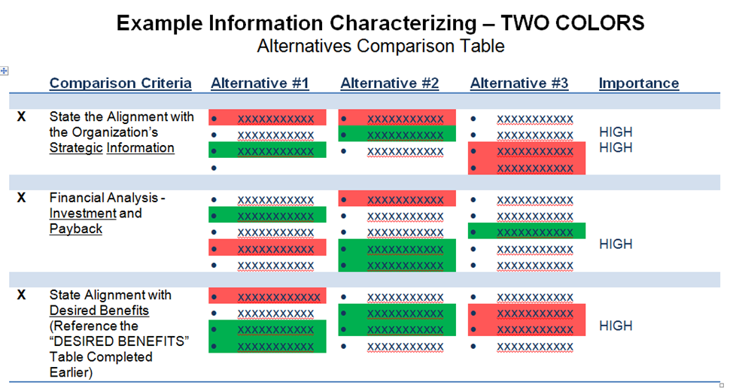
Example 2 – Four Color Highlighting Approach


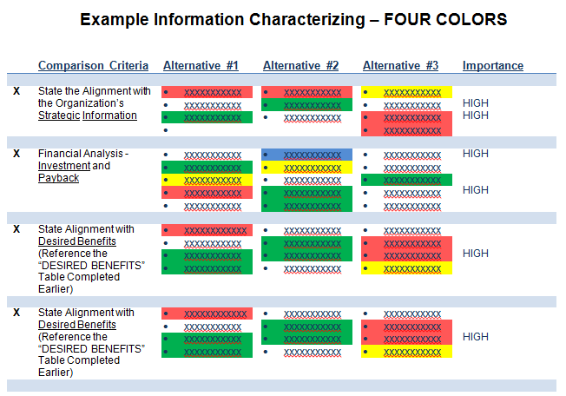

Example 3 – Color Highlighting With “HIGH” Importance Denoted

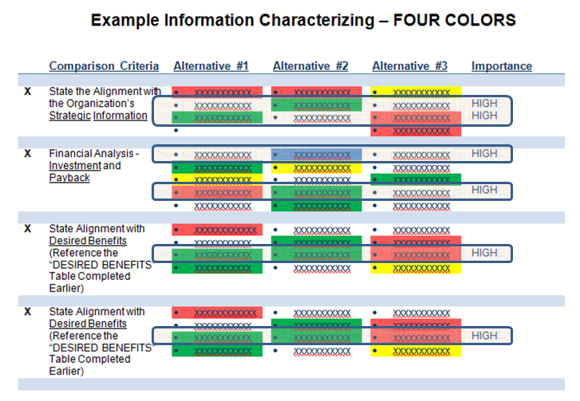

Weighted and Non-Weighted Numeric Scoring Approaches

Some teams may consider a “numeric scoring” comparison approach. An example of such an approach is described by the following. Note the concerns noted at the end.

Non- Weighted Scoring
- Each alternative is given a score for each criteria and one example would be a score from 1 to 10 where 10 is great and 1 is very poor relative to meeting the given criteria.
- In the example below, Alternative 1 is scored as an “8” out of 10 for meeting criteria #1 meaning it does a very good job of meeting that criteria.
- A total of all of these “Raw Scores” for each alternative could be used to support the selection of the best alternative and this would be a “Non-Weighted” scoring approach.
- This approach would sum all of the scores for each alternative in the example table below in the “Raw Score” columns and the columns highlighted in yellow would not be used.
Weighted Scoring
- All criteria is generally not of equal importance and an importance rating scheme, or “criteria weighting approach,” can be used to support a more accurate comparison.
- Where criteria is weighted, each criteria would have an assigned “weight” denoting the relative importance of that criteria when compared to other criteria.
- In the example table below, “Criteria #1” has an assigned weight of 4 (out of 4) indicating it is of highest importance. Criteria #4, on the other hand, has an assigned weight of 1 (out of 4) indicating it is of lowest importance relative to other criteria. Criteria #4 is still important for comparing the alternatives, but is less important than other criteria with higher weights.
- As scores for all alternatives for all criteria are defined, a numeric total “weighted score” for each alternative can determined by taking the product of each individual criteria weight and the score for a given alternative and then summing all of these products for a given alternative to form a total weighted score for that alternative.
- In the simple example, Alternative #1 has a weighted score of 60 and Alternative #2 has a total weighted score of 47 meaning Alternative #1 meets the composite of all criteria better than Alternative #2.

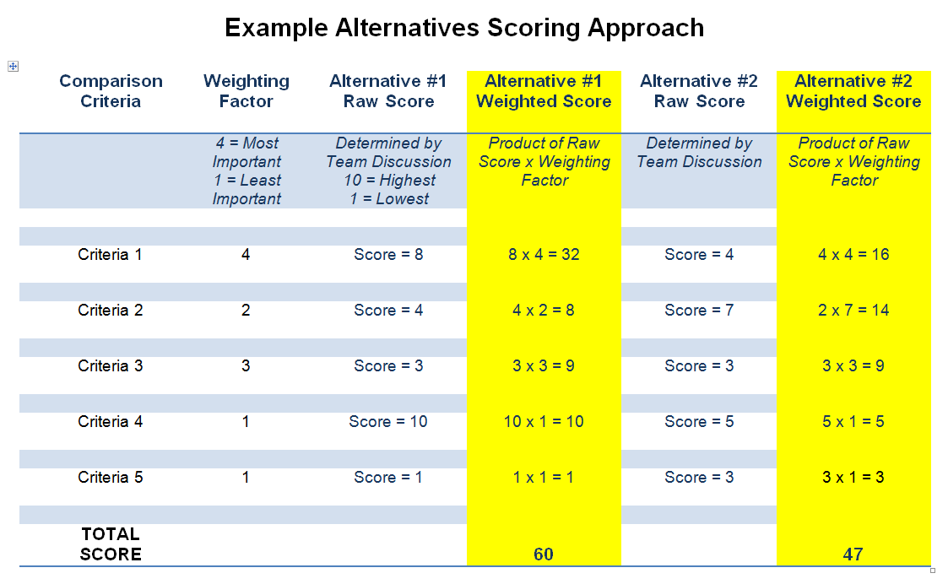

Concerns - Such a weighted scoring approach can have value in some situations, but in the opinion of the author of this worksheet, such approaches are prone to error as the definition of the weighting factors (sometimes chosen with insufficient forethought) can significantly sway the final results. The quote “tell me what answer you want and I can adjust the weighting factors to get that answer” is something to keep in mind. If scoring approaches such as the example are used, care should be taken in the assignment of criteria weights and any selection resulting from such an approach should be reviewed to ensure it makes sense overall and is really the best alternative selection.

10.2) Form a Bottom Line DRAFT Recommendation and Generate Rationale

This step is the draft selection of the best alternative and the generation of rationale for that decision.

As your team reviews the comparison table coded or colored information and moves to make a recommendation, note that your recommendation might be any of the following:

- One of the stated alternatives
- One of the stated alternatives that is modified
- A combination of 2 or more alternatives, where one or more may also be modified
- Several alternatives that are implemented in a phased or sequenced approach
- None of the alternatives and something else not previously identified
- A decision to “do nothing”

Instructions – As the information in the comparison table is analyzed, do the following.
- Make an initial recommendation on which alternative is selected
- Ask the team “what is wrong with our selection?”
- Generate the rationale for your recommendation
- Review you decision and finalize your draft recommendation with rationale

Complete the following:

Recommendation - The bottom line recommendation is ……………………

The rationale for this decision is
- xx
- xx
- xx

This recommendation is based on the following conditions or assumptions being true.
- Condition 1 ……………………
- Condition 2 ……………………
- Condition 3 ……………………

Non-Selected Alternatives – The following alternatives were not selected for the noted reasons.

The reasons “Alternative A” was not selected are
- xx
- xx
- xx

The reasons “Alternative B” was not selected are
- xx
- xx
- xx

10.3) Identify a Backup Plan

This step is the selection of a backup plan which might be selected if the primary recommendation is not accepted or fails to be a viable solution for any reason. The backup approach can be one of the alternatives not selected or some other contingency approach.

Example
Take a business case that is being completed to resolve a poor functioning system and the identified solutions or alternatives were “a new system, an upgraded system and outsourcing the work performed by the respective system.” For this example, let’s say that the “New System” alternative was selected. If for some reason this solution becomes unfeasible due to technology issues, costs or other factors, the other non-selected alternatives that were the modification of the existing system or the outsourcing of the work could be backup plans or contingencies.

Instructions – As the draft recommendation is completed, work with the team to
- Determine if a backup plan is needed (it is usually the best idea to have one)
- Determine if a backup plan is feasible
- Determine what the backup plan should be
  - A non-selected alternative, or
  - Another approach
- Capture the description of the backup plan and the rationale for its selection.

Use the following to capture your backup plan information.

☐ No Feasible Backup Plans Exist

The reasoning behind this determination is ………………………………

☐ Potential Backup Plans Are:

Backup Plan #1 is ……………………….
This Backup Plan Would Require:
- xx
- xx
Positive Aspects of this Backup Plan are:
- xx
- xx
Negative Aspects of this Backup Plan are:
- xx
- xx

Backup Plan #2 is ……………………….
This Backup Plan Would Require:
- xx
- xx
Positive Aspects of this Backup Plan are:
- xx
- xx
Negative Aspects of this Backup Plan are:
- xx
- xx

10.4) Define Needed Management and Customer Involvement

This step answers the question “For this effort to be successful, what support from management, sponsors or leadership is needed to implement the selected alternative?”

Instructions – Complete the following to define needed support.

The following management involvement is needed:
- xx
- xx

The likely impacts of not having the above management support is:
- xx
- xx

The following customer involvement is needed:
- xx
- xx

The likely impacts of not having the above customer support is:
- xx
- xx

10.5) Define any Needed “Third Party” Relationships

This step identifies any needed support from any third parties to support the selected alternative being successful. Examples of third parties can be partnerships, major subcontractors, strategic alliances, significant regulatory agencies, financial institutions and state and local governments.

Instructions – Complete the following to define any and all third party relationships needed for this effort:

Third Party “xxxxxx” Relationship
For this effort, the needed relationship is ……………………….
The current status of this relationship is one of the following:
☐ New Relationship ☐ Existing Relationship, No Change ☐ Existing Relationship, Will Change as Follows: ………

Third Party “xxxxxx” Relationship
For this effort, the needed relationship is ……………………….
The current status of this relationship is one of the following:
☐ New Relationship ☐ Existing Relationship, No Change ☐ Existing Relationship, Will Change as Follows: ………

Third Party “xxxxxx” Relationship
For this effort, the needed relationship is ……………………….
The current status of this relationship is one of the following:
☐ New Relationship ☐ Existing Relationship, No Change ☐ Existing Relationship, Will Change as Follows: ………

Third Party “xxxxx” Relationship
For this effort, the needed relationship is ……………………….
The current status of this relationship is one of the following:
☐ New Relationship ☐ Existing Relationship, No Change ☐ Existing Relationship, Will Change as Follows: ………

10.6) Define Needed Resources for the Selected Alternative and Assumptions

This step is an estimate of costs, resources and overall schedule to implement the selected alternative and the assumptions that have been made.

Several situations may exist:
- The previously completed “Financial Analysis” has sufficient cost detail for this point in the business case review and decision process and only schedule and resource estimates are needed to support a final decision
- The previously completed “Financial Analysis” has insufficient cost detail for this point in the business case review and decision process and more detailed cost information along with schedule and resource estimates are needed to support a final decision

Use Your Format for Cost, Resource and Schedule Estimates
Simple Example Follows

- Financial Needs, Total Costs
  - Xx
  - xx
- Schedule Needed Duration
- Personnel Needs
  - Full Time =
  - Part Time =
- Non-Personnel Resources Needed
  - Facilities ……………………………
  - Equipment ………………………….
  - Subcontractors ……………………….
  - (other) ………………………………….
  - (other) ………………………………….

Assumptions

The following assumptions are key to the successful implementation of the selected alternative.
- Xx
- Xx
- Xx
- Xx
- Xx

10.7) Develop the “Plan to Proceed”

This step identifies the plan to implement the selected solution and answers the question “If this effort is authorized, how will this effort be accomplished?”

NOTE – This section is not necessarily a detailed project plan, as that detail plan may be prepared after the authorization to proceed is made which will happen after this business case is completed. This step is a top level summary of “what will be done” “by whom” and “when” to provide a basic understanding of the general nature of the effort needed to implement the selected solution.

Instructions – Complete the following to describe a top level approach for implementing the selected alternative.

Plan Summary – This effort will be accomplished by ………(include a short summary of what the project will be)…………..

Top Level Plan Content – [ Insert Here or Reference ]
- Work Summary – Work Outline or Top Level WBS
- Schedule Summary – Milestones and Top Level Flow Chart
  - Potential Start and Complete Dates
  - Milestones
  - Flow Chart
- Organization Needed and Roles – “Whom” will do “What”
  - Project Organization Chart
  - Table of Roles

10.8) Prepare the Draft Business Case Report and Distribute to Selected Stakeholders for Comment

This step is the preparation of the draft business case report for initial review and comment. This is not the final report.

Instructions –
- Select a report approach, see examples below
- Prepare the report using the information contained in this worksheet
- Have the team review the completed draft report
- Distribute the draft report to selected stakeholders for awareness and comment
- Collect comments for report finalization

Example Report Options - Several options can be considered for the business case report.

Detailed Report

Report Document – Provide this completed worksheet as a detailed report document possibly highlighting those sections that would be of most interest to the reviewing stakeholders.

Presentation – Summarize the contents of this worksheet and include information from most or all sections in your slide set.

Summary Report

Report Document – Condense this worksheet for a documented report. Consider including the following sections from this worksheet.
- The Need, the Problem or the Needed Improvement
- Current Environment
- Define “Needed Outcomes”
- Root Causes of the Problem or the Root Drivers
- Root Causes You Can Affect and the Most Important Root Causes
- Alternative Solutions to Attain the Needed Outcomes
- Alternatives Comparison Table
- Recommendation with Rationale and Backup Plan
- Possible Plan Forward

Presentation – Summarize the above content in a slide set.

10.9) Identify and Complete Needed Final Tasks

This step is the identification of any remaining tasks needed to complete the business case and the final report.

Instructions – As the draft report is reviewed, list and complete any final next steps needed to respond to questions or comments from reviewers of the draft report or to complete any remaining business case information gathering, analysis, communications, approvals or related actions.

 | Next Step | Due Date | Responsibility | Status
1 | xx | xx | xx | xx
2 | xx | xx | xx | xx
3 | xx | xx | xx | xx
4 | xx | xx | xx | xx

10.10) Prepare the Final Business Case Report

This step is the preparation and final distribution of the final report.

Instructions
- Complete the final business case report as the final steps noted above are completed.
- Note that the final report might be the “Detailed Version” described earlier even if you drafted a summary report
- Distribute the report as needed by your organization and prepare for any required presentations
- Include the team, as possible, in any presentation to management
- Notify the team that they may be needed to respond to leadership questions or directed changes and thank them for their efforts

<< Back to Contents >>

===============================================================
===============================================================

END OF
Business Case
WORKSHEET
Comprehensive Version
Multiple Alternatives Version

Latest Version of this Worksheet and Other Worksheet Versions Available at www.manageprojectsbetter.com

===============================================================
===============================================================

