
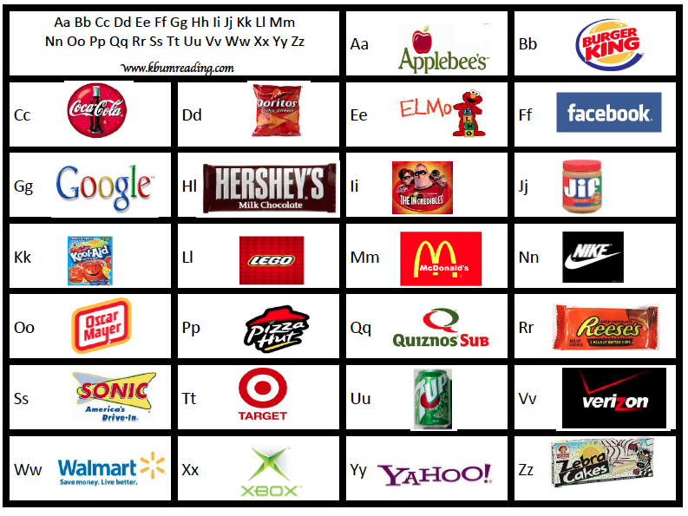
NO EXCUSE Words for My Writing
www.kbumreading.com

Aa  again and  also an  after are  away | Bb  be  because  boy  been | Cc  can can’t  cannot come  could | Dd  do  don’t  day  does  didn’t | Ee  every  everybody  everywhere  eat
Ff  fun  funny  for  friend  family | Gg  go  get  got | Hh  have has  happy he  his her  him | Ii  I in  is it  if isn’t | Jj  jump  job
Kk  kind  kiss | Ll  like  love  left  live | Mm  me  make | Nn  not  night  never | Oo  of  over
Pp  please put  people | Qq  quiet  quit | Rr  ran  run  right | Ss  see said  saw say  seen sat  she | Tt  to tell  too talk  today
Uu  us  up  use | Vv  visit | Ww  we will  want was  where why  what when | Xx | Yy  yes  yesterday  you  your
Zz  zipper  zoo  zero | Family  dad father  mom mother  brother  sister  cousin  grandmother  grandfather  aunt  uncle  mawmaw  pawpaw | Numbers  zero 0  one 1  two 2  three 3  four 4  five 5  six 6  seven 7  eight 8  nine 9  ten 10 | Days of Week  Sunday  Monday  Tuesday  Wednesday  Thursday  Friday  Saturday | www.kbumreading.com

