INVESTIGATION TECHNIQUES/Formula

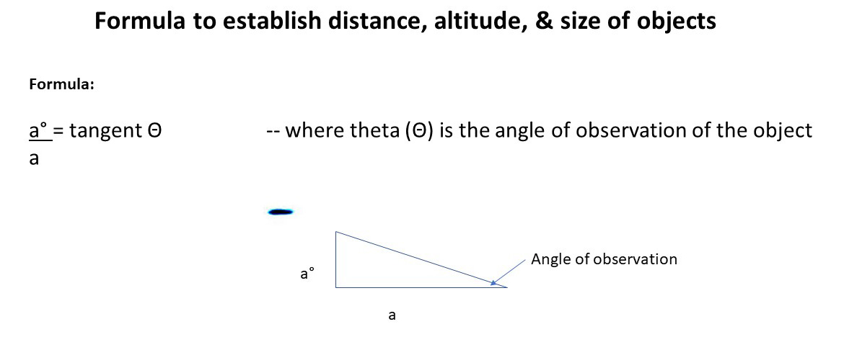

INVESTIGATION TECHNIQUES/Length of the UFO: Metadata
Example:
The camera used was an iPhone 11 Pro Max that has a sensor with 1.4 micron size of its pixels, or .0014 mm/pixel. The image used came from frame 1:22:15 which measured 24 pixels in length. Size calculation assumes the following relationship:

Li = Di To calculate length of object: Li x Do = Lo
Lo Do Di
--Li (Length of the image): 24 pixels x .0014 mm/pixel = .0336 mm.
--28 mm is the focal length of the image for the iPhone 11 pro Max. (Di).
(where Li = Length of the image .0336 mm, Lo = Length of the object = 7.2 m, Di = Distance of the image 28 mm, Do = Distance of the object 5,996 m, line-of-sight). Image in this case is the small image within the camera.

How to find the line-of-sight distance?
(Cont’d)

INVESTIGATION TECHNIQUES/ 3 Formulas
Getting Line-of-Sight distance

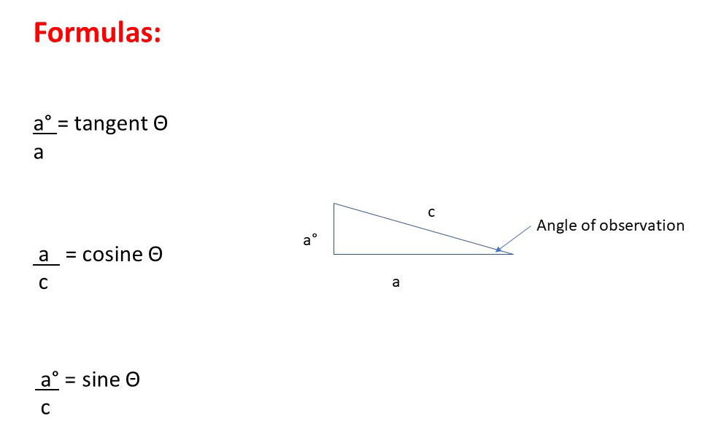

Good Metadata sites:

Jeffrey Friedl’s Exif Metadata Viewer: http://exif.regex.info/exif.cgi
Metadata 2 Go: https://www.metadata2go.com/

(Formula calculation next page)

