CONFIRMING FAITH 2022
Holy Family Parish Confirmation Programme.
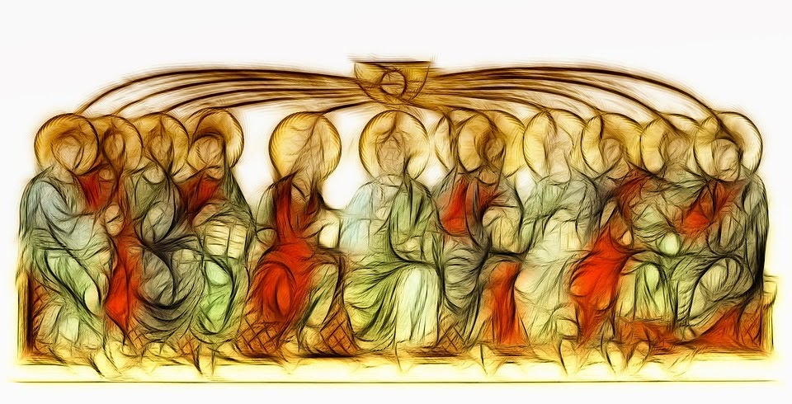
Parishioners who are Year 10 or above are welcome to join the programme to discern whether they want to receive the sacrament of Confirmation.
What is involved:
- A commitment to Personal Prayer.(Each day candidates are invited to take 5-10 minutes to give thanks to God for all the good aspects of their lives, to ask for all they need)
- Attendance at our Saturday evening Mass during Lent and the short Group Sessions that will follow, starting 5th March.
- Take part in 4 sessions of the After School Confirmation Group at Salesian School on Wednesdays after Half Term
- Make the Confirmation Pilgrimage Walk.
If you are interested please email the Parish Secretary at secretary@holy-family-parish.net
Fr John Dickson SDB

