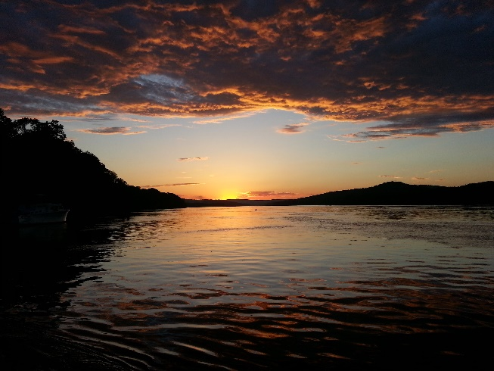
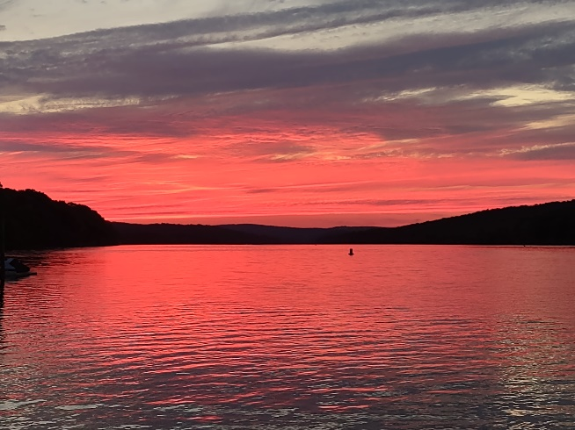
July 19, 2022 July 27, 2022
The Midway Times Summer/Fall 2022
“Keeping the Pleasure in pleasure boating”
Ahoy Captains, Mates and Crews: Thoughts and Free Dockage!
What a Summer so far! Sure beats last year’s rainy July. Evidenced by this season’s photos, two of the many beautiful sunsets from our docks. So encouraged by years of Summer Solstice sunsets directly up river we are naming our section of the river “Solstice Harbor”. For all of our customers to enjoy we invite you for a free night or two of transient dockage. We also offer a 15% discount here at The Blue Oar Restaurant. Hopefully next year some transient moorings will also be available across the river. They will take in sunsets and a view of the East Haddam Swing Bridge to the South. Great fresh water swimming too. Or dingy up the scenic Salmon River and to historic East Haddam. These moorings could be utilized for winter storage haul and launch as well.
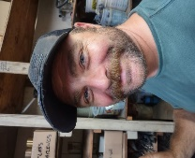
New Midway Team Heeeres Johnny!: Introducing T. John Berchulski. John joined us full time this Spring. No stranger to the business and a family friend since he baby sat Scott’s kids. A brief resume would include: Mechanic, Dock Boy, Bottom painter, US Army, Afghanistan x 2, Hawaii, Marino Crane, boat owner, and Friend & Prodigy of Dan. That is to say at the least! In the last six months he has connected with Vinal Tech’s program to employ 2 part time aspiring Mechanical students. He has proven excellent management of employees and customer relations. We think you will find John very helpful with your service needs and look forward to a great partnership with all.
Winter Storage Contracts You are our best salesmen so bring in your referrals and get your 10% credit. No limit. We have plenty of room. Winter Storage contracts are enclosed and please review our commissioning check list on our website (midwaymarinaCT.com) for anything you need serviced or fixed. It will greatly facilitate the mad Spring rush if you get your request in early. We apologize for the price increases but we too must keep up with inflation.
Fall Customer Appreciation Party:
This year the Fall customer appreciation party will be on Saturday October 22nd rain or shine. Best burgers, dogs and company! Wishing you smooth sailing and looking forward to seeing you soon!
The Crew at Damar

