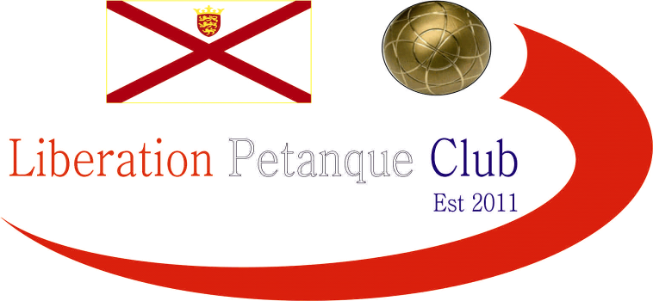

2022
CLUB SUPER 7’S CUP

15 players took part in this year’s tournament, our last club competition of the year.

Round one saw a couple of shocks as Ross Payne lost to Tom Le Sueur 5 – 4 and Cassie Stewart Le Gallais beat 2022’s top player Laurent Pellaton 6 – 5.

2019 winner Toby Northern beat Tim Jackson 11 – 2 and this was also the score as Neil Selby beat Ian Black. A win for 2018 champion Geoffroy Buffetrille against Mo De Gruchy and Callum Stewart v Jean Stewart.

Round two saw five of the seven matches being settled by just one point. Geoffroy beat Toby, Cassie beat Tom and Callum beat James all 6-5 scores. Ross beat Jim and Mo beat Ian 5-4 with Laurent winning 5 – 3 against Tim.

The biggest win going to Neil over Paul Bell 9 – 5.

Round three saw Neil continue his high scoring winning 10 – 5 against Cassie. Geoffroy made it three from three winning 6 – 4 over Callum. James Gennoe lost his second successive match by one point on the last end losing 7-6 to Laurent.

Toby also lost on the last end again with Ross taking it 6-5. Jean had a big win 10-4 over Paul and Jim won his first match 4-3 over Tim and Tom beat Mo.

Round four saw a big win for Mo 8-1 over Jim, Toby got the win over James Gennoe and Ross beat Callum 5 – 2.

Geoffroy won a close match 5-4 over Neil and this was the score for Paul over Ian. Big wins for Cassie over Jean and Laurent over Tom.

Round five saw the first zero of the day as Toby beat Paul 12 – 0! Tom Le Sueur also scored 12 points beating Jean 12 – 4. Neil handed out doubles team-mate Ross a heavy defeat 10 – 2.

Mo De gruchy added to James woe’s winning 6-5. Callum had a big win over Laurent 8-2 with Geoffroy beating Cassie for five from five.

Round six saw Toby score big again winning 11 – 3 over Ian, but Mo went one point better winning 11 – 2 over Laurent!

Tom Le Sueur beat Neil in another shock result but no more as Geoffroy beat Ross. Wins also for Callum, Paul and Tim.

The final round would decide the top eight players going through. Tom Le Sueur booked his place handing Geoffroy his first defeat, despite this Geoffroy finished top win Tom in second place.

Callum took third place with his fifth win but only just against Mo 5 – 4, Mo also qualified finishing seventh.

Toby took fourth place with five wins beating Neil 7 – 5 with Neil qualifying in sixth. Ross beat Paul 7 – 4 to take fifth with four wins.

The last qualifying place went to Cassie also on four wins as Laurent lost in a shock result to Jim.

FINAL SWISS RANKINGS

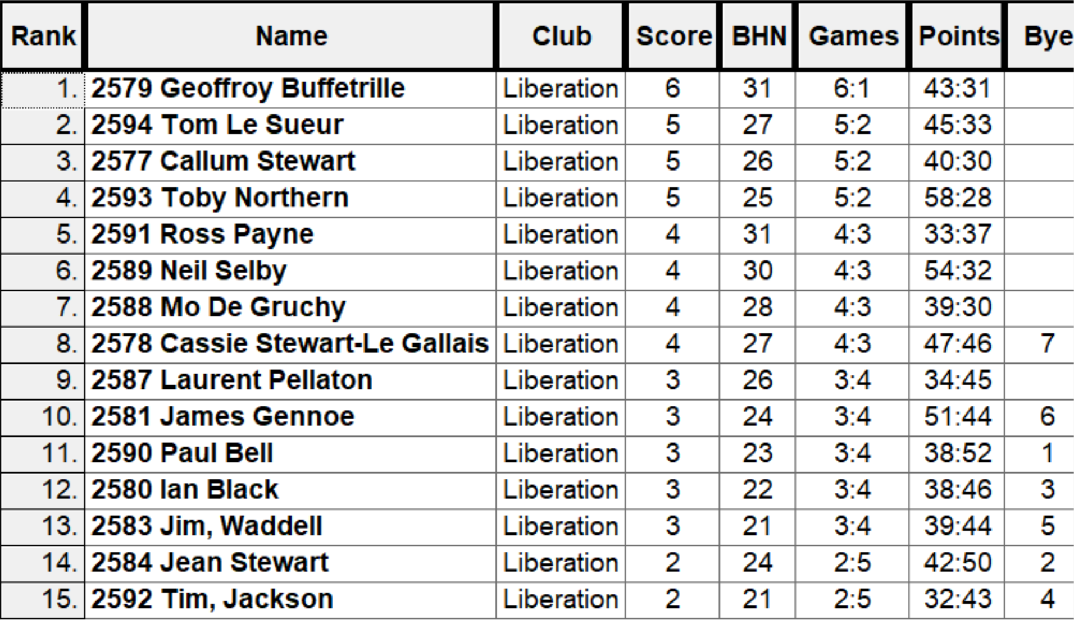

Quarter Finals

Ranked 1st Geoffroy Buffetrille v Cassie Stewart-Le Gallais Ranked 8th

Ranked 2nd Tom Le Sueuer v Mo De Gruchy Ranked 7th

Ranked 3rd Callum Stewart v Neil Selby Ranked 6th

Ranked 4th Toby Northern v Ross Payne Ranked 5th

A huge shock as Mo De Gruchy knocked out Tom Le Sueur winning 8 – 5 in a fairly high scoring match.

Toby gained revenge over Ross winning 5 – 4 on the last end with Ross missing two fires for the win.

Callum gained revenge over Neil who beat him in the HandyCap cup final. Callum winning 8 – 1!

Geoffroy also won with a big score 11 – 4 over Cassie.

No

Semi Finals

Ranked 1st Geoffroy Buffetrille v Toby Northern Ranked 4th

Ranked 3rd Callum Stewart v Mo De Gruchy Ranked 7th

Experience showed in the end as Mo impressive performance in the competition came to an end as Callum made another final winning 6 – 3.

Toby was on top form as he consistently out placed and out shot Geoffroy to run out 11 – 0 winner.

Third Place went to Geoffroy winning 11 – 0 over Mo.

In the Final Toby won the first three ends taking a 4 – 0 lead before Callum tied it at 4 – 4 after five ends. On the sixth end Toby hit a perfect carreaux to get three points so just needed to make sure that Callum didn’t score three points on the last end which he did scoring another three points to win 10 – 4 to win his second Super Sevens title.

2022 – Winner – Toby Northern

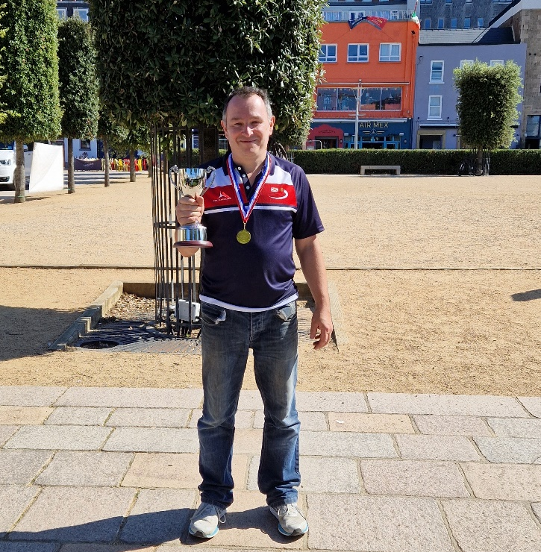

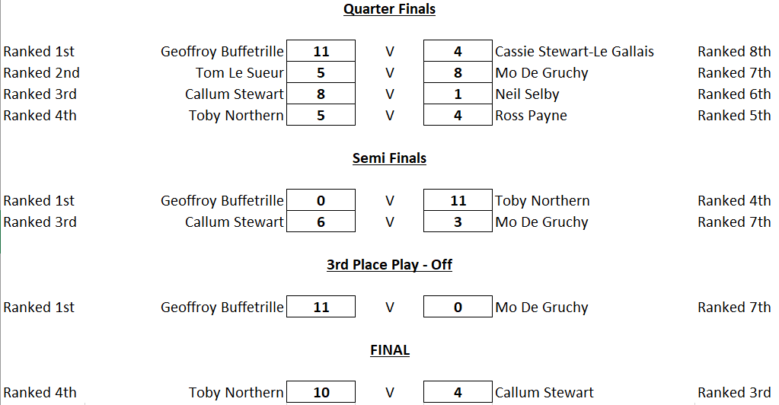

Thanks to all those who helped out on the day to make it another great competition.

Sponsored by



CoinShares | Digital Asset Investment Strategies for Professionals 🚀

Club email address - liberationpc@gmail.com

Club Website - www.liberationpetanque.co.uk

Kind Regards

Toby Northern

Chairman

Liberation Petanque Club

