WELCOME TO
HOLY SPIRIT LUTHERAN CHURCH
A Member of the Evangelical Lutheran Church in America, New Jersey Synod
1220 Bayshore Rd., Villas, NJ 08251, 609-886-2414,
holyspiritlutheran@comcast.net, holyspiritvillas.com, facebook.com/holyspiritvillas
Vicar Vince Piekarski can be contacted at any time for conversation or prayer through call or text at 412-225-0287, or through email at vpie8282@gmail.com.
SUNDAY, FEBRUARY 15TH, 2026
TRANSFIGURATION OF OUR LORD
LAST SUNDAY AFTER EPIPHANY
10:30AM WORSHIP SERVICE WITH HOLY COMMUNION
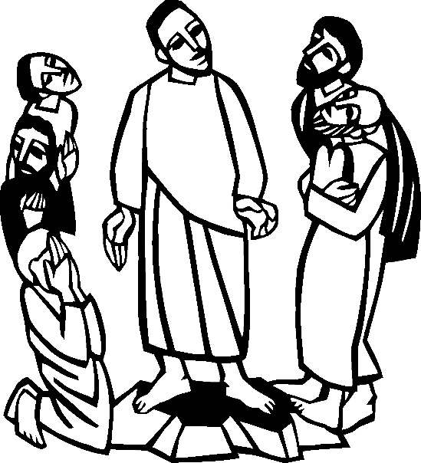

We, the Evangelical Lutheran Church of the Holy Spirit, are People of God, who
are called by the Holy Spirit to pray, worship, joyfully proclaim Jesus Christ,
and compassionately witness and serve others in Christian Love.


We are glad that you joined us for Worship today! Thank you for enriching our time together! We would like to get to know you better, and for you to get to know us better too. Brochures, welcome gifts, prayer shawls, Bibles, and other items are available throughout the church. We would be happy to show you around and share about our ministries. Please do not hesitate to speak up and ask questions.
Also, please make sure you sign-in on our clipboard on the podium in the lobby.


Our Worship Services are conducted in coordination with our Conference Call.
Join us at 657-390-7423 or 701-802-5170, with access code 8221190#.
You may need to dial 1 first depending on your phone plan. After logging in please announce your name and feel free to talk with others until we get started.


SANCTUARY CANDLE FOR FEBRUARY
Given to the Glory of God & In Memory of JAMES P. ROONEY
by Del McKenna & Children.
ALTAR CANDLES FOR FEBRUARY
Given to the Glory of God & In Memory of CLAIRE MILLER
by Jean, Phil, & Bob Zimmerman.
CONFERENCE CALL CHECK-IN, WELCOME, & ANNOUNCEMENTS
(Vicar (V), Assistant (A), Reader (R), and Congregation (C).)

INTRODUCTION
A. Today’s festival is a bridge between the Advent-Christmas-Epiphany cycle that
comes to a close today and the Lent-Easter cycle that begins in several days. On
a high mountain Jesus is revealed as God’s beloved Son, echoing the words at
his baptism. This vision of glory sustains us as Jesus faces his impending death
in Jerusalem. We turn this week to Ash Wednesday and our yearly baptismal
journey from Lent to Easter. Some churches put aside the alleluia at the
conclusion of today’s liturgy. This word of joy will be omitted during the penitential
season of Lent and will be sung again at Easter.

PRELUDE
(Music offered by our Organist at the start of our Worship Service.)
How Majestic is Your Name

CHIMES
(Music offered by our Organist at the start of our Worship Service.)
My Jesus I Love Thee

V. We invite you to stand as you are able.

CONFESSION & FORGIVENESS
(All may make the sign of the cross, the sign that is marked at baptism.)
V. Blessed be the holy Trinity, ☩ one God,
the Creator of heaven and earth,
the Word who spoke life into being,
the Wind stirring the waters.
C. Amen.

V. Let us turn in confession to the one who knows us completely.

(Silence is kept for reflection.)

V. Mighty God, lover of justice,
C. you call us to life in community,
but we have served our own interests at the expense of our neighbors.
We have sown deceit where honesty was needed.
We say the right words, but our hearts are far from you.
Turn us to seek your face.
Knit us together and give us the mind of Christ,
that we may do justice, love mercy,
and walk humbly with you, our God.
Amen.

V. The former things have passed away,
and new things God now declares:
Like a spring of water that never fails,
God covers you in the righteousness of Christ,
and forgives your sin in ☩ Jesus’ name.
May the Spirit give you strength to live for others,
and bless you with the gift of peace.
C. Amen.

GATHERING HYMN
(We invite you to sing along.)
With One Voice—Blue Book
651—Shine, Jesus, Shine

APOSTOLIC GREETING
V. May the grace of our Lord Jesus Christ, the love of God,
and the communion of the Holy Spirit be with you all.
C. And also with you.

KYRIE
V. In peace, let us pray to the Lord.
C. Lord, have mercy.

V. For the peace from above, and for our salvation, let us pray to the Lord.
C. Lord, have mercy.

V. For the peace of the whole world, for the well-being of the church of God,
and for the unity of all, let us pray to the Lord.
C. Lord, have mercy.

V. For this holy house, and for all who offer here their worship and praise,
let us pray to the Lord.
C. Lord, have mercy.

V. Help, save, comfort, and defend us, gracious Lord.
C. Amen.

HYMN OF PRAISE
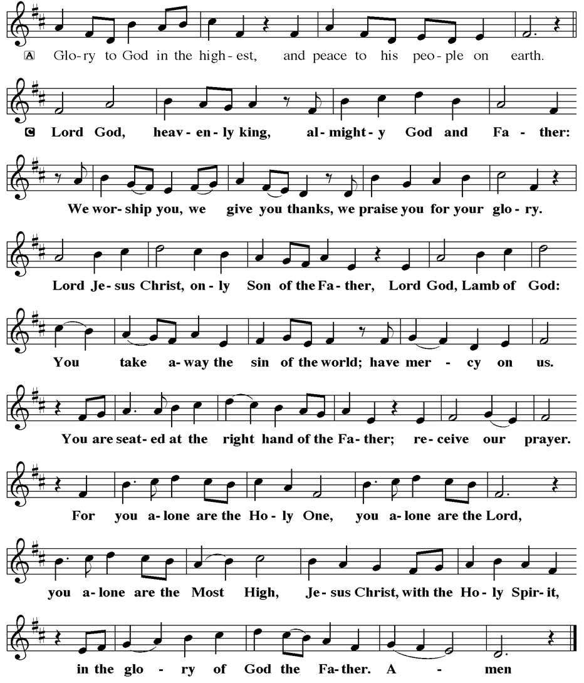
PRAYER OF THE DAY
V. The Lord be with you.
C. And also with you.

V. Let us pray,
O God, in the transfiguration of your Son you confirmed the mysteries of the faith
by the witness of Moses and Elijah, and in the voice from the bright cloud
declaring Jesus your beloved Son, you foreshadowed our adoption as your
children. Make us heirs with Christ of your glory, and bring us to enjoy its fullness,
through Jesus Christ, our Savior and Lord, who lives and reigns with you and the
Holy Spirit, one God, now and forever.
C. Amen.

(We invite you to be seated for our Readings and Psalm.)

FIRST READING
At Mount Sinai, Moses experienced the presence of God for forty days and forty
nights. The “glory of the Lord” settled on the mountain, and on the seventh day
God called out to Moses. On the mountain God gave Moses the stone tablets
inscribed with the ten commandments.

R. Our First Reading is from the 24th Chapter of Exodus (Verses 12-18).

R. 12 The Lord said to Moses, “Come up to me on the mountain and wait there; I will
give you the tablets of stone, with the law and the commandment, which I have
written for their instruction.” 13 So Moses set out with his assistant Joshua, and
Moses went up onto the mountain of God. 14 To the elders he had said, “Wait
here for us, until we come back to you. Look, Aaron and Hur are with you;
whoever has a dispute may go to them.”

15 Then Moses went up on the mountain, and the cloud covered the mountain.
16 The glory of the Lord settled on Mount Sinai, and the cloud covered it for six
days; on the seventh day he called to Moses out of the cloud. 17 Now the
appearance of the glory of the Lord was like a devouring fire on the top of the
mountain in the sight of the Israelites. 18 Moses entered the cloud and went up
on the mountain. Moses was on the mountain for forty days and forty nights.

R. This is the Word of the Lord.
C. Thanks be to God.

PSALM
R. Our Responsorial Psalm is from the 2nd Psalm.
C. You are my son; this day have I begotten you. (Ps. 2:7)

R. 1 Why are the nations in an uproar?
Why do the peoples mutter empty threats?
2 Why do the kings of the earth rise up in revolt, and the princes plot together,
against the Lord and against the Lord’s anointed?
3 “Let us break their yoke,” they say;
“let us cast off their bonds from us.”
4 God whose throne is in heaven is laughing;
the Lord holds them in derision.
C. You are my son; this day have I begotten you. (Ps. 2:7)

R. 5 Then in wrath God speaks to them,
and in rage fills them with terror.
6 “As for me, I have anointed my king
upon Zion, my holy mountain.”
7 Let me announce the decree of the Lord,
who said to me, “You are my son; this day have I begotten you.
8 Ask of me, and I will give you the nations for your inheritance
and the ends of the earth for your possession.
C. You are my son; this day have I begotten you. (Ps. 2:7)

R. 9 You shall crush them with an iron rod
and shatter them like a piece of pottery.”
10 And now, you kings, be wise;
be warned, you rulers of the earth.
11 Submit to the Lord with fear,
and with trembling bow in worship;
12 lest the Lord be angry, and you perish in a sudden blaze of wrath.
Happy are all who take refuge in God!
C. You are my son; this day have I begotten you. (Ps. 2:7)

SECOND READING
At the transfiguration, God’s voice was heard, declaring Jesus to be the beloved
Son. By the activity of the Holy Spirit, God’s voice continues to be heard through
the word of scripture.

R. Our Second Reading is from the 1st Chapter of 2nd Peter (Verses 16-21).

R. 16 We did not follow cleverly devised myths when we made known to you the
power and coming of our Lord Jesus Christ, but we had been eyewitnesses of his
majesty. 17 For he received honor and glory from God the Father when that voice
was conveyed to him by the Majestic Glory, saying, “This is my Son, my Beloved,
with whom I am well pleased.” 18 We ourselves heard this voice come from
heaven, while we were with him on the holy mountain.

19 So we have the prophetic message more fully confirmed. You will do well to be
attentive to this as to a lamp shining in a dark place, until the day dawns and the
morning star rises in your hearts. 20 First of all you must understand this, that no
prophecy of scripture is a matter of one’s own interpretation, 21 because no
prophecy ever came by human will, but men and women moved by the Holy
Spirit spoke from God.

R. This is the Word of the Lord.
C. Thanks be to God.

V. I invite you to stand as you are able, and I invite you to announce the Gospel
Acclamation with me.

GOSPEL ACCLAMATION
C. Alleluia. This is my Son, my Chosen, listen to him! Alleluia. (Luke 9:35)

GOSPEL READING
Shortly before he enters Jerusalem, where he will be crucified, Jesus is revealed
to Peter, James, and John in a mountaintop experience of divine glory called the
transfiguration.

V. The Holy Gospel According to Matthew, the 17th Chapter (Verses 1-9).
C. Glory to you, O Lord.

V. 1 Six days later, Jesus took with him Peter and James and his brother John and
led them up a high mountain, by themselves. 2 And he was transfigured before
them, and his face shone like the sun, and his clothes became bright as light.
3 Suddenly there appeared to them Moses and Elijah, talking with him. 4 Then
Peter said to Jesus, “Lord, it is good for us to be here; if you wish, I will set up
three tents here, one for you, one for Moses, and one for Elijah.” 5 While he was
still speaking, suddenly a bright cloud overshadowed them, and a voice from the
cloud said, “This is my Son, the Beloved; with him I am well pleased; listen to
him!” 6 When the disciples heard this, they fell to the ground and were overcome
by fear. 7 But Jesus came and touched them, saying, “Get up and do not be
afraid.” 8 And when they raised their eyes, they saw no one except Jesus himself
alone.

9 As they were coming down the mountain, Jesus ordered them, “Tell no one
about the vision until after the Son of Man has been raised from the dead.”

V. This is the Gospel of the Lord,
C. Praise to you, O Christ.

(We invite you to be seated.)

SERMON
(Delivered by Vicar Vince Piekarski.)

(Following the Sermon, we invite you to stand as you are able.)

HYMN OF THE DAY
(We invite you to sing along.)
Lutheran Book of Worship—Green Book
518—Beautiful Savior

APOSTLES’ CREED
V. God has made us his people through our Baptism into Christ. Living together in
trust and hope let us confess our faith together using the Apostles’ Creed.
C. I believe in God, the Father almighty,
creator of heaven and earth.

I believe in Jesus Christ, God’s only Son, our Lord,
who was conceived by the Holy Spirit,
born of the Virgin Mary,
suffered under Pontius Pilate,
was crucified, died, and was buried;
he descended to the dead.
On the third day he rose again;
he ascended into heaven,
he is seated at the right hand of the Father,
and he will come to judge the living and the dead.

I believe in the Holy Spirit,
the holy catholic church,
the communion of saints,
the forgiveness of sins,
the resurrection of the body
and the life everlasting.
Amen.

PRAYERS OF INTERCESSION
V. As God’s beloved children united in Christ, let us pray for the church, the whole
human community, and the well-being of the earth, our home.

(A brief silence.)

A. Revealing God, your Spirit sustains the church. Strengthen the faithful with the
revelation of Christ transfigured, that we may joyfully follow him in the way of the
cross. Merciful God,
C. receive our prayer.

A. Life-giving God, creation is full of your majesty. Nurture in us a deep respect for
the interdependence of all life, and make us wise and vigilant stewards of your
good earth. Merciful God,
C. receive our prayer.

A. Peacemaking God, the nations are in turmoil. We pray for an end to violent
conflict. Give wisdom to negotiators and sanctuary to refugees. Defend any who
are in danger. Merciful God,
C. receive our prayer.

A. Healing God, you desire wholeness for all people. Bring healing to any who are
experiencing illness, chronic pain, or mental anguish. Comfort the dying and
those who grieve; especially:
BettyAnn Rich-White (Church Member)
Chip & Marie Hand (Church Members)
Lynn Bargstadt (Church Member)
Frank Ford (Church Member)
Carol Amundsen (Church Member)
Kim McGinley (Church Member)
Anthony DeLuca (Church Member)
Frank Brunner (Church Member)
Joan Sommerman (Church Family)
Arleen Kinka (Church Family)
Rick Lang (Church Family)
Suzie Clark (Rose Lang's Friend)
Francis Clock (Dianna DeNote’s Family)
Andrew Hudak (Rose Lang’s Friend)
Viena Murtha (Bob Fritsch’s Friend)
Sharon Waicus (Skip & Bonnie Millard's Friend)
Karen O'Brien (Paul Bowker's Friend)
Dustin Irizzary (Mary Melnicoff's Family)
The Bryan Family (Wanda Bryan's Family)
Craig Brearey (Judy Brannan & Mary Melnicoff's Friend)
Sarah Dutton (Frank Ford's Family)
Christina McNasby (Fran Green’s Family)
Mark Stephen Dennis (Diana DeNote's Family)
Bill Lodge (Skip & Bonnie Millard's Friend)
Ron Anderson (Bill Kelly's Friend)
Bud Brearey (Judy Brannan & Mary Melnicoff's Friend)
Mary Skain (Kathy Poehler's Friend)
Robert Chaplin (Mary Melnicoff's Friend)
Jack Wieckouski (Theresa & Kim McGinley's Family)
Carolyn Santarpio (Bob Fritsch's Friend)
Harry (Judy Brannan's Friend)
Janet K (Philomena Noak's Friend)
Michael Hart (Diana DeNote's Friend)
Rocco Leonard DeNote (Diana DeNote's Family)
Sherri Lynn (Bob Fritsch's Friend)
John Bannco (Bob Fritsch's Friend)
Nancy Pazarinie (Bob Fritsch's Family)
Jane & Paul Eiben (Rose Lang's Friend)
Joe DiMassimo (Judy Brannan & Mary Melnicoff's Friend)
Denny Papst (Rose Lang’s Friend)
Mike & Alice Rhoades (Rose Lang’s Friends)
Chris (Judy Brannan's Friend)
Helen Ehlers (Judy Brannan's Friend)
Leanne Bueth (Joan Kilcoyne's Family)
Janett MacFarlane (Carol Amundsen's Friend)
Thish Kelly (Theresa & Kim McGinley's Family)
Edward Chapleski (Allison Call's Family)
Scott Levin (Rose Lang's Friend)
Alice Ann Dennis (Diana DeNote's Family)
Nancy Taylor (Ted & Diane Bell's Family)
Santa Isabel Lutheran Church (Elizabeth, NJ)
Messiah Lutheran Church (Oakland, NJ)
Joyce Thompson (TDPWC Member)
Barbara Paynter (Leon Stitt’s Family)
Ruth (Anthony & Vincent Bruno's Family)
William T Hodgetts (Pastor William Hodgetts’ Family)
Paul Bowker (Church Member)
BettyAnn & Bill Whitman (Mary Melnicoff's Friends)
Bob Poole (Kathy Poehler's Family)
David Smith (Heather & Vicar Vince Piekarski’s Family)
The Family & Friends of Joe Smith (Heather & Vicar Vince Piekarski's Family)
Barbara Hoitink (Lucas & Sabrina Munson's Family)
Kathy Raynor (Philomena Noak & Mary Melnicoff’s Friend)
Jordan (Carol Amundsen's Friend)
Jeremy Pochatko (Vicar Vince Piekarski's Friend)
Ann Wieckouski (Theresa & Kim McGinley's Family)
Rich (Kim McGinley's Friend)
Amy Johnson (Ted Bell's Sister)
Jerry & Marlana (Carol Amundsen's Friend)
Theresa Dolan (Joan Kilcoyne's Family)
Sandy Bloomberg (Judy Brannan's Family)
Simon (Carol Amundsen's Family)
Bill Ransing & Family (Frank Ford’s Friends)
Barbara Brosius (Philomena Noak's Friend)
Barbara Schmiedel (Bob Fritsch's Family)
Cathy Bell (Ted & Diane Bell's Family)
Doreen Kinzler (Church Member)
Linda Stonelake (Kathy & Butch Poehler's Friend)
Anne Pfaff (Bonnie Millard & Vicki Rinier's Friend)
Tom Keywood (Gloria Sutton's Family)
Celeste (Community Member)
Robin (Community Member)
(Additional Names Added Prior to the Worship Service.)
A. Merciful God,
C. receive our prayer.

A. Holy God, in our worship we glimpse your glory, hear your voice, and receive
assurance of your love. Inspire all who prepare, lead, and participate in worship
to serve you with reverence and joy. Merciful God,
C. receive our prayer.
A. Transforming God, you bring life from death. We give thanks for the witness of
those who have died in faith, and we praise you for the hope we have in Christ,
our Morning Star. Merciful God,
C. receive our prayer.

(Here other intercessions may be offered.)

V. Watch over all of us who are worried and suffering, and especially those whose
names we now say aloud or hold within our hearts (pause). Merciful God,
C. receive our prayer.

V. Confident that the Holy Spirit receives our prayers and answers us, we commend
all for whom we pray to God’s loving-kindness made known to us in Christ Jesus
our Savior.
C. Amen.

SHARING OF THE PEACE
V. May the peace of the Lord be with you always.
C. And also with you.
V. Now, let us share God’s Peace with one another.



(Please respect your neighbor if they desire to still only offer a peace sign or wave.)

(Please respect your neighbor if they desire to still only offer a peace sign or wave.)

(Following the Sharing of the Peace, we invite you to be seated.)

OFFERING
V. We now worship God with our tithes and offerings, wine and bread for use in holy
communion, and monetary gifts to support our ministry for service in God’s name.
Our Ushers will be around to your pews to pass the Offering Plates.

(Ushers come forward to get the Offering Plates from the Assistant.)

(Vicar and Assistant prepare the Altar for Communion.)
OFFERING SONG
(We invite you to sing along.)
Worship & Praise
156—What Have We to Offer?
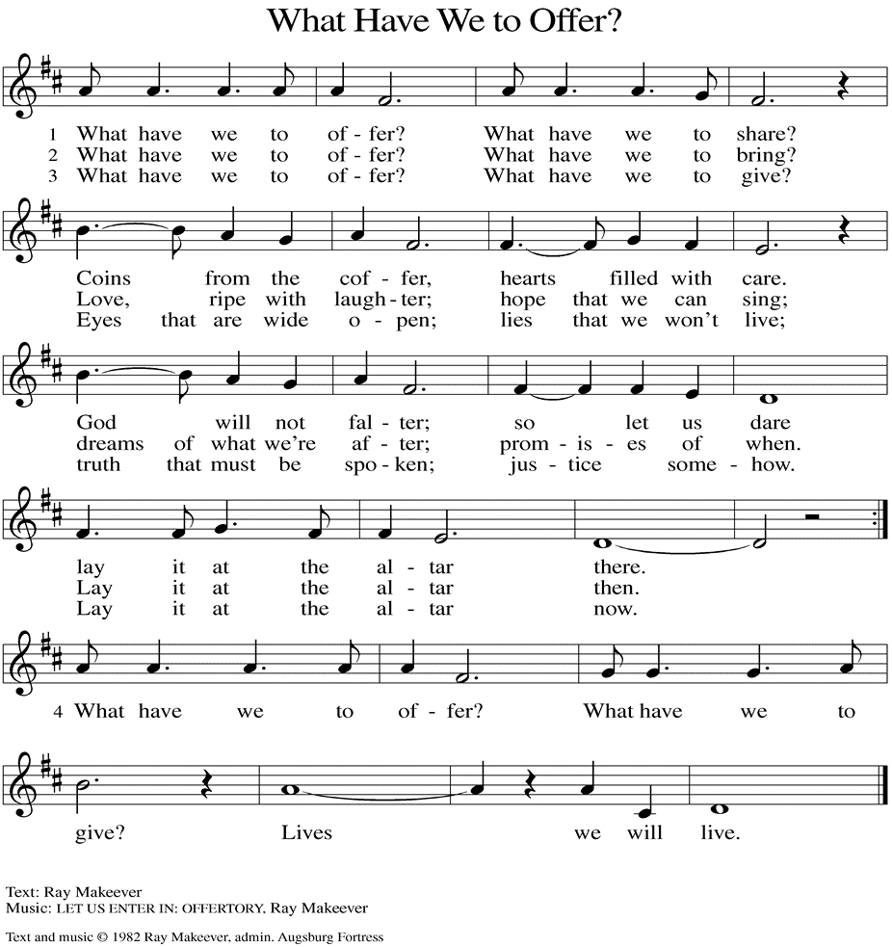
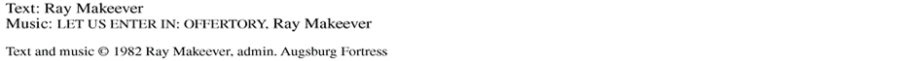

(Usher(s) brings the Tithes and Offerings up front to the Assistant.)
V. We invite you to stand as you are able.

OFFERING PRAYER
V. Let us pray,
God of majesty,
no eye has seen, no ear has heard
what you have prepared for those who love you,
yet in this meal you reveal the wideness of your mercy.
Use what we have gathered
to feed us with the reign of God come near,
Jesus Christ, our Savior and Lord.
C. Amen.

GREAT THANKSGIVING
V. The Lord be with you.
C. And also with you.

V. Lift up your hearts.
C. We lift them to the Lord.

V. Let us give thanks to the Lord our God.
C. It is right to give him thanks and praise.

V. It is indeed right and salutary that we should at all times and in all places offer
thanks and praise to you, O Lord, holy Father, through Christ our Lord; who rose
beyond the bounds of death and, as he promised, poured out your Spirit of life
and power upon the chosen disciples. At this the whole earth exults in boundless
joy. And so, with the Church on earth and the hosts of heaven, we praise your
name and join their unending hymn:

SANCTUS
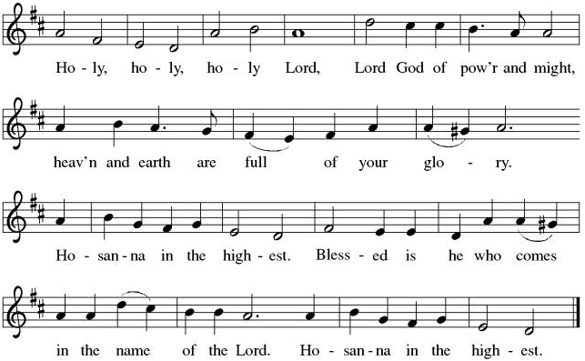

THE EUCHARISTIC PRAYER
V. Blessed are you, Lord of heaven and earth, in mercy for our fallen world you gave
your only Son, that all those who believe in Him should not perish, but have
eternal life. We give thanks to you for the salvation you have prepared for us
through Jesus Christ. Send now your Holy Spirit into our hearts that we may
receive our Lord with a living faith as He comes to us in His holy supper.
C. Amen. Come, Lord Jesus.

V. In the night in which he was betrayed our Lord Jesus took bread,
he gave thanks; broke it, and gave it to his disciples, saying:
Take and eat; this is my body, given for you.
Do this for the remembrance of me.

V. Again, after supper, He took the cup, he gave thanks,
and gave it for all to drink, saying:
This cup is the new covenant in my blood,
shed for you and for all people for the forgiveness of sin.
Do this for the remembrance of me.

THE LORD’S PRAYER
(We ring the bell throughout the Lord’s Prayer at all services to
invite those in the community to join in praying the Lord’s Prayer.)
V. May we now join with one another and pray together as Jesus has taught us.
C. Our Father, who art in heaven, hallowed be thy name, thy kingdom come,
thy will be done, on earth as it is in heaven. Give us this day our daily
bread; and forgive us our trespasses, as we forgive those who trespass
against us; and lead us not into temptation, but deliver us from evil. For
thine is the kingdom, and the power, and the glory, forever and ever.
Amen.

LAMB OF GOD

(We invite you to be seated.)

HOLY COMMUNION
V. Communion here is pretty simple, and all who are baptized and believe in Jesus
Christ are welcome at the table.

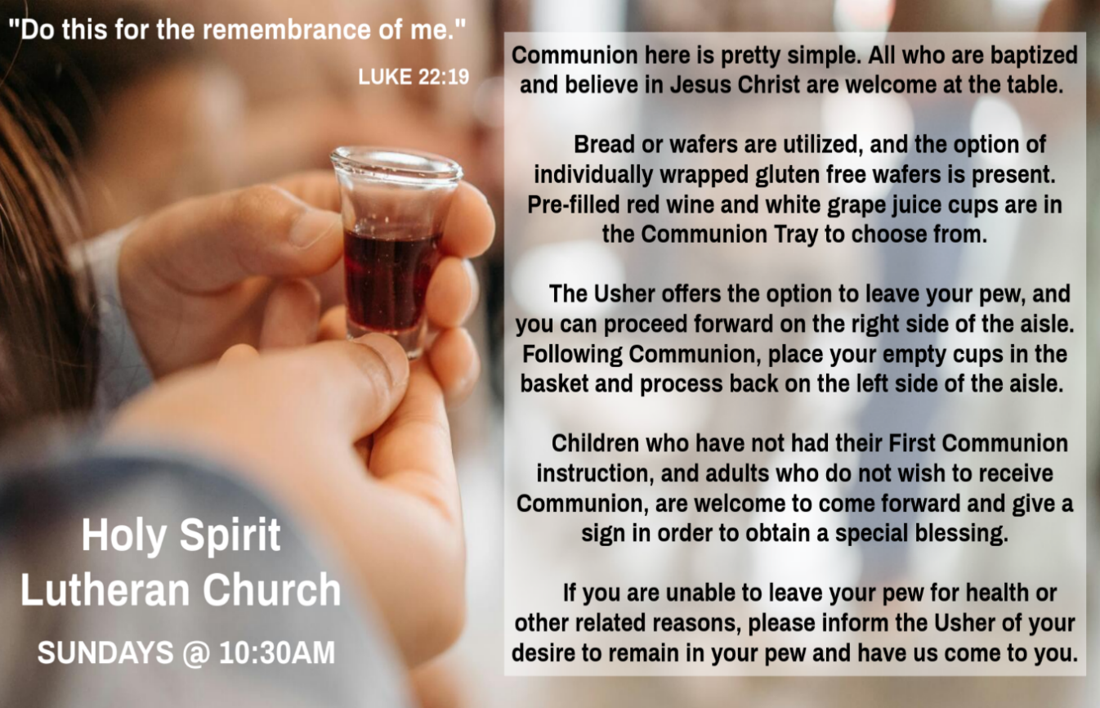

INVITATION TO COMMUNION
V. Here is the Lamb of God who takes away the sin of the world!
Come to the table; taste and see.
C. Amen.

(Distribution of Holy Communion)

COMMUNION HYMN
(Please enjoy various music offered by our Organist during your
quiet time, prayer, and reflection following Holy Communion.)

(Vicar and Assistant remove Communion Vessels from the Altar.)

V. We invite you to stand as you are able.

POST COMMUNION BLESSING
V. May the body and blood of our Lord Jesus Christ strengthen us and keep us
always in His grace.
C. Amen.
POST COMMUNION CANTICLE
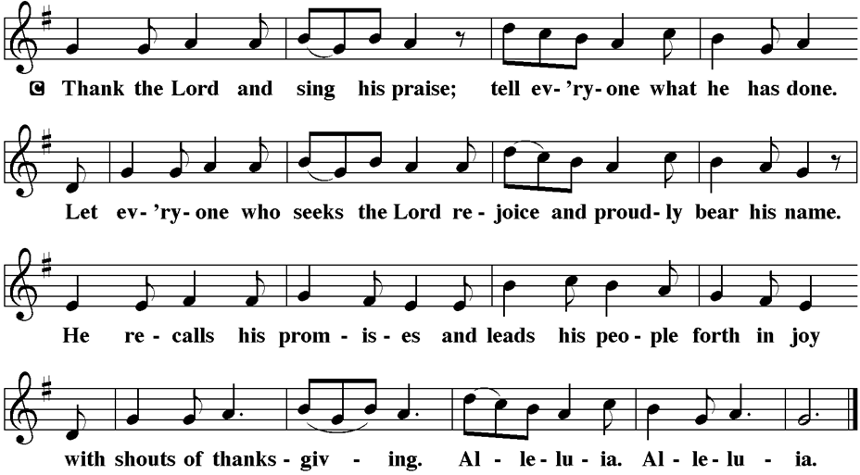

PRAYER AFTER COMMUNION
A. Let us pray,
Radiant God,
we have seen your glory in the face of Jesus Christ.
In the sacrament of his body and blood
you have drawn us to your heart.
Send us from this table with delight,
that our lives may reflect the beauty of your love,
and bear witness to all we have seen and heard,
through Jesus Christ, our Savior and Lord.
C. Amen.

BLESSING
V. May the triune God,
who has put a new song in your mouth
and tuned your heart for praise
☩ bless you now and forever.
C. Amen.

SENDING HYMN
(We invite you to sing along.)
Lutheran Book of Worship—Green Book
390—I Love to Tell the Story

(Assistant extinguishes the Altar Candles half way through the Sending Hymn.)

(Vicar processes out once the Altar Candles have been extinguished.)

(We invite you to be seated.)

BIRTHDAYS, ANNIVERSARIES, & ANNOUNCEMENTS
(Offered by Assistant and Congregation.)

BIRTHDAYS
21st Christine Basco
21st Kim McGinley

DISMISSAL
A. Go in peace. Do justice. Love mercy.
C. Thanks be to God.

POSTLUDE
(Music offered by our Organist as we depart following our Worship Service.)
Jesus Calls Us O’er The Tumult

LICENSES & EXPIRATION DATES
Worship Service Content is used via permission through Augsburg Fortress Liturgies Annual License #SB144368. The next Subscription Renewal Date is 2/28/2026.
Our Hymns and Worship Music are used via permission through CCLI One
License #11327166. The next Subscription Renewal Date is 1/31/2027.



WORSHIP MINISTRY
The most important thing we do each week is gather together as God's people to Worship. God is the center and focus of everything we do. Participating in Worship is active, as Liturgy means the work and actions of the people gathered. Everything we do during the week to prepare for Worship, and everything we do as we Assist in leading Worship is important. We are thankful for all the wonderful work being done. If you have questions, or are interested in any position, reach out to Vicar Vince.
Sign-up sheets are located on the bulletin board between the church offices.

CHURCH COUNCIL
Share your comments, concerns, questions, or joys with one of our Church Council Members who can bring them back to our meetings. Visitors are always welcome to attend and listen to what is going on in and around the church. Join us In- Person or on our Conference Call at our next Meeting on Tuesday, February 17th, at 6PM.

ASH WEDNESDAY AT BROOKDALE & HOLY SPIRIT
Vicar Vince will be preaching at Brookdale Senior Living in Cape May Court House, on Wednesday, February 18th, at 1PM. Holy Communion will follow the service.
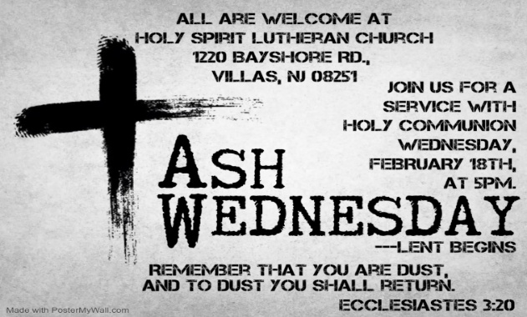

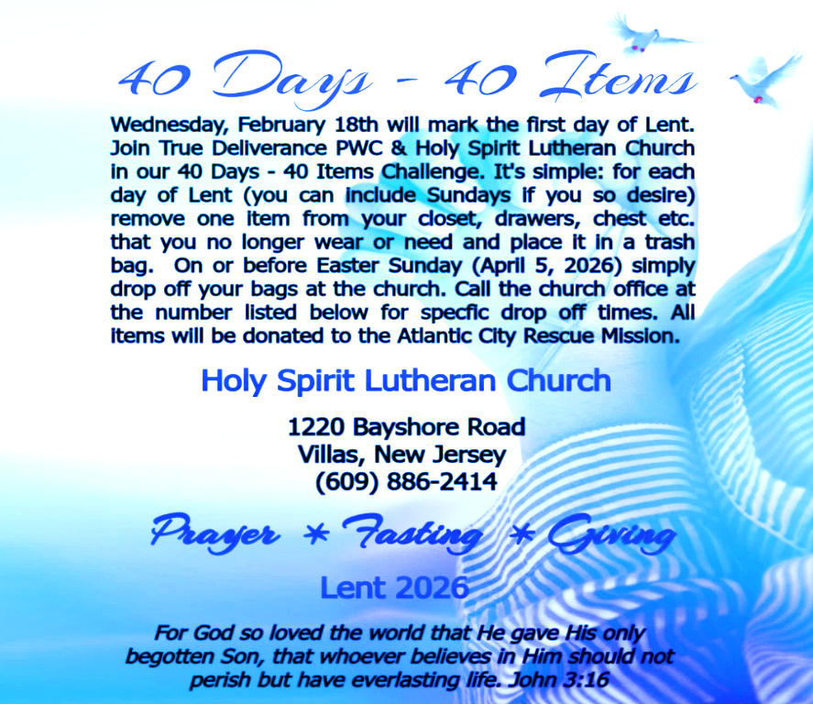

FOOD PANTRY
Open every Thursday, and the last Saturday of every month, from 10AM to 1PM. 134 people were served in January and 134 people have been served in 2026. Donations can be dropped in the outdoor drop-box, in the money jug in the back of the Church, mailed into the Church Office, or placed in the Offering Plate. Volunteers are needed. Sign-up sheets are located on the bulletin board between the church offices. If you have questions or need training see Heather, Vicar Vince, or Bonnie.
A special thank you goes out to all who donate, pray, and help in any way!

Thursday, 2/19 | Thursday, 2/26 | Saturday, 2/28
Patti, Bob, Kim, & Theresa | Patti & Tori | Vicki & Bonnie
COMMUNITY FOOD DONATIONS, DELIVERIES, & MORE
North Cape May Acme provides us with Expiring, Recently Expired, and Slightly Damaged Food and Items. Kathy delivers on Saturdays in the community, brings items to church and the food pantry, and to the Branches Outreach in Rio Grande.

BULLETIN ENTRY DEADLINE
The Bulletin is printed on Thursdays during Church Office Hours. Changes need to be submitted to Vicar Vince no later than Thursday by 4PM. Thank you!

CHURCH OFFICE HOURS
Open Thursdays from 6PM to 8PM. It is open to serve the Congregation, the Community, and to handle the business of the Church. Feel free to stop in to talk, pick-up or drop off something, pray in the Sanctuary, or for whatever reason.


2025 Church Directories are by the Church Office on the bookshelves. We continue keeping it updated, but we undoubtedly miss a few changes or have made a few errors. If you have changes or updates, please inform the Church Office to keep us up to date. Our 2026 Directory will be available sometime later in February.

MISSION DISTRICT MEETING
Our annual meeting of the Southern Mission District will be on Saturday, February 21st, at 10am at Christ Lutheran Church in Whiting. The partial agenda for our time together is election of a clergy member to the Synod Council. We will be joined by Bishop Christa Compton. Please see Vicar Vince if you would like to attend.

CONFIRMATION & SUNDAY SCHOOL
“Here We Stand” allows our young folks to go through a 2-year process focusing on the Bible and Luther’s Small Catechism. Classes are on Sundays from 9-10AM. The young folks are out of town. Class will resume on Sunday, February 22nd.

BIBLE STUDY & FAITH DISCUSSIONS
Bible Study & Faith Discussions focuses on various readings, books, Bible verses, people of faith, and other general topics. Group Members offer various points of view while being respectful and supportive of one another. Join us on Tuesdays at 6PM.
We will resume following our Church Council week on Tuesday, February 24th.
DONATION STATION
Get on the train and place all purchased items in the specified project donation bins located on the counter by the front doors. See Heather for more information.


WOMEN OF THE CHURCH
They will be on Winter Break and will Resume Meetings on Monday, March 2nd, at 6PM. New members are always welcome to attend! Contact Judy for more info.

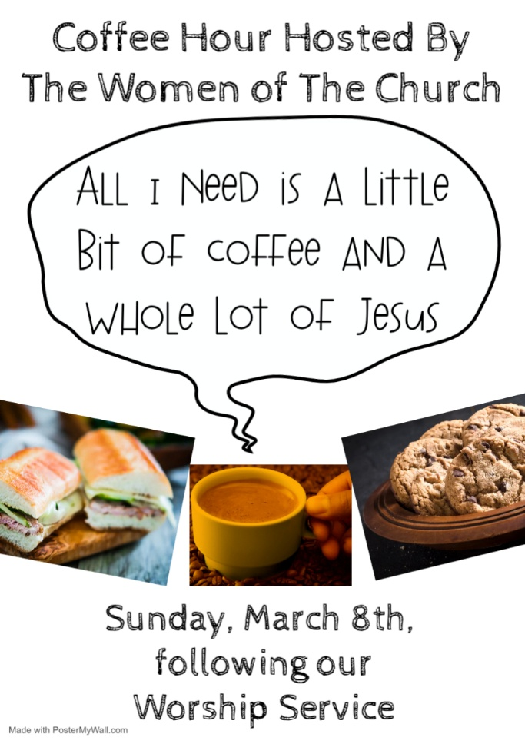

NEWSLETTER
Collect information, stories, pictures, and reports for our next publication. Everything needs submitted to Vicar Vince in-person or via email at vpie8282@gmail.com.
The deadline for information to be submitted for Spring is Sunday, March 15th.


Our NJ Synod Assembly transitions back to a one-day event on Saturday, May 30th, 2026. Mary & Judy are considering attending with Vicar Vince.

TITHES, OFFERINGS, & ENVELOPES
We worship God with our tithes and offerings. We hear in scripture, “Each of you must give as you have made up your mind, not reluctantly or under compulsion, for God loves a cheerful giver.” (2 Corinthians 9:7) Envelopes can be dropped in the offering plate, mailed to the church, or dropped in the locked mailbox. Thanks for your support in the mission of our church, its ministries, the NJ Synod, etc!

SPACE AVAILABLE
​​​​​Interested in utilizing our Fellowship Hall for a Party or Event? There is a suggested $50 refundable security deposit, and it is $250 for facility use. No alcohol or games of chance permitted due to ELCA policy. Please contact Vicar Vince for more info.

ED GREEN CAPITAL IMPROVEMENT FUND
We are seeking out a new fundraiser at this time. We also have the donation bin in the back of the church and we have our Annual Church Rummage Sale to raise funds. Thanks for your continued donations, prayers, and support!

HOME COMMUNION MINISTRY
A Minister is available if you have a loved one, or if you desire services. We look forward in sharing the Word and Holy Communion! Please inform Vicar Vince, Kathy, or the Church Office so plans can be made for visits.

PRAYER SHAWL MINISTRY
Prayer Shawls, Lap Quilts, Scarves, and other items have been made with love. Blessed items are located in the Narthex, and are free for anyone. Members of the group continue working at home on new stitches and patterns. We are blessed to be able to continue collecting new items. We have a donation station of yarn and other items located in the Narthex. You can find some new supplies for your next creation!
PRAYER LIST
Our Prayer List continues to lengthen and we realize the important need for prayers and healing. Sometimes the unfortunate result is that someone has passed away, and the words “The Family & Friends of” appear before someone’s name. However, sometimes we forget names are still on the list and their health has improved and they can be removed. Please share various stories as we continue to pray for strength and healing. Names can be added or removed from the list on the clipboard in the Narthex prior to the Worship Service, by calling the church office, or addressing it on the Conference Call. Please let us know the relation to the person(s) you listed so we can be more mindful with our prayers.

LIBRARY
New books are added to our library from time to time. Several are borrowed and read and exchanged. Who knows, you might find one particularly interesting and share that with someone as well. Reading is a great way to pass spare time, learn, and explore. You may find some fresh ideas for prayer, ways to grow more spiritually, ways to grow closer to God, or some opportunities to understand our faith more. We also have an extended library located in Vicar Vince’s office. There are Bibles of various translations, books from his personal collection, books inherited from Pastor Leah, movies, past Bible Study Curriculums, and more. Visit the library between the church offices, or just ask to be able to check things out.

FAVORITE HYMNS
Carol is willing to play some of your favorite hymns for the Prelude & Postlude each Sunday during our Worship Service. Feel free to let her know of your suggestions.

INTERESTED IN BECOMING A NEW MEMBER
Have you been attending our church for a while? Have you just recently returned to church after being away for a bit? Maybe you transitioned from another church,
or just started to recently attend our church. We are glad to have you, and would love to have you as a member of our Congregation. See Vicar Vince for more info.

BAPTISM
We are a church whose unity is in Jesus Christ, who gathers us around word and water, wine and bread. Baptism is a significant part of our faith journey as we come from the baptismal waters to live a new life as children of God. Our baptism sets us out on a lifelong journey that is characterized by our relationship to God, our relationship to our faith community, our relationships in our community and the wider world. Living our baptismal covenant means living a life of growth in the faith practices of discipleship. Please see Vicar Vince for more information.
FIRST COMMUNION
Although no particular age for first communion is prescribed by The Use of the Means of Grace, one guideline is offered. Because admission to the Sacrament is by invitation of the Lord to the baptized, "baptized children begin to commune on a regular basis at a time determined through mutual conversation that includes the pastor/vicar, the child, and the parents or sponsors involved, within the accepted practices of the congregation.” Each congregation is encouraged to ask the question of readiness for first communion, establish their own policies regarding age and practice, and accompany that practice with catechesis appropriate to the age of the communicant. If anyone has questions, please see Vicar Vince.

JERSEY JOTTINGS
There is a weekly e-newsletter connecting our synod together with weekly prayer, upcoming events, synod and churchwide activities, mission stories, congregational activities, & more. Sign up at www.njsynod.org/stay-connected or download the app.

VICE PASTOR UPDATE
Pastor William Hodgetts continues to attend our Church Council Meetings
and provides Supervision and Support to Vicar Vince.

VICAR VINCE’S DAY OF REST
A day of rest can have physical, mental, and spiritual benefits. “Mittwoch,” German for mid-week, or Wednesday, is the day that Vicar Vince will use to recharge and do some other things. Please do not hesitate to reach out if there is an emergency!

WHAT IS THE EVANGELICAL LUTHERAN CHURCH IN AMERICA?
The ELCA was formed in 1987 by the merger of three Lutheran Church bodies –
the ALC (American Lutheran Church), the LCA (Lutheran Church in America), and the AELC (Association of Evangelical Lutheran Churches). Learn more at elca.org.

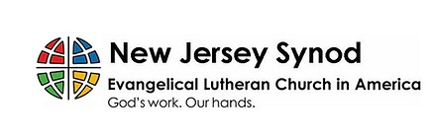
The New Jersey Synod is a geographical grouping of Evangelical Lutheran Church in America (ELCA) congregations that share the mission and ministry of the Church on the New Jersey territory. It is one of 65 synods in the ELCA. The NJ Synod is comprised of 143 congregations, which include over 45,000 baptized members.

VICAR APPOINTMENT ON MARCH 19TH, 2023
A Memorandum of Understanding on the Matter of Pastoral Appointment
In Theological Education for Emerging Ministries (TEEM) Candidacy
TO: Congregation Council, Holy Spirit Lutheran Church, Villas
FROM: The Rev. Tracie L. Bartholomew, Bishop, New Jersey Synod

Dear Brother and Sisters in Christ,
This memorandum is in support of your discussions with Vincent Piekarski as pastor of Holy Spirit, Villas. Because this is not the usual pattern for completing the educational and candidacy requirements for ordination, it is my hope that this memorandum will both provide guidelines and engage in conversation with those who are invested in this process.

I would say at the outset that because Vincent is an outstanding candidate for the Ministry of Word and Sacrament, we will all want to do whatever is necessary to assure that his placement serves the mission of the church in the best possible fashion.

The following notes reflect my own understanding of this matter:
(1) The appointment for Vincent will begin on April 1, 2023. At this time, Vincent
will assume all responsibilities of a regularly called pastor, including presiding at
the Sacrament of Holy Communion and Baptism at Holy Spirit, Villas.
(2) A pastoral appointment in the TEEM process is an option for completing
seminary educational requirements and the steps of the candidacy process.
Upon completion of the candidacy process and seminary education, the
candidate may receive and accept a call to ordained ministry from the
congregation where the appointment is being served.
(3) This appointment is jointly supervised by the Office of the Bishop and the TEEM
pastor’s seminary. A mentoring relationship with a local pastor is required for the
length of this appointment.
(4) The synod of candidacy origin will be responsible for the approval process.
(5) Upon approval for ordination, the congregation would be expected to extend a
call to the pastoral appointee.
(6) Compensation for the TEEM pastor will be according to the guidelines of the New
Jersey Synod. All normal forms of compensation should be in place for the term
of the appointment, including stipulation that base salary and housing shall be in
accord with synod guidelines for first call at time of ordination.
(7) The ELCA Portico benefit plan for lay persons in full-time church service should
be used for the pastoral appointee up to the time of ordination, whereupon the
benefit package is to be converted to the plan for ELCA clergy.

(8) A decision for Pastoral Appointment is made with the agreement of a synod and
its candidacy committee, and the ELCA, normally represented by the regional
staff person of each in consultation with the seminary and its Director for
Contextual Education.
(9) Pastoral Appointment in a TEEM Candidacy is an option that is to serve the
mission of the Church in a particular and vital way and is not to be viewed or
used as a means to circumvent the normal candidacy process and/or first call
placement process.

In the specific case of Vincent, the New Jersey Synod remains responsible for the candidacy and approval process, and has agreed to this proposal for Appointment at Holy Spirit, Villas.

Continued blessings to both Holy Spirit and Vincent Piekarski as you embark on this journey of mutual ministry. As partners in ministry, we walk with you and rejoice in this new relationship.

TRUE DELIVERANCE PRAISE & WORSHIP CENTER
TDPWC utilizes our facilities from 1-4PM on Sundays. TDPWC hosts or assists with other events. TDPWC hosts a Prayer Line on Mondays, Wednesdays, & Fridays at 5PM on the Conference Call 1-657-390-7957; & Bible Study on Thursdays at 6:30PM on Zoom. See Rev. Brooks for more information.

JUST FRIENDS
The group promotes a spirit of fellowship among adults 50 years and older. Bring your own lunch, beverages and deserts are provided. Everyone is welcome. The group meets in Our Lady Star of The Sea Parish Hall on the last Wednesday of the month from 12Noon to 2PM from September through May. For information, please call Martine Simonis 609-884-5312 x 110.

ADDITIONAL OFFERINGS FROM OUR FRIENDS & NEIGHBORS
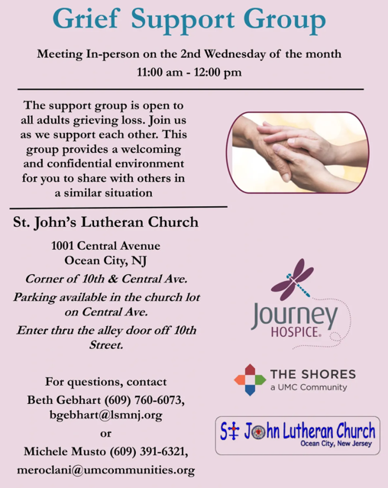

2025 FINANCIAL STANDING
DECEMBER INCOME | $18,368.12
DECEMBER SPENDING | $6,154.14
DECEMBER GAIN OR (LOSS) | $12,213.98
2025 INCOME | $89,570.50
2025 SPENDING | $81,652.42
2025 GAIN OR (LOSS) | $7,918.08
ED GREEN CAPITAL IMPROVEMENT FUND | $2,058.55
FOOD PANTRY FUND (SOCIAL MINISTRY) | $13,621.22
CD | $26,414.45

CHURCH STAFF & VOLUNTEERS
VICAR
Vicar Vince Piekarski
VICE PASTOR
Pastor William Hodgetts
ORGANIST & PIANIST
Carol Amundsen
CHURCH OFFICE, SUNDAY SCHOOL, & FOOD PANTRY
Heather Piekarski
CHURCH COUNCIL PRESIDENT & CHURCH PROPERTY
Wayne Rand
CHURCH COUNCIL VICE PRESIDENT & WOMEN OF THE CHURCH
Judy Brannan
CHURCH COUNCIL TREASURER
Bonnie Millard
CHURCH COUNCIL SECRETARY
Vicki Rinier

