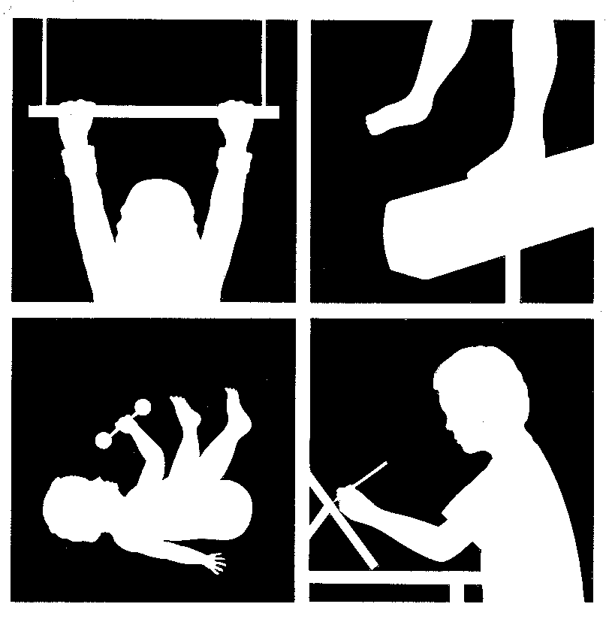
Therapy Rita Patterson OTR/L & Associates

Solutions 836 Ritchie Hwy, Suite 6
For Severna Park, Maryland 21146
Children 410-421-8920 / Fax 410-421-8923
Inc.

HISTORY INFORMATION

Child’s Name: ____________________________ Date of Birth: _________________________
Current School or Program: _________________________________________________________________
Teacher’s Name: __________________________ Phone #: _____________________________

Please describe your concerns and primary reasons for seeking eval/treatment: _________________________
_________________________________________________________________________________________
_________________________________________________________________________________________
_________________________________________________________________________________________

Briefly describe medical history (or attach reports that will summarize information): _____________________
_________________________________________________________________________________________
_________________________________________________________________________________________

Allergies (Mild/Severe): _____________________________________________________________________
_________________________________________________________________________________________

Describe current health status: ________________________________________________________________
_________________________________________________________________________________________
_________________________________________________________________________________________

Please briefly describe development and therapeutic history: ________________________________________
_________________________________________________________________________________________
_________________________________________________________________________________________

Pregnancy and Birth History:
1. Length of pregnancy: __________________
2. Describe any complications during pregnancy: __________________________________________________
__________________________________________________________________________________________
3. Did mother have any infections or illnesses during pregnancy? ______________________________________
___________________________________________________________________________________________
4. Did mother’s water break more than 24 hours prior to delivery? ______________________________________
5. Did mother develop toxemia/ high blood pressure? When? __________________________________________
6. Did mother have any shocks or unusual stress during pregnancy? ____________________________________
___________________________________________________________________________________________
7. Were there any complications during labor or delivery? ____________________________________________
___________________________________________________________________________________________
8.Were any drugs used during labor? _____________________________________________________________

9.Were there any problems at birth? (breech, c-section, others) ________________________________________
___________________________________________________________________________________________
___________________________________________________________________________________________
10. Birth weight: ______________ Weight at discharge: ___________________
11. Did baby require any blood transfusions, oxygen, or time in NICU? _________________________________
___________________________________________________________________________________________

12. Did your child have any of the following:
Prematurity _________
Respiratory problems ________
Need a respirator _______ How long? ___________
Small for Gestational age ___________
Heart Defect __________
Jaundice __________
How long under lights? _____________________
Seizures _________
Infections ____________________________
Feeding problems as a newborn ___________________________________________
Surgery as a newborn ___________________________________________________
Congenital Abnormalities _______________________________________________

13. At what age did the following occur?
a. Turn head from side to side while on stomach ___________________________
b. Roll over __________________
c. Sit alone unsupported ____________________
d. Crawl ___________________
e. Stand alone __________________
f. Walk independently ___________________
g. Run __________________
h. Show hand preference _______________

Please provide any additional information about your child that we may need to know.

___________________________________________________________________________________________
___________________________________________________________________________________________
___________________________________________________________________________________________
___________________________________________________________________________________________

