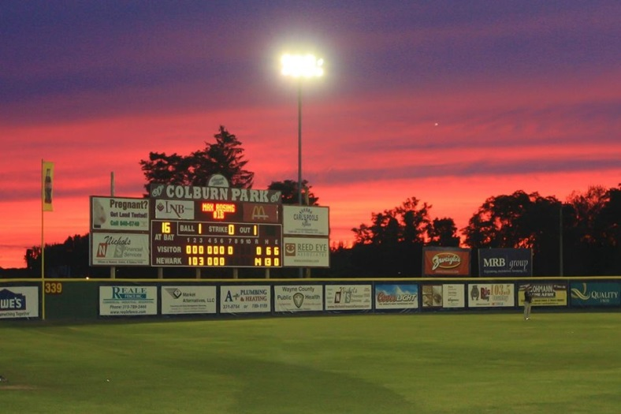

2014 Division III Baseball New York Regional to Be Held In Newark, NY

The Division III Champions Committee has approved Ithaca College to host the 2014 Division III Baseball New York Regional at Colburn Park in Newark, NY. This will be Newark’s first time hosting this tournament that in the past has been held in Auburn, NY. The tournament will be held May 14th-18th.

The eight-team double elimination event will be 14 games with a possible 15th game on Sunday the 18th. The tournament kicks off at 10:00 a.m. Wednesday May 14th.

“We are really excited to be hosting this event in Newark this year”, said Brian Connell, General Manger of the Newark Pilots. “This is a great opportunity for not only the Pilots, but the Village of Newark as well, to show off what great facilities we have at Colburn Park and what a great community this is.”

The tournament is expected to bring around 1,500 fans or more a day from all over. While the teams in the tournament have not yet been decided, they will most likely be coming from New York, Pennsylvania and the New England region.

So if you want to see some great college baseball, head to Colburn Park in Newark, NY, May 14th-18th to check out the 2014 Division III Baseball New York Regional. Game times are listed below:

Wednesday, May 14th
10:00am, 1:15pm, 4:30pm, 7:45pm

Thursday, May 15th
10:00am, 1:15pm, 4:30pm, 7:45pm

Friday, May 16th
10:00am, 1:15pm, 4:30pm, 7:45pm

Saturday, May 17th
1:00pm and 5:00pm

Sunday May 18th
1:00pm (If Necessary)

